EL NIÑO/SOUTHERN OSCILLATION (ENSO) DIAGNOSTIC DISCUSSION

issued by

CLIMATE PREDICTION CENTER/NCEP/NWS

and the International Research Institute for Climate and Society

14 March 2019

ENSO Alert System Status: El Niño Advisory

Synopsis: Weak El Niño conditions are likely to continue through the Northern Hemisphere spring 2019 (~80% chance) and summer (~60% chance).

El Niño conditions strengthened during February 2019, as above-average sea surface temperatures (SSTs) increased across the equatorial Pacific Ocean (Fig. 1) and the associated atmospheric anomalies became increasingly well-defined. The SST index values in the Niño3, Niño3.4 and Niño4 regions all increased during February, with the latest weekly values near +1°C in each region (Fig. 2). The anomalous upper-ocean heat content (averaged across 180°-100°W) increased appreciably during February (Fig. 3), due to an increase in above-average temperatures at depth in association with a downwelling equatorial oceanic Kelvin wave (Fig. 4). Enhanced equatorial convection prevailed near the Date Line, while suppressed convection was observed over Indonesia (Fig. 5). Low-level wind anomalies were westerly in the central Pacific Ocean, while upper-level wind anomalies were mostly westerly over the far western and far eastern Pacific. The equatorial and traditional Southern Oscillation Index values were both negative (-1.4 standard deviations). Overall, these features are consistent with weak El Niño conditions.
The majority of models in the IRI/CPC plume predict a Niño 3.4 index of +0.5°C or greater through the Northern Hemisphere early autumn 2019 (Fig. 6). Given the recent downwelling Kelvin wave, and the increase in both the SSTs and subsurface ocean temperatures, most forecasters expect positive SST anomalies to persist across the central and eastern Pacific for at least the next several months. During that time, forecasters predict the SST anomalies in the Niño 3.4 region to remain between +0.5°C and +1.0°C, indicating weak El Niño conditions. However, because forecasts made during spring tend to be less accurate, the predicted chance that El Niño will persist beyond summer is currently about 50%. In summary, weak El Niño conditions are likely to continue through the Northern Hemisphere spring 2019 (~80% chance) and summer (~60% chance); click CPC/IRI consensus forecast for the chance of each outcome for each 3-month period.
This discussion is a consolidated effort of the National Oceanic and Atmospheric Administration (NOAA), NOAA’s National Weather Service, and their funded institutions. Oceanic and atmospheric conditions are updated weekly on the Climate Prediction Center web site (El Niño/La Niña Current Conditions and Expert Discussions). Forecasts are also updated monthly in the Forecast Forum of CPC's Climate Diagnostics Bulletin. Additional perspectives and analysis are also available in an ENSO blog. The next ENSO Diagnostics Discussion is scheduled for 11 April 2019. To receive an e-mail notification when the monthly ENSO Diagnostic Discussions are released, please send an e-mail message to: ncep.list.enso-update@noaa.gov.

Climate Prediction Center
National Centers for Environmental Prediction
NOAA/National Weather Service
College Park, MD 20740

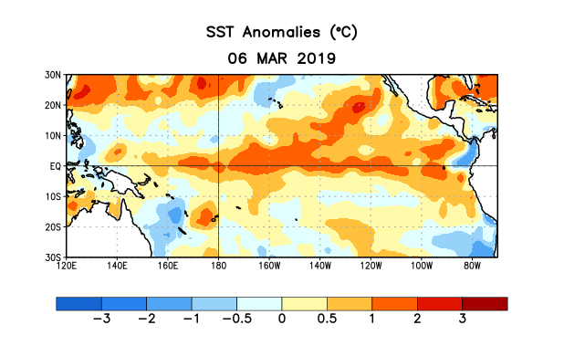
Figure 1. Average sea surface temperature (SST) anomalies (°C) for the week centered on 6 March 2019. Anomalies are computed with respect to the 1981-2010 base period weekly means.

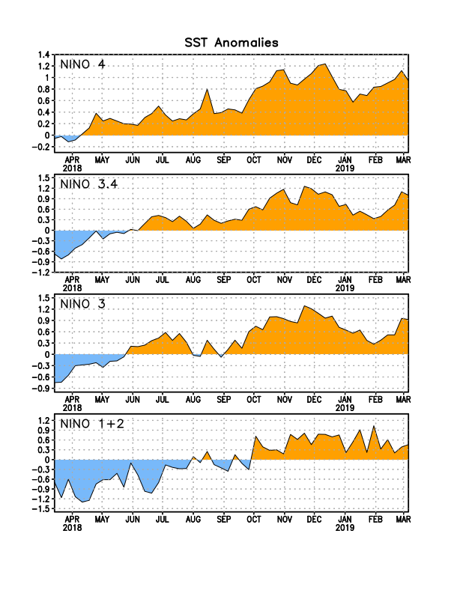
Figure 2. Time series of area-averaged sea surface temperature (SST) anomalies (°C) in the Niño regions [Niño-1+2 (0°-10°S, 90°W-80°W), Niño-3 (5°N-5°S, 150°W-90°W), Niño-3.4 (5°N-5°S, 170°W-120°W), Niño-4 (5ºN-5ºS , 150ºW-160ºE)]. SST anomalies are departures from the 1981-2010 base period weekly means.
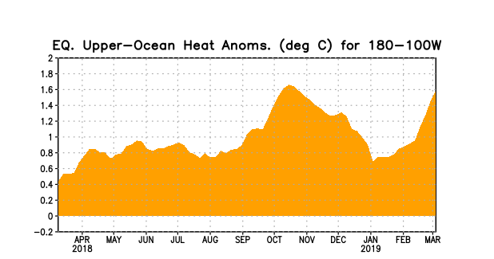
Figure 3. Area-averaged upper-ocean heat content anomaly (°C) in the equatorial Pacific (5°N-5°S, 180º-100ºW). The heat content anomaly is computed as the departure from the 1981-2010 base period pentad means.

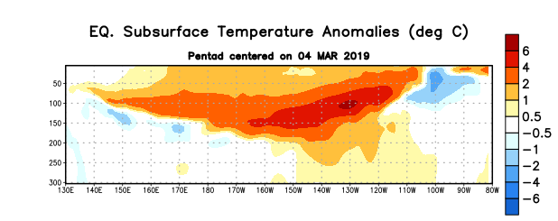
Figure 4. Depth-longitude section of equatorial Pacific upper-ocean (0-300m) temperature anomalies (°C) centered on the pentad of 4 March 2019. Anomalies are departures from the 1981-2010 base period pentad means.

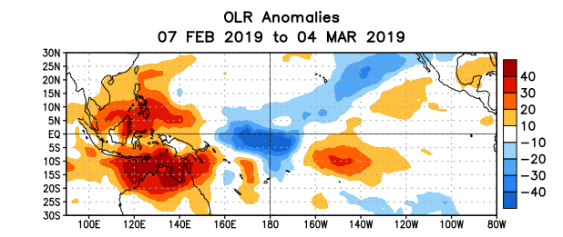
Figure 5. Average outgoing longwave radiation (OLR) anomalies (W/m²) for the period 7 February – 4 March 2019. OLR anomalies are computed as departures from the 1981-2010 base period pentad means.
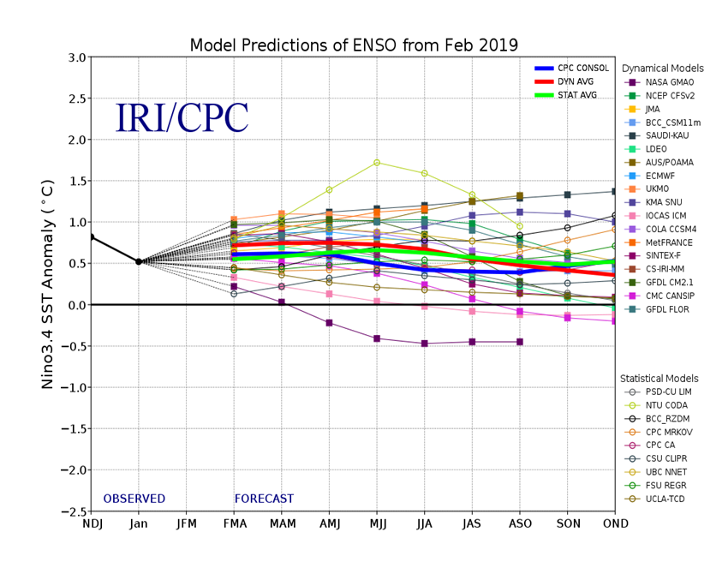
Figure 6. Forecasts of sea surface temperature (SST) anomalies for the Niño 3.4 region (5°N-5°S, 120°W-170°W). Figure updated 19 February 2019.

