EL NIÑO/SOUTHERN OSCILLATION (ENSO) DIAGNOSTIC DISCUSSION

issued by

CLIMATE PREDICTION CENTER/NCEP/NWS

and the International Research Institute for Climate and Society

12 March 2020

ENSO Alert System Status: Not Active

Synopsis: ENSO-neutral is favored for the Northern Hemisphere spring 2020 (~65% chance), continuing through summer 2020 (~55% chance).

During February 2020, above-average sea surface temperatures (SSTs) were evident across the western, central, and far eastern Pacific Ocean (Fig. 1). The latest weekly Niño-3.4 and Niño-3 indices were near-to-above average (+0.5°C and +0.1°C, respectively), with the Niño-4 and Niño-1+2 indices warmer, at +1.1°C (Fig. 2). Equatorial subsurface temperatures (averaged across 180°-100°W) remained above average during the month (Fig. 3), with positive anomalies spanning the western to the east-central equatorial Pacific, from the surface to ~150m depth (Fig. 4). Also during the month, low-level westerly wind anomalies persisted over the western tropical Pacific Ocean, while upper-level wind anomalies were mostly westerly over the eastern half of the basin. Tropical convection remained suppressed over Indonesia and was enhanced near and just west of the Date Line (Fig. 5). While the equatorial Southern Oscillation index (SOI) was negative, the traditional SOI was near average. Overall, the combined oceanic and atmospheric system remained consistent with ENSO-neutral.
The majority of models in the IRI/CPC plume (Fig. 6) favor ENSO-neutral (Niño-3.4 index between -0.5°C and +0.5°C) through the Northern Hemisphere fall. Despite elevated Niño 3.4 index values in the near-term, the forecaster consensus expects the Niño-3.4 index values will decrease gradually through the spring and summer. In summary, ENSO-neutral is favored for the Northern Hemisphere spring 2020 (~65% chance), continuing through summer 2020 (~55% chance; click CPC/IRI consensus forecast for the chance of each outcome for each 3-month period).
This discussion is a consolidated effort of the National Oceanic and Atmospheric Administration (NOAA), NOAA’s National Weather Service, and their funded institutions. Oceanic and atmospheric conditions are updated weekly on the Climate Prediction Center web site (El Niño/La Niña Current Conditions and Expert Discussions). Forecasts are also updated monthly in the Forecast Forum of CPC's Climate Diagnostics Bulletin. Additional perspectives and analysis are also available in an ENSO blog. The next ENSO Diagnostics Discussion is scheduled for 9 April 2020. To receive an e-mail notification when the monthly ENSO Diagnostic Discussions are released, please send an e-mail message to: ncep.list.enso-update@noaa.gov.

Climate Prediction Center
National Centers for Environmental Prediction
NOAA/National Weather Service
College Park, MD 20740

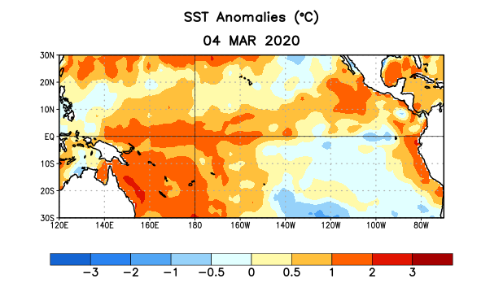
Figure 1. Average sea surface temperature (SST) anomalies (°C) for the week centered on 4 March 2020. Anomalies are computed with respect to the 1981-2010 base period weekly means.

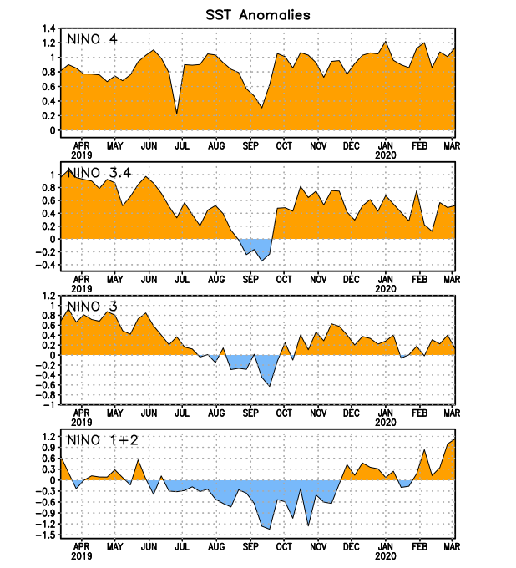
Figure 2. Time series of area-averaged sea surface temperature (SST) anomalies (°C) in the Niño regions [Niño-1+2 (0°-10°S, 90°W-80°W), Niño-3 (5°N-5°S, 150°W-90°W), Niño-3.4 (5°N-5°S, 170°W-120°W), Niño-4 (5ºN-5ºS , 150ºW-160ºE)]. SST anomalies are departures from the 1981-2010 base period weekly means.
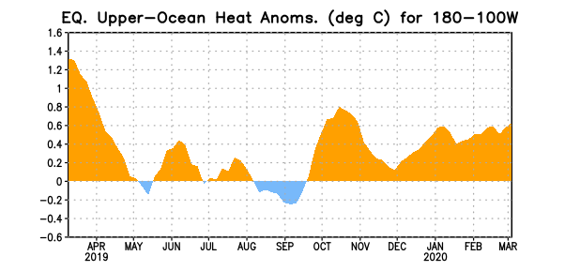
Figure 3. Area-averaged upper-ocean heat content anomaly (°C) in the equatorial Pacific (5°N-5°S, 180º-100ºW). The heat content anomaly is computed as the departure from the 1981-2010 base period pentad means.

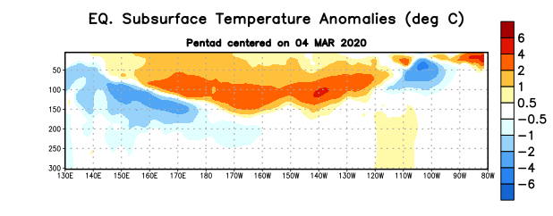
Figure 4. Depth-longitude section of equatorial Pacific upper-ocean (0-300m) temperature anomalies (°C) centered on the pentad of 4 March 2020. Anomalies are departures from the 1981-2010 base period pentad means.

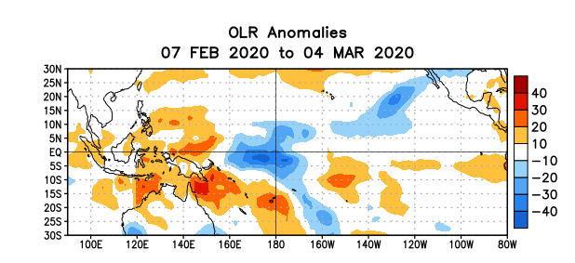
Figure 5. Average outgoing longwave radiation (OLR) anomalies (W/m²) for the period 7 February – 4 March 2020. OLR anomalies are computed as departures from the 1981-2010 base period pentad means.

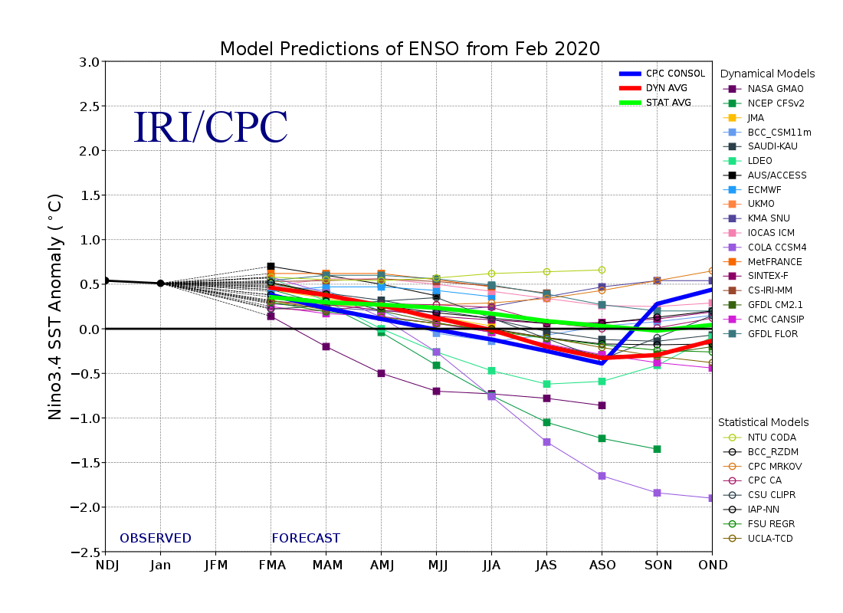
Figure 6. Forecasts of sea surface temperature (SST) anomalies for the Niño 3.4 region (5°N-5°S, 120°W-170°W). Figure updated 19 February 2020.

