EL NIÑO/SOUTHERN OSCILLATION (ENSO) DIAGNOSTIC DISCUSSION

issued by

CLIMATE PREDICTION CENTER/NCEP/NWS

and the International Research Institute for Climate and Society

11 March 2021

ENSO Alert System Status: La Niña Advisory

Synopsis: There is a ~60% chance of a transition from La Niña to ENSO-Neutral during the Northern Hemisphere spring 2021 (April-June).

La Niña continued during February, reflected by below-average sea surface temperatures (SST) anomalies, which extended from the western to east-central Pacific Ocean (Fig. 1). SSTs returned to near average in the eastern Pacific Ocean by late January, before oscillating during February, as indicated by the week-to-week variability in most of the Niño index regions (Fig. 2). The latest weekly Niño index values in the central (Niño-4) and east-central (Niño-3.4) Pacific Ocean were -0.8ºC and -0.7ºC. The below-average SSTs were linked to negative subsurface temperature anomalies (Fig. 3), which weakened noticeably during the month. Currently, negative subsurface anomalies extended from the surface to approximately ~150m below the surface between 150°E and 90°W (Fig. 4). Low-level wind anomalies showed periods of enhanced, but localized, easterlies in the east-central Pacific. Upper-level wind anomalies were westerly across the central and eastern tropical Pacific. The suppression of tropical convection over the western and central Pacific weakened during February, as did the enhancement of rainfall around the Philippines and Indonesia (Fig. 5) compared to the previous few months. The Southern Oscillation and Equatorial Southern Oscillation remained positive, but also weakened. Overall, the coupled ocean-atmosphere system is consistent with a weak or decaying La Niña.
Most of the models in the IRI/CPC plume predict a transition to ENSO-neutral during the Northern Hemisphere spring 2021 (Fig. 6). The forecaster consensus agrees with this transition and then predicts a continuation of ENSO-neutral at least through the Northern Hemisphere summer. In part, due to the uncertainty in predictions made at this time of year, the forecast for September-November remains lower confidence with a 45-50% for La Niña and 40-45% for ENSO-Neutral, with a low chance for El Niño. In summary, there is a ~60% chance of a transition from La Niña to ENSO-Neutral during the Northern Hemisphere spring 2021 (April-June; click CPC/IRI consensus forecast for the chances in each 3-month period).
La Niña is anticipated to affect climate across the United States during the upcoming months. The 3-month seasonal temperature and precipitation outlooks will be updated on Thursday March 18th.
This discussion is a consolidated effort of the National Oceanic and Atmospheric Administration (NOAA), NOAA’s National Weather Service, and their funded institutions. Oceanic and atmospheric conditions are updated weekly on the Climate Prediction Center web site (El Niño/La Niña Current Conditions and Expert Discussions). Additional perspectives and analysis are also available in an ENSO blog. A probabilistic strength forecast is available here. The next ENSO Diagnostics Discussion is scheduled for 8 April 2021. To receive an e-mail notification when the monthly ENSO Diagnostic Discussions are released, please send an e-mail message to: ncep.list.enso-update@noaa.gov.

Climate Prediction Center
National Centers for Environmental Prediction
NOAA/National Weather Service
College Park, MD 20740

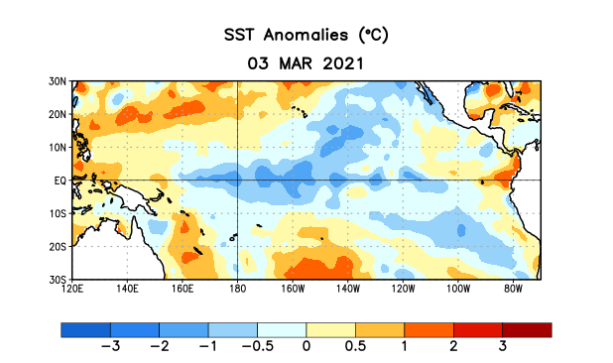
Figure 1. Average sea surface temperature (SST) anomalies (°C) for the week centered on 3 March 2021. Anomalies are computed with respect to the 1991-2020 base period weekly means.

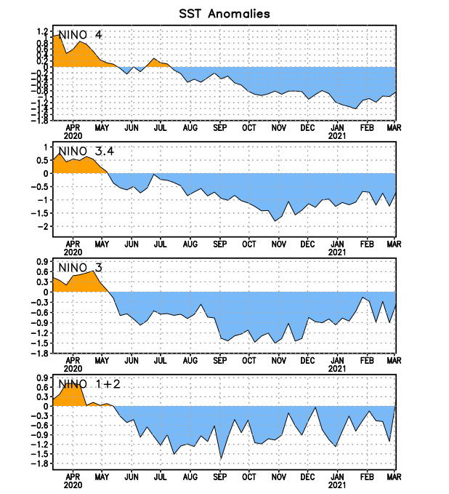
Figure 2. Time series of area-averaged sea surface temperature (SST) anomalies (°C) in the Niño regions [Niño-1+2 (0°-10°S, 90°W-80°W), Niño-3 (5°N-5°S, 150°W-90°W), Niño-3.4 (5°N-5°S, 170°W-120°W), Niño-4 (5ºN-5ºS , 150ºW-160ºE)]. SST anomalies are departures from the 1991-2020 base period weekly means.
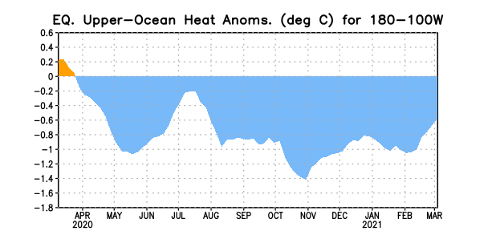
Figure 3. Area-averaged upper-ocean heat content anomaly (°C) in the equatorial Pacific (5°N-5°S, 180º-100ºW). The heat content anomaly is computed as the departure from the 1991-2020 base period pentad means.

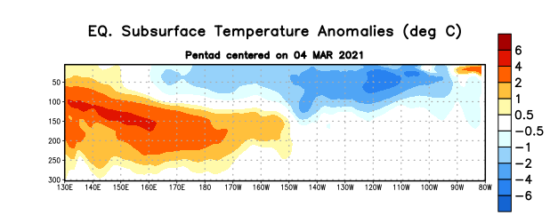
Figure 4. Depth-longitude section of equatorial Pacific upper-ocean (0-300m) temperature anomalies (°C) centered on the pentad of 4 March 2021. Anomalies are departures from the 1991-2020 base period pentad means.

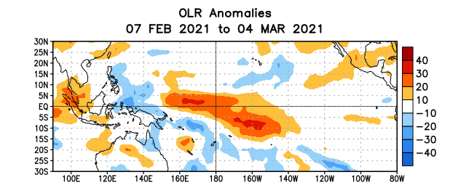
Figure 5. Average outgoing longwave radiation (OLR) anomalies (W/m²) for the period 7 February – 4 March 2021. OLR anomalies are computed as departures from the 1981-2010 base period pentad means.

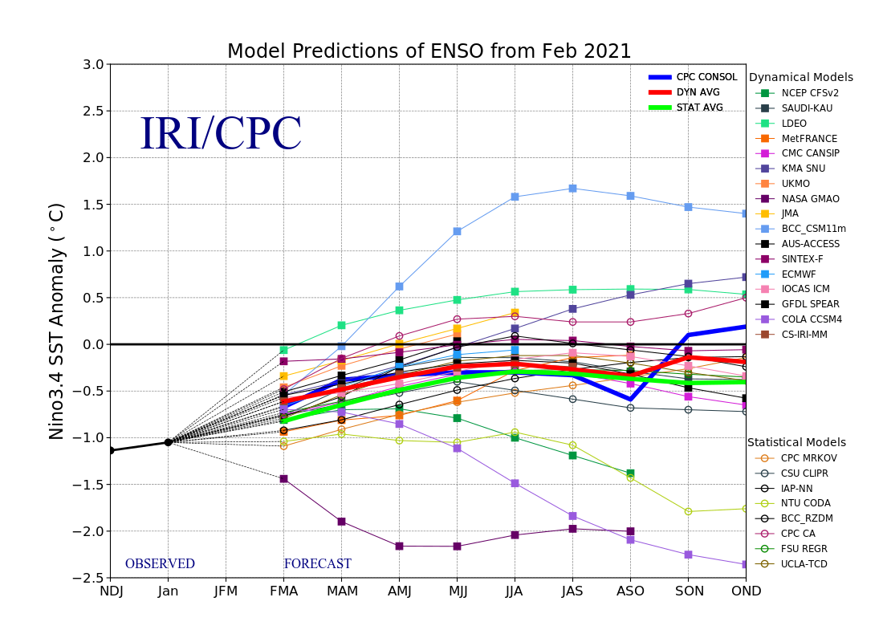
Figure 6. Forecasts of sea surface temperature (SST) anomalies for the Niño 3.4 region (5°N-5°S, 120°W-170°W). Figure updated 19 February 2021.

