EL NIÑO/SOUTHERN OSCILLATION (ENSO) DIAGNOSTIC DISCUSSION

issued by

CLIMATE PREDICTION CENTER/NCEP/NWS

and the International Research Institute for Climate and Society

10 March 2022

ENSO Alert System Status: La Niña Advisory

Synopsis: La Niña is favored to continue into the Northern Hemisphere summer (53% chance during June-August 2022), with a 40-50% chance of La Niña or ENSO-neutral thereafter.

Below-average sea surface temperatures (SSTs) strengthened during February 2022 across the central and east-central tropical Pacific, with negative anomalies stretching from the central to eastern equatorial Pacific Ocean (Fig. 1). In particular, the weekly Niño-3.4 index decreased from -0.6ºC at the beginning of February to -1.1ºC in the last week (Fig. 2), while the other Niño SST regions were between -0.6ºC and -1.3ºC in the last week. Subsurface temperatures anomalies (averaged between 180º-100ºW and 0-300m depth) were near zero (Fig. 3), as the recent warming associated with the downwelling Kelvin wave has attenuated. Below-average temperatures have expanded near the surface and at depth near ~150ºW (Fig. 4). Tropical atmospheric anomalies strengthened during the past month, with the extension of enhanced low-level easterly winds across the equatorial Pacific and upper-level westerly wind anomalies remaining over the east-central and eastern Pacific Ocean. Suppressed convection strengthened around the Date Line, while convection was enhanced near Indonesia (Fig. 5). Overall, the coupled ocean-atmosphere system reflected the continuation of La Niña.
The IRI/CPC plume average for the Niño-3.4 SST index continues to forecast a transition to ENSO-neutral during the Northern Hemisphere spring (Fig. 6). This month, the forecaster consensus favors a slower decay of La Niña due to the recent renewal of ocean-atmosphere coupling, which contributed to cooler near-term forecasts from several state-of-the-art climate models. For the summer and beyond, there is large uncertainty in the state of ENSO; however forecasters lean toward negative Niño-3.4 index values even if the index does not reach La Niña thresholds. In summary, La Niña is favored to continue into the Northern Hemisphere summer (53% chance during June-August 2022), with a 40-50% chance of La Niña or ENSO-neutral thereafter; click CPC/IRI consensus forecast for the chances in each 3-month period).
La Niña is anticipated to affect temperature and precipitation across the United States during the upcoming months (the 3-month seasonal temperature and precipitation outlooks will be updated on Thurs. Mar. 17th).
This discussion is a consolidated effort of the National Oceanic and Atmospheric Administration (NOAA), NOAA’s National Weather Service, and their funded institutions. Oceanic and atmospheric conditions are updated weekly on the Climate Prediction Center web site (El Niño/La Niña Current Conditions and Expert Discussions). Additional perspectives and analysis are also available in an ENSO blog. A probabilistic strength forecast is available here. The next ENSO Diagnostics Discussion is scheduled for 14 April 2022. To receive an e-mail notification when the monthly ENSO Diagnostic Discussions are released, please send an e-mail message to: ncep.list.enso-update@noaa.gov.

Climate Prediction Center
National Centers for Environmental Prediction
NOAA/National Weather Service
College Park, MD 20740

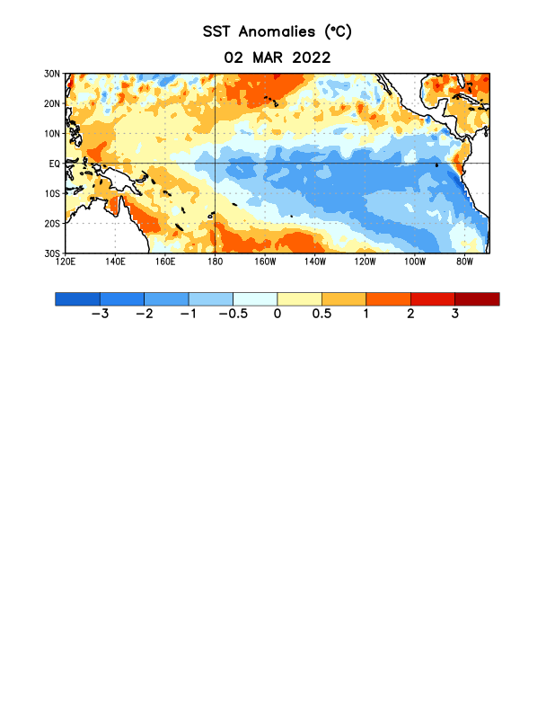
Figure 1. Average sea surface temperature (SST) anomalies (°C) for the week centered on 2 March 2022. Anomalies are computed with respect to the 1991-2020 base period weekly means.

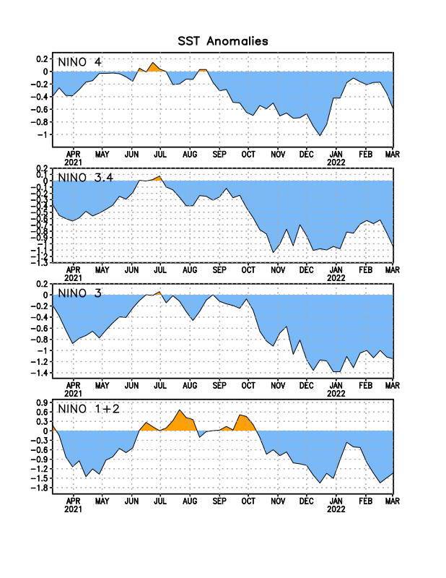
Figure 2. Time series of area-averaged sea surface temperature (SST) anomalies (°C) in the Niño regions [Niño-1+2 (0°-10°S, 90°W-80°W), Niño-3 (5°N-5°S, 150°W-90°W), Niño-3.4 (5°N-5°S, 170°W-120°W), Niño-4 (5ºN-5ºS, 150ºW-160ºE)]. SST anomalies are departures from the 1991-2020 base period weekly means.
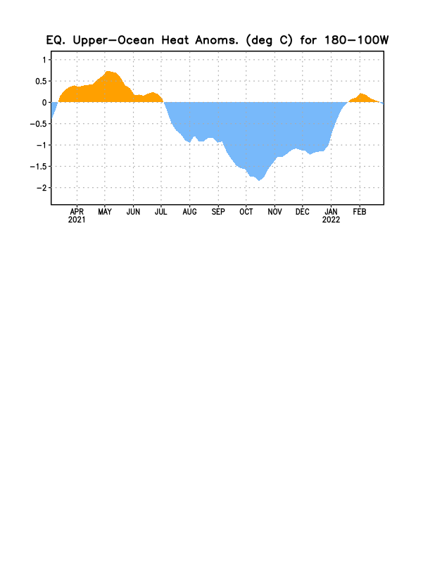
Figure 3. Area-averaged upper-ocean heat content anomaly (°C) in the equatorial Pacific (5°N-5°S, 180º-100ºW). The heat content anomaly is computed as the departure from the 1991-2020 base period pentad means.

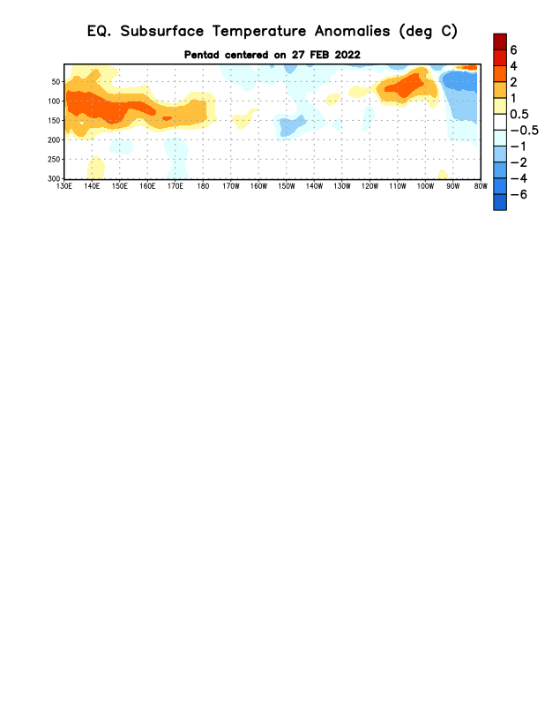

Figure 4. Depth-longitude section of equatorial Pacific upper-ocean (0-300m) temperature anomalies (°C) centered on the pentad of 27 February 2022. Anomalies are departures from the 1991-2020 base period pentad means.

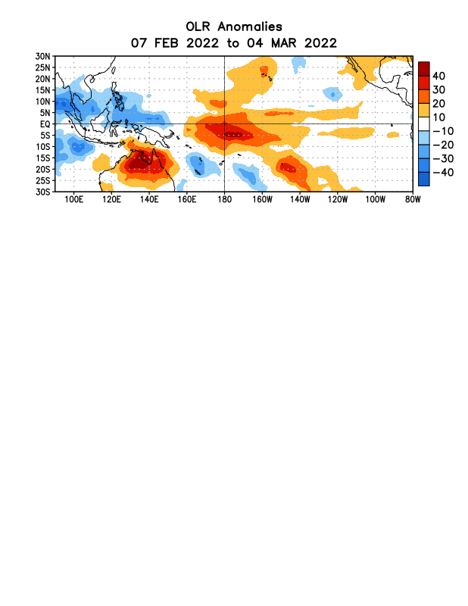

Figure 5. Average outgoing longwave radiation (OLR) anomalies (W/m²) for the period 7 February – 4 March 2022. OLR anomalies are computed as departures from the 1991-2020 base period pentad means.

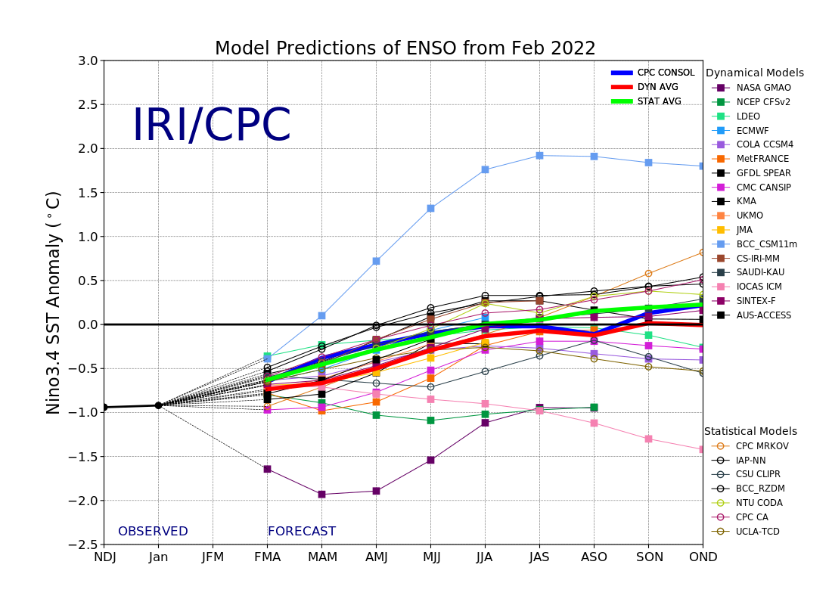
Figure 6. Forecasts of sea surface temperature (SST) anomalies for the Niño 3.4 region (5°N-5°S, 120°W-170°W). Figure updated 18 February 2022.

