EL NIÑO/SOUTHERN OSCILLATION (ENSO) DIAGNOSTIC DISCUSSION

issued by

CLIMATE PREDICTION CENTER/NCEP/NWS

9 March 2023

ENSO Alert System Status: Final La Niña Advisory

Synopsis: La Niña has ended and ENSO-neutral conditions are expected to continue through the Northern Hemisphere spring and early summer 2023.

During February 2023, below-average sea surface temperatures (SSTs) weakened and currently persist only in the central Pacific Ocean (Fig. 1). The latest weekly Niño-3.4 index value was -0.2ºC (Fig. 2). In contrast to the central Pacific, SSTs in parts of the eastern Pacific Ocean were significantly above average, with the latest Niño-1+2 index value at +1.1ºC. In the last month, area-averaged subsurface temperatures became slightly above average (Fig. 3), with positive temperature anomalies spanning the Pacific, though remaining mostly at depth (Fig. 4). The atmospheric circulation anomalies across the tropical Pacific are lagging the changes in the ocean. Low-level easterly wind anomalies continue over the central Pacific Ocean. Upper-level westerly wind anomalies were evident over most of the Pacific. Suppressed convection persisted over the central tropical Pacific, while enhanced convection was observed over Indonesia (Fig. 5). Collectively, the coupled ocean-atmosphere system was consistent with ENSO-neutral.
The most recent IRI plume favors ENSO-neutral to continue through the spring, with El Niño forming during summer 2023 and persisting through the fall (Fig. 6). In contrast, the forecaster consensus favors ENSO-neutral through summer 2023, with elevated chances of El Niño developing afterwards. The smaller chances of El Niño relative to the model predictions are primarily because ENSO forecasts made during the spring are less accurate, and also the tropical Pacific atmosphere is still fairly consistent with a cool/La Niña-like state. However, it is possible that strong warming near South America may portend a more rapid evolution toward El Niño and will be closely monitored. In summary, La Niña has ended and ENSO-neutral conditions are expected to continue through the Northern Hemisphere spring and early summer 2023 (Fig. 7).
This discussion is a consolidated effort of the National Oceanic and Atmospheric Administration (NOAA), NOAA’s National Weather Service, and their funded institutions. Oceanic and atmospheric conditions are updated weekly on the Climate Prediction Center website (El Niño/La Niña Current Conditions and Expert Discussions). Additional perspectives and analyses are also available in an ENSO blog. A probabilistic strength forecast is available here. The next ENSO Diagnostics Discussion is scheduled for 13 April 2023. To receive an e-mail notification when the monthly ENSO Diagnostic Discussions are released, please send an e-mail message to: ncep.list.enso-update@noaa.gov.

Climate Prediction Center
National Centers for Environmental Prediction
NOAA/National Weather Service
College Park, MD 20740
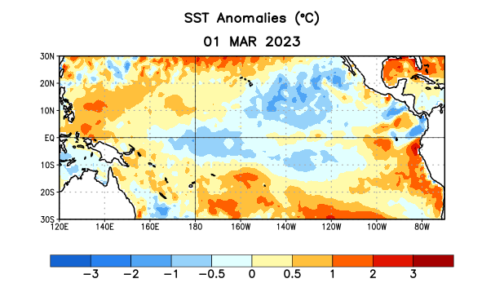
Figure 1. Average sea surface temperature (SST) anomalies (°C) for the week centered on 1 March 2023. Anomalies are computed with respect to the 1991-2020 base period weekly means.

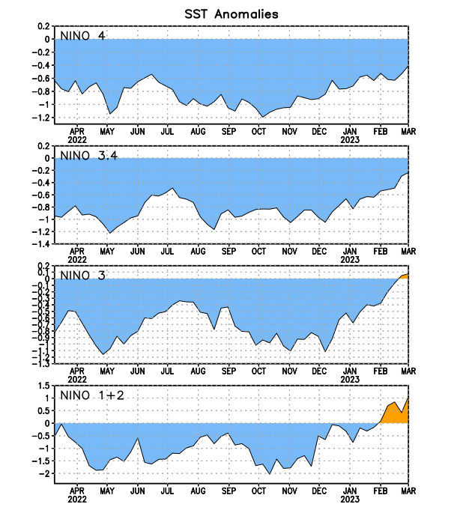
Figure 2. Time series of area-averaged sea surface temperature (SST) anomalies (°C) in the Niño regions [Niño-1+2 (0°-10°S, 90°W-80°W), Niño-3 (5°N-5°S, 150°W-90°W), Niño-3.4 (5°N-5°S, 170°W-120°W), Niño-4 (5ºN-5ºS, 150ºW-160ºE)]. SST anomalies are departures from the 1991-2020 base period weekly means.

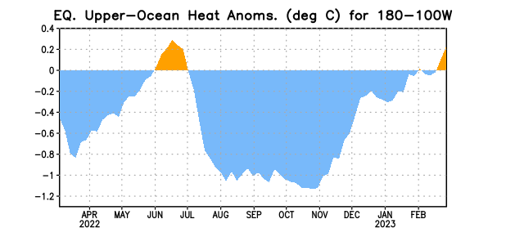

Figure 3. Area-averaged upper-ocean heat content anomaly (°C) in the equatorial Pacific (5°N-5°S, 180º-100ºW). The heat content anomaly is computed as the departure from the 1991-2020 base period pentad means.

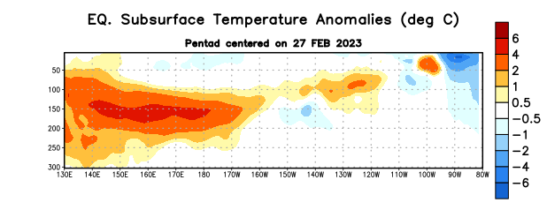
Figure 4. Depth-longitude section of equatorial Pacific upper-ocean (0-300m) temperature anomalies (°C) centered on the pentad of 27 February 2023. Anomalies are departures from the 1991-2020 base period pentad means.

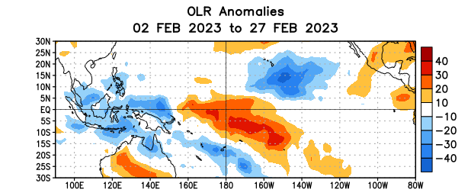

Figure 5. Average outgoing longwave radiation (OLR) anomalies (W/m²) for the period 2 – 27 February 2023. OLR anomalies are computed as departures from the 1991-2020 base period pentad means.

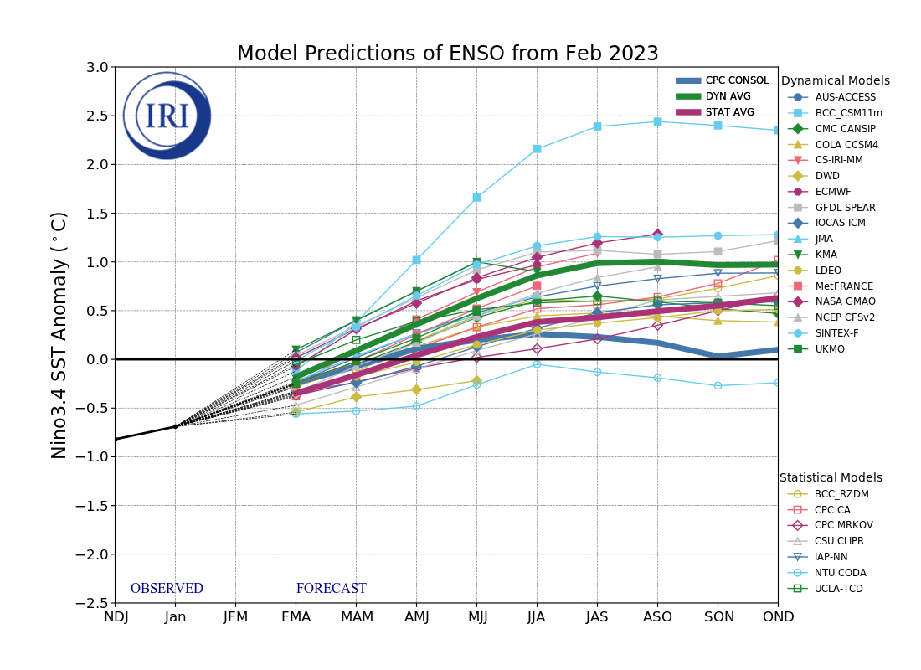
Figure 6. Forecasts of sea surface temperature (SST) anomalies for the Niño 3.4 region (5°N-5°S, 120°W-170°W). Figure updated 20 February 2023 by the International Research Institute (IRI) for Climate and Society.
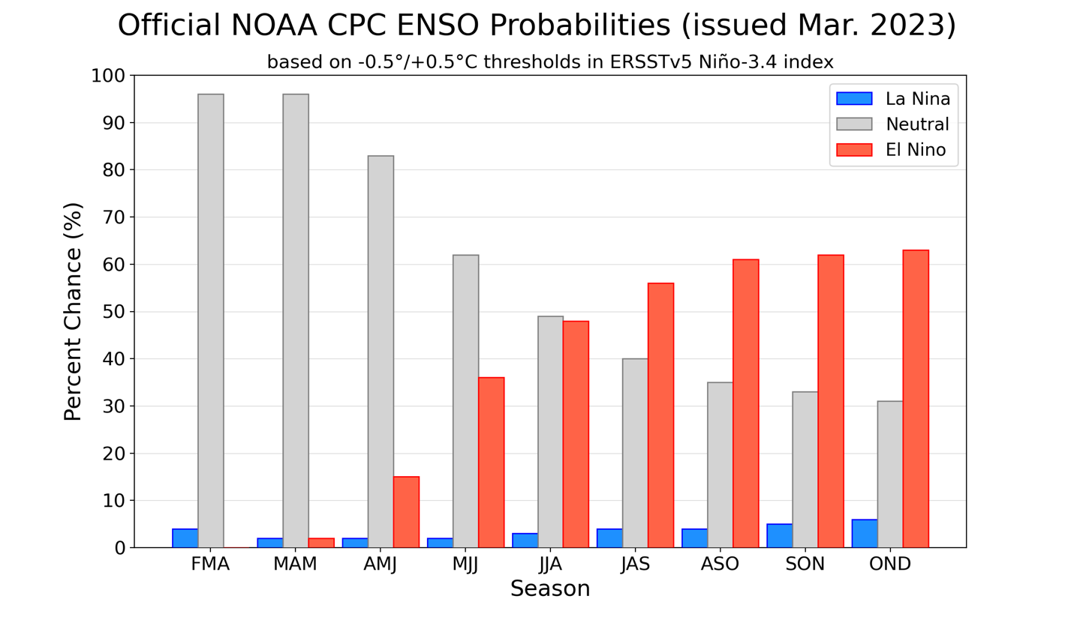
Figure 7. Official ENSO probabilities for the Niño 3.4 sea surface temperature index (5°N-5°S,
120°W-170°W). Figure updated 9 March 2023.

