EL NIÑO/SOUTHERN OSCILLATION (ENSO) DIAGNOSTIC DISCUSSION

issued by

CLIMATE PREDICTION CENTER/NCEP/NWS

14 March 2024

ENSO Alert System Status: El Niño Advisory / La Niña Watch

Synopsis: A transition from El Niño to ENSO-neutral is likely by April-June 2024 (83% chance), with the odds of La Niña developing by June-August 2024 (62% chance).

During February 2024, sea surface temperature (SST) anomalies continued to weaken across most of the equatorial Pacific Ocean. In the last week, below-average SSTs emerged in a small region of the eastern equatorial Pacific Ocean (~100°W; Fig. 1). The weekly Niño indices weakened but remained positive, with the latest value in Niño-3.4 standing at 1.4°C (Fig. 2). Area-averaged subsurface temperature anomalies were slightly negative (Fig. 3), reflecting the consequences of an upwelling Kelvin wave and associated below-average temperatures across the equatorial Pacific Ocean (Fig. 4). Low-level winds were near average over most of the equatorial Pacific, while upper-level wind anomalies were easterly over the east-central Pacific. Convection was enhanced near the Date Line and was suppressed near Indonesia (Fig. 5). Collectively, the coupled ocean-atmosphere system reflected a weakening El Niño.
The most recent IRI plume indicates a transition to ENSO-neutral during spring 2024, with La Niña potentially developing during summer 2024 (Fig. 6). While different types of models suggest La Niña will develop, the forecast team favors the dynamical model guidance, which is slightly more accurate for forecasts made during this time of year. Even though forecasts made through the spring season tend to be less reliable, there is a historical tendency for La Niña to follow strong El Niño events. In summary, a transition from El Niño to ENSO-neutral is likely by April-June 2024 (83% chance), with the odds of La Niña developing by June-August 2024 (62% chance; Fig. 7).
This discussion is a consolidated effort of the National Oceanic and Atmospheric Administration (NOAA), NOAA’s National Weather Service, and their funded institutions. Oceanic and atmospheric conditions are updated weekly on the Climate Prediction Center website (El Niño/La Niña Current Conditions and Expert Discussions). Additional perspectives and analyses are also available in an ENSO blog. A probabilistic strength forecast is available here. The next ENSO Diagnostics Discussion is scheduled for 11 April 2024. To receive an e-mail notification when the monthly ENSO Diagnostic Discussions are released, please send an e-mail message to: ncep.list.enso-update@noaa.gov.

Climate Prediction Center
National Centers for Environmental Prediction
NOAA/National Weather Service
College Park, MD 20740
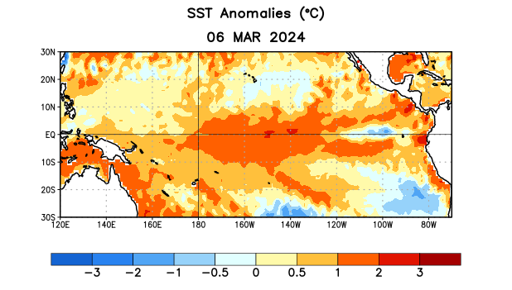
Figure 1. Average sea surface temperature (SST) anomalies (°C) for the week centered on 6 March 2024. Anomalies are computed with respect to the 1991-2020 base period weekly means.

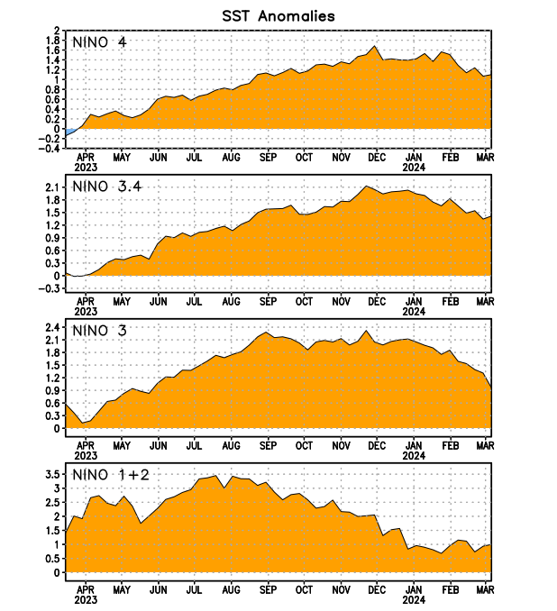
Figure 2. Time series of area-averaged sea surface temperature (SST) anomalies (°C) in the Niño regions [Niño-1+2 (0°-10°S, 90°W-80°W), Niño-3 (5°N-5°S, 150°W-90°W), Niño-3.4 (5°N-5°S, 170°W-120°W), Niño-4 (5ºN-5ºS, 150ºW-160ºE)]. SST anomalies are departures from the 1991-2020 base period weekly means.

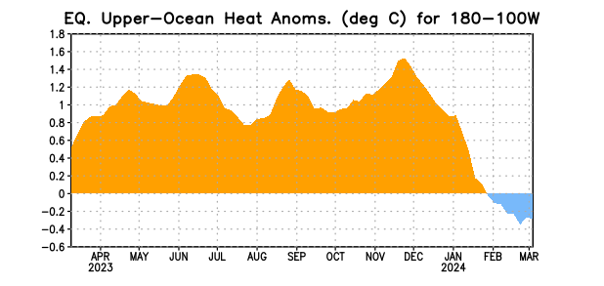

Figure 3. Area-averaged upper-ocean heat content anomaly (°C) in the equatorial Pacific (5°N-5°S, 180º-100ºW). The heat content anomaly is computed as the departure from the 1991-2020 base period pentad means.

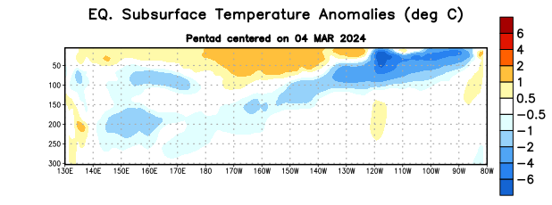
Figure 4. Depth-longitude section of equatorial Pacific upper-ocean (0-300m) temperature anomalies (°C) centered on the pentad of 4 March 2024. Anomalies are departures from the 1991-2020 base period pentad means.

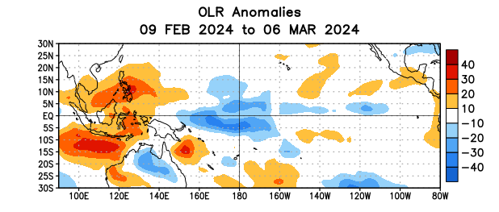

Figure 5. Average outgoing longwave radiation (OLR) anomalies (W/m²) for the period 9 February – 6 March 2024. OLR anomalies are computed as departures from the 1991-2020 base period pentad means.

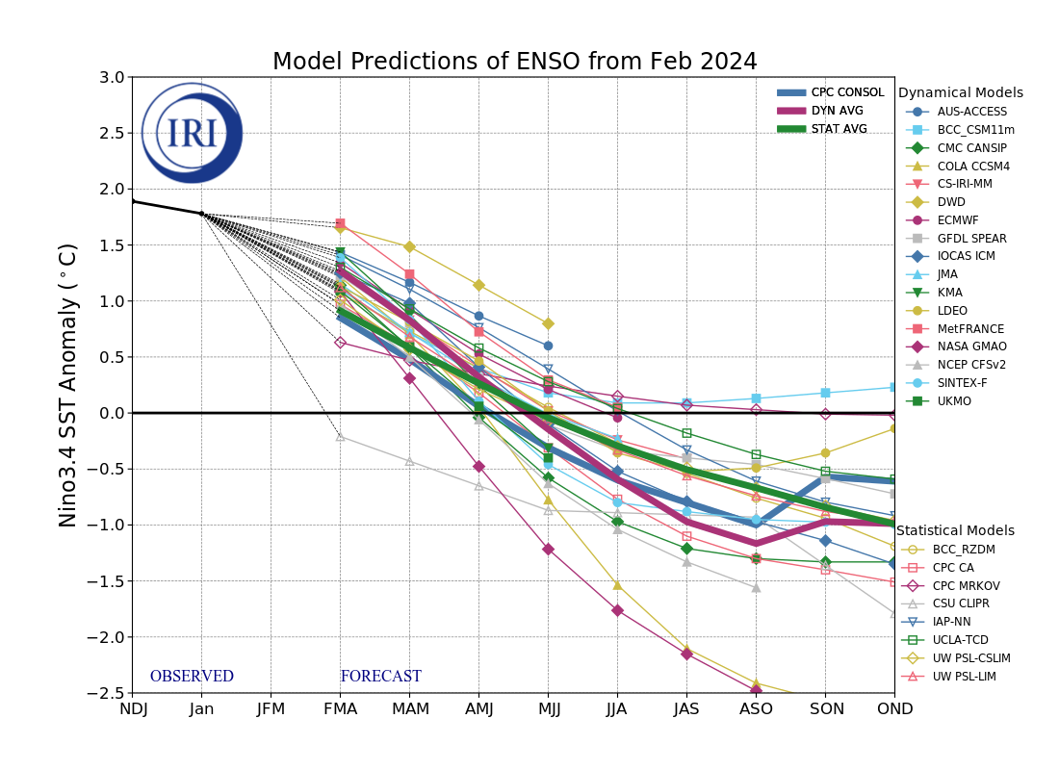
Figure 6. Forecasts of sea surface temperature (SST) anomalies for the Niño 3.4 region (5°N-5°S, 120°W-170°W). Figure updated 19 February 2024 by the International Research Institute (IRI) for Climate and Society.
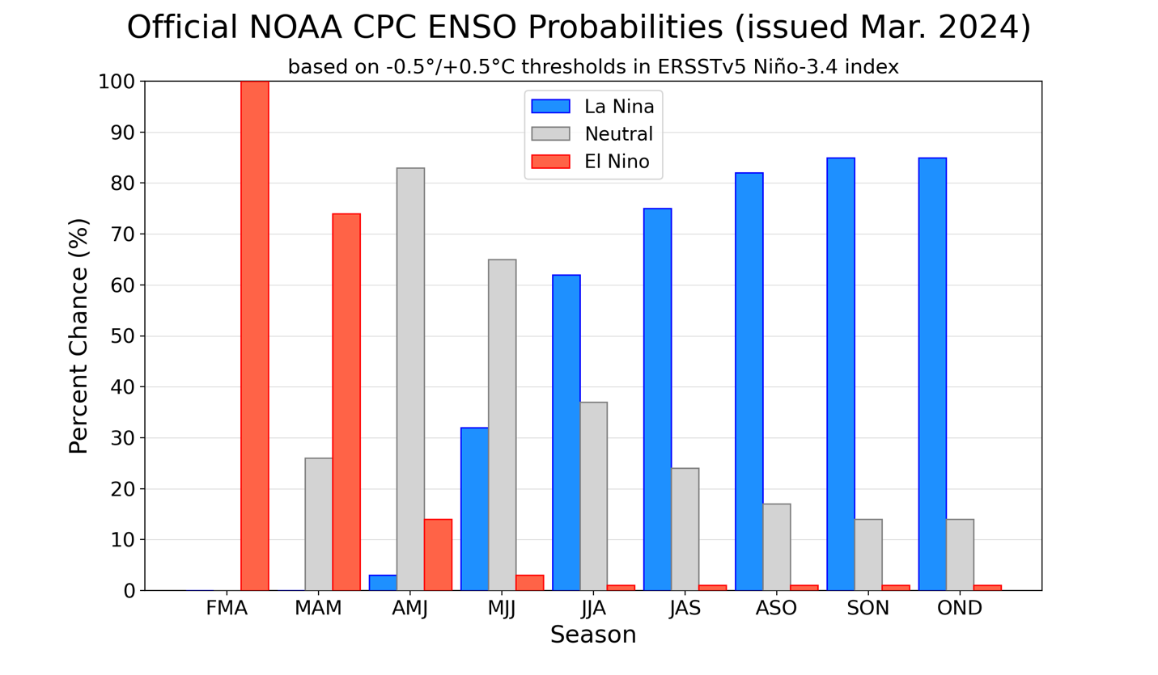
Figure 7. Official ENSO probabilities for the Niño 3.4 sea surface temperature index (5°N-5°S, 120°W-170°W). Figure updated 14 March 2024.

