EL NIÑO/SOUTHERN OSCILLATION (ENSO) DIAGNOSTIC DISCUSSION
issued by
CLIMATE PREDICTION CENTER/NCEP/NWS
8 May 2008

Synopsis: A transition from La Niña to ENSO-neutral conditions is possible during June- July 2008.
La Niña continued to weaken during April 2008, as reflected by changes in sea surface temperatures (SSTs) across the equatorial Pacific Ocean. Negative SST anomalies in the central and east-central equatorial Pacific have weakened, while positive SST anomalies are confined to parts of the eastern equatorial Pacific (Fig. 1). The latest weekly SSTs in the westernmost Niño-4 and Niño-3.4 regions are between 0.6°C and 0.8°C below average, while departures in the easternmost Niño-3 and Niño-1+2 regions are 0°C and −0.3°C respectively (Fig. 2).
Positive subsurface ocean temperatures at thermocline depth have continued to increase in central and east-central equatorial Pacific (Fig. 3). While this increase has resulted in positive heat content anomalies (average temperatures in the upper 300m of the ocean; Fig 4), a shallow layer of negative anomalies in the central Pacific continues to persist between the surface and 100m. Despite these changes, SSTs remain sufficiently cool to maintain the persistent atmospheric anomalies associated with La Niña. Enhanced low-level easterly winds and upper-level westerly winds continued across the central equatorial Pacific, convection remained suppressed throughout the central equatorial Pacific, and enhanced convection covered the far western Pacific. Collectively, these atmospheric and oceanic conditions indicate an ongoing La Niña.
A majority of the recent dynamical and statistical SST forecasts for the Niño 3.4 region indicate La Niña will persist through May-June-July 2008 (Fig. 5). Thereafter, there is considerable spread in the forecasts, with the majority reflecting ENSO-neutral conditions (−0.5 to 0.5 in the Niño-3.4 region) during the second half of the year. However, the spread of the models spans the possibility of a return to La Niña or even an El Niño by the end of 2008. Based on current atmospheric and oceanic conditions and recent trends, a transition from La Niña to ENSO-neutral conditions is possible during June- July 2008.
Atmospheric conditions related to La Niña often persist for a couple months after SSTs return to ENSO-neutral conditions. Expected La Niña impacts during May- July 2008 include a continuation of above-average precipitation over Indonesia and below-average precipitation over the central equatorial Pacific.
This discussion is a consolidated effort of the National Atmospheric and Oceanic Administration (NOAA), NOAA’s National Weather Service, and their funded institutions. Oceanic and atmospheric conditions are updated weekly on the Climate Prediction Center web site (El Niño/La Niña Current Conditions and Expert Discussions). Forecasts for the evolution of El Niño/La Niña are updated monthly in the Forecast Forum section of CPC's Climate Diagnostics Bulletin. The next ENSO Diagnostics Discussion is scheduled for 5 June 2008. To receive an e-mail notification when the monthly ENSO Diagnostic Discussions are released, please send an e-mail message to: ncep.list.enso-update@noaa.gov.
Climate Prediction Center
National Centers for Environmental Prediction
NOAA/National Weather Service
Camp Springs, MD 20746-4304

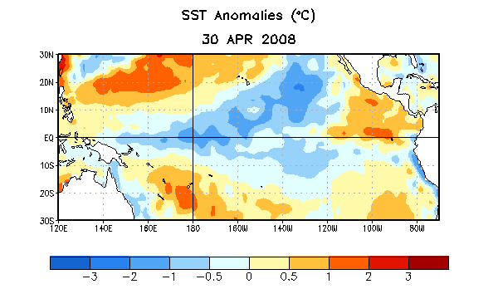
Figure 1. Weekly sea surface temperature (SST) anomalies (°C) centered on 30 April 2008. Anomalies are computed with respect to the 1971-2000 base period weekly means (Xue et al. 2003, J. Climate, 16, 1601-1612).

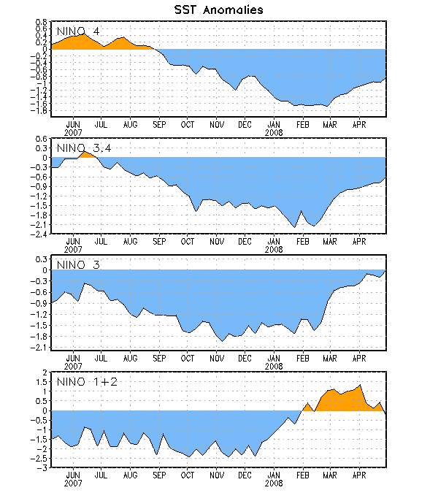
Figure 2. Time series of area-averaged sea surface temperature (SST) anomalies (°C) in the Niño regions [Niño-1+2 (0°-10°S, 90°-80°W), Niño 3 (5°N-5°S, 150°W-90°W), Niño-3.4 (5°N-5°S, 170°W-120°W), Niño-4 (150ºW-160ºE and 5ºN-5ºS)]. SST anomalies are departures are from the 1971-2000 base period weekly means (Xue et al. 2003, J. Climate, 16, 1601-1612).

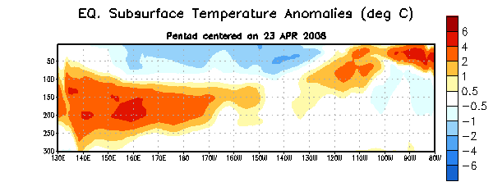
Figure 3. Depth-longitude section of equatorial Pacific upper-ocean (0-300m) temperature anomalies (°C) centered on the week of 23 April 2008. The anomalies are averaged between 5°N-5°S. Anomalies are departures from the 1982-2004 base period weekly means.

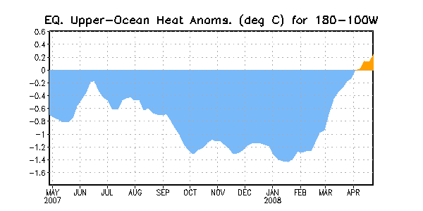
Figure 4. Area-averaged upper-ocean heat content anomalies (°C) in the equatorial Pacific (5°N-5°S, 180º-100ºW). Heat content anomalies are computed as departures from the 1982-2004 base period weekly means.

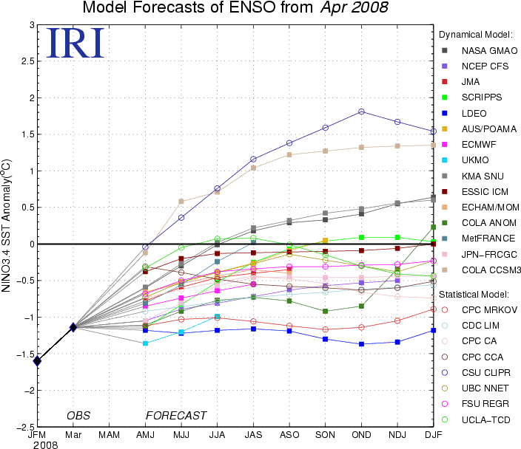

Figure 5. Forecasts of sea surface temperature (SST) anomalies for the Niño 3.4 region (5°N-5°S, 120°W-170°W). Figure courtesy of the International Research Institute (IRI) for Climate and Society. Figure updated 18 April 2008.

