EL NIÑO/SOUTHERN OSCILLATION (ENSO) DIAGNOSTIC DISCUSSION
issued by
CLIMATE PREDICTION CENTER/NCEP/NWS
7 May 2009

ENSO Alert System Status: Final La Niña Advisory

Synopsis: ENSO-neutral conditions are expected to continue into the Northern Hemisphere Summer.
During April 2009, the equatorial Pacific Ocean transitioned from La Niña to ENSO-neutral conditions, ending the 2008-09 La Niña. Negative sea surface temperature (SST) anomalies weakened across the equatorial Pacific Ocean and positive anomalies developed in areas of the eastern Pacific (Fig. 1). Correspondingly, the latest weekly SST indices were near zero in all Niño regions, except for the easternmost Niño-1+2 region (Fig. 2). Subsurface oceanic heat content anomalies (average temperatures in the upper 300m of the ocean, Fig. 3) became positive for the first time since mid-August 2008, reflecting an eastward spread of above-average temperatures near thermocline depth (Fig. 4).
Atmospheric anomalies consistent with La Niña weakened during April, with enhanced convection decreasing over Indonesia, although convection remained suppressed near the International Date Line. Also, Madden Julian Oscillation (MJO) activity strongly influenced the atmospheric circulation across the global tropics, and contributed to the periodic fluctuation in the strength of the low-level easterly winds and upper-level westerly winds over the equatorial Pacific Ocean. Collectively, these oceanic and atmospheric anomalies are consistent with a transition to ENSO-neutral conditions.
A majority of model forecasts for the Niño-3.4 region show that ENSO-neutral conditions will continue through the remainder of 2009 (Fig. 5). The dynamical models, such as the NCEP Climate Forecast System (CFS), increasingly favor above-average temperatures in the Niño-3.4 region, while statistical models predict below- or near-average temperatures. Compared to the statistical models, the dynamical models are more responsive to subsurface temperatures, which have recently increased as positive anomalies have spread eastward. Based on current observations, recent trends, and model forecasts, ENSO-neutral conditions are expected to continue into the Northern Hemisphere Summer.
This discussion is a consolidated effort of the National Oceanic and Atmospheric Administration (NOAA), NOAA’s National Weather Service, and their funded institutions. Oceanic and atmospheric conditions are updated weekly on the Climate Prediction Center web site (El Niño/La Niña Current Conditions and Expert Discussions). Forecasts for the evolution of El Niño/La Niña are updated monthly in the Forecast Forum section of CPC's Climate Diagnostics Bulletin. The next ENSO Diagnostics Discussion is scheduled for 11 June 2009. To receive an e-mail notification when the monthly ENSO Diagnostic Discussions are released, please send an e-mail message to: ncep.list.enso-update@noaa.gov.
Climate Prediction Center
National Centers for Environmental Prediction
NOAA/National Weather Service
Camp Springs, MD 20746-4304

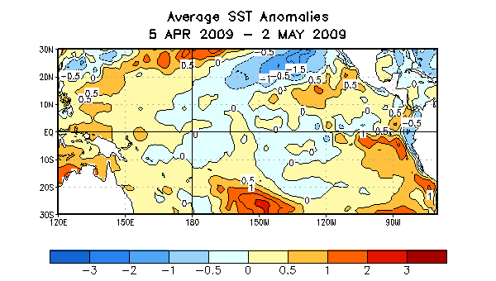

Figure 1. Average sea surface temperature (SST) anomalies (°C) for the four-week period 5 April – 2 May 2009. Anomalies are computed with respect to the 1971-2000 base period weekly means (Xue et al. 2003, J. Climate, 16, 1601-1612).

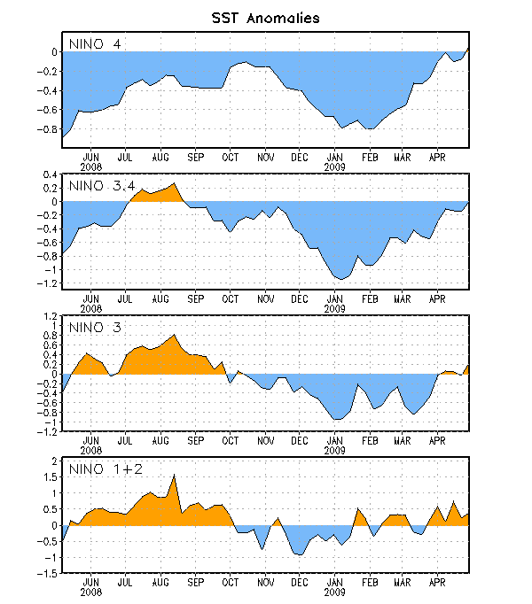
Figure 2. Time series of area-averaged sea surface temperature (SST) anomalies (°C) in the Niño regions [Niño-1+2 (0°-10°S, 90°W-80°W), Niño 3 (5°N-5°S, 150°W-90°W), Niño-3.4 (5°N-5°S, 170°W-120°W), Niño-4 (150ºW-160ºE and 5ºN-5ºS)]. SST anomalies are departures from the 1971-2000 base period weekly means (Xue et al. 2003, J. Climate, 16, 1601-1612).

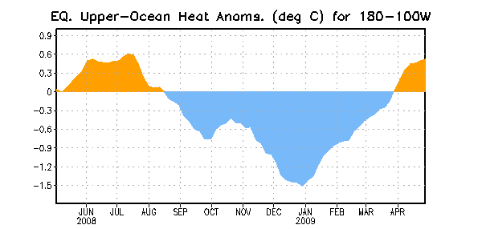
Figure 3. Area-averaged upper-ocean heat content anomalies (°C) in the equatorial Pacific (5°N-5°S, 180º-100ºW). Heat content anomalies are computed as departures from the 1982-2004 base period pentad means.

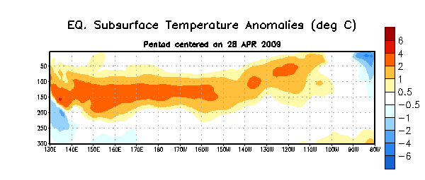
Figure 4. Depth-longitude section of equatorial Pacific upper-ocean (0-300m) temperature anomalies (°C) centered on the week of 23 April 2009. The anomalies are averaged between 5°N-5°S. Anomalies are departures from the 1982-2004 base period pentad means.

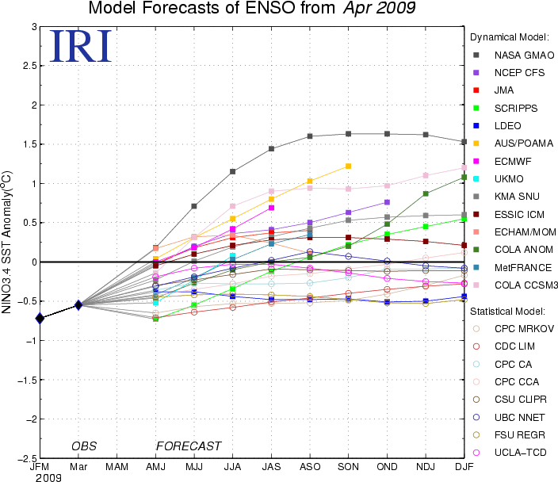

Figure 5. Forecasts of sea surface temperature (SST) anomalies for the Niño 3.4 region (5°N-5°S, 120°W-170°W). Figure courtesy of the International Research Institute (IRI) for Climate and Society. Figure updated 15 April 2009.

