EL NIÑO/SOUTHERN OSCILLATION (ENSO) DIAGNOSTIC DISCUSSION

issued by

CLIMATE PREDICTION CENTER/NCEP/NWS
5 May 2011

ENSO Alert System Status: La Niña Advisory

Synopsis: ENSO-neutral conditions are expected to develop during May-June 2011 and continue through the Northern Hemisphere summer 2011.
During April 2011, La Niña continued to weaken as indicated by increasing surface and subsurface temperature anomalies across the equatorial Pacific Ocean. The latest weekly Niño indices reflected below-average sea surface temperatures (SSTs) in the central and east-central Pacific (–0.6°C in Nino-4 and Nino-3.4 regions), and near-average to above-average SSTs in the eastern Pacific (–0.1°C in Nino-3 and +0.8°C in Nino-1+2 regions; Figs. 1 and 2). The subsurface oceanic heat content anomalies (average temperatures in the upper 300m of the ocean, Fig. 3) increased slightly, due to an expanded area of above-average temperatures at thermocline depth (Fig. 4). Consistent with other transitions to ENSO-neutral conditions, the atmospheric circulation anomalies related to La Niña remained considerable over the tropical and subtropical Pacific. Convection was enhanced over much of Indonesia and suppressed over the western and central equatorial Pacific (Fig. 5). Also, anomalous low-level easterly and upper-level westerly winds have persisted in this region. Collectively, these oceanic and atmospheric anomalies reflect a weakening La Niña, but with ongoing global impacts.
Current observed trends, along with forecasts from nearly all of the ENSO models, indicate La Niña will continue to weaken in the coming months, with a return to ENSO-neutral during May-June-July 2011 (three-month average in the Nino-3.4 index between –0.5°C and +0.5°C; Fig. 6). Thereafter, the majority of models and all multi-model forecasts (shown by the thick lines) predict ENSO-neutral conditions to continue through the remainder of 2011. However, the status of ENSO beyond the Northern Hemisphere summer remains uncertain due to lower model forecast skill at longer lead times.
La Niña will continue to have global impacts even as the episode diminishes. Expected La Niña impacts during May-July 2011 include suppressed convection over the west-central tropical Pacific Ocean, and enhanced convection over Indonesia. Potential La Niña impacts in the United States include an enhanced chance for below-average precipitation across southeastern Texas and Louisiana, and an increased chance of below-average temperatures for the Pacific Northwest (see 3-month seasonal outlook released on April 21st, 2011).
This discussion is a consolidated effort of the National Oceanic and Atmospheric Administration (NOAA), NOAA’s National Weather Service, and their funded institutions. Oceanic and atmospheric conditions are updated weekly on the Climate Prediction Center web site (El Niño/La Niña Current Conditions and Expert Discussions). Forecasts for the evolution of El Niño/La Niña are updated monthly in the Forecast Forum section of CPC's Climate Diagnostics Bulletin. The next ENSO Diagnostics Discussion is scheduled for 9 June 2011. To receive an e-mail notification when the monthly ENSO Diagnostic Discussions are released, please send an e-mail message to: ncep.list.enso-update@noaa.gov.
Climate Prediction Center
National Centers for Environmental Prediction
NOAA/National Weather Service
Camp Springs, MD 20746-4304

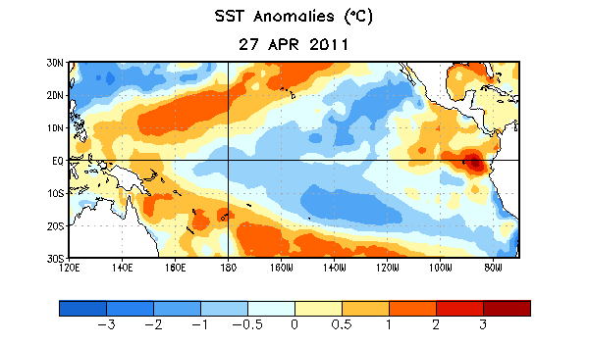
Figure 1. Average sea surface temperature (SST) anomalies (°C) for the week centered on 27 April 2011. Anomalies are computed with respect to the 1971-2000 base period weekly means (Xue et al. 2003, J. Climate, 16, 1601-1612).

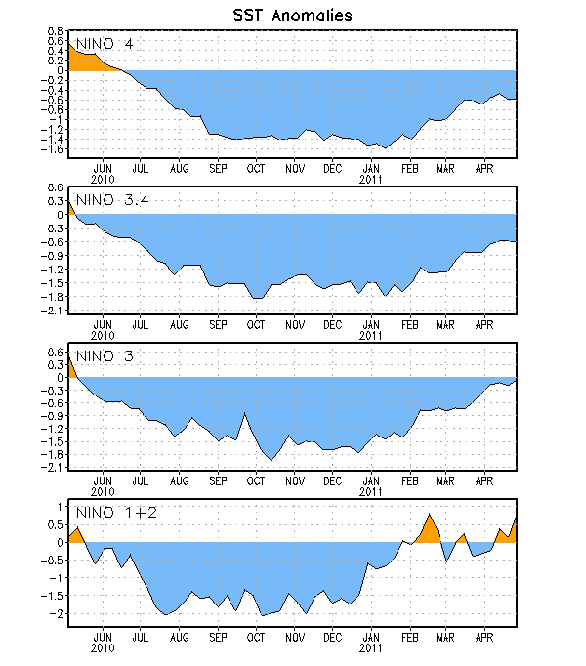
Figure 2. Time series of area-averaged sea surface temperature (SST) anomalies (°C) in the Niño regions [Niño-1+2 (0°-10°S, 90°W-80°W), Niño 3 (5°N-5°S, 150°W-90°W), Niño-3.4 (5°N-5°S, 170°W-120°W), Niño-4 (150ºW-160ºE and 5ºN-5ºS)]. SST anomalies are departures from the 1971-2000 base period weekly means (Xue et al. 2003, J. Climate, 16, 1601-1612).

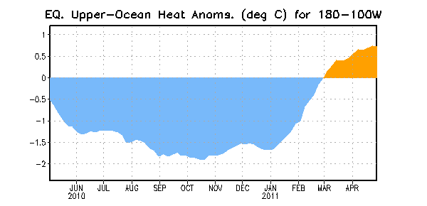
Figure 3. Area-averaged upper-ocean heat content anomalies (°C) in the equatorial Pacific (5°N-5°S, 180º-100ºW). Heat content anomalies are computed as departures from the 1982-2004 base period pentad means.

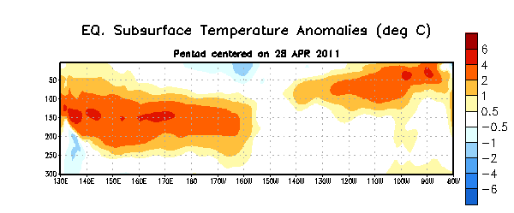
Figure 4. Depth-longitude section of equatorial Pacific upper-ocean (0-300m) temperature anomalies (°C) centered on the week of 28 April 2011. The anomalies are averaged between 5°N-5°S. Anomalies are departures from the 1982-2004 base period pentad means.

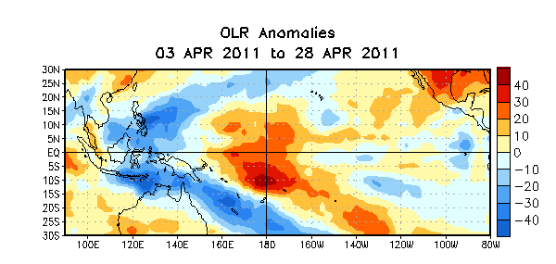

Figure 5. Average outgoing longwave radiation (OLR) anomalies (W/m²) for the four-week period 3 – 28 April 2011. OLR anomalies are computed as departures from the 1979-1995 base period pentad means.

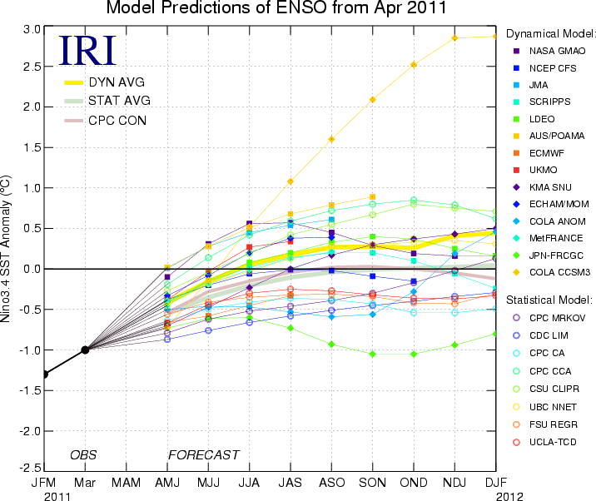
Figure 6. Forecasts of sea surface temperature (SST) anomalies for the Niño 3.4 region (5°N-5°S, 120°W-170°W). Figure courtesy of the International Research Institute (IRI) for Climate and Society. Figure updated 19 April 2011.

