EL NIÑO/SOUTHERN OSCILLATION (ENSO) DIAGNOSTIC DISCUSSION

issued by

CLIMATE PREDICTION CENTER/NCEP/NWS
and the International Research Institute for Climate and Society
3 May 2012

ENSO Alert System Status: Final La Niña Advisory

Synopsis: La Niña has transitioned to ENSO-neutral conditions, which are expected to continue through northern summer 2012.
La Niña dissipated during April 2012, as below-average SSTs weakened across most of the equatorial Pacific Ocean and above-average SSTs persisted in the east (Fig. 1). The Niño 4 and Niño 3.4 indices were warmer than -0.5ºC throughout the month, and the Niño 3 and Niño 1+2 indices remained positive (Fig. 2). The oceanic heat content (average temperature in the upper 300m of the ocean) anomalies also became positive in April (Fig. 3), as below-average sub-surface temperatures largely disappeared and above-average sub-surface temperatures expanded in both the central and eastern Pacific (Fig. 4). Consistent with the demise of La Niña, enhanced trade winds and reduced convection over the central equatorial Pacific were much weakened during April, and the area of enhanced convection that had previously dominated the western Pacific and Indonesia became disorganized (Fig. 5). Collectively, these oceanic and atmospheric patterns indicate a transition from La Niña to ENSO-neutral conditions.
The current and evolving conditions, combined with model forecasts (Fig. 6), suggest that La Niña is unlikely to re-develop later this year. A majority of models predict ENSO-neutral conditions to continue from April-June (AMJ) through the June-August (JJA) season (Fig. 6). However, at least half of the dynamical models predict development of El Niño conditions by JJA. Still, from JJA onward there is considerable forecast uncertainty as to whether ENSO-neutral or El Niño conditions will prevail, due largely to the inability to predict whether the warmer SST will result in the ocean-atmosphere coupling required for a sustained El Niño event. The official forecast calls for ENSO-neutral conditions through JAS, followed by approximately equal chances of Neutral or El Niño conditions for the remainder of the year (see CPC/IRI consensus forecast).
This discussion is a consolidated effort of the National Oceanic and Atmospheric Administration (NOAA), NOAA’s National Weather Service, and their funded institutions. Oceanic and atmospheric conditions are updated weekly on the Climate Prediction Center web site (El Niño/La Niña Current Conditions and Expert Discussions). Forecasts for the evolution of El Niño/La Niña are updated monthly in the Forecast Forum section of CPC's Climate Diagnostics Bulletin. The next ENSO Diagnostics Discussion is scheduled for 7 June 2012. To receive an e-mail notification when the monthly ENSO Diagnostic Discussions are released, please send an e-mail message to: ncep.list.enso-update@noaa.gov.

Climate Prediction Center
National Centers for Environmental Prediction
NOAA/National Weather Service
Camp Springs, MD 20746-4304

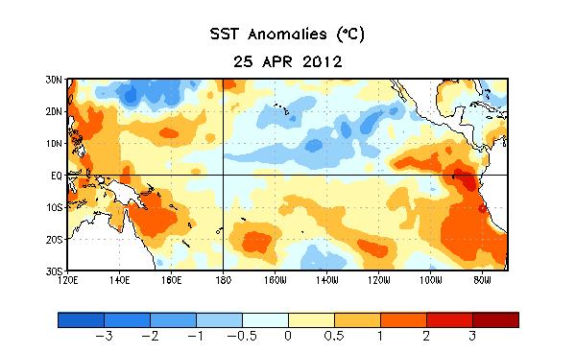
Figure 1. Average sea surface temperature (SST) anomalies (°C) for the week centered on 25 April 2012. Anomalies are computed with respect to the 1971-2000 base period weekly means (Xue et al. 2003, J. Climate, 16, 1601-1612).
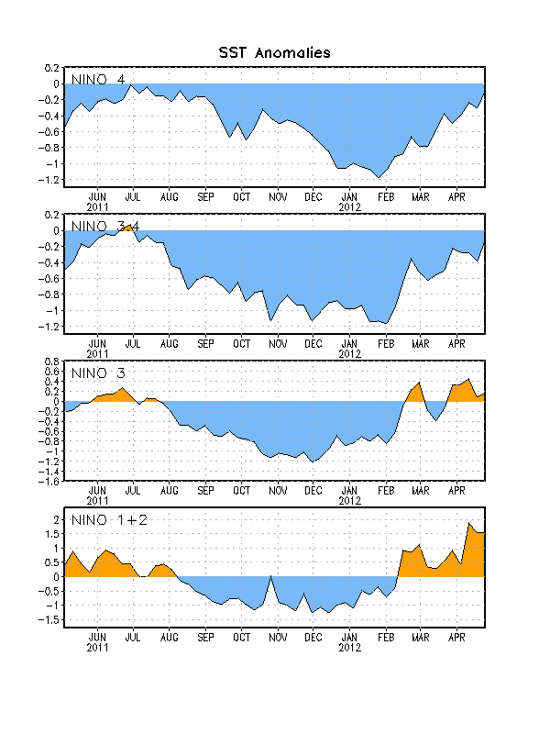
Figure 2. Time series of area-averaged sea surface temperature (SST) anomalies (°C) in the Niño regions [Niño-1+2 (0°-10°S, 90°W-80°W), Niño 3 (5°N-5°S, 150°W-90°W), Niño-3.4 (5°N-5°S, 170°W-120°W), Niño-4 (150ºW-160ºE and 5ºN-5ºS)]. SST anomalies are departures from the 1971-2000 base period weekly means (Xue et al. 2003, J. Climate, 16, 1601-1612).

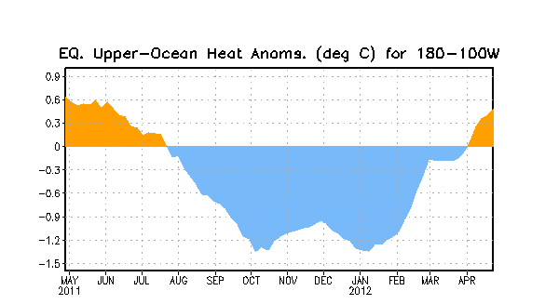
Figure 3. Area-averaged upper-ocean heat content anomaly (°C) in the equatorial Pacific (5°N-5°S, 180º-100ºW). The heat content anomaly is computed as the departure from the 1982-2004 base period pentad means.

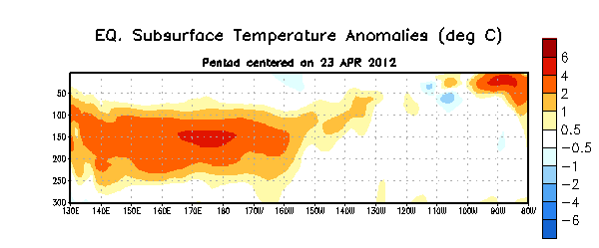
Figure 4. Depth-longitude section of equatorial Pacific upper-ocean (0-300m) temperature anomalies (°C) centered on the pentad of 23 April 2012. The anomalies are averaged between 5°N-5°S. Anomalies are departures from the 1982-2004 base period pentad means.

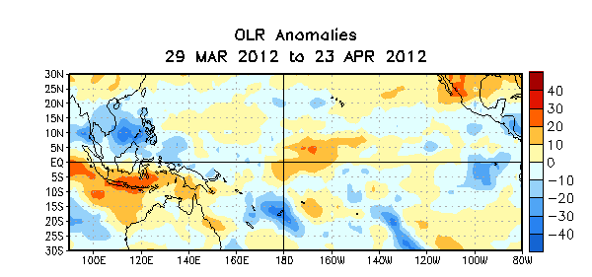

Figure 5. Average outgoing longwave radiation (OLR) anomalies (W/m²) for the four-week period 29 March – 23 April 2012. OLR anomalies are computed as departures from the 1979-1995 base period pentad means.

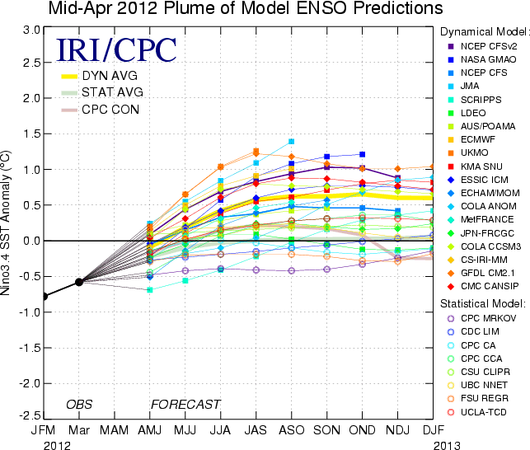
Figure 6. Forecasts of sea surface temperature (SST) anomalies for the Niño 3.4 region (5°N-5°S, 120°W-170°W). Figure courtesy of the International Research Institute (IRI) for Climate and Society. Figure updated 17 April 2012.

