EL NIÑO/SOUTHERN OSCILLATION (ENSO) DIAGNOSTIC DISCUSSION

issued by

CLIMATE PREDICTION CENTER/NCEP/NWS
and the International Research Institute for Climate and Society
14 May 2015

ENSO Alert System Status: El Niño Advisory

Synopsis: There is an approximately 90% chance that El Niño will continue through Northern Hemisphere summer 2015, and a greater than 80% chance it will last through 2015.
By early May 2015, weak to moderate El Niño conditions were reflected by above-average sea surface temperatures (SST) across the equatorial Pacific (Fig. 1), and by the corroborating tropical atmospheric response. The latest weekly Niño indices were +1.2°C in the Niño-4 region, +1.0°C in the Niño-3.4 region, and +1.2°C and +2.3°C in the Niño-3 and Niño-1+2 regions, respectively (Fig. 2). Subsurface temperature anomalies remained substantially above average (Fig. 3), partly in response to a downwelling oceanic Kelvin wave, which resulted in strong positive subsurface anomalies across the central and eastern Pacific (Fig. 4). This anomalous warmth has subsequently persisted in association with El Niño-related ocean-atmosphere coupling. This coupling includes enhanced convection over the central equatorial Pacific (Fig. 5), along with persistent low-level westerly wind anomalies over the western and central equatorial Pacific and persistent upper-level easterly wind anomalies over the central Pacific. Also, the equatorial Southern Oscillation Index (EQSOI) remained negative during the month. Collectively, these features reflect weak to moderate strength El Niño conditions.
Nearly all models predict El Niño (3-month values of the Niño-3.4 index 0.5°C or greater) to continue throughout 2015, and many are also predicting SST anomalies to increase during the next several months (Fig. 6). These forecasts are supported by the continuation of positive subsurface temperature anomalies, enhanced convection near the Date Line, and the persistence of low-level westerly wind anomalies. Given these factors, it is likely that SST anomalies will continue to increase in the coming months. However, model forecast skill tends to be lower during the Northern Hemisphere spring, which somewhat limits confidence in these forecasts. Therefore, there remains considerable uncertainty about how strong this event may become. In summary, there is an approximately 90% chance that El Niño will continue through Northern Hemisphere summer 2015, and a greater than 80% chance it will last through 2015 (click CPC/IRI consensus forecast for the chance of each outcome for each 3-month period).
This discussion is a consolidated effort of the National Oceanic and Atmospheric Administration (NOAA), NOAA’s National Weather Service, and their funded institutions. Oceanic and atmospheric conditions are updated weekly on the Climate Prediction Center web site (El Niño/La Niña Current Conditions and Expert Discussions). Forecasts are also updated monthly in the Forecast Forum of CPC's Climate Diagnostics Bulletin. Additional perspectives and analysis are also available in an ENSO blog. The next ENSO Diagnostics Discussion is scheduled for 11 June 2015. To receive an e-mail notification when the monthly ENSO Diagnostic Discussions are released, please send an e-mail message to: ncep.list.enso-update@noaa.gov.

Climate Prediction Center
National Centers for Environmental Prediction
NOAA/National Weather Service
College Park, MD 20740

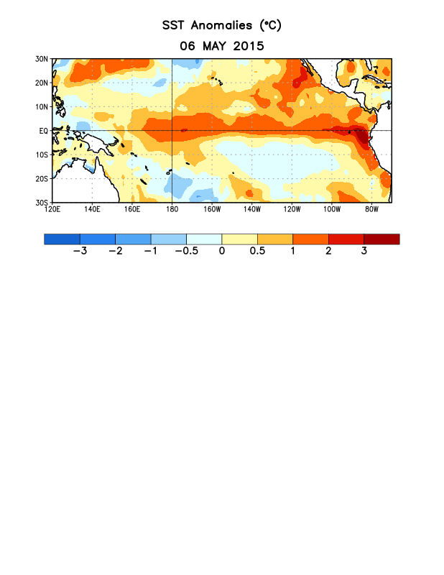
Figure 1. Average sea surface temperature (SST) anomalies (°C) for the week centered on 6 May 2015. Anomalies are computed with respect to the 1981-2010 base period weekly means.

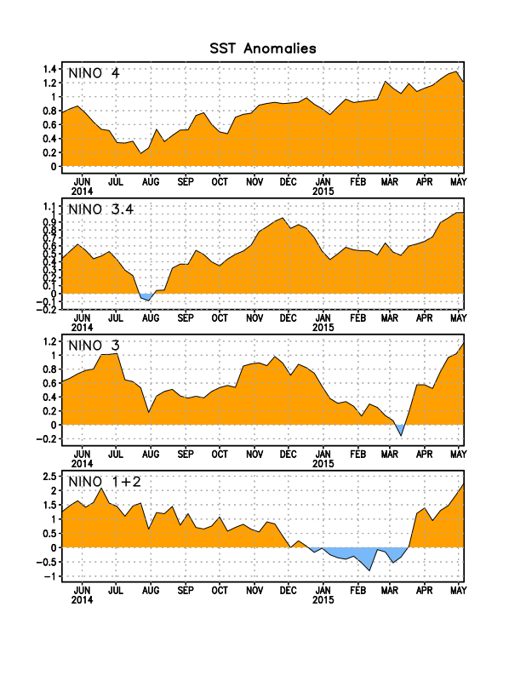
Figure 2. Time series of area-averaged sea surface temperature (SST) anomalies (°C) in the Niño regions [Niño-1+2 (0°-10°S, 90°W-80°W), Niño 3 (5°N-5°S, 150°W-90°W), Niño-3.4 (5°N-5°S, 170°W-120°W), Niño-4 (5ºN-5ºS , 150ºW-160ºE]. SST anomalies are departures from the 1981-2010 base period weekly means.
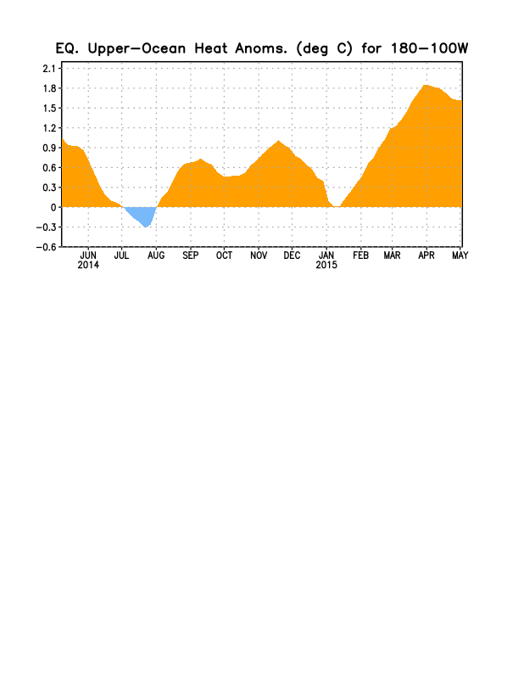
Figure 3. Area-averaged upper-ocean heat content anomaly (°C) in the equatorial Pacific (5°N-5°S, 180º-100ºW). The heat content anomaly is computed as the departure from the 1981-2010 base period pentad means.

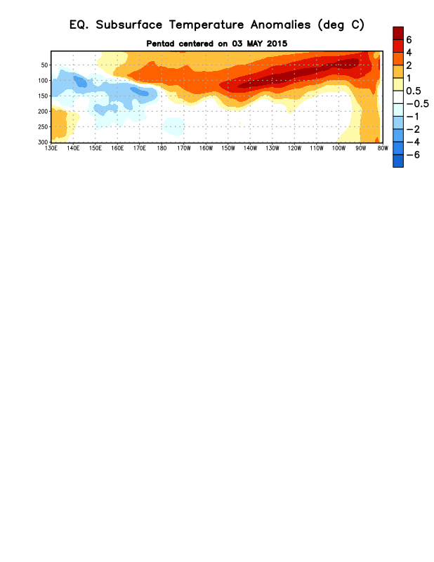
Figure 4. Depth-longitude section of equatorial Pacific upper-ocean (0-300m) temperature anomalies (°C)
centered on the pentad of 3 May 2015. The anomalies are averaged between 5°N-5°S. Anomalies are departures from the 1981-2010 base period pentad means.

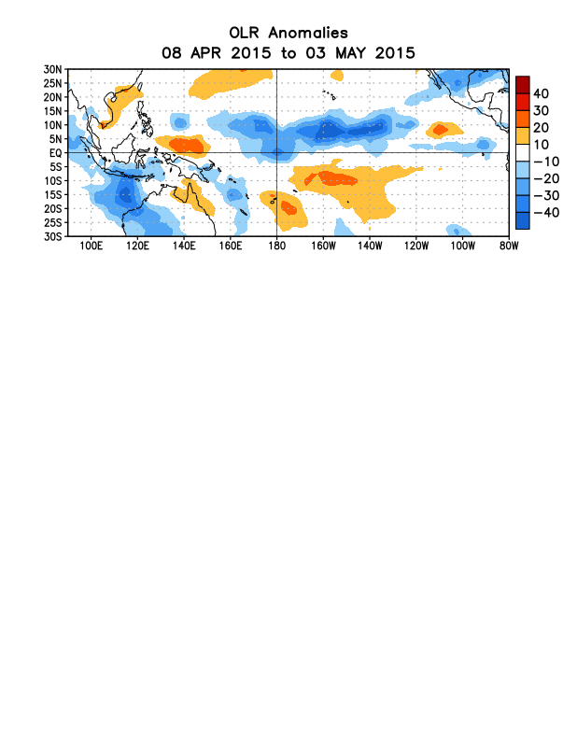
Figure 5. Average outgoing longwave radiation (OLR) anomalies (W/m²) for the period 8 April – 3 May 2015. OLR anomalies are computed as departures from the 1979-1995 base period pentad means.

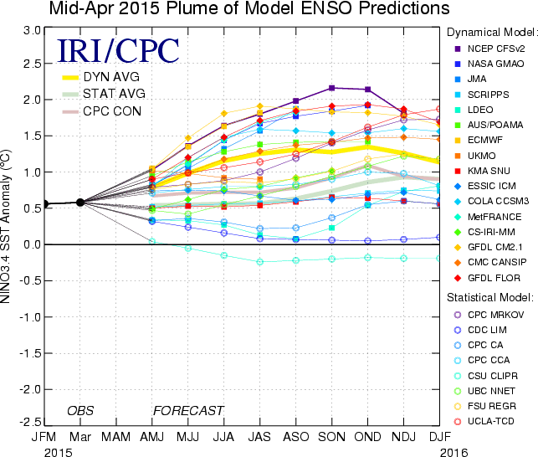

Figure 6. Forecasts of sea surface temperature (SST) anomalies for the Niño 3.4 region (5°N-5°S, 120°W-170°W). Figure updated 7 April 2015.

