EL NIÑO/SOUTHERN OSCILLATION (ENSO) DIAGNOSTIC DISCUSSION

issued by

CLIMATE PREDICTION CENTER/NCEP/NWS
and the International Research Institute for Climate and Society
11 May 2017

ENSO Alert System Status: Not Active

Synopsis: ENSO-neutral and El Niño are nearly equally favored during the Northern Hemisphere summer and fall 2017.
ENSO-neutral persisted during April, with near-average sea surface temperatures (SSTs) observed across the central equatorial Pacific and above-average SSTs in the eastern Pacific (Fig. 1). The latest weekly Niño index values were +0.5°C in the Niño-3 and Niño-3.4 regions, and +0.3 and +0.8°C in the Niño-4 and Niño-1+2 regions, respectively (Fig. 2). The upper-ocean heat content anomaly was slightly positive during April (Fig. 3), reflecting the strengthening of above-average temperatures at depth around the Date Line (Fig. 4). Atmospheric convection anomalies were weak over the central tropical Pacific and Maritime Continent (Fig. 5), while the lower-level and upper-level winds were near average over most of the tropical Pacific. Overall, the ocean and atmosphere system remains consistent with ENSO-neutral.

Most models predict the onset of El Niño (3-month average Niño-3.4 index at or greater than 0.5°C) during the Northern Hemisphere summer (Fig. 6). However, the NCEP CFSv2 and most of the statistical models are more conservative and indicate that while Niño-3.4 index may be near or greater than +0.5°C for several months, the warmth may not last long enough to qualify as an El Niño episode (5 consecutive overlapping seasons) and/or may not significantly impact the atmospheric circulation. Relative to last month, the forecaster consensus reflects slightly lower chances of El Niño (~45%), in part due to the conflicting model guidance and lack of a clear shift toward El Niño in the observational data. In summary, while chances are slightly lower than 50%, ENSO-neutral and El Niño are nearly equally favored during the Northern Hemisphere summer and fall 2017 (click CPC/IRI consensus forecast for the chance of each outcome for each 3-month period).

This discussion is a consolidated effort of the National Oceanic and Atmospheric Administration (NOAA), NOAA’s National Weather Service, and their funded institutions. Oceanic and atmospheric conditions are updated weekly on the Climate Prediction Center web site (El Niño/La Niña Current Conditions and Expert Discussions). Forecasts are also updated monthly in the Forecast Forum of CPC's Climate Diagnostics Bulletin. Additional perspectives and analysis are also available in an ENSO blog. The next ENSO Diagnostics Discussion is scheduled for 8 June 2017. To receive an e-mail notification when the monthly ENSO Diagnostic Discussions are released, please send an e-mail message to: ncep.list.enso-update@noaa.gov.

Climate Prediction Center
National Centers for Environmental Prediction
NOAA/National Weather Service
College Park, MD 20740

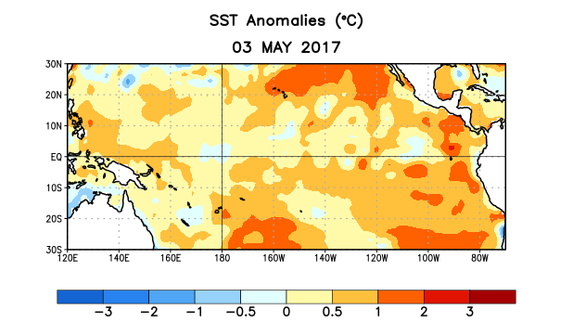
Figure 1. Average sea surface temperature (SST) anomalies (°C) for the week centered on 3 May 2017. Anomalies are computed with respect to the 1981-2010 base period weekly means.

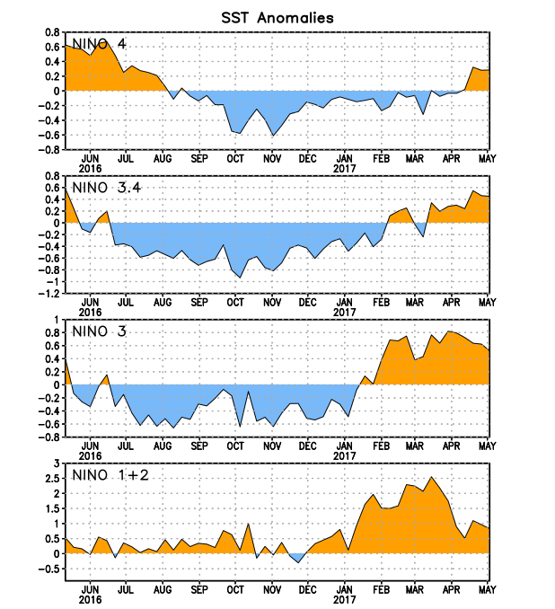
Figure 2. Time series of area-averaged sea surface temperature (SST) anomalies (°C) in the Niño regions [Niño-1+2 (0°-10°S, 90°W-80°W), Niño 3 (5°N-5°S, 150°W-90°W), Niño-3.4 (5°N-5°S, 170°W-120°W), Niño-4 (5ºN-5ºS , 150ºW-160ºE]. SST anomalies are departures from the 1981-2010 base period weekly means.
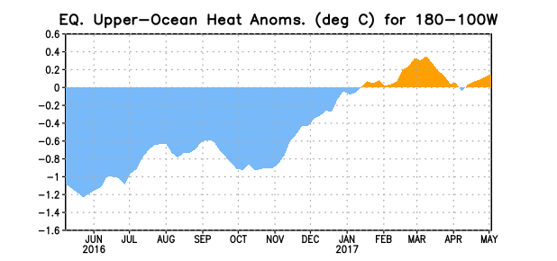
Figure 3. Area-averaged upper-ocean heat content anomaly (°C) in the equatorial Pacific (5°N-5°S, 180º-100ºW). The heat content anomaly is computed as the departure from the 1981-2010 base period pentad means.

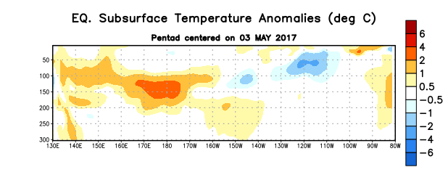
Figure 4. Depth-longitude section of equatorial Pacific upper-ocean (0-300m) temperature anomalies (°C) centered on the pentad of 3 May 2017. The anomalies are averaged between 5°N-5°S. Anomalies are departures from the 1981-2010 base period pentad means.

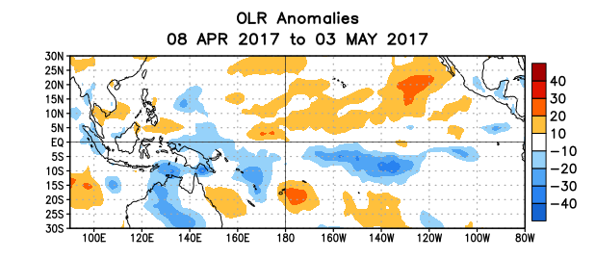
Figure 5. Average outgoing longwave radiation (OLR) anomalies (W/m²) for the period 8 April – 3 May 2017. OLR anomalies are computed as departures from the 1981-2010 base period pentad means.

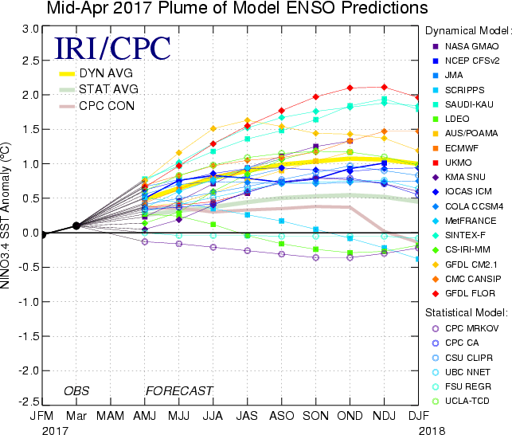

Figure 6. Forecasts of sea surface temperature (SST) anomalies for the Niño 3.4 region (5°N-5°S, 120°W-170°W). Figure updated 18 April 2017.

