EL NIÑO/SOUTHERN OSCILLATION (ENSO) DIAGNOSTIC DISCUSSION

issued by

CLIMATE PREDICTION CENTER/NCEP/NWS

and the International Research Institute for Climate and Society

10 May 2018

ENSO Alert System Status: Final La Niña Advisory

Synopsis: ENSO-neutral is favored through September-November 2018, with the possibility of El Niño nearing 50% by Northern Hemisphere winter 2018-19.

During April 2018, the tropical Pacific returned to ENSO-neutral, as indicated by mostly near-to- below average sea surface temperatures (SSTs) along the equator (Fig. 1). The latest weekly Niño indices were near zero in all regions (between +0.2°C and -0.3°C), except for Niño-1+2, which remained negative (-0.6°C; Fig. 2). Subsurface temperature anomalies (averaged across 180°-100°W) remained positive (Fig. 3), due to the continued influence of a downwelling oceanic Kelvin wave (Fig. 4). Atmospheric indictors related to La Niña also continued to fade. While convection remained suppressed near and east of the Date Line, rainfall near Indonesia was also below average during the month (Fig. 5). Low-level winds were near average over most of the tropical Pacific Ocean, and upper-level winds were anomalous westerly over the eastern Pacific. Overall, the ocean and atmosphere system reflected a return to ENSO-neutral.
The majority of models in the IRI/CPC plume predict ENSO-neutral to continue at least through the Northern Hemisphere summer 2018 (Fig. 6). As the fall and winter approaches, many models indicate an increasing chance for El Niño. Therefore, the forecaster consensus hedges in the direction of El Niño as the winter approaches, but given the considerable uncertainty in ENSO forecasts made at this time of year, the probabilities for El Niño are below 50%. In summary, ENSO-neutral is favored through September-November 2018, with the possibility of El Niño nearing 50% by Northern Hemisphere winter 2018-19 (click CPC/IRI consensus forecast for the chance of each outcome for each 3-month period).
This discussion is a consolidated effort of the National Oceanic and Atmospheric Administration (NOAA), NOAA’s National Weather Service, and their funded institutions. Oceanic and atmospheric conditions are updated weekly on the Climate Prediction Center web site (El Niño/La Niña Current Conditions and Expert Discussions). Forecasts are also updated monthly in the Forecast Forum of CPC's Climate Diagnostics Bulletin. Additional perspectives and analysis are also available in an ENSO blog. The next ENSO Diagnostics Discussion is scheduled for 14 June 2018. To receive an e-mail notification when the monthly ENSO Diagnostic Discussions are released, please send an e-mail message to: ncep.list.enso-update@noaa.gov.

Climate Prediction Center
National Centers for Environmental Prediction
NOAA/National Weather Service
College Park, MD 20740

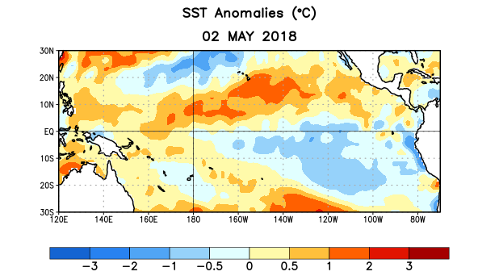
Figure 1. Average sea surface temperature (SST) anomalies (°C) for the week centered on 2 May 2018. Anomalies are computed with respect to the 1981-2010 base period weekly means.

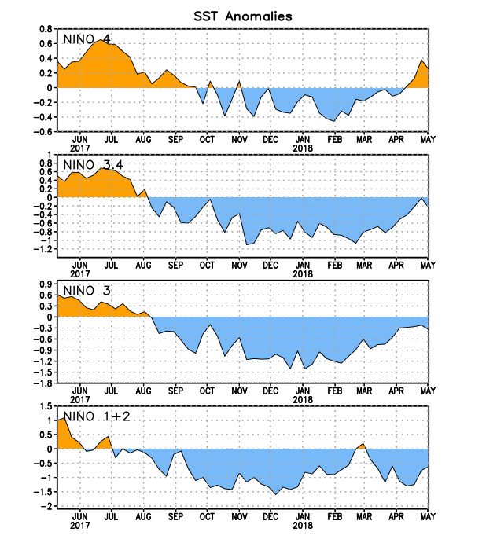
Figure 2. Time series of area-averaged sea surface temperature (SST) anomalies (°C) in the Niño regions [Niño-1+2 (0°-10°S, 90°W-80°W), Niño-3 (5°N-5°S, 150°W-90°W), Niño-3.4 (5°N-5°S, 170°W-120°W), Niño-4 (5ºN-5ºS , 150ºW-160ºE]. SST anomalies are departures from the 1981-2010 base period weekly means.
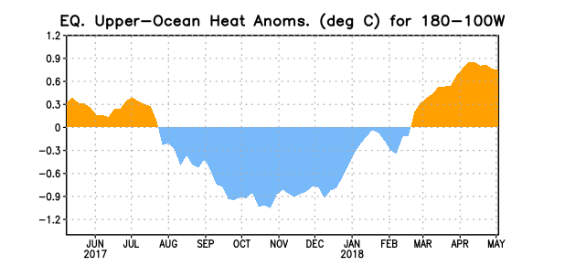
Figure 3. Area-averaged upper-ocean heat content anomaly (°C) in the equatorial Pacific (5°N-5°S, 180º-100ºW). The heat content anomaly is computed as the departure from the 1981-2010 base period pentad means.

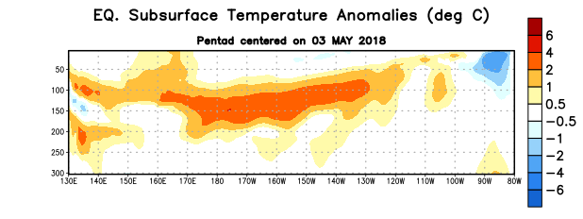
Figure 4. Depth-longitude section of equatorial Pacific upper-ocean (0-300m) temperature anomalies (°C) centered on the pentad of 3 May 2018. Anomalies are departures from the 1981-2010 base period pentad means.

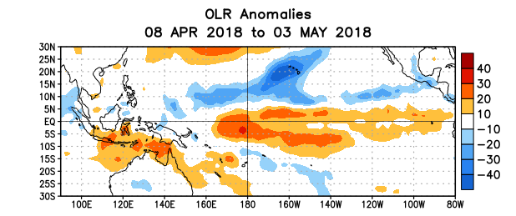
Figure 5. Average outgoing longwave radiation (OLR) anomalies (W/m²) for the period 8 April – 3 May 2018. OLR anomalies are computed as departures from the 1981-2010 base period pentad means.

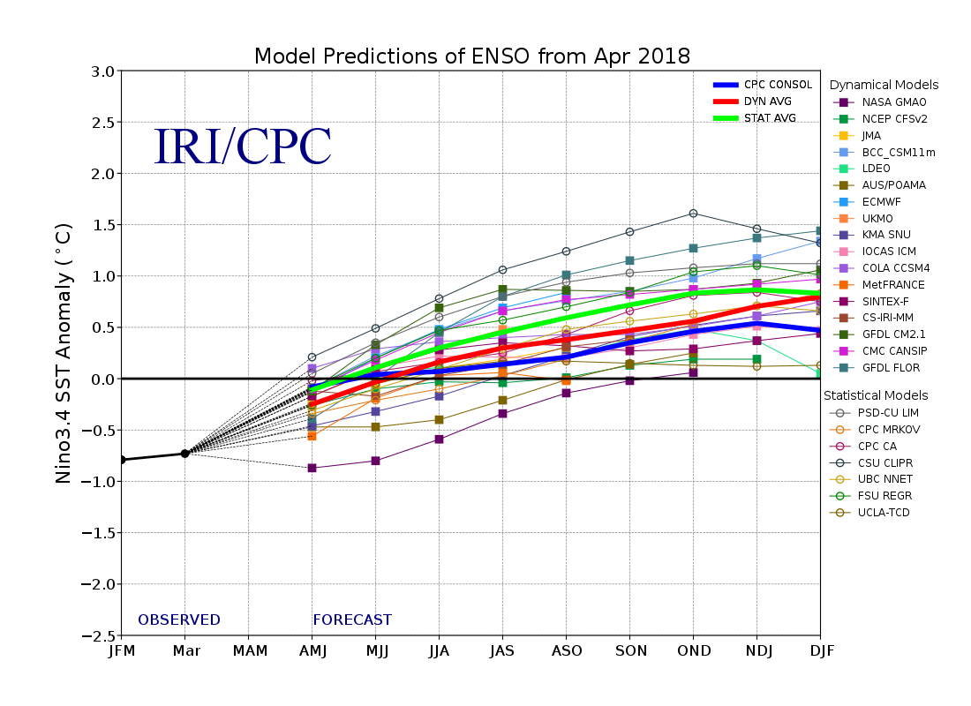
Figure 6. Forecasts of sea surface temperature (SST) anomalies for the Niño 3.4 region (5°N-5°S, 120°W-170°W). Figure updated 19 April 2018.

