EL NIÑO/SOUTHERN OSCILLATION (ENSO) DIAGNOSTIC DISCUSSION

issued by

CLIMATE PREDICTION CENTER/NCEP/NWS

and the International Research Institute for Climate and Society

9 May 2019

ENSO Alert System Status: El Niño Advisory

Synopsis: El Niño is likely to continue through the Northern Hemisphere summer 2019 (70% chance) and fall (55-60% chance).

During April, above-average sea surface temperatures (SSTs) persisted across most of the equatorial Pacific Ocean (Fig. 1), reflecting the ongoing El Niño. All of the latest weekly Niño indices were near +0.8°C, except for Niño-1+2 index, which was at +0.3°C (Fig. 2). While surface indicators were relatively unchanged during the month, the anomalous upper-ocean subsurface temperatures (averaged across 180°-100°W) decreased through April (Fig. 3). Subsurface temperature anomalies remained positive close to the surface across the equatorial Pacific Ocean, but were increasingly negative at depth (Fig. 4). Suppressed tropical convection was evident near Indonesia and enhanced convection continued near the Date Line, though weaker compared to the last two months (Fig. 5). Low-level wind anomalies were weak over the tropical Pacific Ocean, with easterly anomalies evident over the western Pacific. Upper-level wind anomalies were easterly over the western Pacific and westerly over most of the eastern Pacific. Overall, oceanic and atmospheric conditions were consistent with El Niño.
The majority of models in the IRI/CPC plume predict El Niño to continue through 2019, with SST anomalies in the Niño-3.4 region clustering between +0.5°C and +1.0°C (Fig. 6). However, model predictions made during the spring tend to be less accurate relative to the rest of the year, so uncertainty remains whether this outcome will occur. In the shorter term, a recent increase in westerly wind anomalies over the west-central Pacific Ocean portends the possible development of another downwelling oceanic Kelvin wave, which could build up the above-average subsurface temperatures needed for El Niño to persist. In summary, El Niño is likely to continue through the Northern Hemisphere summer 2019 (70% chance) and fall (55-60% chance; click CPC/IRI consensus forecast for the chance of each outcome for each 3-month period).
This discussion is a consolidated effort of the National Oceanic and Atmospheric Administration (NOAA), NOAA’s National Weather Service, and their funded institutions. Oceanic and atmospheric conditions are updated weekly on the Climate Prediction Center web site (El Niño/La Niña Current Conditions and Expert Discussions). Forecasts are also updated monthly in the Forecast Forum of CPC's Climate Diagnostics Bulletin. Additional perspectives and analysis are also available in an ENSO blog. The next ENSO Diagnostics Discussion is scheduled for 13 June 2019. To receive an e-mail notification when the monthly ENSO Diagnostic Discussions are released, please send an e-mail message to: ncep.list.enso-update@noaa.gov.

Climate Prediction Center
National Centers for Environmental Prediction
NOAA/National Weather Service
College Park, MD 20740

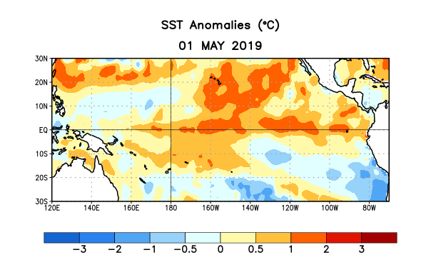
Figure 1. Average sea surface temperature (SST) anomalies (°C) for the week centered on 1 May 2019. Anomalies are computed with respect to the 1981-2010 base period weekly means.

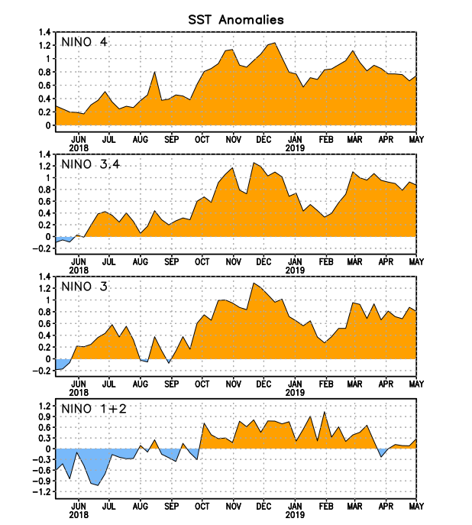
Figure 2. Time series of area-averaged sea surface temperature (SST) anomalies (°C) in the Niño regions [Niño-1+2 (0°-10°S, 90°W-80°W), Niño-3 (5°N-5°S, 150°W-90°W), Niño-3.4 (5°N-5°S, 170°W-120°W), Niño-4 (5ºN-5ºS , 150ºW-160ºE)]. SST anomalies are departures from the 1981-2010 base period weekly means.
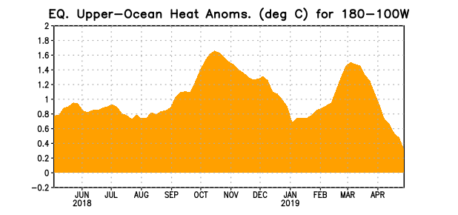
Figure 3. Area-averaged upper-ocean heat content anomaly (°C) in the equatorial Pacific (5°N-5°S, 180º-100ºW). The heat content anomaly is computed as the departure from the 1981-2010 base period pentad means.

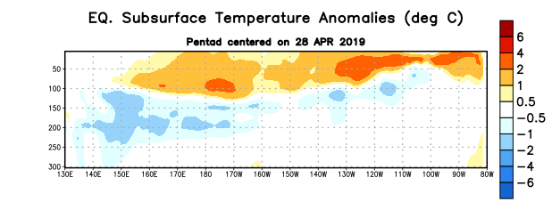
Figure 4. Depth-longitude section of equatorial Pacific upper-ocean (0-300m) temperature anomalies (°C) centered on the pentad of 28 April 2019. Anomalies are departures from the 1981-2010 base period pentad means.

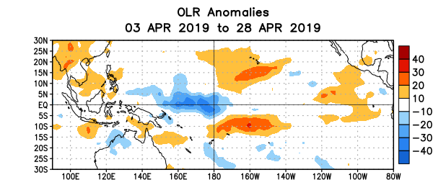
Figure 5. Average outgoing longwave radiation (OLR) anomalies (W/m²) for the period 3 – 28 April 2019. OLR anomalies are computed as departures from the 1981-2010 base period pentad means.
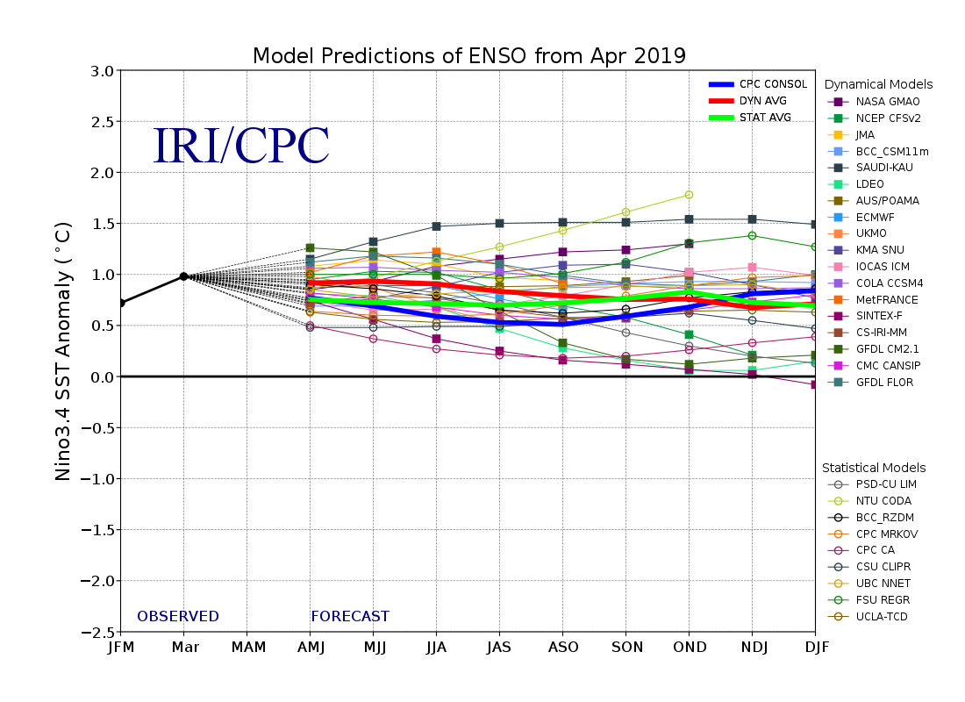
Figure 6. Forecasts of sea surface temperature (SST) anomalies for the Niño 3.4 region (5°N-5°S, 120°W-170°W). Figure updated 19 April 2019.

