EL NIÑO/SOUTHERN OSCILLATION (ENSO) DIAGNOSTIC DISCUSSION

issued by

CLIMATE PREDICTION CENTER/NCEP/NWS

and the International Research Institute for Climate and Society

14 May 2020

ENSO Alert System Status: Not Active

Synopsis: There is a ~65% chance of ENSO-neutral during Northern Hemisphere summer 2020, with chances decreasing through the autumn (to 45-50%).

During April 2020, positive sea surface temperature (SST) anomalies weakened and were near zero by the end of the month (Fig. 1). All of the Niño indices decreased during the month, with the latest weekly Niño index values near +0.2°C (Fig. 2). Equatorial subsurface temperatures (averaged across 180°-100°W) declined further and were below average (Fig. 3), due to the eastward expansion of below-average subsurface temperatures into the eastern Pacific (Fig. 4). Also during the month, low-level wind anomalies were easterly across the central and east-central Pacific, while upper-level wind anomalies were westerly over the central and eastern portions of the basin. Tropical convection was near average around Indonesia and suppressed over the Date Line (Fig. 5). Overall, the combined oceanic and atmospheric system remained consistent with ENSO-neutral.
The majority of models in the IRI/CPC plume (Fig. 6) favor ENSO-neutral (Niño-3.4 index between -0.5°C and +0.5°C) through the Northern Hemisphere autumn, though considerable spread is evident at longer lead times. Niño 3.4 index values are expected to decrease through the remainder of the Northern Hemisphere spring and into the summer; with the possibility of below-average temperatures becoming more established toward the latter half of the year. The consensus of forecasters favors ENSO-neutral conditions through the summer and fall, and slightly tilts toward La Niña at the end of the year (~45% chance). There is a ~10% chance of El Niño from the summer through the end the year. In summary, there is a ~65% chance of ENSO-neutral during Northern Hemisphere summer 2020, with chances decreasing through the autumn (45-50%; click CPC/IRI consensus forecast for the chance of each outcome for each 3-month period).
This discussion is a consolidated effort of the National Oceanic and Atmospheric Administration (NOAA), NOAA’s National Weather Service, and their funded institutions. Oceanic and atmospheric conditions are updated weekly on the Climate Prediction Center web site (El Niño/La Niña Current Conditions and Expert Discussions). Forecasts are also updated monthly in the Forecast Forum of CPC's Climate Diagnostics Bulletin. Additional perspectives and analysis are also available in an ENSO blog. The next ENSO Diagnostics Discussion is scheduled for 11 June 2020. To receive an e-mail notification when the monthly ENSO Diagnostic Discussions are released, please send an e-mail message to: ncep.list.enso-update@noaa.gov.

Climate Prediction Center
National Centers for Environmental Prediction
NOAA/National Weather Service
College Park, MD 20740

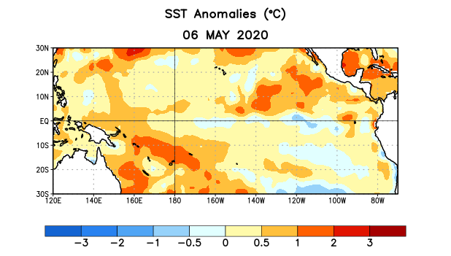
Figure 1. Average sea surface temperature (SST) anomalies (°C) for the week centered on 6 May 2020. Anomalies are computed with respect to the 1981-2010 base period weekly means.

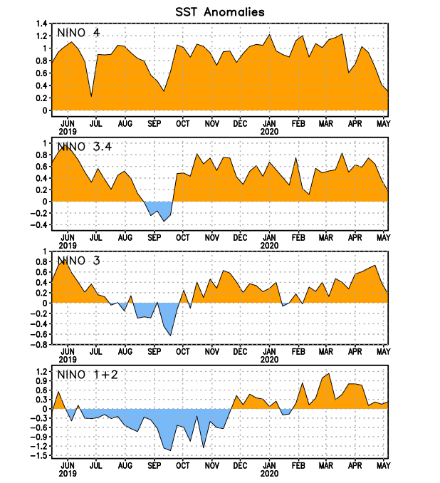
Figure 2. Time series of area-averaged sea surface temperature (SST) anomalies (°C) in the Niño regions [Niño-1+2 (0°-10°S, 90°W-80°W), Niño-3 (5°N-5°S, 150°W-90°W), Niño-3.4 (5°N-5°S, 170°W-120°W), Niño-4 (5ºN-5ºS , 150ºW-160ºE)]. SST anomalies are departures from the 1981-2010 base period weekly means.
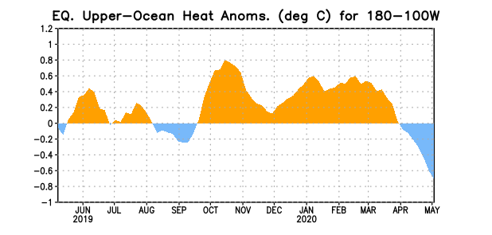
Figure 3. Area-averaged upper-ocean heat content anomaly (°C) in the equatorial Pacific (5°N-5°S, 180º-100ºW). The heat content anomaly is computed as the departure from the 1981-2010 base period pentad means.

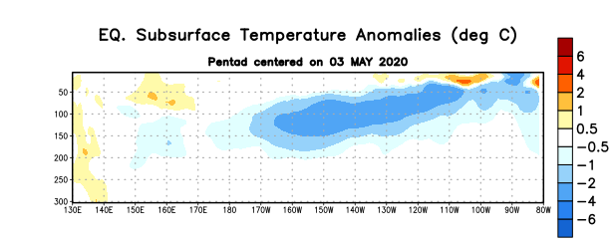
Figure 4. Depth-longitude section of equatorial Pacific upper-ocean (0-300m) temperature anomalies (°C) centered on the pentad of 3 May 2020. Anomalies are departures from the 1981-2010 base period pentad means.

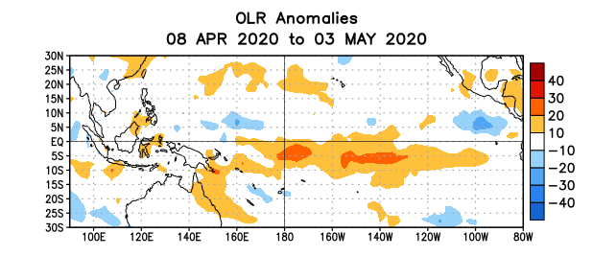
Figure 5. Average outgoing longwave radiation (OLR) anomalies (W/m²) for the period 8 April – 3 May 2020. OLR anomalies are computed as departures from the 1981-2010 base period pentad means.

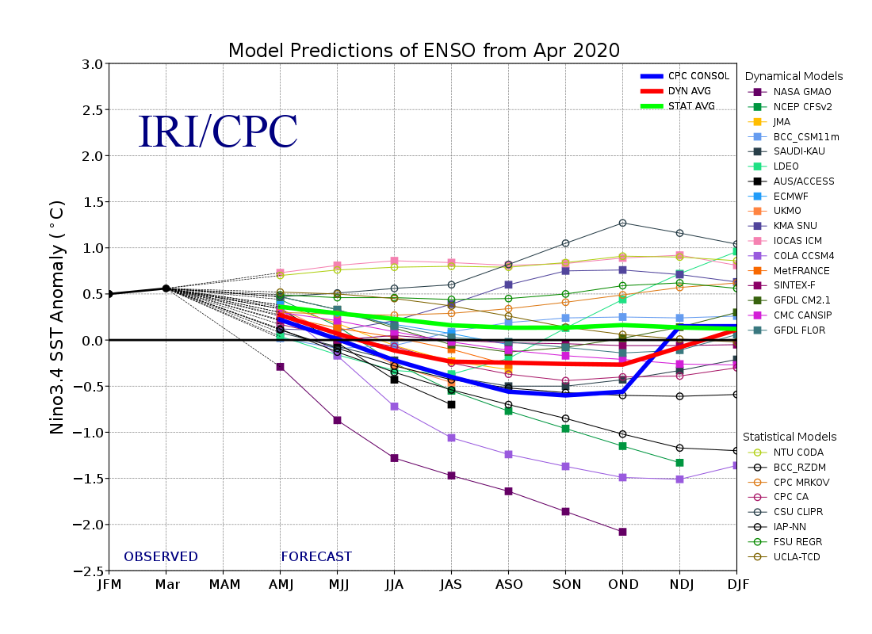
Figure 6. Forecasts of sea surface temperature (SST) anomalies for the Niño 3.4 region (5°N-5°S, 120°W-170°W). Figure updated 19 April 2020.

