EL NIÑO/SOUTHERN OSCILLATION (ENSO) DIAGNOSTIC DISCUSSION

issued by

CLIMATE PREDICTION CENTER/NCEP/NWS

and the International Research Institute for Climate and Society

13 May 2021

ENSO Alert System Status: Final La Niña Advisory

Synopsis: La Niña has ended, with ENSO-neutral likely to continue through the Northern Hemisphere summer (67% chance in June-August 2021).

During April, the tropical Pacific Ocean returned to ENSO-neutral conditions as the coupling between the atmosphere and ocean weakened. Sea surface temperatures were near-to-below average across most of the equatorial Pacific Ocean in the past month (Fig. 1). The Niño indices have generally trended toward normal during the last several months, except for the easternmost Niño-1+2 region, which was -0.7ºC in the past week (Fig. 2). Subsurface temperature anomalies continued to increase (Fig. 3) due to a downwelling Kelvin wave, which reinforced the positive temperature anomalies along the thermocline (Fig. 4). Low-level easterly wind anomalies were weakly present in the east-central Pacific, but were westerly in the far western Pacific Ocean, while upper-level wind anomalies remained westerly across the central and east-central tropical Pacific. Tropical convection became near average around the Date Line in the past month, with suppressed convection evident over Indonesia (Fig. 5). Overall, the ocean and atmosphere system reflected a return to ENSO-neutral.
Most of the models in the IRI/CPC plume predict a continuation of ENSO-neutral through the Northern Hemisphere summer 2021 (Fig. 6). The forecaster consensus agrees with this set of models through the summer, and then begins hedging toward cooler conditions as the Northern Hemisphere fall approaches. La Niña chances are around 50-55% during the late fall and winter, which is in alignment with forecasts from the NCEP Climate Forecast System and North American Multi-model Ensemble. However, there is typically large uncertainty with forecasts made in the spring, so confidence in ENSO-neutral for the coming seasons is highest. In summary, La Niña has ended, with ENSO-neutral likely to continue through the Northern Hemisphere summer (67% chance in June-August 2021; click CPC/IRI consensus forecast for the chances in each 3-month period).
This discussion is a consolidated effort of the National Oceanic and Atmospheric Administration (NOAA), NOAA’s National Weather Service, and their funded institutions. Oceanic and atmospheric conditions are updated weekly on the Climate Prediction Center web site (El Niño/La Niña Current Conditions and Expert Discussions). Additional perspectives and analysis are also available in an ENSO blog. A probabilistic strength forecast is available here. The next ENSO Diagnostics Discussion is scheduled for 10 June 2021. To receive an e-mail notification when the monthly ENSO Diagnostic Discussions are released, please send an e-mail message to: ncep.list.enso-update@noaa.gov.

Climate Prediction Center
National Centers for Environmental Prediction
NOAA/National Weather Service
College Park, MD 20740

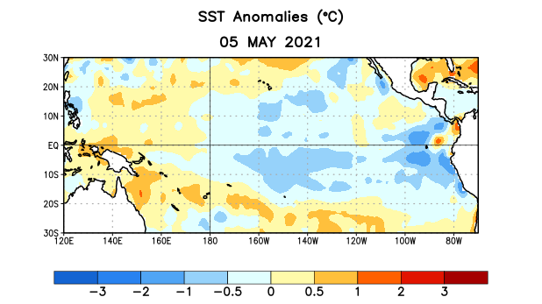
Figure 1. Average sea surface temperature (SST) anomalies (°C) for the week centered on 5 May 2021. Anomalies are computed with respect to the 1991-2020 base period weekly means.

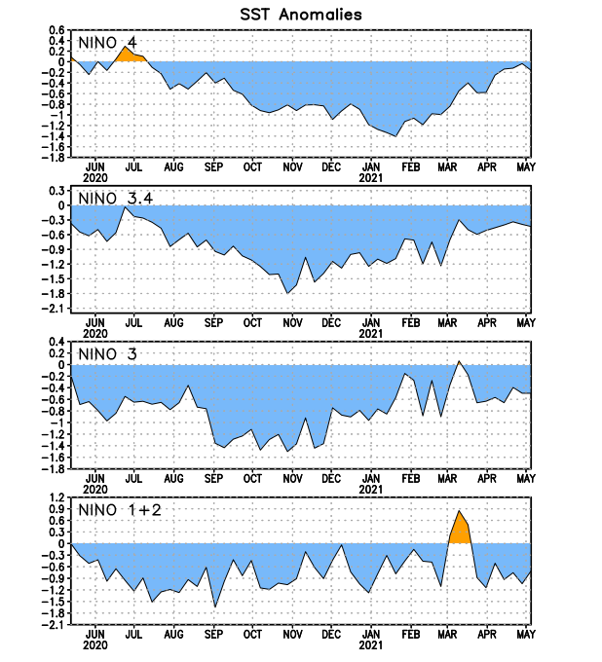
Figure 2. Time series of area-averaged sea surface temperature (SST) anomalies (°C) in the Niño regions [Niño-1+2 (0°-10°S, 90°W-80°W), Niño-3 (5°N-5°S, 150°W-90°W), Niño-3.4 (5°N-5°S, 170°W-120°W), Niño-4 (5ºN-5ºS , 150ºW-160ºE)]. SST anomalies are departures from the 1991-2020 base period weekly means.
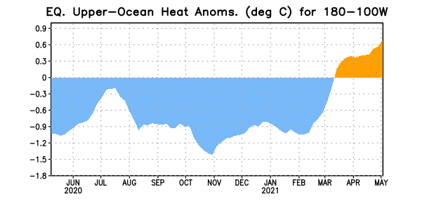
Figure 3. Area-averaged upper-ocean heat content anomaly (°C) in the equatorial Pacific (5°N-5°S, 180º-100ºW). The heat content anomaly is computed as the departure from the 1991-2020 base period pentad means.

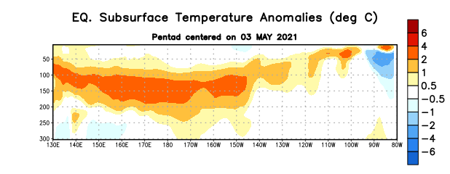
Figure 4. Depth-longitude section of equatorial Pacific upper-ocean (0-300m) temperature anomalies (°C) centered on the pentad of 3 May 2021. Anomalies are departures from the 1991-2020 base period pentad means.

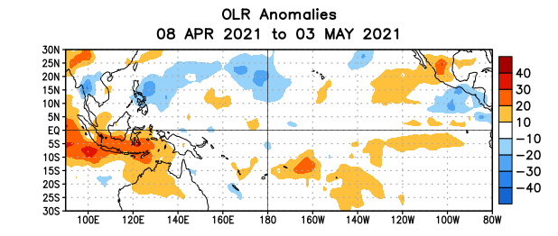
Figure 5. Average outgoing longwave radiation (OLR) anomalies (W/m²) for the period 8 April – 3 May 2021. OLR anomalies are computed as departures from the 1991-2020 base period pentad means.

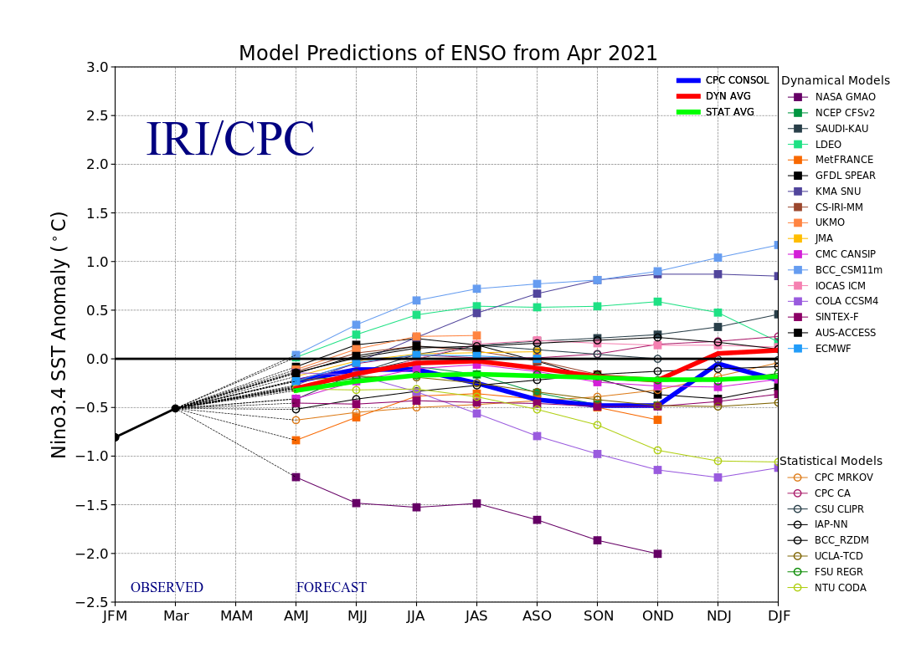
Figure 6. Forecasts of sea surface temperature (SST) anomalies for the Niño 3.4 region (5°N-5°S, 120°W-170°W). Figure updated 19 April 2021.

