EL NIÑO/SOUTHERN OSCILLATION (ENSO) DIAGNOSTIC DISCUSSION

issued by

CLIMATE PREDICTION CENTER/NCEP/NWS

and the International Research Institute for Climate and Society

12 May 2022

ENSO Alert System Status: La Niña Advisory

Synopsis: Though La Niña is favored to continue, the odds for La Niña decrease into the late Northern Hemisphere summer (58% chance in August-October 2022) before slightly increasing through the Northern Hemisphere fall and early winter 2022 (61% chance).

Below-average sea surface temperatures (SSTs) persisted during April across most of the central and eastern equatorial Pacific Ocean (Fig. 1). Over the past month, the Niño index values decreased, with the latest weekly values ranging from -1.1ºC to -1.5ºC (Fig. 2), which are quite negative for this time of year. Subsurface temperatures anomalies (averaged between 180º-100ºW and 0-300m depth) remained negative (Fig. 3), reflecting an extensive area of below-average temperatures from the surface to ~100m depth across the central and eastern equatorial Pacific Ocean (Fig. 4). For the monthly average, low-level easterly and upper-level westerly wind anomalies dominated the equatorial Pacific. Convection remained significantly suppressed around the Date Line and was enhanced over the Philippines (Fig. 5). Overall, the coupled ocean-atmosphere system reflected the continuation of La Niña.
The most recent IRI/CPC plume average for the Niño-3.4 SST index forecasts borderline La Niña conditions during the Northern Hemisphere summer, with increasing odds for La Niña into the fall (Fig. 6). Similar to last month, the forecaster consensus predicts Niño-3.4 index values to weaken into the summer, but remaining below the threshold of La Niña (Niño-3.4 values equal to or less than -0.5ºC). In the near-term, westerly wind anomalies are predicted for mid-late May which supports the weakening of below-average surface and subsurface oceanic temperatures in the coming months. However, much of the model guidance is also hinting at a re-strengthening of La Niña conditions again in the fall and upcoming winter. In summary, though La Niña is favored to continue, the odds for La Niña decrease into the late Northern Hemisphere summer (58% chance in August-October 2022) before slightly increasing through the Northern Hemisphere fall and early winter 2022 (61% chance; click CPC/IRI consensus forecast for the chances in each 3-month period).
This discussion is a consolidated effort of the National Oceanic and Atmospheric Administration (NOAA), NOAA’s National Weather Service, and their funded institutions. Oceanic and atmospheric conditions are updated weekly on the Climate Prediction Center web site (El Niño/La Niña Current Conditions and Expert Discussions). Additional perspectives and analysis are also available in an ENSO blog. A probabilistic strength forecast is available here. The next ENSO Diagnostics Discussion is scheduled for 9 June 2022. To receive an e-mail notification when the monthly ENSO Diagnostic Discussions are released, please send an e-mail message to: ncep.list.enso-update@noaa.gov.

Climate Prediction Center
National Centers for Environmental Prediction
NOAA/National Weather Service
College Park, MD 20740

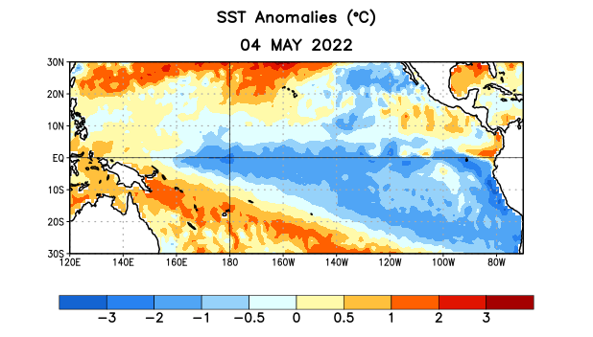
Figure 1. Average sea surface temperature (SST) anomalies (°C) for the week centered on 4 May 2022. Anomalies are computed with respect to the 1991-2020 base period weekly means.

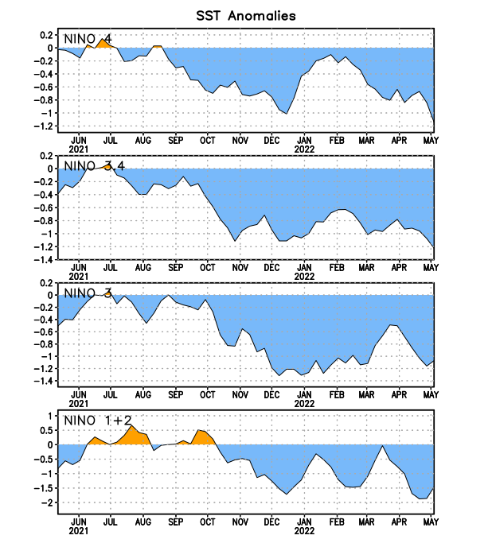
Figure 2. Time series of area-averaged sea surface temperature (SST) anomalies (°C) in the Niño regions [Niño-1+2 (0°-10°S, 90°W-80°W), Niño-3 (5°N-5°S, 150°W-90°W), Niño-3.4 (5°N-5°S, 170°W-120°W), Niño-4 (5ºN-5ºS, 150ºW-160ºE)]. SST anomalies are departures from the 1991-2020 base period weekly means.
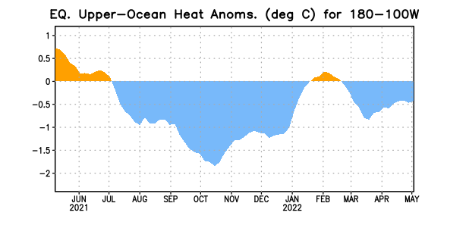
Figure 3. Area-averaged upper-ocean heat content anomaly (°C) in the equatorial Pacific (5°N-5°S, 180º-100ºW). The heat content anomaly is computed as the departure from the 1991-2020 base period pentad means.

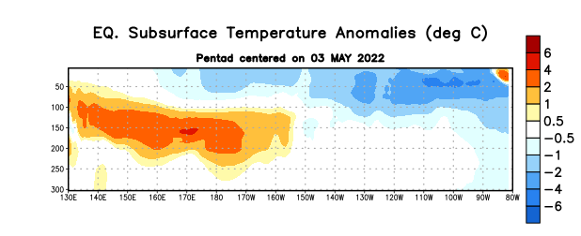

Figure 4. Depth-longitude section of equatorial Pacific upper-ocean (0-300m) temperature anomalies (°C) centered on the pentad of 3 May 2022. Anomalies are departures from the 1991-2020 base period pentad means.

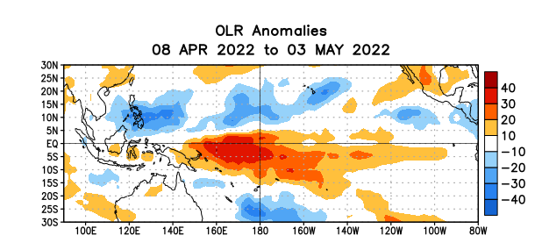
Figure 5. Average outgoing longwave radiation (OLR) anomalies (W/m²) for the period 8 April – 3 May 2022. OLR anomalies are computed as departures from the 1991-2020 base period pentad means.

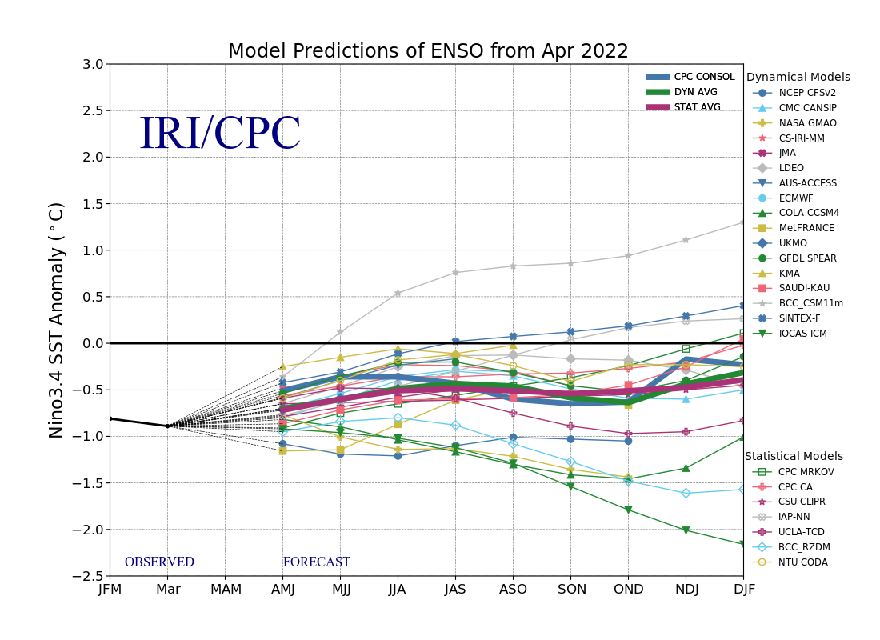
Figure 6. Forecasts of sea surface temperature (SST) anomalies for the Niño 3.4 region (5°N-5°S, 120°W-170°W). Figure updated 19 April 2022.

