EL NIÑO/SOUTHERN OSCILLATION (ENSO) DIAGNOSTIC DISCUSSION

issued by

CLIMATE PREDICTION CENTER/NCEP/NWS

11 May 2023

ENSO Alert System Status: El Niño Watch

Synopsis: A transition from ENSO-neutral is expected in the next couple of months, with a greater than 90% chance of El Niño persisting into the Northern Hemisphere winter.

During April, above-average sea surface temperatures (SSTs) expanded slightly westward to the east-central equatorial Pacific Ocean (Fig. 1). The latest weekly Niño-3.4 index value was +0.4ºC, with the easternmost Niño-3 and Niño1+2 regions at +0.8ºC and +2.7ºC, respectively (Fig. 2). Area-averaged subsurface temperatures anomalies continued to increase (Fig. 3), reflecting widespread positive temperature anomalies below the surface of the equatorial Pacific Ocean (Fig. 4). Low-level wind anomalies were westerly during mid-April before switching back to easterly by the end of the month. Upper-level wind anomalies were westerly across most of the Pacific Ocean. Suppressed convection was observed over parts of Indonesia and anomalies weakened near the Date Line (Fig. 5). While the warming near coastal South America remains striking, the basin-wide coupled ocean-atmosphere system remained consistent with ENSO-neutral.
The most recent IRI plume also indicates El Niño is likely to form during the May-July season and persist into the winter (Fig. 6). The combination of a forecasted third westerly wind event in mid-late May, and high levels of above-average oceanic heat content, means that a potentially significant El Niño is on the horizon. While at least a weak El Niño is likely, the range of possibilities at the end of the year (November-January) include a 80% chance of at least a moderate El Niño (Niño-3.4 ≥ 1.0°C) to a ~55% chance of a strong El Niño (Niño-3.4 ≥ 1.5°C). It is still possible the tropical atmosphere does not couple with the ocean, and El Niño fails to materialize (5-10% chance). In summary, a transition from ENSO-neutral is expected in the next couple of months, with a greater than 90% chance of El Niño persisting into the Northern Hemisphere winter (Fig. 7).
This discussion is a consolidated effort of the National Oceanic and Atmospheric Administration (NOAA), NOAA’s National Weather Service, and their funded institutions. Oceanic and atmospheric conditions are updated weekly on the Climate Prediction Center website (El Niño/La Niña Current Conditions and Expert Discussions). Additional perspectives and analyses are also available in an ENSO blog. A probabilistic strength forecast is available here. The next ENSO Diagnostics Discussion is scheduled for 8 June 2023. To receive an e-mail notification when the monthly ENSO Diagnostic Discussions are released, please send an e-mail message to: ncep.list.enso-update@noaa.gov.

Climate Prediction Center
National Centers for Environmental Prediction
NOAA/National Weather Service
College Park, MD 20740
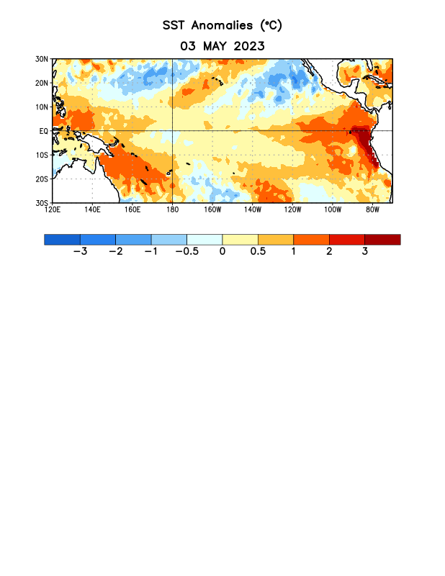
Figure 1. Average sea surface temperature (SST) anomalies (°C) for the week centered on 3 May 2023. Anomalies are computed with respect to the 1991-2020 base period weekly means.

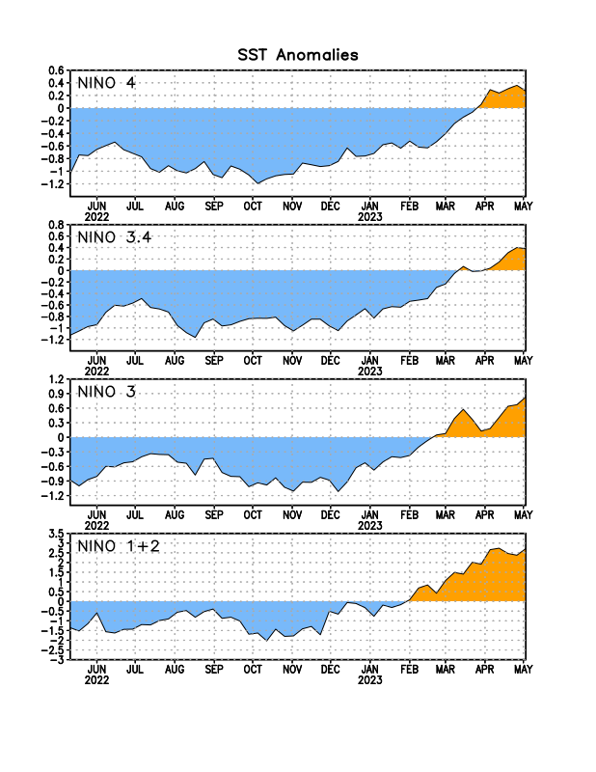
Figure 2. Time series of area-averaged sea surface temperature (SST) anomalies (°C) in the Niño regions [Niño-1+2 (0°-10°S, 90°W-80°W), Niño-3 (5°N-5°S, 150°W-90°W), Niño-3.4 (5°N-5°S, 170°W-120°W), Niño-4 (5ºN-5ºS, 150ºW-160ºE)]. SST anomalies are departures from the 1991-2020 base period weekly means.

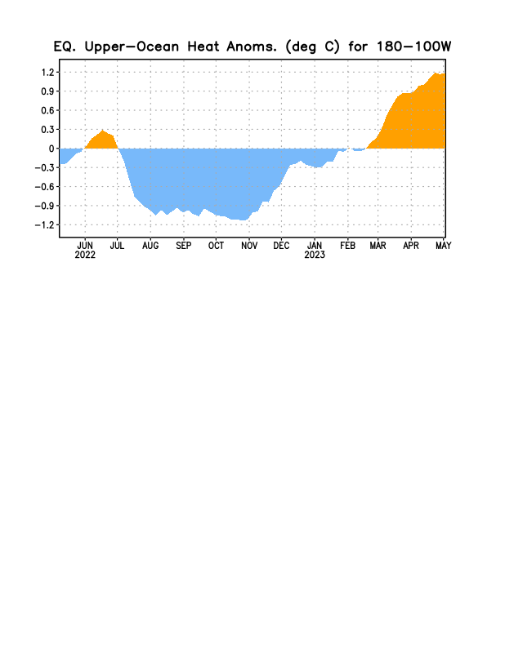

Figure 3. Area-averaged upper-ocean heat content anomaly (°C) in the equatorial Pacific (5°N-5°S, 180º-100ºW). The heat content anomaly is computed as the departure from the 1991-2020 base period pentad means.

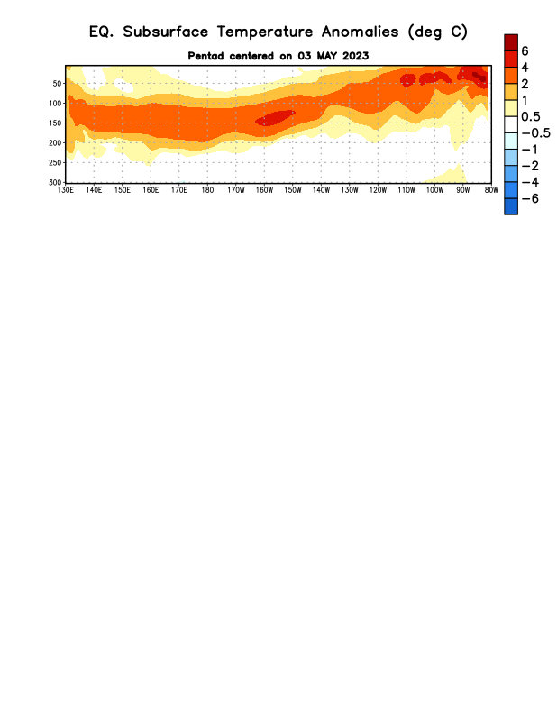
Figure 4. Depth-longitude section of equatorial Pacific upper-ocean (0-300m) temperature anomalies (°C) centered on the pentad of 3 May 2023. Anomalies are departures from the 1991-2020 base period pentad means.

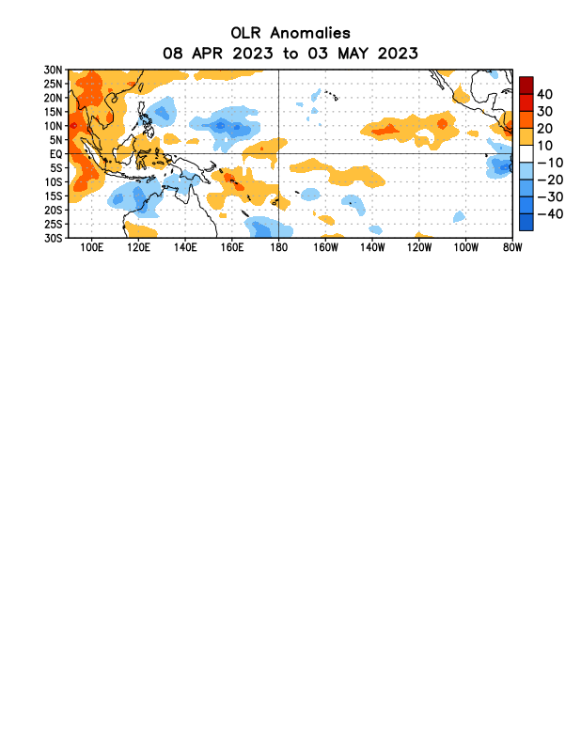

Figure 5. Average outgoing longwave radiation (OLR) anomalies (W/m²) for the period 8 April – 3 May 2023. OLR anomalies are computed as departures from the 1991-2020 base period pentad means.

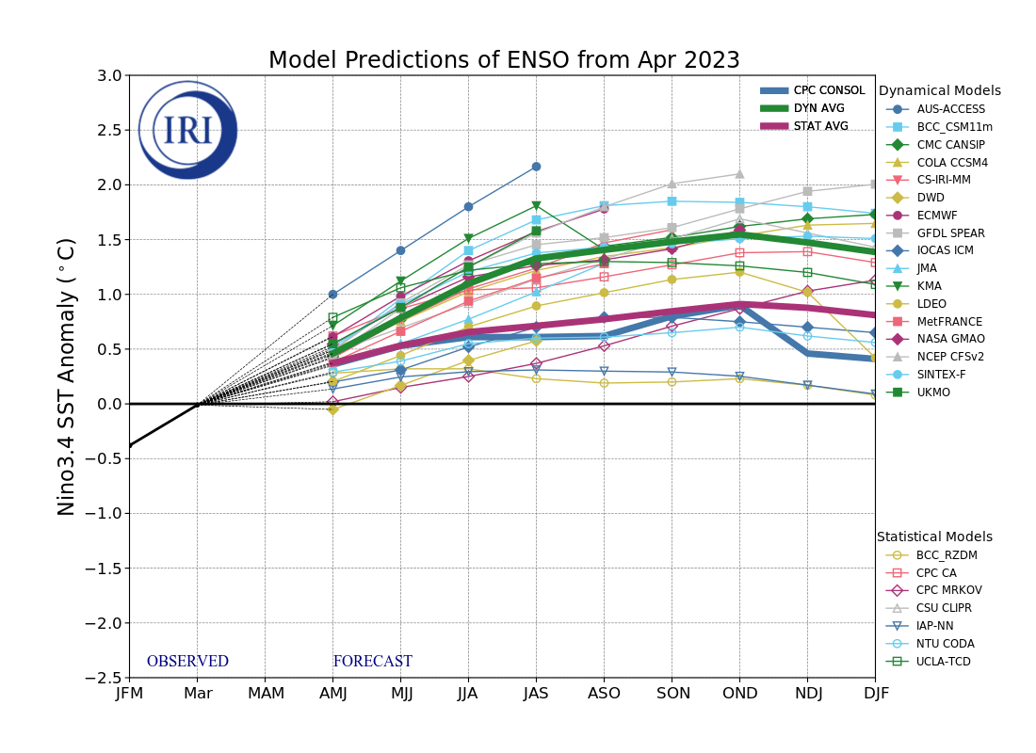
Figure 6. Forecasts of sea surface temperature (SST) anomalies for the Niño 3.4 region (5°N-5°S, 120°W-170°W). Figure updated 19 April 2023 by the International Research Institute (IRI) for Climate and Society.
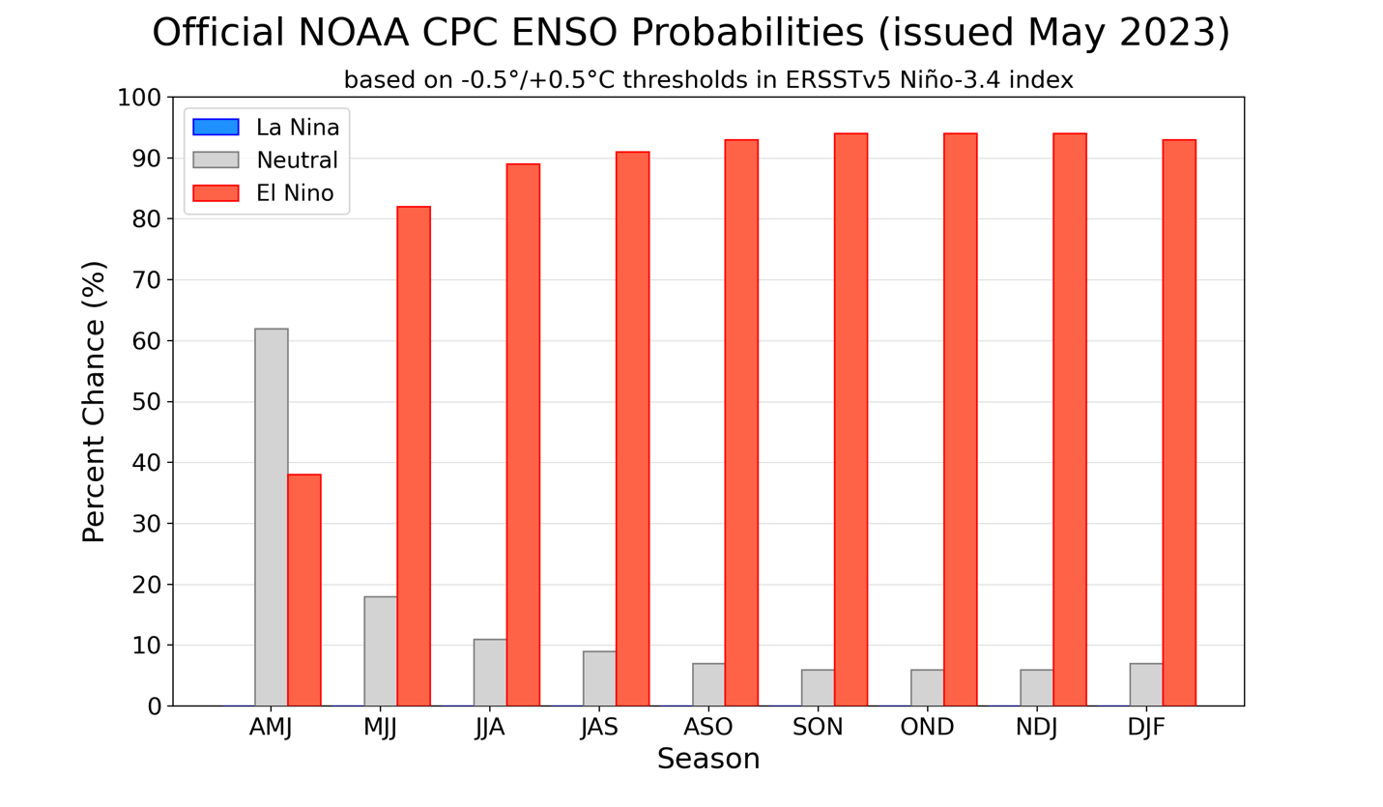
Figure 7. Official ENSO probabilities for the Niño 3.4 sea surface temperature index (5°N-5°S,
120°W-170°W). Figure updated 11 May 2023.

