EL NIÑO/SOUTHERN OSCILLATION (ENSO) DIAGNOSTIC DISCUSSION

issued by

CLIMATE PREDICTION CENTER/NCEP/NWS

9 May 2024

ENSO Alert System Status: El Niño Advisory / La Niña Watch

Synopsis: A transition from El Niño to ENSO-neutral is likely in the next month. La Niña may develop in June-August (49% chance) or July-September (69% chance).

During April 2024, below-average equatorial sea surface temperatures (SSTs) emerged in small regions of the eastern Pacific Ocean. However, above-average SSTs prevailed across the rest of the equatorial Pacific (Fig. 1). The latest weekly Niño index values remained between +0.5°C and +0.8°C in all regions, except for Niño-3 which was +0.3°C (Fig. 2). Below-average subsurface temperatures held steady during the month (area-averaged index in Fig. 3), with negative anomalies extending from the Date Line to the eastern Pacific Ocean (Fig. 4). Low-level wind anomalies were easterly over the western equatorial Pacific, while upper-level winds were near average. Convection was near average overall across the equatorial Pacific Ocean and Indonesia (Fig. 5). Collectively, the coupled ocean-atmosphere system reflected the continued weakening of El Niño and transition toward ENSO-neutral.
The most recent IRI plume favors an imminent transition to ENSO-neutral, with La Niña developing during July-September 2024 and then persisting through the Northern Hemisphere winter (Fig. 6). The forecast team continues to favor the dynamical model guidance, which suggests La Niña could form as early as June-August 2024, with higher confidence of La Niña during the following seasons. La Niña generally tends to follow strong El Niño events, which also provides added confidence in the model guidance favoring La Niña. In summary, a transition from El Niño to ENSO-neutral is likely in the next month. La Niña may develop in June-August (49% chance) or July-September (69% chance; Fig. 7).
This discussion is a consolidated effort of the National Oceanic and Atmospheric Administration (NOAA), NOAA’s National Weather Service, and their funded institutions. Oceanic and atmospheric conditions are updated weekly on the Climate Prediction Center website (El Niño/La Niña Current Conditions and Expert Discussions). Additional perspectives and analyses are also available in an ENSO blog. A probabilistic strength forecast is available here. The next ENSO Diagnostics Discussion is scheduled for 13 June 2024. To receive an e-mail notification when the monthly ENSO Diagnostic Discussions are released, please send an e-mail message to: ncep.list.enso-update@noaa.gov.

Climate Prediction Center
National Centers for Environmental Prediction
NOAA/National Weather Service
College Park, MD 20740
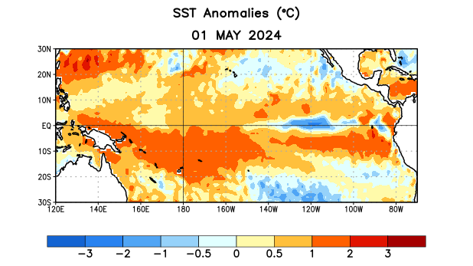
Figure 1. Average sea surface temperature (SST) anomalies (°C) for the week centered on 1 May 2024. Anomalies are computed with respect to the 1991-2020 base period weekly means.

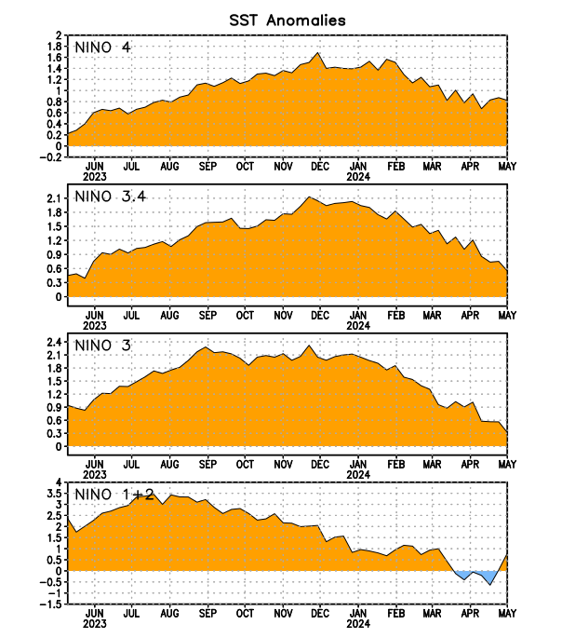
Figure 2. Time series of area-averaged sea surface temperature (SST) anomalies (°C) in the Niño regions [Niño-1+2 (0°-10°S, 90°W-80°W), Niño-3 (5°N-5°S, 150°W-90°W), Niño-3.4 (5°N-5°S, 170°W-120°W), Niño-4 (5ºN-5ºS, 150ºW-160ºE)]. SST anomalies are departures from the 1991-2020 base period weekly means.

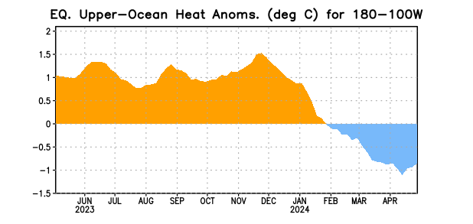

Figure 3. Area-averaged upper-ocean heat content anomaly (°C) in the equatorial Pacific (5°N-5°S, 180º-100ºW). The heat content anomaly is computed as the departure from the 1991-2020 base period pentad means.

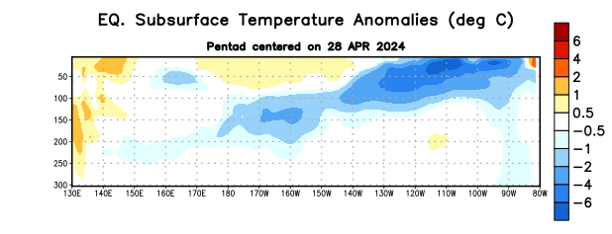
Figure 4. Depth-longitude section of equatorial Pacific upper-ocean (0-300m) temperature anomalies (°C) centered on the pentad of 28 April 2024. Anomalies are departures from the 1991-2020 base period pentad means.

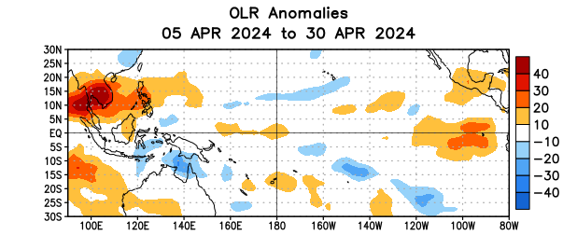

Figure 5. Average outgoing longwave radiation (OLR) anomalies (W/m²) for the period 5 April – 30 April 2024. OLR anomalies are computed as departures from the 1991-2020 base period pentad means.

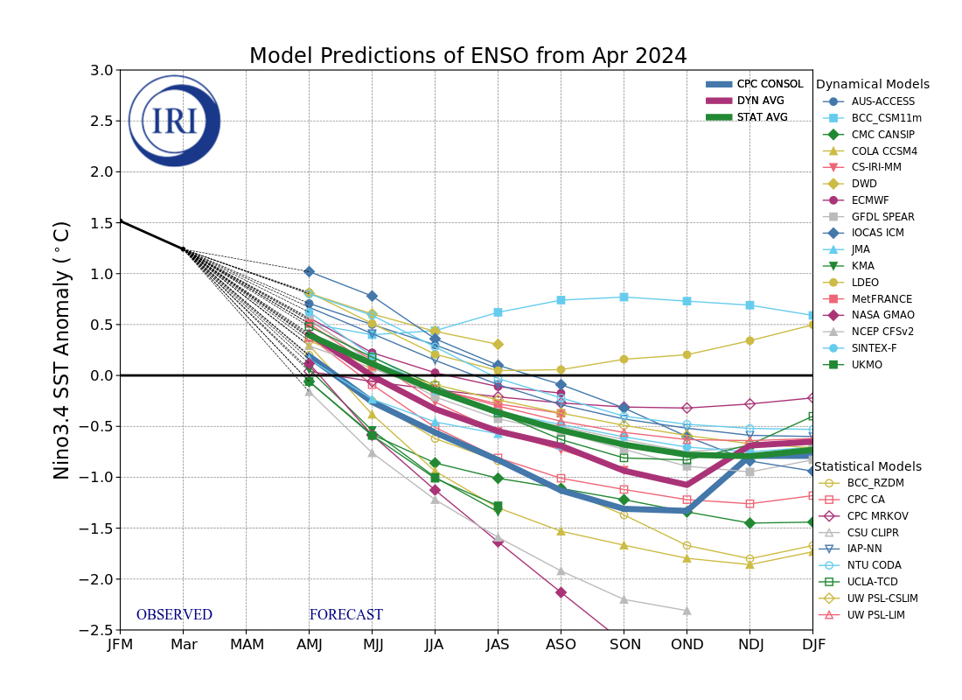
Figure 6. Forecasts of sea surface temperature (SST) anomalies for the Niño 3.4 region (5°N-5°S, 120°W-170°W). Figure updated 19 April 2024 by the International Research Institute (IRI) for Climate and Society.

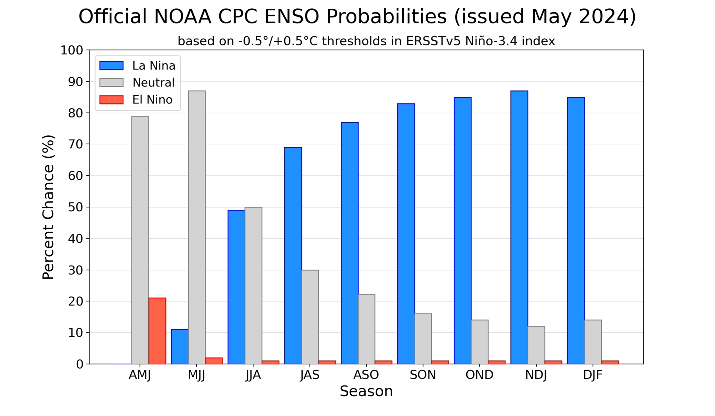
Figure 7. Official ENSO probabilities for the Niño 3.4 sea surface temperature index (5°N-5°S, 120°W-170°W). Figure updated 9 May 2024.

