EL NIÑO/SOUTHERN OSCILLATION (ENSO) DIAGNOSTIC DISCUSSION

issued by

CLIMATE PREDICTION CENTER/NCEP/NWS

8 May 2025

ENSO Alert System Status: Not Active

Synopsis: ENSO-neutral is favored through the Northern Hemisphere summer 2025 (74% chance during June-August), with chances exceeding 50% through August-October 2025.

In April 2025, ENSO-neutral continued, with near-average sea surface temperatures (SSTs) covering most of the equatorial Pacific Ocean (Fig. 1). All of the latest weekly Niño index values were near zero, ranging from -0.2°C to +0.1°C (Fig. 2). Subsurface temperatures were mostly near average in the central and eastern Pacific Ocean (Fig. 3), with above-average subsurface temperatures remaining at depth in the western Pacific (Fig. 4). For the month, low-level and upper-level winds were near average across the equatorial Pacific. Convection remained suppressed near and west of the Date Line and was enhanced near Indonesia (Fig. 5). Collectively, the coupled ocean-atmosphere system was ENSO-neutral.
The IRI and North American Multi-Model Ensemble anticipate ENSO-neutral will continue through the Northern Hemisphere summer and early autumn 2025 (Fig. 6). The forecast team also favors ENSO-neutral, especially through the summer, with chances nearing 50% during the autumn. The uncertainty increases at longer time horizons, with a 46% chance of ENSO-neutral and a 41% chance of La Niña during November 2025 - January 2026 (chances of El Niño are under 15%). In summary, ENSO-neutral is favored through the Northern Hemisphere summer 2025 (74% chance during June-August), with chances exceeding 50% through August-October 2025 (Fig. 7).
This discussion is a consolidated effort of the National Oceanic and Atmospheric Administration (NOAA), NOAA’s National Weather Service, and their funded institutions. Oceanic and atmospheric conditions are updated weekly on the Climate Prediction Center website (El Niño/La Niña Current Conditions and Expert Discussions). Additional perspectives and analyses are also available in an ENSO blog. A probabilistic strength forecast is available here. The next ENSO Diagnostics Discussion is scheduled for 12 June 2025. To receive an e-mail notification when the monthly ENSO Diagnostic Discussions are released, please send an e-mail message to: ncep.list.enso-update@noaa.gov.

Climate Prediction Center
National Centers for Environmental Prediction
NOAA/National Weather Service
College Park, MD 20740

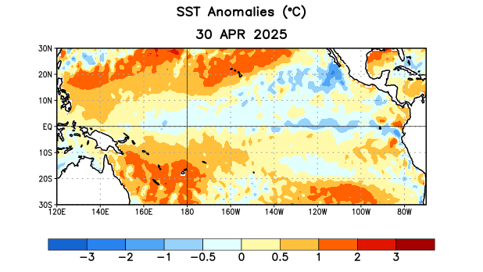
Figure 1. Average sea surface temperature (SST) anomalies (°C) for the week centered on 30 April 2025. Anomalies are computed with respect to the 1991-2020 base period weekly means.

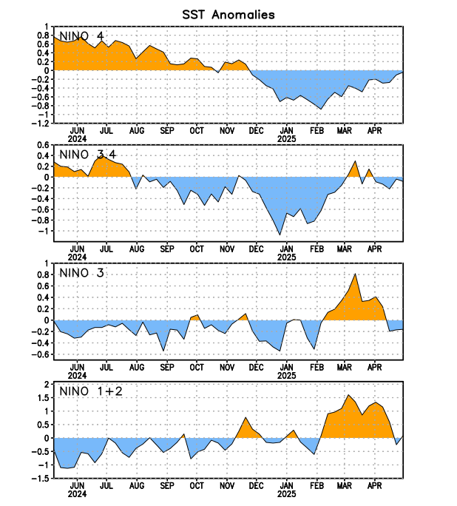
Figure 2. Time series of area-averaged sea surface temperature (SST) anomalies (°C) in the Niño regions [Niño-4 (5ºN-5ºS, 150ºW-160ºE), Niño-3.4 (5°N-5°S, 170°W-120°W), Niño-3 (5°N-5°S, 150°W-90°W), Niño-1+2 (0°-10°S, 90°W-80°W)]. SST anomalies are departures from the 1991-2020 base period weekly means.

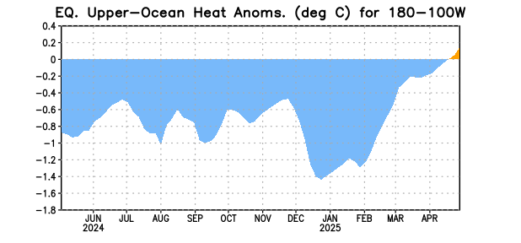
Figure 3. Area-averaged upper-ocean heat content anomaly (°C) in the equatorial Pacific (5°N-5°S, 180º-100ºW). The heat content anomaly is computed as the departure from the 1991-2020 base period pentad means.

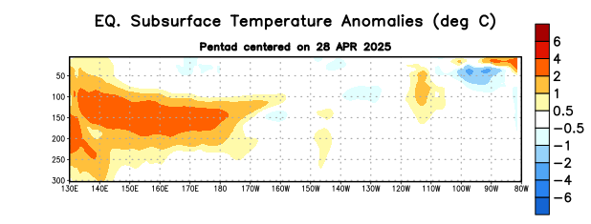
Figure 4. Depth-longitude section of equatorial Pacific upper-ocean (0-300m) temperature anomalies (°C) centered on the pentad of 28 April 2025. Anomalies are departures from the 1991-2020 base period pentad means.

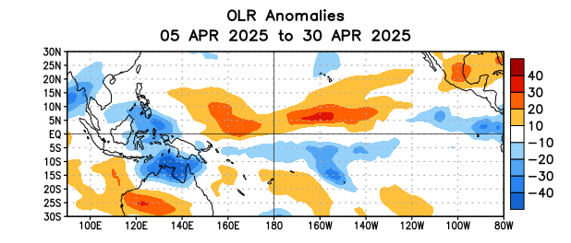
Figure 5. Average outgoing longwave radiation (OLR) anomalies (W/m²) for the period 5 – 30 April 2025. OLR anomalies are computed as departures from the 1991-2020 base period pentad means.
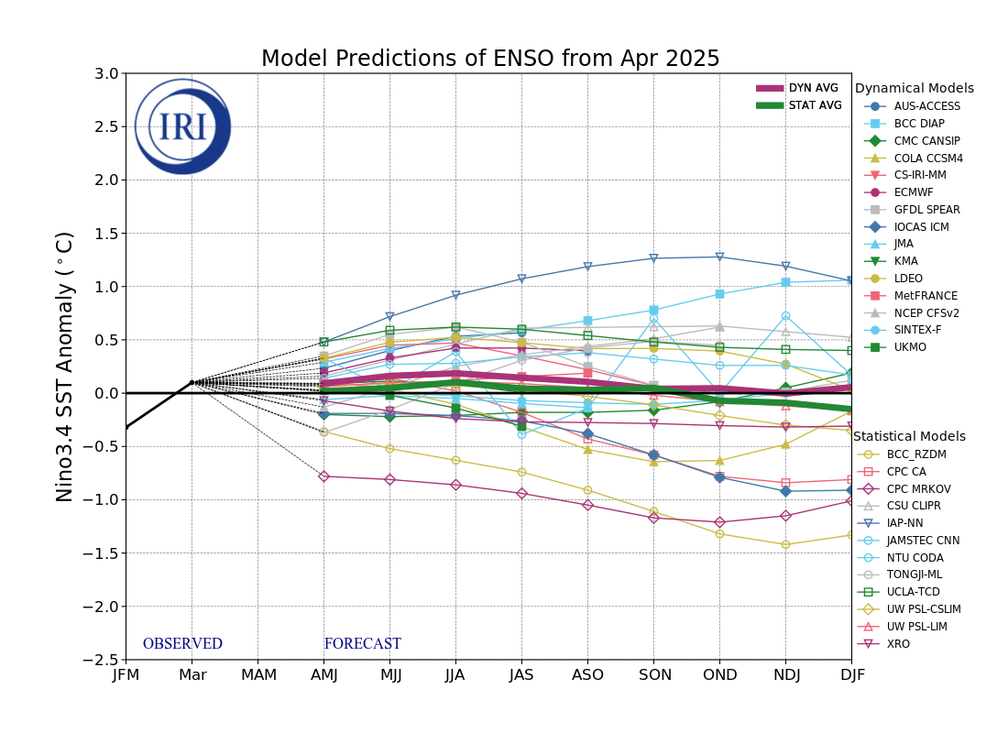
Figure 6. Forecasts of sea surface temperature (SST) anomalies for the Niño 3.4 region (5°N-5°S, 120°W-170°W). Figure updated 21 April 2025 by the International Research Institute (IRI) for Climate and Society.

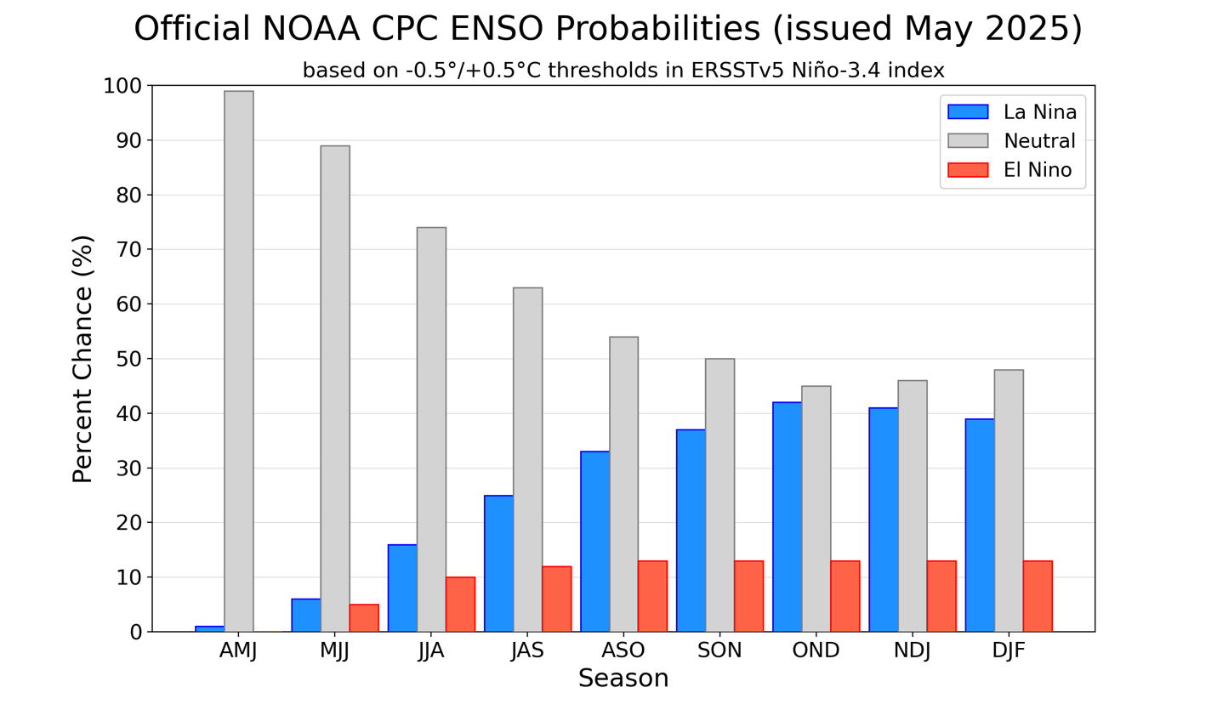
Figure 7. Official ENSO probabilities for the Niño 3.4 sea surface temperature index (5°N-5°S, 120°W-170°W). Figure updated 8 May 2025.

