EL NIÑO/SOUTHERN OSCILLATION (ENSO) DIAGNOSTIC DISCUSSION
issued by
CLIMATE PREDICTION CENTER/NCEP/NWS
8 November 2007

Synopsis: La Niña will likely continue into early 2008.
La Niña continued to strengthen during October 2007, as equatorial sea surface temperature (SST) anomalies became increasingly negative from 170ºE to the South American coast (Fig. 1). The latest 4-week analysis shows the largest SST departures (−2ºC to −3ºC) located between 140ºW and the South American coast, with departures of −0.5°C to −1°C observed near the Date Line (Fig. 2). All of the Niño region indices, except for Niño-4, remained lower than −1.0°C (Fig. 3) indicating that La Niña is approaching moderate-strength (3 -month running mean value of the Niño 3.4 index below −1.0°C).
Also during October, the upper-ocean heat content (average temperatures in the upper 300 m of the ocean) in the central and east-central equatorial Pacific remained below average (Fig. 4), with temperatures ranging from 2°C to 6°C below average at thermocline depth (Fig. 5). Consistent with these oceanic conditions, the low-level easterly winds and upper-level westerly winds remained stronger than average across the central equatorial Pacific, convection remained suppressed throughout the central and eastern equatorial Pacific, and an area of slightly enhanced convection covered parts of the far western Pacific. Collectively, these oceanic and atmospheric conditions reflect La Niña.
The recent SST forecasts (dynamical and statistical models) for the Niño 3.4 region indicate a continuation of La Niña into early 2008 (Fig. 6). Over half of the models indicate at least a moderate La Niña through December, followed by gradual weakening thereafter. Current atmospheric and oceanic conditions and recent trends are consistent with the model forecasts.
Expected La Niña impacts during November – January include a continuation of above-average precipitation over Indonesia and below-average precipitation over the central equatorial Pacific. For the contiguous United States, potential impacts include above average precipitation in the Northern Rockies, Northern California, and in southern and eastern regions of the Pacific Northwest. Below-average precipitation is expected across the southern tier, particularly in the southwestern and southeastern states.
This discussion is a consolidated effort of the National Atmospheric and Oceanic Administration (NOAA), NOAA’s National Weather Service, and their funded institutions. Oceanic and atmospheric conditions are updated weekly on the Climate Prediction Center web site (El Niño/La Niña Current Conditions and Expert Discussions). Forecasts for the evolution of El Niño/La Niña are updated monthly in the Forecast Forum section of CPC's Climate Diagnostics Bulletin. The next ENSO Diagnostics Discussion is scheduled for 6 December 2007. To receive an e-mail notification when the monthly ENSO Diagnostic Discussions are released, please send an e-mail message to: ncep.list.enso-update@noaa.gov.
Climate Prediction Center
National Centers for Environmental Prediction
NOAA/National Weather Service
Camp Springs, MD 20746-4304

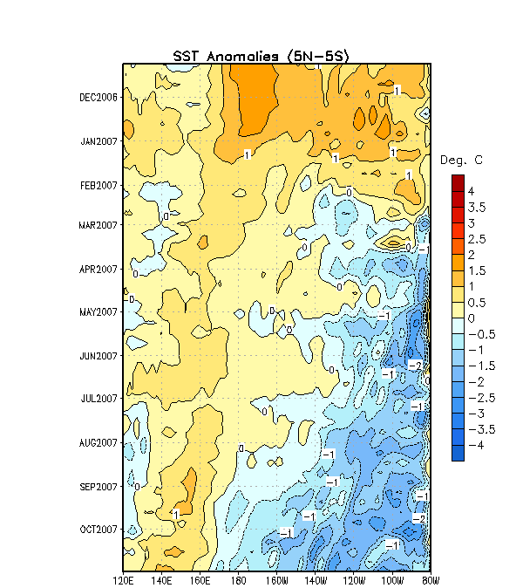

Figure 1. Time- longitude section of weekly SST anomalies (°C) averaged for the latitude band 5ºN-5ºS. Time increases downward and longitude ranges from Indonesia on the left to South America on the right. SST anomalies are departures are from the 1971-2000 base period weekly means (Xue et al. 2003, J. Climate, 16, 1601-1612).

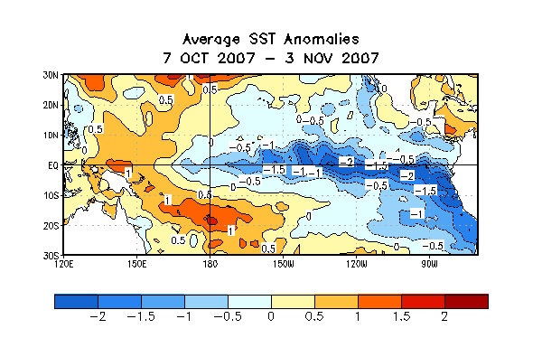
Figure 2. Sea surface temperature (SST) anomalies (°C) during the period 7 October- 3 November 2007. SST anomalies are computed with respect to the 1971-2000 base period weekly means (Xue et al. 2003, J. Climate, 16, 1601-1612).

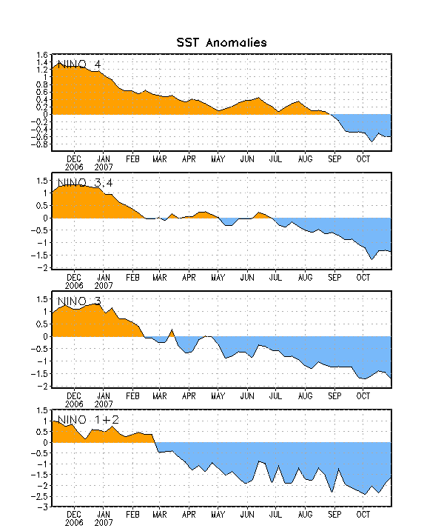

Figure 3. Time series of area-averaged sea surface temperature (SST) anomalies (°C) in the Niño regions [Niño-1+2 (0°-10°S, 90°-80°W), Niño 3 (5°N-5°S, 150°W-90°W), Niño-3.4 (5°N-5°S, 170°W-120°W), Niño-4 (150ºW-160ºE and 5ºN-5ºS)]. SST anomalies are departures are from the 1971-2000 base period weekly means (Xue et al. 2003, J. Climate, 16, 1601-1612).
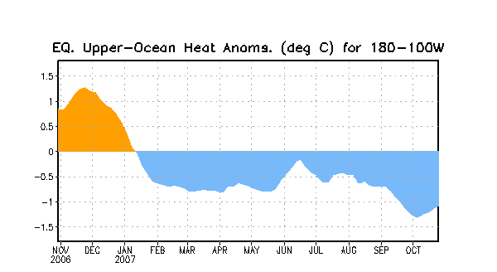

Figure 4. Area-averaged upper-ocean heat content anomalies (°C) in the equatorial Pacific (5°N-5°S, 180º-100ºW). Heat content anomalies are computed as departures from the 1982-2004 base period weekly means.

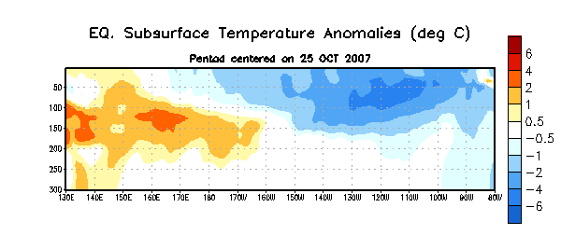
Figure 5. Depth-longitude section of equatorial Pacific upper-ocean (0-300m) temperature anomalies (°C) centered on the week of 25 October. The anomalies are averaged between 5°N-5°S. Anomalies are departures from the 1982-2004 base period weekly means.

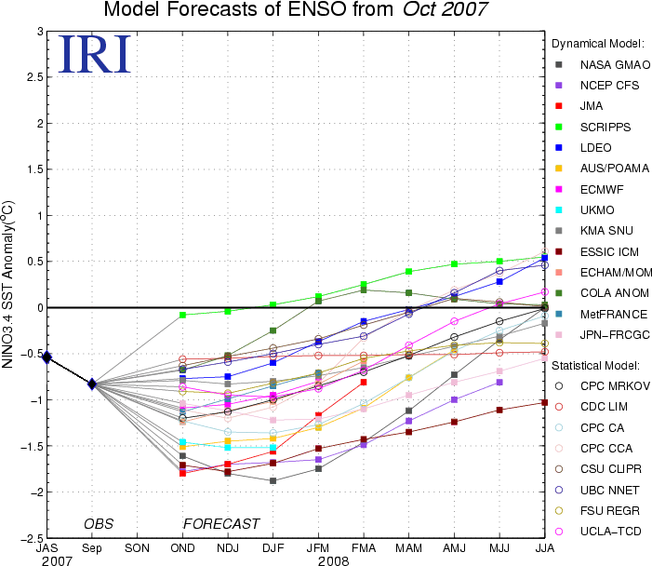

Figure 6. Forecasts of sea surface temperature (SST) anomalies for the Niño 3.4 region (5°N-5°S, 120°W-170°W). Figure courtesy of the International Research Institute (IRI) for Climate and Society. Figure updated 16 October 2007.

