EL NIÑO/SOUTHERN OSCILLATION (ENSO) DIAGNOSTIC DISCUSSION
issued by
CLIMATE PREDICTION CENTER/NCEP/NWS
6 November 2008

Synopsis: ENSO-neutral conditions are expected to continue into early 2009.
ENSO-neutral conditions continued during October 2008, as equatorial sea surface temperatures (SSTs) were near-average across much of the Pacific Ocean, except for small areas of below-average SSTs in the east-central Pacific and off the coast of South America (Fig. 1). Correspondingly, the latest weekly SST index values were near-average in all Niño regions except for Niño-1+2 (−0.8°C, Fig. 2). Subsurface oceanic heat content anomalies (average temperatures in the upper 300m of the ocean, Fig. 3) became less negative due to the eastward shift of positive temperature anomalies at thermocline depth to ~160°W, but anomalies remained negative in the eastern half of the Pacific (Fig. 4).
The atmospheric winds and convection patterns exhibited a high degree of week-to-week variability across the tropical Pacific during October in response to the Madden-Julian Oscillation (MJO). The cumulative effects of the MJO were above-average convection over Indonesia, and enhanced low-level easterly winds, enhanced upper-level westerly winds, and suppressed convection over the western equatorial Pacific. Overall, the ocean-atmosphere system remains consistent with ENSO-neutral conditions.
A majority of the SST forecasts indicate a continuation of ENSO-neutral conditions (−0.5°C to 0.5°C in the Niño-3.4 region) into the first half of 2009 (Fig. 5). Several dynamical models suggest the development of a La Niña during Northern Hemisphere Winter 2008-09. This outcome becomes more likely if the current MJO were to stall in a location that favors enhanced low-level easterlies and increased upwelling in the east-central and eastern Pacific. However, it is rare for La Niña to develop late in the year. Therefore, based on current atmospheric and oceanic conditions and recent trends, ENSO-neutral conditions are expected to continue into early 2009.
This discussion is a consolidated effort of the National Atmospheric and Oceanic Administration (NOAA), NOAA’s National Weather Service, and their funded institutions. Oceanic and atmospheric conditions are updated weekly on the Climate Prediction Center web site (El Niño/La Niña Current Conditions and Expert Discussions). Forecasts for the evolution of El Niño/La Niña are updated monthly in the Forecast Forum section of CPC's Climate Diagnostics Bulletin. The next ENSO Diagnostics Discussion is scheduled for 11 December 2008. To receive an e-mail notification when the monthly ENSO Diagnostic Discussions are released, please send an e-mail message to: ncep.list.enso-update@noaa.gov.
Climate Prediction Center
National Centers for Environmental Prediction
NOAA/National Weather Service
Camp Springs, MD 20746-4304

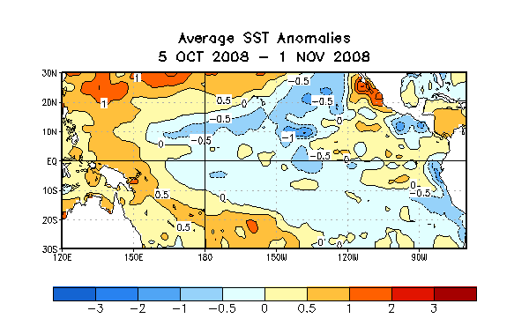

Figure 1. Average sea surface temperature (SST) anomalies (°C) for the four-week period 5 October - 1 November 2008. Anomalies are computed with respect to the 1971-2000 base period weekly means (Xue et al. 2003, J. Climate, 16, 1601-1612).

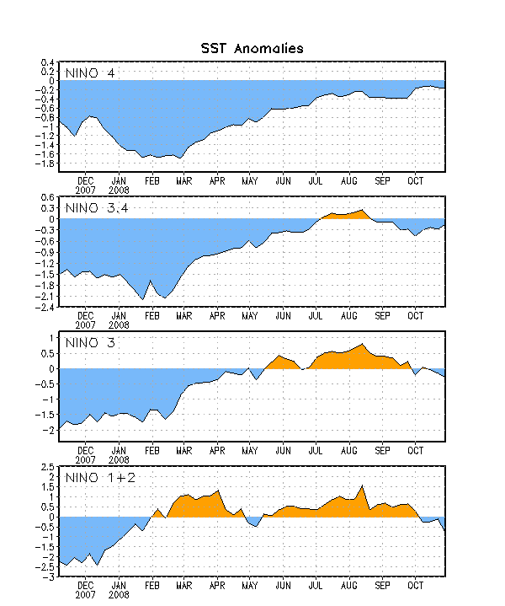
Figure 2. Time series of area-averaged sea surface temperature (SST) anomalies (°C) in the Niño regions [Niño-1+2 (0°-10°S, 90°W-80°W), Niño 3 (5°N-5°S, 150°W-90°W), Niño-3.4 (5°N-5°S, 170°W-120°W), Niño-4 (150ºW-160ºE and 5ºN-5ºS)]. SST anomalies are departures from the 1971-2000 base period weekly means (Xue et al. 2003, J. Climate, 16, 1601-1612).

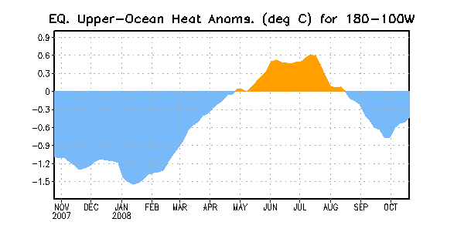
Figure 3. Area-averaged upper-ocean heat content anomalies (°C) in the equatorial Pacific (5°N-5°S, 180º-100ºW). Heat content anomalies are computed as departures from the 1982-2004 base period pentad means.

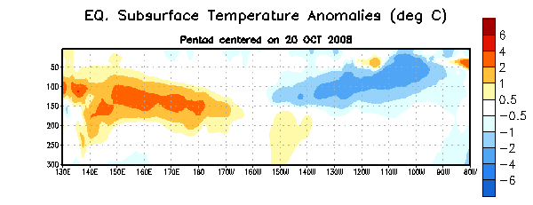
Figure 4. Depth-longitude section of equatorial Pacific upper-ocean (0-300m) temperature anomalies (°C) centered on the week of 20 October 2008. The anomalies are averaged between 5°N-5°S. Anomalies are departures from the 1982-2004 base period pentad means.

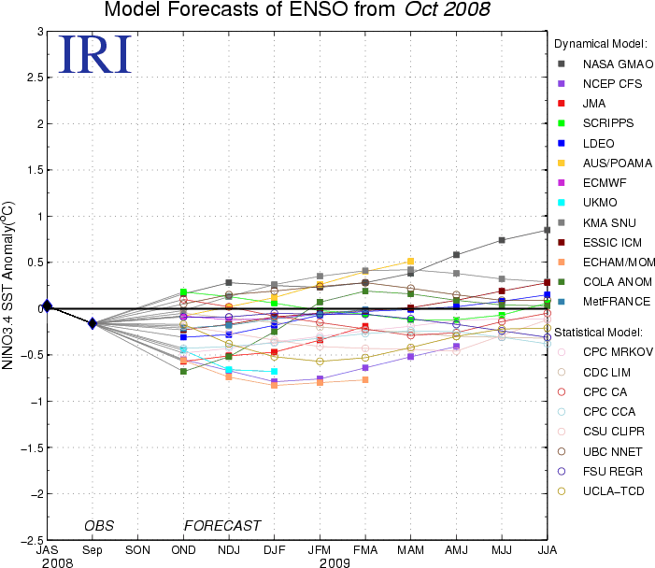

Figure 5. Forecasts of sea surface temperature (SST) anomalies for the Niño 3.4 region (5°N-5°S, 120°W-170°W). Figure courtesy of the International Research Institute (IRI) for Climate and Society. Figure updated 24 October 2008.

