EL NIÑO/SOUTHERN OSCILLATION (ENSO) DIAGNOSTIC DISCUSSION
issued by
CLIMATE PREDICTION CENTER/NCEP/NWS
5 November 2009

ENSO Alert System Status: El Niño Advisory

Synopsis: El Niño is expected to continue strengthening and last through at least the Northern Hemisphere winter 2009-2010.
During October 2009, sea surface temperature (SST) anomalies increased across the central and eastern equatorial Pacific Ocean (Figs. 1 & 2). The Niño-3.4 index increased nearly a degree with the most recent weekly value at +1.5°C (Fig. 2). Above-average subsurface temperature anomalies increased across a large region of the central and east-central Pacific, with anomalies ranging between +1 to +5°C by the end of the month (Fig. 3). Consistent with this warming, subsurface oceanic heat content anomalies (average departures in the upper 300m of the ocean, Fig. 4) also increased during the month. In addition, low-level westerly and upper-level easterly wind anomalies strengthened over much of the equatorial Pacific. The pattern of tropical convection also remained consistent with El Niño, with enhanced convection over the west-central Pacific and suppressed convection over Indonesia. Collectively, these oceanic and atmospheric anomalies reflect a strengthening El Niño.
There continues to be disagreement among the models on the eventual strength of El Niño, but the majority indicate that the three-month average Niño-3.4 SST index value will range between +1.0°C and +1.5°C during the Northern Hemisphere winter (Fig. 5). Consistent with the historical evolution of El Niño, a peak in SST anomalies is expected sometime during November-January. At this time, there is a high degree of uncertainty over how long this event will persist. Most of the models suggest that this event will last through March-May 2010, although the most likely outcome is that El Niño will peak at least at moderate strength (3-month Niño-3.4 SST index of +1.0°C or greater) and last through at least the Northern Hemisphere winter 2009-10.
Expected El Niño impacts during November 2009-January 2010 include enhanced precipitation over the central tropical Pacific Ocean and a continuation of drier-than-average conditions over Indonesia. For the contiguous United States, potential impacts include above-average precipitation for Florida, central and eastern Texas, and California, with below-average precipitation for parts of the Pacific Northwest. Above-average temperatures and below-average snowfall is most likely for the Northern Rockies, Northern Plains, and Upper Midwest, while below-average temperatures are expected for the southeastern states.
This discussion is a consolidated effort of the National Oceanic and Atmospheric Administration (NOAA), NOAA’s National Weather Service, and their funded institutions. Oceanic and atmospheric conditions are updated weekly on the Climate Prediction Center web site (El Niño/La Niña Current Conditions and Expert Discussions). Forecasts for the evolution of El Niño/La Niña are updated monthly in the Forecast Forum section of CPC's Climate Diagnostics Bulletin. The next ENSO Diagnostics Discussion is scheduled for 10 December 2009. To receive an e-mail notification when the monthly ENSO Diagnostic Discussions are released, please send an e-mail message to: ncep.list.enso-update@noaa.gov.
Climate Prediction Center
National Centers for Environmental Prediction
NOAA/National Weather Service
Camp Springs, MD 20746-4304
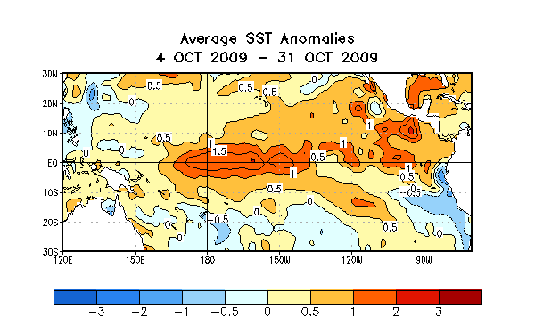
Figure 1. Average sea surface temperature (SST) anomalies (°C) for the four-week period 4 October 2009 - 31 October 2009. Anomalies are computed with respect to the 1971-2000 base period weekly means (Xue et al. 2003, J. Climate, 16, 1601-1612).

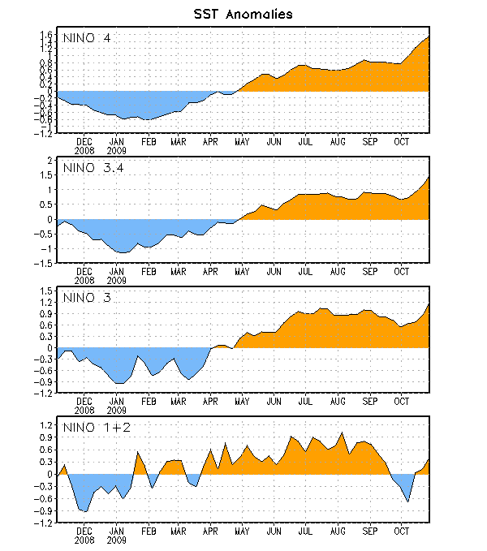

Figure 2. Time series of area-averaged sea surface temperature (SST) anomalies (°C) in the Niño regions [Niño-1+2 (0°-10°S, 90°W-80°W), Niño 3 (5°N-5°S, 150°W-90°W), Niño-3.4 (5°N-5°S, 170°W-120°W), Niño-4 (150ºW-160ºE and 5ºN-5ºS)]. SST anomalies are departures from the 1971-2000 base period weekly means (Xue et al. 2003, J. Climate, 16, 1601-1612).

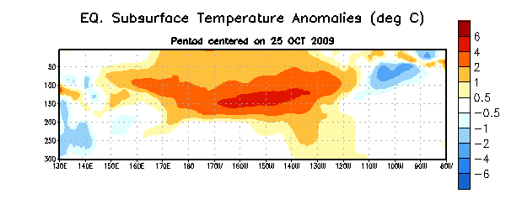

Figure 3. Depth-longitude section of equatorial Pacific upper-ocean (0-300m) temperature anomalies (°C) centered on the week of 25 October 2009. The anomalies are averaged between 5°N-5°S. Anomalies are departures from the 1982-2004 base period pentad means.

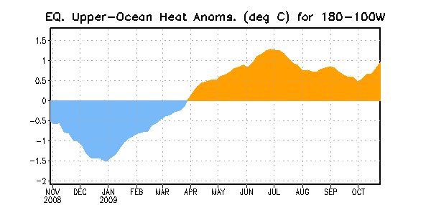

Figure 4. Area-averaged upper-ocean heat content anomalies (°C) in the equatorial Pacific (5°N-5°S, 180º-100ºW). Heat content anomalies are computed as departures from the 1982-2004 base period pentad means.

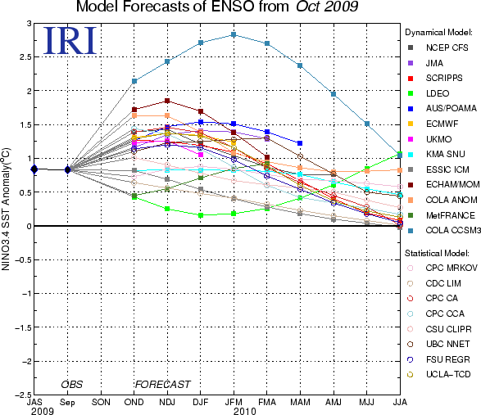

Figure 5. Forecasts of sea surface temperature (SST) anomalies for the Niño 3.4 region (5°N-5°S, 120°W-170°W). Figure courtesy of the International Research Institute (IRI) for Climate and Society. Figure updated 15 October 2009.

