EL NIÑO/SOUTHERN OSCILLATION (ENSO) DIAGNOSTIC DISCUSSION

issued by

CLIMATE PREDICTION CENTER/NCEP/NWS
4 November 2010

ENSO Alert System Status: La Niña Advisory

Synopsis: La Niña is expected to last at least into the Northern Hemisphere spring 2011.
La Niña continued during October 2010, as indicated by below-average sea surface temperatures (SSTs) across most of the equatorial Pacific Ocean (Fig. 1). The weekly Niño SST index values remained nearly unchanged, and were all –1.4°C at the end of the month (Fig. 2). The subsurface heat content (average temperatures in the upper 300m of the ocean, Fig. 3) also changed little during October, and remained well below-average in association with a shallower-than-average thermocline across the central and eastern Pacific (Fig. 4). Convection remained enhanced over Indonesia and suppressed over the western and central equatorial Pacific (Fig. 5). This pattern was linked to a continuation of enhanced low-level easterly trade winds and anomalous upper-level westerly winds over the western and central equatorial Pacific. Collectively, these oceanic and atmospheric anomalies reflect the ongoing La Niña.
Consistent with nearly all ENSO forecast models (Fig. 6), La Niña is expected to last at least into the Northern Hemisphere spring 2011. A large majority of models also predict La Niña to become a strong episode (defined by a 3-month average Niño-3.4 index of –1.5°C or colder) by the November-January season before gradually weakening. A few of the models, including the NCEP Climate Forecast System (CFS), suggest that La Niña could persist into the Northern Hemisphere summer 2011. However, no particular outcome is favored beyond the Northern Hemisphere spring due to large model disagreement and lower model skill during the period.
Likely La Niña impacts during November 2010-January 2011 include suppressed convection over the central tropical Pacific Ocean, and enhanced convection over Indonesia. Expected impacts in the United States include an enhanced chance of above-average precipitation in the Pacific Northwest, Northern Rockies (along with a concomitant increase in snowfall), and Ohio Valley, while below-average precipitation is most likely across the south-central and southeastern states. An increased chance of below-average temperatures is predicted for coastal and near-coastal regions of the northern West Coast, and a higher possibility of above-average temperatures is expected for much of the southern and central U.S. (see 3-month seasonal outlook released on October 21st, 2010).
This discussion is a consolidated effort of the National Oceanic and Atmospheric Administration (NOAA), NOAA’s National Weather Service, and their funded institutions. Oceanic and atmospheric conditions are updated weekly on the Climate Prediction Center web site (El Niño/La Niña Current Conditions and Expert Discussions). Forecasts for the evolution of El Niño/La Niña are updated monthly in the Forecast Forum section of CPC's Climate Diagnostics Bulletin. The next ENSO Diagnostics Discussion is scheduled for 9 December 2010. To receive an e-mail notification when the monthly ENSO Diagnostic Discussions are released, please send an e-mail message to: ncep.list.enso-update@noaa.gov.
Climate Prediction Center
National Centers for Environmental Prediction
NOAA/National Weather Service
Camp Springs, MD 20746-4304
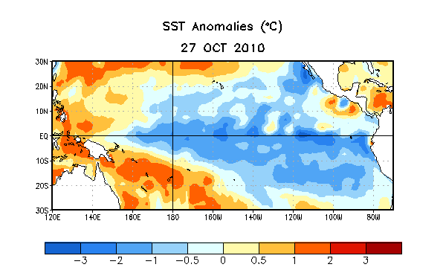
Figure 1. Average sea surface temperature (SST) anomalies (°C) for the week centered on 27 October 2010. Anomalies are computed with respect to the 1971-2000 base period weekly means (Xue et al. 2003, J. Climate, 16, 1601-1612).

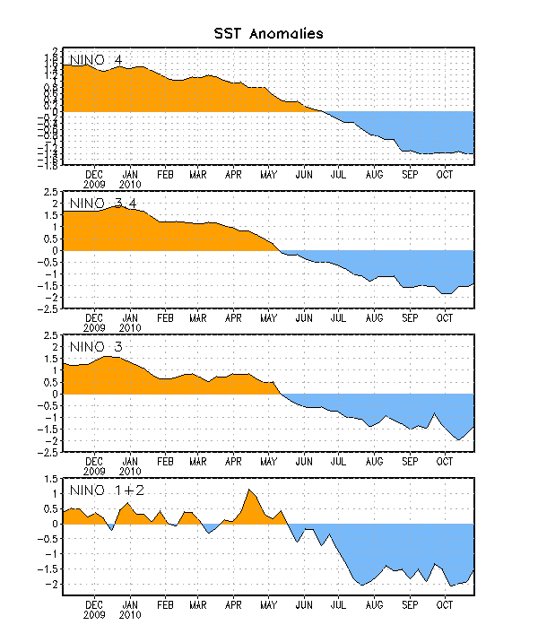
Figure 2. Time series of area-averaged sea surface temperature (SST) anomalies (°C) in the Niño regions [Niño-1+2 (0°-10°S, 90°W-80°W), Niño 3 (5°N-5°S, 150°W-90°W), Niño-3.4 (5°N-5°S, 170°W-120°W), Niño-4 (150ºW-160ºE and 5ºN-5ºS)]. SST anomalies are departures from the 1971-2000 base period weekly means (Xue et al. 2003, J. Climate, 16, 1601-1612).

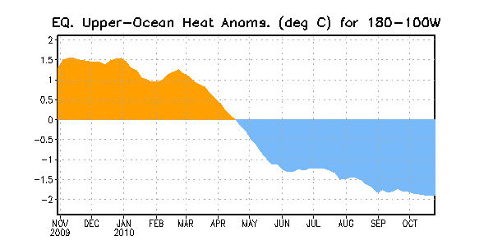
Figure 3. Area-averaged upper-ocean heat content anomalies (°C) in the equatorial Pacific (5°N-5°S, 180º-100ºW). Heat content anomalies are computed as departures from the 1982-2004 base period pentad means.

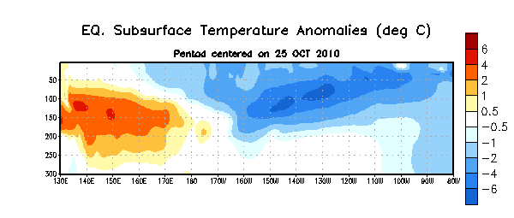
Figure 4. Depth-longitude section of equatorial Pacific upper-ocean (0-300m) temperature anomalies (°C) centered on the week of 25 October 2010. The anomalies are averaged between 5°N-5°S. Anomalies are departures from the 1982-2004 base period pentad means.

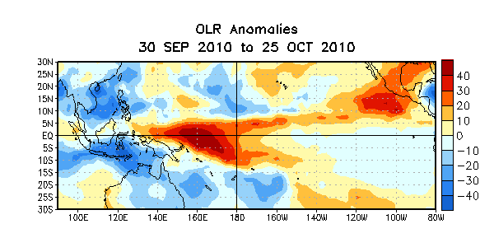
Figure 5. Average outgoing longwave radiation (OLR) anomalies (W/m²) for the four-week period 30 September – 25 October 2010. OLR anomalies are computed as departures from the 1979-1995 base period pentad means.

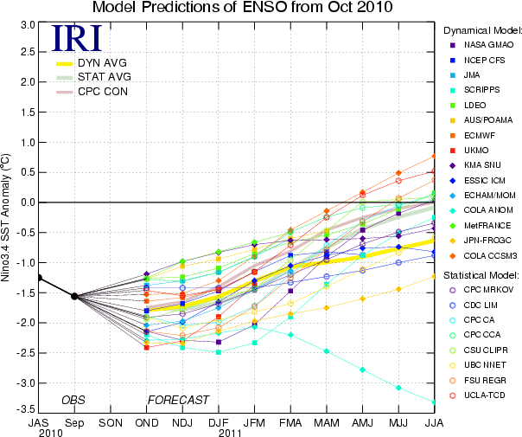
Figure 6. Forecasts of sea surface temperature (SST) anomalies for the Niño 3.4 region (5°N-5°S, 120°W-170°W). Figure courtesy of the International Research Institute (IRI) for Climate and Society. Figure updated 19 October 2010.

