EL NIÑO/SOUTHERN OSCILLATION (ENSO) DIAGNOSTIC DISCUSSION

issued by

CLIMATE PREDICTION CENTER/NCEP/NWS
10 November 2011

ENSO Alert System Status: La Niña Advisory

Synopsis: La Niña is expected to continue through the Northern Hemisphere winter 2011-12.
During October 2011, below-average sea surface temperatures (SST) associated with La Niña conditions strengthened across the east-central equatorial Pacific Ocean (Fig. 1). As a result, the recent weekly SST index values in the Niño-3.4 and Niño-3 regions dropped to near –1.0°C (Fig. 2). Also, the oceanic heat content (average temperature in the upper 300m of the ocean, Fig. 3) remained below-average, reflecting an extensive area of below-average temperatures at depth (Fig. 4). The atmospheric circulation over the global tropics featured strong week-to-week variability during October in response to the Madden Julian Oscillation (MJO). Averaged over the month, convection remained suppressed near the Date Line in association with La Niña, but was near-normal over Indonesia as the MJO acted to offset the increased convection typically associated with La Niña (Fig. 5). In addition, anomalous low-level easterly and upper-level westerly winds shifted into the western Pacific and over Papua New Guinea. Collectively, these oceanic and atmospheric patterns reflect the continuation of La Niña conditions, although modified slightly by the MJO.
A majority of the models now predict La Niña to continue through the Northern Hemisphere winter (Fig. 6) and then gradually weaken after peaking during the November – January period. The models are roughly split between those that predict La Niña to remain weak (3-month average in the Nino-3.4 region less than -0.9°C) and those that predict a stronger episode. Over the last half-century, La Niña events that were preceded by ENSO-neutral conditions during the Northern Hemisphere summer (May-August) were less likely to attain strong amplitude (less than –1.5°C) the following winter. This observation, in combination with the model forecasts, favors a weak-to-moderate strength La Niña during the Northern Hemisphere winter.
During November 2011-January 2012, there is an increased chance of above-average temperatures across the south-central U.S. with the odds favoring below-average temperatures over the north-central U.S. Also, above-average precipitation is favored across the northern tier of states, excluding New England, and drier-than-average conditions are more probable across the southern tier of the U.S. (see 3-month seasonal outlook released on 20 October 2011).
This discussion is a consolidated effort of the National Oceanic and Atmospheric Administration (NOAA), NOAA’s National Weather Service, and their funded institutions. Oceanic and atmospheric conditions are updated weekly on the Climate Prediction Center web site (El Niño/La Niña Current Conditions and Expert Discussions). Forecasts for the evolution of El Niño/La Niña are updated monthly in the Forecast Forum section of CPC's Climate Diagnostics Bulletin. The next ENSO Diagnostics Discussion is scheduled for 8 December 2011. To receive an e-mail notification when the monthly ENSO Diagnostic Discussions are released, please send an e-mail message to: ncep.list.enso-update@noaa.gov.
Climate Prediction Center
National Centers for Environmental Prediction
NOAA/National Weather Service
Camp Springs, MD 20746-4304
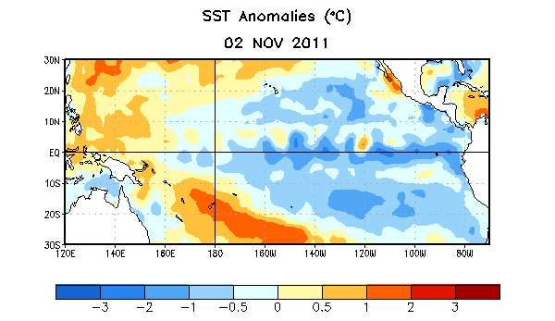

Figure 1. Average sea surface temperature (SST) anomalies (°C) for the week centered on 2 November 2011. Anomalies are computed with respect to the 1971-2000 base period weekly means (Xue et al. 2003, J. Climate, 16, 1601-1612).

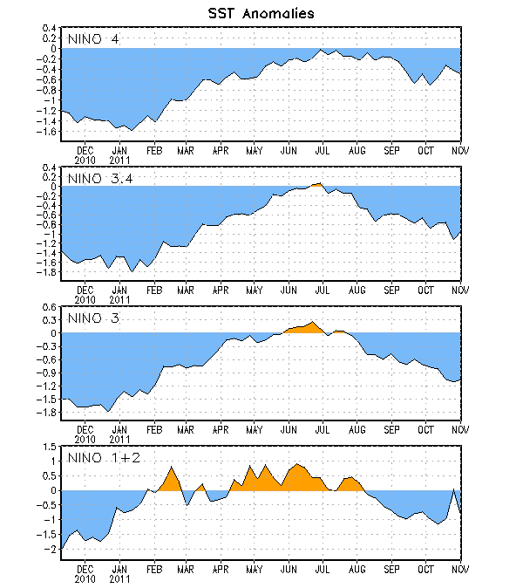
Figure 2. Time series of area-averaged sea surface temperature (SST) anomalies (°C) in the Niño regions [Niño-1+2 (0°-10°S, 90°W-80°W), Niño 3 (5°N-5°S, 150°W-90°W), Niño-3.4 (5°N-5°S, 170°W-120°W), Niño-4 (150ºW-160ºE and 5ºN-5ºS)]. SST anomalies are departures from the 1971-2000 base period weekly means (Xue et al. 2003, J. Climate, 16, 1601-1612).

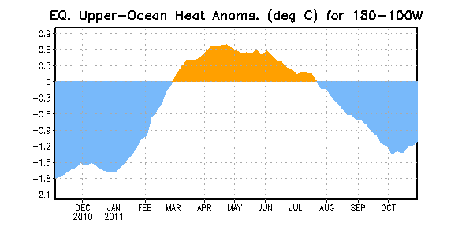
Figure 3. Area-averaged upper-ocean heat content anomaly (°C) in the equatorial Pacific (5°N-5°S, 180º-100ºW). The heat content anomaly is computed as the departure from the 1982-2004 base period pentad means.

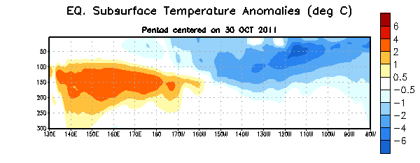
Figure 4. Depth-longitude section of equatorial Pacific upper-ocean (0-300m) temperature anomalies (°C) centered on the week of 30 October 2011. The anomalies are averaged between 5°N-5°S. Anomalies are departures from the 1982-2004 base period pentad means.

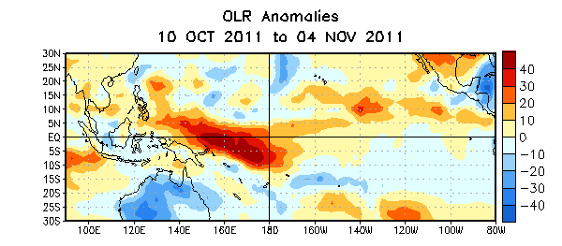

Figure 5. Average outgoing longwave radiation (OLR) anomalies (W/m²) for the four-week period 10 October – 4 November 2011. OLR anomalies are computed as departures from the 1979-1995 base period pentad means.

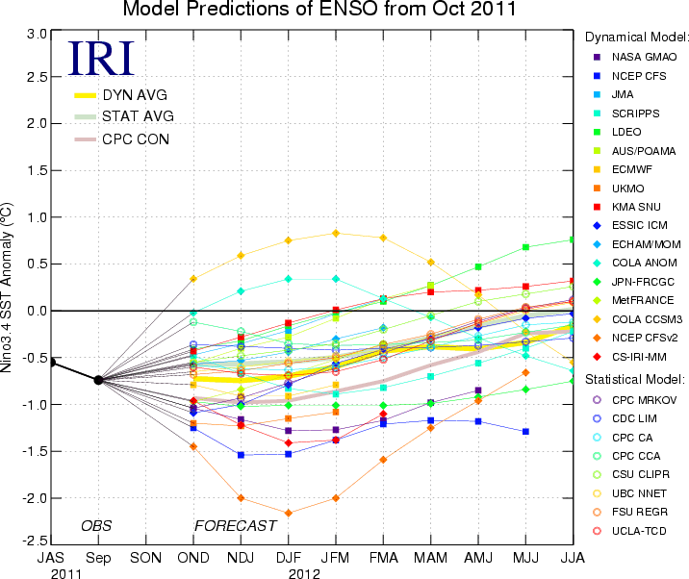
Figure 6. Forecasts of sea surface temperature (SST) anomalies for the Niño 3.4 region (5°N-5°S, 120°W-170°W). Figure courtesy of the International Research Institute (IRI) for Climate and Society. Figure updated 18 October 2011.

