EL NIÑO/SOUTHERN OSCILLATION (ENSO) DIAGNOSTIC DISCUSSION

issued by

CLIMATE PREDICTION CENTER/NCEP/NWS
and the International Research Institute for Climate and Society
7 November 2013

ENSO Alert System Status: Not Active

Synopsis: ENSO-neutral is expected through the Northern Hemisphere spring 2014.
During October, ENSO-neutral persisted, as reflected by near-average sea surface temperatures (SST) across much of the equatorial Pacific Ocean (Fig. 1). During the month, slightly below-average SSTs were evident in most of the Niño regions, except for Niño-4, which remained near zero (Fig. 2). However, the oceanic heat content (average temperature in the upper 300m of the ocean) rose from near average to slightly above average (Fig. 3), due to the eastward shift of a downwelling oceanic Kelvin wave, which was reflected in the above-average subsurface temperatures across the western half of the Pacific (Fig. 4). The atmospheric circulation remained largely near average during the month, with generally small departures in equatorial convection (Fig. 5) and upper and lower-level winds. Collectively, these atmospheric and oceanic conditions reflect ENSO-neutral.
The majority of model forecasts indicate that ENSO-neutral (Niño-3.4 index between -0.5°C and 0.5°C) will persist into the Northern Hemisphere summer 2014 (Fig. 6). Though confidence is highest for ENSO-neutral, there are also growing probabilities for warm conditions (relative to cool conditions) toward the spring/summer 2014. The consensus forecast is for ENSO-neutral to continue through the Northern Hemisphere spring 2014 (see CPC/IRI consensus forecast).
This discussion is a consolidated effort of the National Oceanic and Atmospheric Administration (NOAA), NOAA’s National Weather Service, and their funded institutions. Oceanic and atmospheric conditions are updated weekly on the Climate Prediction Center web site (El Niño/La Niña Current Conditions and Expert Discussions). Forecasts for the evolution of El Niño/La Niña are updated monthly in the Forecast Forum section of CPC's Climate Diagnostics Bulletin. The next ENSO Diagnostics Discussion is scheduled for 5 December 2013. To receive an e-mail notification when the monthly ENSO Diagnostic Discussions are released, please send an e-mail message to: ncep.list.enso-update@noaa.gov.
Climate Prediction Center
National Centers for Environmental Prediction
NOAA/National Weather Service
College Park, MD 20740

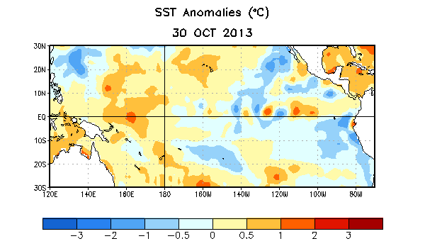
Figure 1. Average sea surface temperature (SST) anomalies (°C) for the week centered on 30 October 2013. Anomalies are computed with respect to the 1981-2010 base period weekly means.

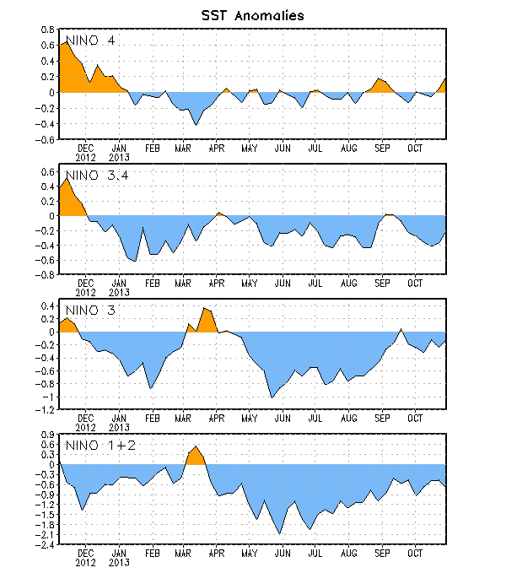
Figure 2. Time series of area-averaged sea surface temperature (SST) anomalies (°C) in the Niño regions [Niño-1+2 (0°-10°S, 90°W-80°W), Niño 3 (5°N-5°S, 150°W-90°W), Niño-3.4 (5°N-5°S, 170°W-120°W), Niño-4 (5ºN-5ºS , 150ºW-160ºE]. SST anomalies are departures from the 1981-2010 base period weekly means.

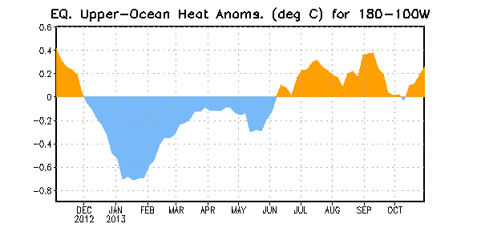
Figure 3. Area-averaged upper-ocean heat content anomaly (°C) in the equatorial Pacific (5°N-5°S, 180º-100ºW). The heat content anomaly is computed as the departure from the 1981-2010 base period pentad means.

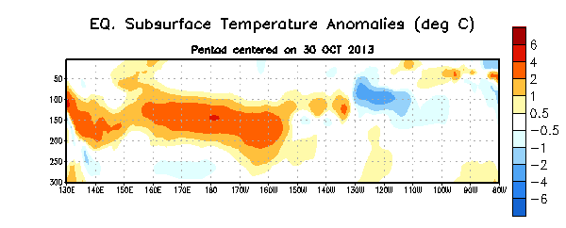
Figure 4. Depth-longitude section of equatorial Pacific upper-ocean (0-300m) temperature anomalies (°C) centered on the pentad of 30 October 2013. The anomalies are averaged between 5°N-5°S. Anomalies are departures from the 1981-2010 base period pentad means.

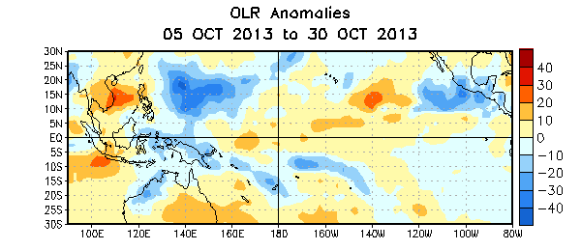
Figure 5. Average outgoing longwave radiation (OLR) anomalies (W/m²) for the period 5 – 30 October 2013. OLR anomalies are computed as departures from the 1979-1995 base period pentad means.

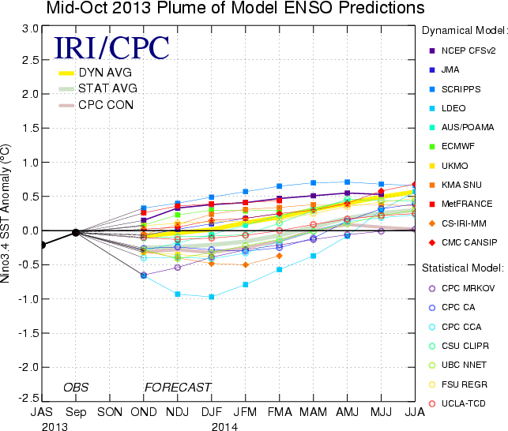
Figure 6. Forecasts of sea surface temperature (SST) anomalies for the Niño 3.4 region (5°N-5°S, 120°W-170°W). Figure updated 15 October 2013.

