EL NIÑO/SOUTHERN OSCILLATION (ENSO) DIAGNOSTIC DISCUSSION

issued by

CLIMATE PREDICTION CENTER/NCEP/NWS
and the International Research Institute for Climate and Society
6 November 2014

ENSO Alert System Status: El Niño Watch

Synopsis: There is a 58% chance of El Niño during the Northern Hemisphere winter, which is favored to last into the Northern Hemisphere spring 2015.
During October 2014, above-average sea surface temperatures (SST) increased slightly across the eastern half of the equatorial Pacific (Fig. 1). The weekly Niño indices were between +0.6°C (Niño-3.4 and Niño-1+2) and +0.9°C (Niño-3) at the end of the month (Fig. 2). Subsurface heat content anomalies (averaged between 180º-100ºW) were largely unchanged (Fig. 3) even as a new downwelling Kelvin wave increased temperatures at depth in the central Pacific (Fig. 4). The monthly equatorial low-level winds were near average, although anomalous westerlies continued to emerge on occasion. Upper-level winds were also mostly average across the Pacific. The Southern Oscillation Index continued to be negative, accompanied by mostly average rainfall near the Date Line and suppressed rainfall over Indonesia (Fig. 5). Overall, several features across the tropical Pacific are characteristic of borderline El Niño conditions, but collectively, the combined atmosphere and oceanic state remains ENSO-neutral.
Similar to last month, most models predict El Niño to develop during October-December 2014 and to continue into early 2015 (Fig. 6). However, the ongoing lack of clear atmosphere-ocean coupling and the latest NCEP CFSv2 model forecast (Fig. 7) have reduced confidence that El Niño will fully materialize (at least five overlapping consecutive 3-month values of the Niño-3.4 index at or greater than 0.5°C). If El Niño does emerge, the forecaster consensus favors a weak event. In summary, there is a 58% chance of El Niño during the Northern Hemisphere winter, which is favored to last into the Northern Hemisphere spring 2015 (click CPC/IRI consensus forecast for the chance of each outcome).
This discussion is a consolidated effort of the National Oceanic and Atmospheric Administration (NOAA), NOAA’s National Weather Service, and their funded institutions. Oceanic and atmospheric conditions are updated weekly on the Climate Prediction Center web site (El Niño/La Niña Current Conditions and Expert Discussions). Forecasts are also updated monthly in the Forecast Forum of CPC's Climate Diagnostics Bulletin. Additional perspectives and analysis are also available in an ENSO blog. The next ENSO Diagnostics Discussion is scheduled for 4 December 2014. To receive an e-mail notification when the monthly ENSO Diagnostic Discussions are released, please send an e-mail message to: ncep.list.enso-update@noaa.gov.

Climate Prediction Center
National Centers for Environmental Prediction
NOAA/National Weather Service
College Park, MD 20740

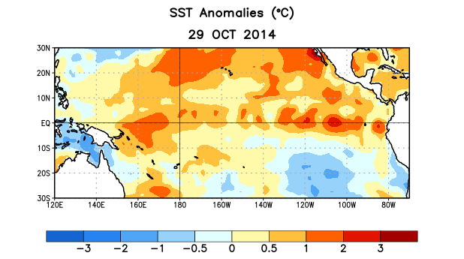
Figure 1. Average sea surface temperature (SST) anomalies (°C) for the week centered on 29 October 2014. Anomalies are computed with respect to the 1981-2010 base period weekly means.

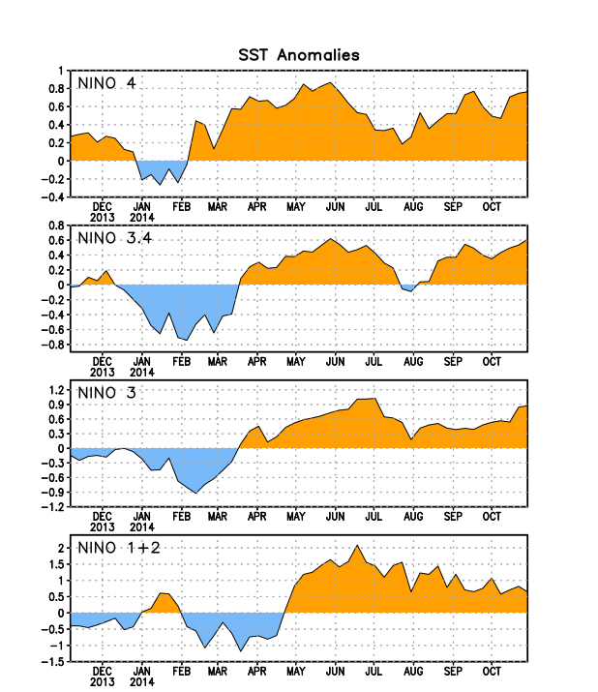
Figure 2. Time series of area-averaged sea surface temperature (SST) anomalies (°C) in the Niño regions [Niño-1+2 (0°-10°S, 90°W-80°W), Niño 3 (5°N-5°S, 150°W-90°W), Niño-3.4 (5°N-5°S, 170°W-120°W), Niño-4 (5ºN-5ºS , 150ºW-160ºE]. SST anomalies are departures from the 1981-2010 base period weekly means.
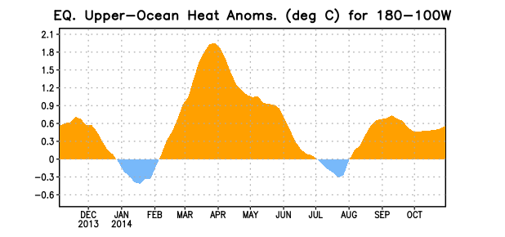
Figure 3. Area-averaged upper-ocean heat content anomaly (°C) in the equatorial Pacific (5°N-5°S, 180º-100ºW). The heat content anomaly is computed as the departure from the 1981-2010 base period pentad means.

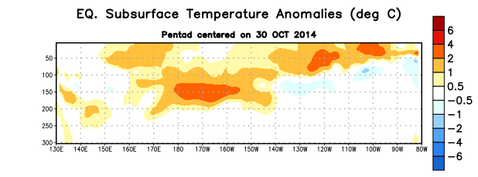
Figure 4. Depth-longitude section of equatorial Pacific upper-ocean (0-300m) temperature anomalies (°C)
centered on the pentad of 30 October 2014. The anomalies are averaged between 5°N-5°S. Anomalies are departures from the 1981-2010 base period pentad means.

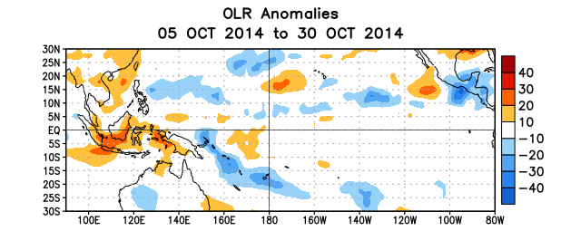
Figure 5. Average outgoing longwave radiation (OLR) anomalies (W/m²) for the period 5 – 30 October 2014. OLR anomalies are computed as departures from the 1979-1995 base period pentad means.

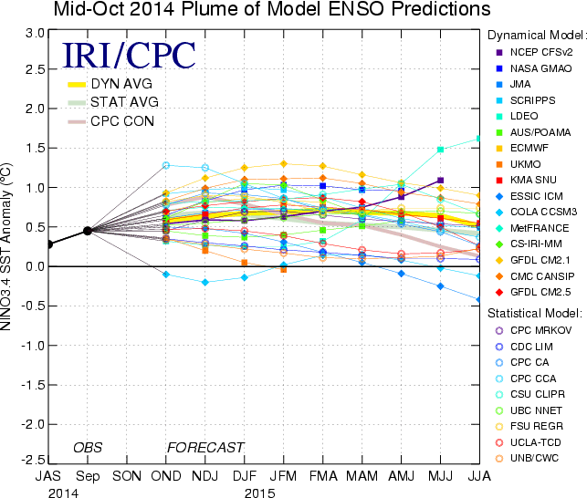

Figure 6. Forecasts of sea surface temperature (SST) anomalies for the Niño 3.4 region (5°N-5°S, 120°W-170°W). Figure updated 14 October 2014.

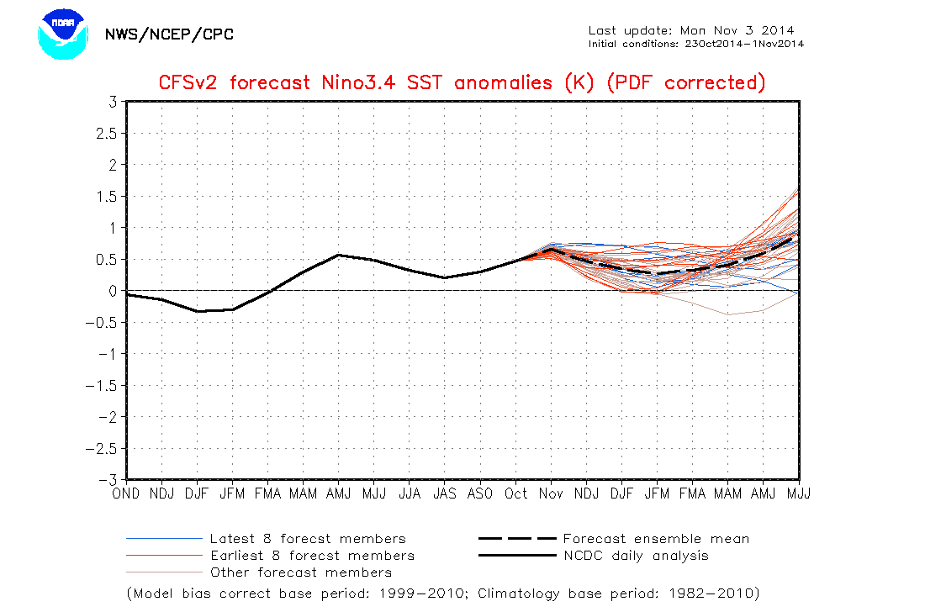

Figure 7. NCEP CFSv2 forecasts of sea surface temperature (SST) anomalies for the Niño 3.4 region (5°N-5°S, 120°W-170°W). Figure updated 3 November 2014.

