EL NIÑO/SOUTHERN OSCILLATION (ENSO) DIAGNOSTIC DISCUSSION

issued by

CLIMATE PREDICTION CENTER/NCEP/NWS
and the International Research Institute for Climate and Society
9 November 2017

ENSO Alert System Status: La Niña Advisory

Synopsis: La Niña conditions are predicted to continue (~65-75% chance) at least through the Northern Hemisphere winter 2017-18.
During October, weak La Niña conditions emerged as reflected by below-average sea surface temperatures (SSTs) across most of the central and eastern equatorial Pacific Ocean (Fig. 1). The weekly Niño indices were variable during the month, with values near -0.5° C during the past week in the Niño-3.4 and Niño-3 regions (Fig. 2). Sub-surface temperatures remained below average during October (Fig. 3), reflecting the anomalously shallow depth of the thermocline across the central and eastern Pacific (Fig. 4). Also, convection was suppressed near the International Date Line and slightly enhanced over parts of the Maritime Continent and the Philippines (Fig. 5). Over the equatorial Pacific Ocean, low-level trade winds were mainly near average, but the upper-level winds were strongly anomalously westerly and the Southern Oscillation Index was positive. Overall, the ocean and atmosphere system reflects the onset of La Niña conditions.
For the remainder of the Northern Hemisphere fall and winter 2017-18, a weak La Niña is favored in the model averages of the IRI/CPC plume (Fig. 6) and also in the North American Multi-Model Ensemble (NMME) (Fig. 7). The consensus of forecasters is for the event to continue through approximately February-April 2018. In summary, La Niña conditions are predicted to continue (~65-75% chance) at least through the Northern Hemisphere winter (click CPC/IRI consensus forecast for the chance of each outcome for each 3-month period).
La Niña is likely to affect temperature and precipitation across the United States during the upcoming months (the 3-month seasonal temperature and precipitation outlooks will be updated on Thursday November 16th). The outlooks generally favor above-average temperatures and below-median precipitation across the southern tier of the United States, and below-average temperatures and above-median precipitation across the northern tier of the United States.
This discussion is a consolidated effort of the National Oceanic and Atmospheric Administration (NOAA), NOAA’s National Weather Service, and their funded institutions. Oceanic and atmospheric conditions are updated weekly on the Climate Prediction Center web site (El Niño/La Niña Current Conditions and Expert Discussions). Forecasts are also updated monthly in the Forecast Forum of CPC's Climate Diagnostics Bulletin. Additional perspectives and analysis are also available in an ENSO blog. The next ENSO Diagnostics Discussion is scheduled for 14 December 2017. To receive an e-mail notification when the monthly ENSO Diagnostic Discussions are released, please send an e-mail message to: ncep.list.enso-update@noaa.gov.

Climate Prediction Center
National Centers for Environmental Prediction
NOAA/National Weather Service
College Park, MD 20740

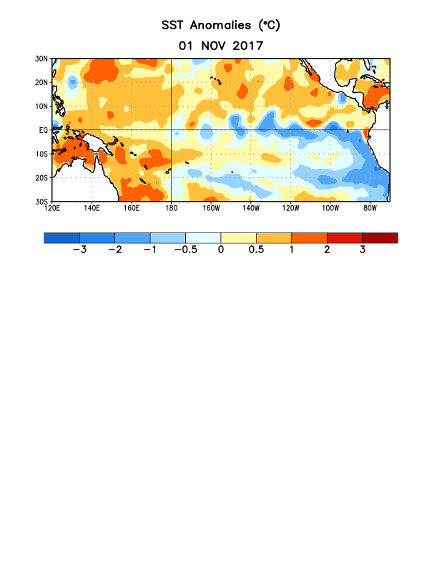
Figure 1. Average sea surface temperature (SST) anomalies (°C) for the week centered on 1 November 2017. Anomalies are computed with respect to the 1981-2010 base period weekly means.

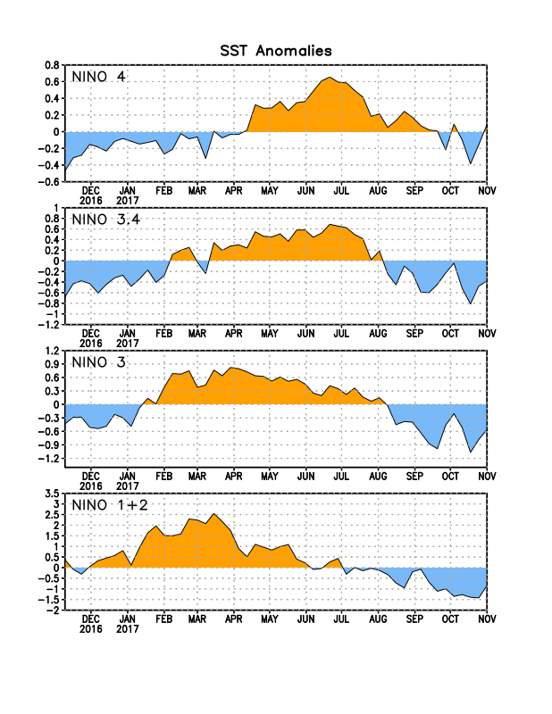
Figure 2. Time series of area-averaged sea surface temperature (SST) anomalies (°C) in the Niño regions [Niño-1+2 (0°-10°S, 90°W-80°W), Niño-3 (5°N-5°S, 150°W-90°W), Niño-3.4 (5°N-5°S, 170°W-120°W), Niño-4 (5ºN-5ºS , 150ºW-160ºE]. SST anomalies are departures from the 1981-2010 base period weekly means.
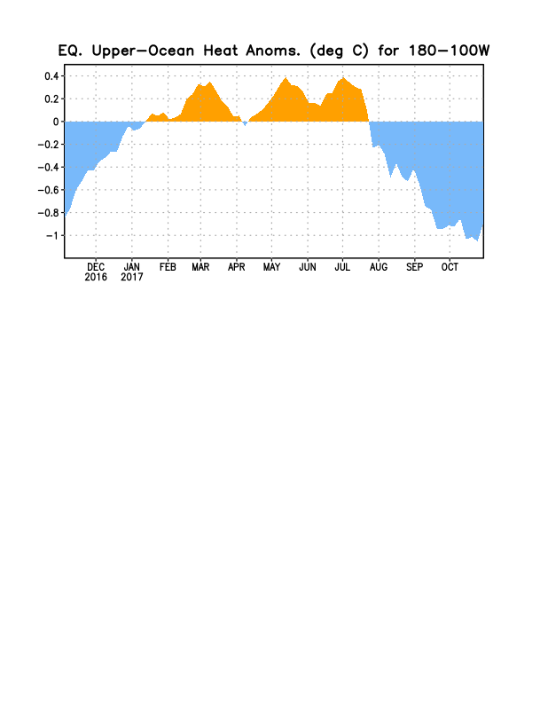
Figure 3. Area-averaged upper-ocean heat content anomaly (°C) in the equatorial Pacific (5°N-5°S, 180º-100ºW). The heat content anomaly is computed as the departure from the 1981-2010 base period pentad means.

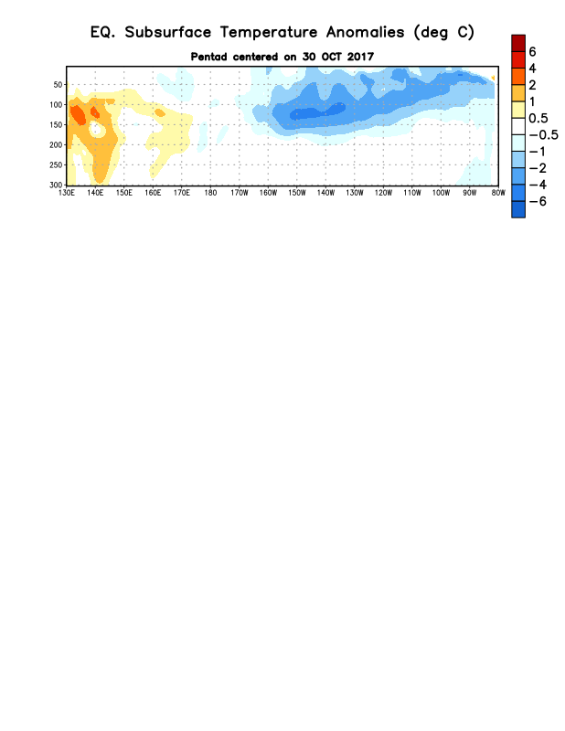
Figure 4. Depth-longitude section of equatorial Pacific upper-ocean (0-300m) temperature anomalies (°C) centered on the pentad of 30 October 2017. Anomalies are departures from the 1981-2010 base period pentad means.

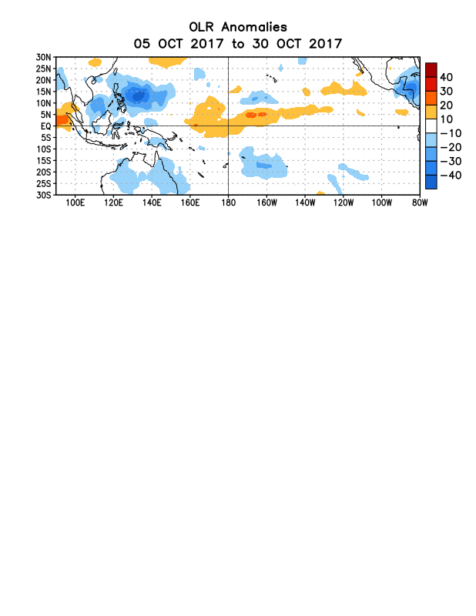
Figure 5. Average outgoing longwave radiation (OLR) anomalies (W/m²) for the period 5– 30 October 2017. OLR anomalies are computed as departures from the 1981-2010 base period pentad means.

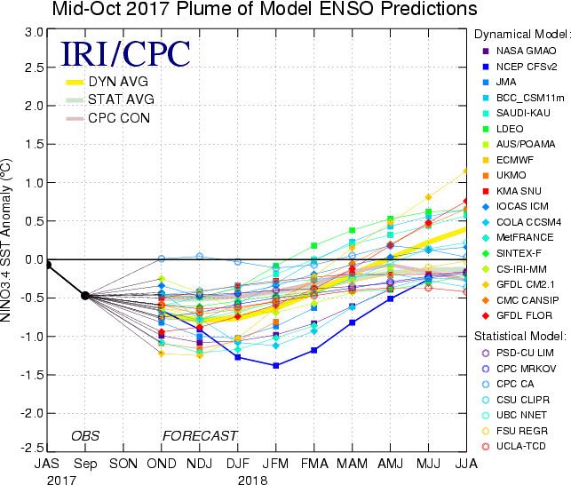

Figure 6. Forecasts of sea surface temperature (SST) anomalies for the Niño 3.4 region (5°N-5°S, 120°W-170°W). Figure updated 17 October 2017.
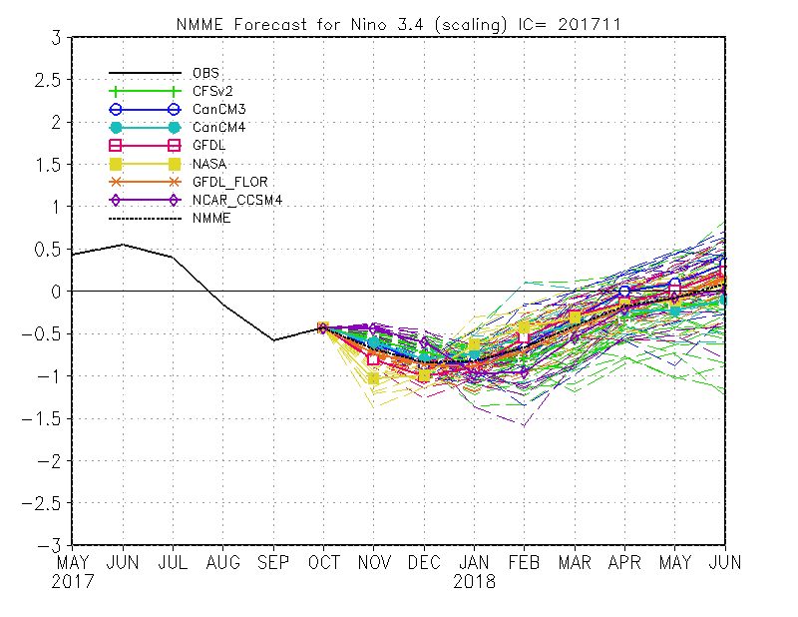
Figure 7. Forecasts of sea surface temperature (SST) anomalies for the Niño 3.4 region (5°N-5°S, 120°W-170°W) from the North American Multi-Model Ensemble. Figure updated 6 November 2017.

