EL NIÑO/SOUTHERN OSCILLATION (ENSO) DIAGNOSTIC DISCUSSION

issued by

CLIMATE PREDICTION CENTER/NCEP/NWS

and the International Research Institute for Climate and Society

14 November 2019

ENSO Alert System Status: Not Active

Synopsis: ENSO-neutral is favored during the Northern Hemisphere winter 2019-20 (~70% chance), continuing through spring 2020 (60 to 65% chance).

Near-to-above average sea surface temperatures (SSTs) were observed in the east-central tropical Pacific Ocean during October (Fig. 1). In the most recent week, the SST indices in the westernmost Niño-4 and Niño-3.4 regions were +0.7°C and +0.5°C, respectively, while farther east in the Niño-3 and Niño-1+2 regions they were near-to-below average (+0.3°C and -0.6°C respectively; Fig. 2). The subsurface temperature anomalies (averaged across 180°-100°W) were above average during the month (Fig. 3) as a downwelling oceanic Kelvin wave that began in September continued progressing eastward into the eastern Pacific (Fig. 4). Low-level winds were near average during October, while easterly upper-level wind anomalies were observed over the eastern Pacific. Finally, tropical convection was suppressed near the Date Line and also over Indonesia, while somewhat enhanced convection prevailed over the western Pacific, northeast of Papua New Guinea (Fig. 5). Overall, despite the recent anomalous warming across the east-central equatorial Pacific, the overall oceanic and atmospheric system reflected ENSO-neutral.
The majority of models in the IRI/CPC plume (Fig. 6) continue to favor ENSO-neutral (Niño-3.4 index between -0.5°C and +0.5°C) through the Northern Hemisphere spring. Many dynamical forecast models, including the NCEP CFSv2, suggest Niño-3.4 SST index values will remain near +0.5°C during November before decreasing toward zero. Forecasters believe this recent warmth reflects sub-seasonal variability and is not indicative of an evolution toward El Niño. The chances for El Niño are predicted to be near 25% during the winter and spring. In summary, ENSO-neutral is favored during the Northern Hemisphere winter 2019-20 (~70% chance), continuing through spring 2020 (60 to 65% chance; click CPC/IRI consensus forecast for the chance of each outcome for each 3-month period).
This discussion is a consolidated effort of the National Oceanic and Atmospheric Administration (NOAA), NOAA’s National Weather Service, and their funded institutions. Oceanic and atmospheric conditions are updated weekly on the Climate Prediction Center web site (El Niño/La Niña Current Conditions and Expert Discussions). Forecasts are also updated monthly in the Forecast Forum of CPC's Climate Diagnostics Bulletin. Additional perspectives and analysis are also available in an ENSO blog. The next ENSO Diagnostics Discussion is scheduled for 12 December 2019. To receive an e-mail notification when the monthly ENSO Diagnostic Discussions are released, please send an e-mail message to: ncep.list.enso-update@noaa.gov.

Climate Prediction Center
National Centers for Environmental Prediction
NOAA/National Weather Service
College Park, MD 20740

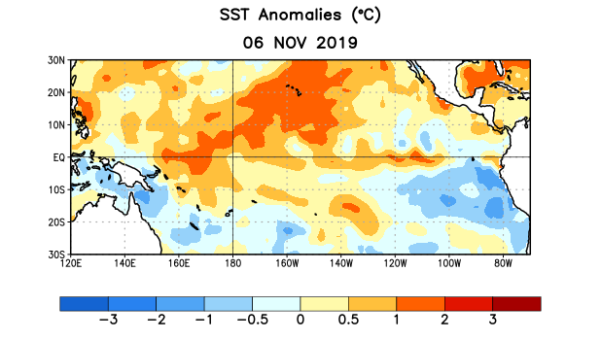
Figure 1. Average sea surface temperature (SST) anomalies (°C) for the week centered on 6 November 2019. Anomalies are computed with respect to the 1981-2010 base period weekly means.

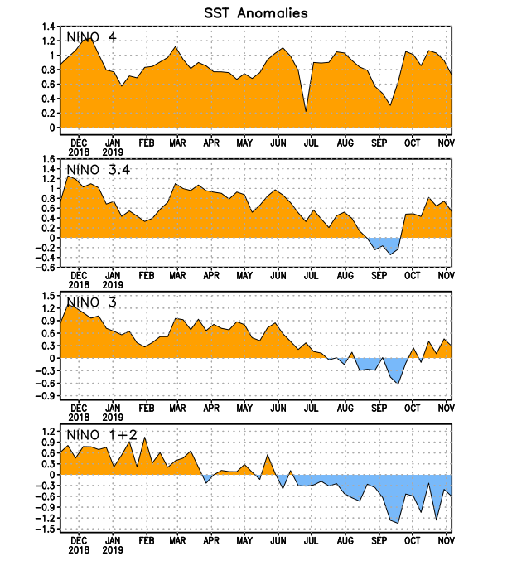
Figure 2. Time series of area-averaged sea surface temperature (SST) anomalies (°C) in the Niño regions [Niño-1+2 (0°-10°S, 90°W-80°W), Niño-3 (5°N-5°S, 150°W-90°W), Niño-3.4 (5°N-5°S, 170°W-120°W), Niño-4 (5ºN-5ºS , 150ºW-160ºE)]. SST anomalies are departures from the 1981-2010 base period weekly means.
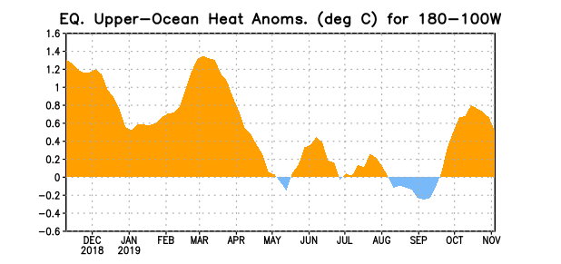
Figure 3. Area-averaged upper-ocean heat content anomaly (°C) in the equatorial Pacific (5°N-5°S, 180º-100ºW). The heat content anomaly is computed as the departure from the 1981-2010 base period pentad means.

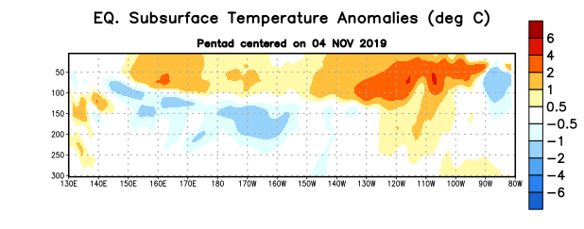
Figure 4. Depth-longitude section of equatorial Pacific upper-ocean (0-300m) temperature anomalies (°C) centered on the pentad of 4 November 2019. Anomalies are departures from the 1981-2010 base period pentad means.

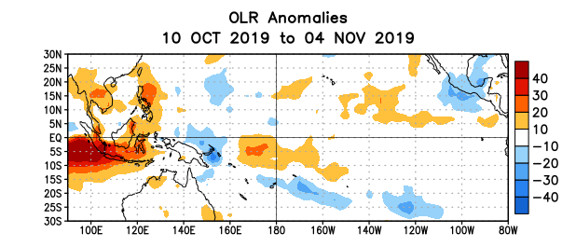
Figure 5. Average outgoing longwave radiation (OLR) anomalies (W/m²) for the period 10 October – 4 November 2019. OLR anomalies are computed as departures from the 1981-2010 base period pentad means.

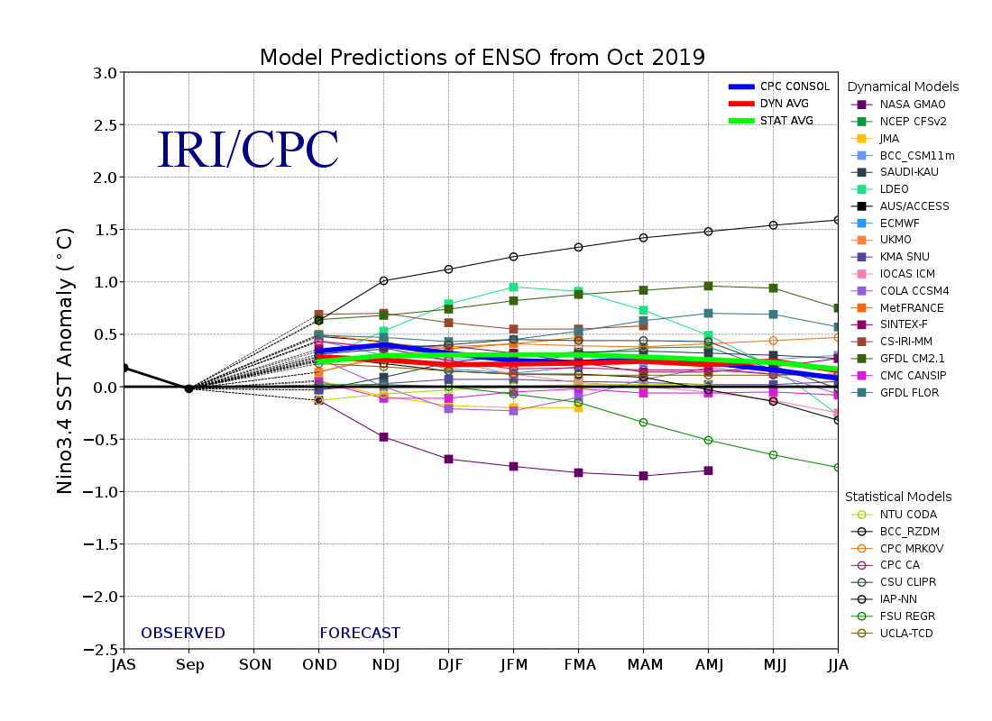
Figure 6. Forecasts of sea surface temperature (SST) anomalies for the Niño 3.4 region (5°N-5°S, 120°W-170°W). Figure updated 18 October 2019.

