EL NIÑO/SOUTHERN OSCILLATION (ENSO) DIAGNOSTIC DISCUSSION

issued by

CLIMATE PREDICTION CENTER/NCEP/NWS

and the International Research Institute for Climate and Society

11 November 2021

ENSO Alert System Status: La Niña Advisory

Synopsis: La Niña is likely to continue through the Northern Hemisphere winter 2021-22 (~90% chance) and into spring 2022 (~50% chance during March-May).

La Niña strengthened in the last month, with below-average sea surface temperatures (SSTs) evident across most of the equatorial Pacific (Fig. 1). In the last week, all of the Niño index values were between -0.7ºC and -1.0ºC, with the coolest anomalies in the Niño-3.4 region (Fig. 2). Below-average subsurface temperatures (averaged from 180-100ºW) were roughly the same amplitude at this time last month (Fig. 3), and reflected the prevalence of below-average temperatures in the eastern Pacific Ocean (Fig. 4). Low-level easterly and upper-level westerly wind anomalies were again observed over parts of the equatorial Pacific, although weaker than last month. Tropical convection was suppressed near and west of the Date Line and was slightly enhanced over Indonesia (Fig. 5). The Southern Oscillation Index and Equatorial Southern Oscillation Index remained positive. Overall, the coupled ocean-atmosphere system was consistent with La Niña.
The IRI/CPC plume average of forecasts for the Niño-3.4 SST index favors La Niña to continue through January-March 2022 season (Fig. 6). The forecaster consensus anticipates La Niña to persist longer, potentially returning to ENSO-neutral during April-June 2022. The Niño-3.4 index has a 66% chance of reaching a value less than -1.0ºC during November 2021 – January 2022, but only a 14% chance of being below -1.5ºC. Thus, at its peak, a moderate-strength La Niña is favored. In summary, La Niña is likely to continue through the Northern Hemisphere winter 2021-22 (~90% chance) and into spring 2022 (~50% chance during March-May; click CPC/IRI consensus forecast for the chances in each 3-month period).
La Niña is anticipated to affect temperature and precipitation across the United States during the upcoming months (the 3-month seasonal temperature and precipitation outlooks will be updated on Thurs. Nov. 18th).
This discussion is a consolidated effort of the National Oceanic and Atmospheric Administration (NOAA), NOAA’s National Weather Service, and their funded institutions. Oceanic and atmospheric conditions are updated weekly on the Climate Prediction Center web site (El Niño/La Niña Current Conditions and Expert Discussions). Additional perspectives and analysis are also available in an ENSO blog. A probabilistic strength forecast is available here. The next ENSO Diagnostics Discussion is scheduled for 9 December 2021. To receive an e-mail notification when the monthly ENSO Diagnostic Discussions are released, please send an e-mail message to: ncep.list.enso-update@noaa.gov.

Climate Prediction Center
National Centers for Environmental Prediction
NOAA/National Weather Service
College Park, MD 20740

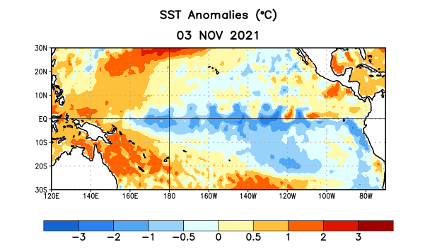
Figure 1. Average sea surface temperature (SST) anomalies (°C) for the week centered on 3 November 2021. Anomalies are computed with respect to the 1991-2020 base period weekly means.

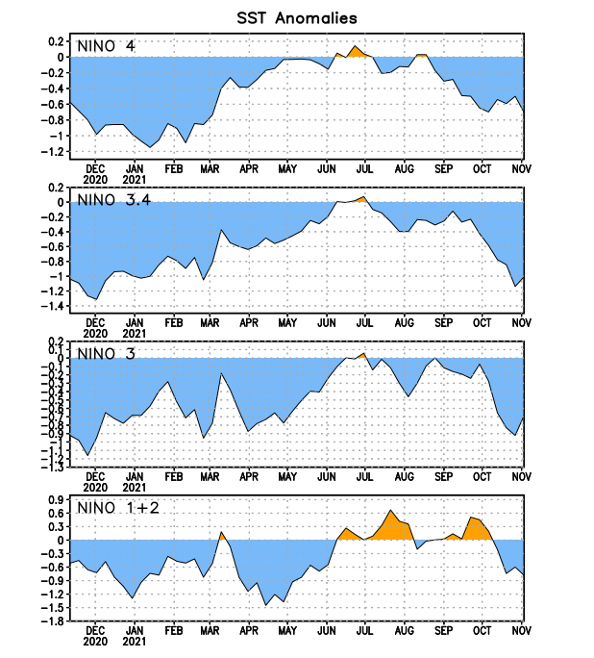
Figure 2. Time series of area-averaged sea surface temperature (SST) anomalies (°C) in the Niño regions [Niño-1+2 (0°-10°S, 90°W-80°W), Niño-3 (5°N-5°S, 150°W-90°W), Niño-3.4 (5°N-5°S, 170°W-120°W), Niño-4 (5ºN-5ºS, 150ºW-160ºE)]. SST anomalies are departures from the 1991-2020 base period weekly means.
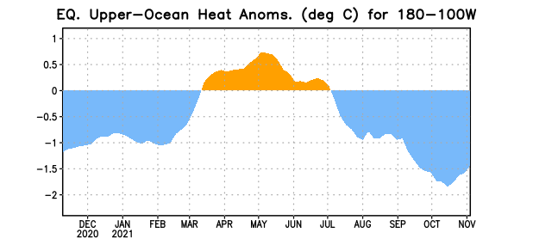
Figure 3. Area-averaged upper-ocean heat content anomaly (°C) in the equatorial Pacific (5°N-5°S, 180º-100ºW). The heat content anomaly is computed as the departure from the 1991-2020 base period pentad means.

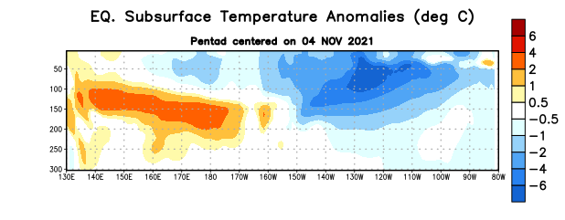

Figure 4. Depth-longitude section of equatorial Pacific upper-ocean (0-300m) temperature anomalies (°C) centered on the pentad of 4 November 2021. Anomalies are departures from the 1991-2020 base period pentad means.

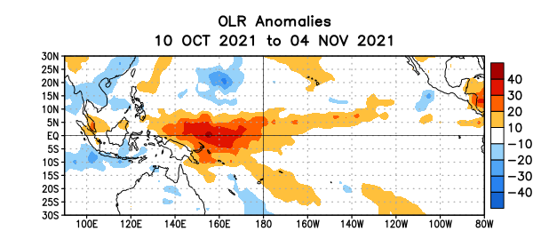
Figure 5. Average outgoing longwave radiation (OLR) anomalies (W/m²) for the period 10 October – 4 November 2021. OLR anomalies are computed as departures from the 1991-2020 base period pentad means.

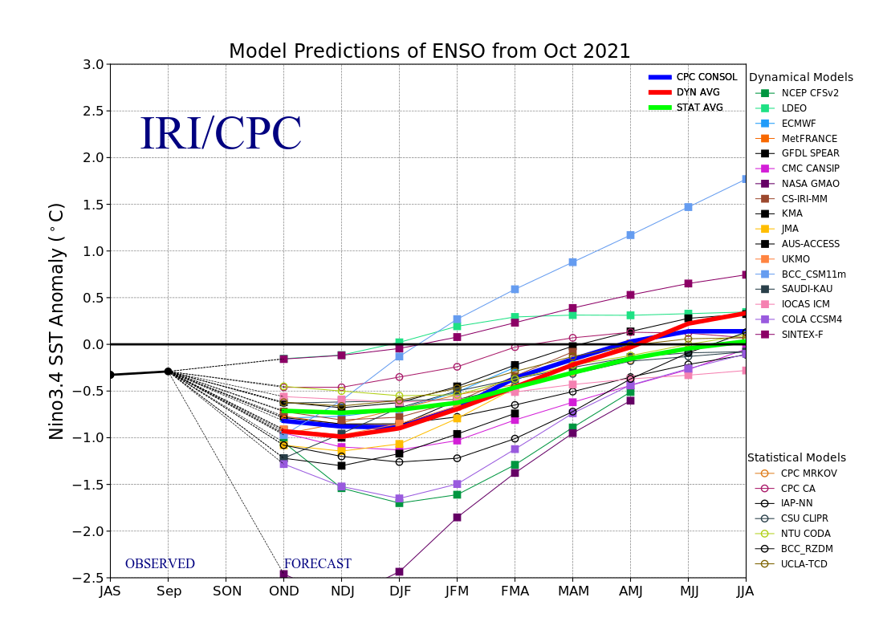
Figure 6. Forecasts of sea surface temperature (SST) anomalies for the Niño 3.4 region (5°N-5°S, 120°W-170°W). Figure updated 19 October 2021.

