EL NIÑO/SOUTHERN OSCILLATION (ENSO) DIAGNOSTIC DISCUSSION

issued by

CLIMATE PREDICTION CENTER/NCEP/NWS

10 November 2022

ENSO Alert System Status: La Niña Advisory

Synopsis: There is a 76% chance of La Niña during the Northern Hemisphere winter (December-February) 2022-23, with a transition to ENSO-neutral favored in February-April 2023 (57% chance).

Below-average sea surface temperatures (SSTs) strengthened in the east-central Pacific Ocean during the past month (Fig. 1). All of the latest weekly Niño index values were near -1.0ºC, with the exception of Niño-1+2 which was at -1.8ºC (Fig. 2). Since late July 2022, negative subsurface temperature anomalies have been quite persistent (Fig. 3), reflecting the stationary pattern of below-average temperatures across the eastern Pacific Ocean (Fig. 4). For the monthly average, low-level easterly wind anomalies and upper-level westerly wind anomalies were evident across most of the equatorial Pacific. However, in the last week, the low-level trade winds weakened in association with sub-seasonal tropical variability. Convection remained suppressed over the western and central tropical Pacific and enhanced over Indonesia (Fig. 5). Overall, the coupled ocean-atmosphere system continued to reflect La Niña.
The most recent IRI plume forecast of the Niño-3.4 SST index indicates La Niña will persist into the Northern Hemisphere winter 2022-23, and then transition to ENSO-neutral in February-April 2023 (Fig. 6). The forecaster consensus, which also considers the North American Multi-Model Ensemble (NMME), is in agreement with the timing of this transition. The recent weakening of the trade winds suggest below-average SSTs may be near their minimum, though considerable uncertainty remains over how gradually the anomalies will decay. In summary, there is a 76% chance of La Niña during the Northern Hemisphere winter (December-February) 2022-23, with a transition to ENSO-neutral favored in February-April 2023 (57% chance; Fig. 7).
This discussion is a consolidated effort of the National Oceanic and Atmospheric Administration (NOAA), NOAA’s National Weather Service, and their funded institutions. Oceanic and atmospheric conditions are updated weekly on the Climate Prediction Center web site (El Niño/La Niña Current Conditions and Expert Discussions). Additional perspectives and analysis are also available in an ENSO blog. A probabilistic strength forecast is available here. The next ENSO Diagnostics Discussion is scheduled for 8 December 2022. To receive an e-mail notification when the monthly ENSO Diagnostic Discussions are released, please send an e-mail message to: ncep.list.enso-update@noaa.gov.

Climate Prediction Center
National Centers for Environmental Prediction
NOAA/National Weather Service
College Park, MD 20740

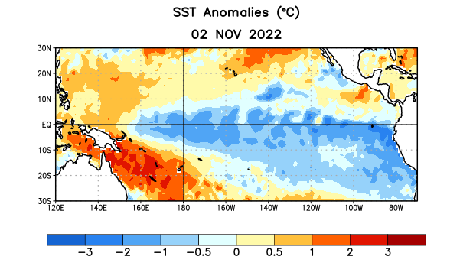
Figure 1. Average sea surface temperature (SST) anomalies (°C) for the week centered on 2 November 2022. Anomalies are computed with respect to the 1991-2020 base period weekly means.

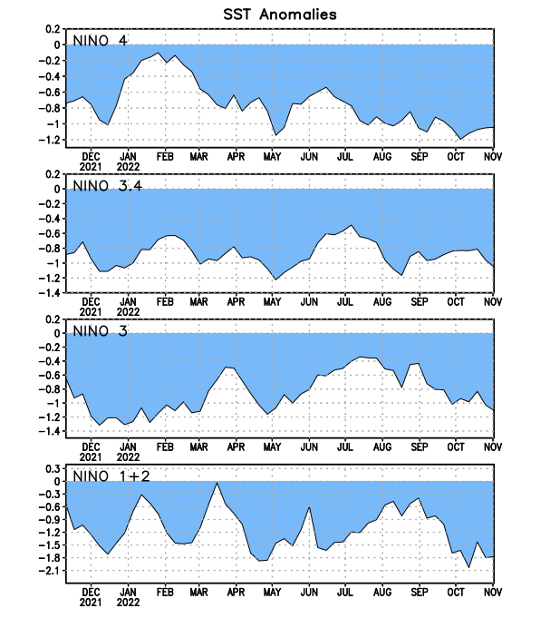
Figure 2. Time series of area-averaged sea surface temperature (SST) anomalies (°C) in the Niño regions [Niño-1+2 (0°-10°S, 90°W-80°W), Niño-3 (5°N-5°S, 150°W-90°W), Niño-3.4 (5°N-5°S, 170°W-120°W), Niño-4 (5ºN-5ºS, 150ºW-160ºE)]. SST anomalies are departures from the 1991-2020 base period weekly means.

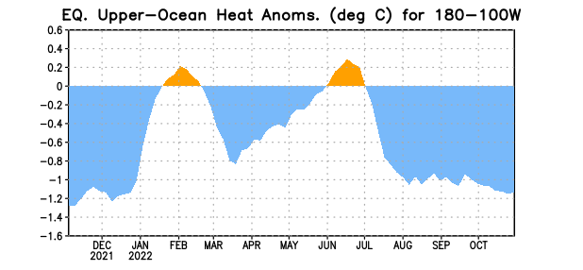

Figure 3. Area-averaged upper-ocean heat content anomaly (°C) in the equatorial Pacific (5°N-5°S, 180º-100ºW). The heat content anomaly is computed as the departure from the 1991-2020 base period pentad means.

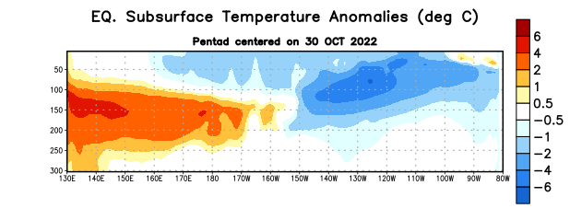
Figure 4. Depth-longitude section of equatorial Pacific upper-ocean (0-300m) temperature anomalies (°C) centered on the pentad of 30 October 2022. Anomalies are departures from the 1991-2020 base period pentad means.

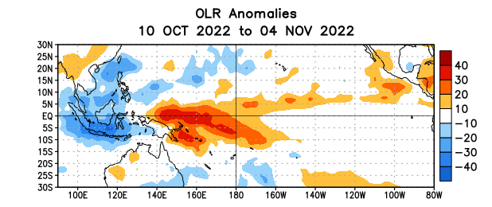

Figure 5. Average outgoing longwave radiation (OLR) anomalies (W/m²) for the period 10 October – 4 November 2022. OLR anomalies are computed as departures from the 1991-2020 base period pentad means.

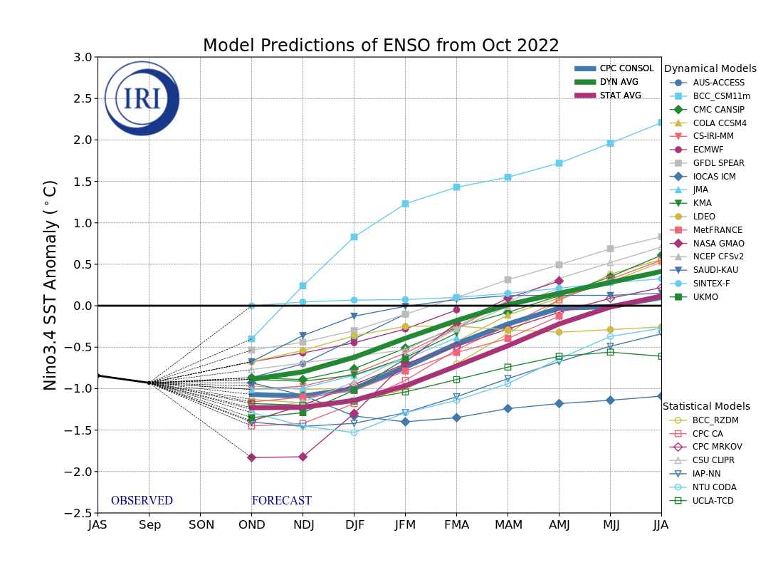
Figure 6. Forecasts of sea surface temperature (SST) anomalies for the Niño 3.4 region (5°N-5°S, 120°W-170°W). Figure updated 19 October 2022 by the International Research Institute (IRI) for Climate and Society.
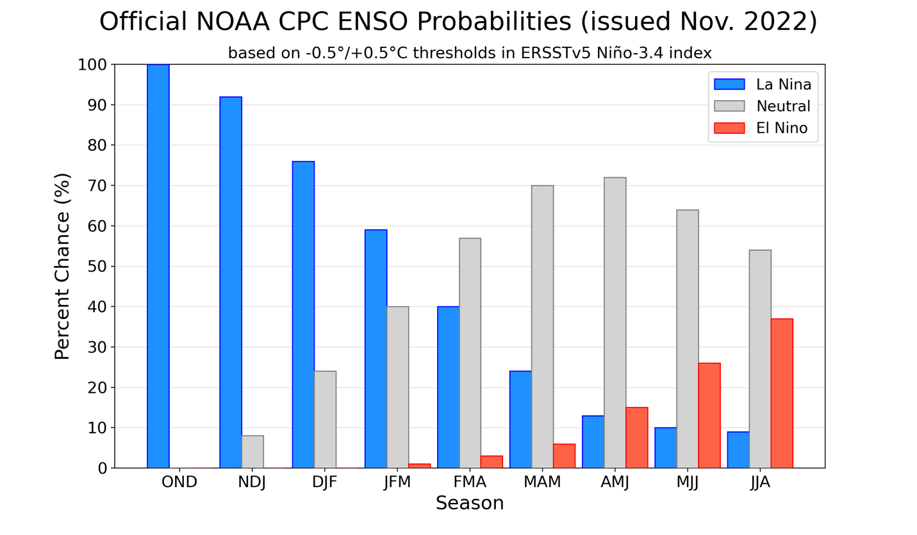
Figure 7. Official ENSO probabilities for the Niño 3.4 sea surface temperature index (5°N-5°S,
120°W-170°W). Figure updated 10 November 2022.

