EL NIÑO/SOUTHERN OSCILLATION (ENSO) DIAGNOSTIC DISCUSSION

issued by

CLIMATE PREDICTION CENTER/NCEP/NWS

9 November 2023

ENSO Alert System Status: El Niño Advisory

Synopsis: El Niño is anticipated to continue through the Northern Hemisphere spring (with a 62% chance during April-June 2024).

Above-average sea surface temperatures (SST) across the equatorial Pacific Ocean (Fig. 1) were indicative of a strong El Niño, with anomalies increasing in the central and east-central Pacific in the past month. The latest weekly Niño index values were +1.4ºC in Niño-4, +1.8ºC in Niño-3.4, +2.1ºC in Niño-3, and +2.2ºC in Niño-1+2 (Fig. 2). Area-averaged subsurface temperatures anomalies increased slightly (Fig. 3) associated with the initiation of a downwelling oceanic Kelvin wave, which strengthened above-average subsurface temperatures in the central equatorial Pacific (Fig. 4). Low-level wind anomalies were westerly in the east-central Pacific, while upper-level wind anomalies were easterly in the western and central Pacific. Convection/rainfall was enhanced around the International Date Line, extending into the eastern Pacific. Suppressed convection/rainfall strengthened around Indonesia (Fig. 5). The equatorial Southern Oscillation Index (SOI) and the station-based SOI remained negative. Collectively, the coupled ocean-atmosphere system reflected a growing El Niño.
The most recent IRI plume favors El Niño to continue through the Northern Hemisphere spring 2024 (Fig. 6). Based on latest forecasts, there is a greater than 55% chance of at least a “strong” El Niño (≥ 1.5°C in Niño-3.4 for a seasonal average) persisting through January-March 2024. There is a 35% chance of this event becoming “historically strong” (≥ 2.0°C) for the November-January season. Stronger El Niño events increase the likelihood of El Niño-related climate anomalies, but do not necessarily equate to strong impacts (see CPC seasonal outlooks for probabilities of temperature and precipitation). In summary, El Niño is anticipated to continue through the Northern Hemisphere spring (with a 62% chance during April-June 2024; Fig. 7).
This discussion is a consolidated effort of the National Oceanic and Atmospheric Administration (NOAA), NOAA’s National Weather Service, and their funded institutions. Oceanic and atmospheric conditions are updated weekly on the Climate Prediction Center website (El Niño/La Niña Current Conditions and Expert Discussions). Additional perspectives and analyses are also available in an ENSO blog. A probabilistic strength forecast is available here. The next ENSO Diagnostics Discussion is scheduled for 14 December 2023. To receive an e-mail notification when the monthly ENSO Diagnostic Discussions are released, please send an e-mail message to: ncep.list.enso-update@noaa.gov.

Climate Prediction Center
National Centers for Environmental Prediction
NOAA/National Weather Service
College Park, MD 20740
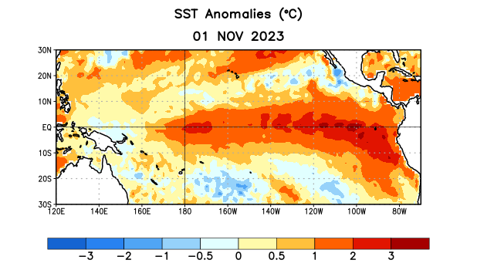
Figure 1. Average sea surface temperature (SST) anomalies (°C) for the week centered on 1 November 2023. Anomalies are computed with respect to the 1991-2020 base period weekly means.

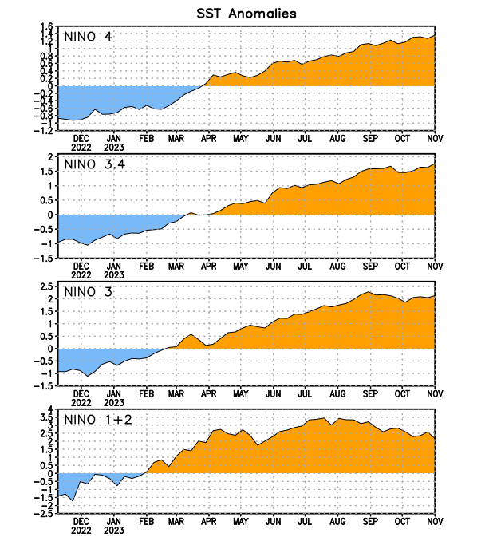
Figure 2. Time series of area-averaged sea surface temperature (SST) anomalies (°C) in the Niño regions [Niño-1+2 (0°-10°S, 90°W-80°W), Niño-3 (5°N-5°S, 150°W-90°W), Niño-3.4 (5°N-5°S, 170°W-120°W), Niño-4 (5ºN-5ºS, 150ºW-160ºE)]. SST anomalies are departures from the 1991-2020 base period weekly means.

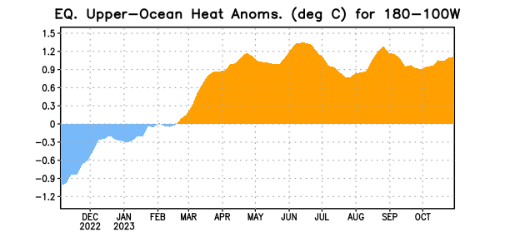

Figure 3. Area-averaged upper-ocean heat content anomaly (°C) in the equatorial Pacific (5°N-5°S, 180º-100ºW). The heat content anomaly is computed as the departure from the 1991-2020 base period pentad means.

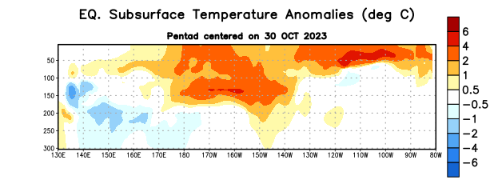
Figure 4. Depth-longitude section of equatorial Pacific upper-ocean (0-300m) temperature anomalies (°C) centered on the pentad of 30 October 2023. Anomalies are departures from the 1991-2020 base period pentad means.

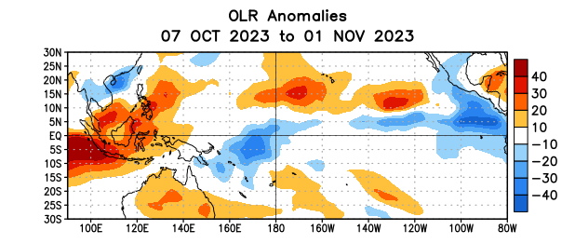

Figure 5. Average outgoing longwave radiation (OLR) anomalies (W/m²) for the period 7 October – 1 November 2023. OLR anomalies are computed as departures from the 1991-2020 base period pentad means.

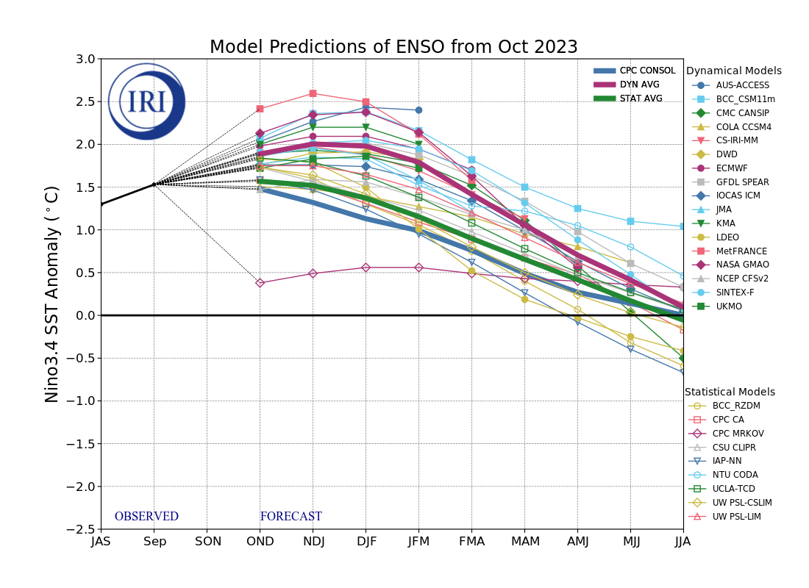
Figure 6. Forecasts of sea surface temperature (SST) anomalies for the Niño 3.4 region (5°N-5°S, 120°W-170°W). Figure updated 19 October 2023 by the International Research Institute (IRI) for Climate and Society.
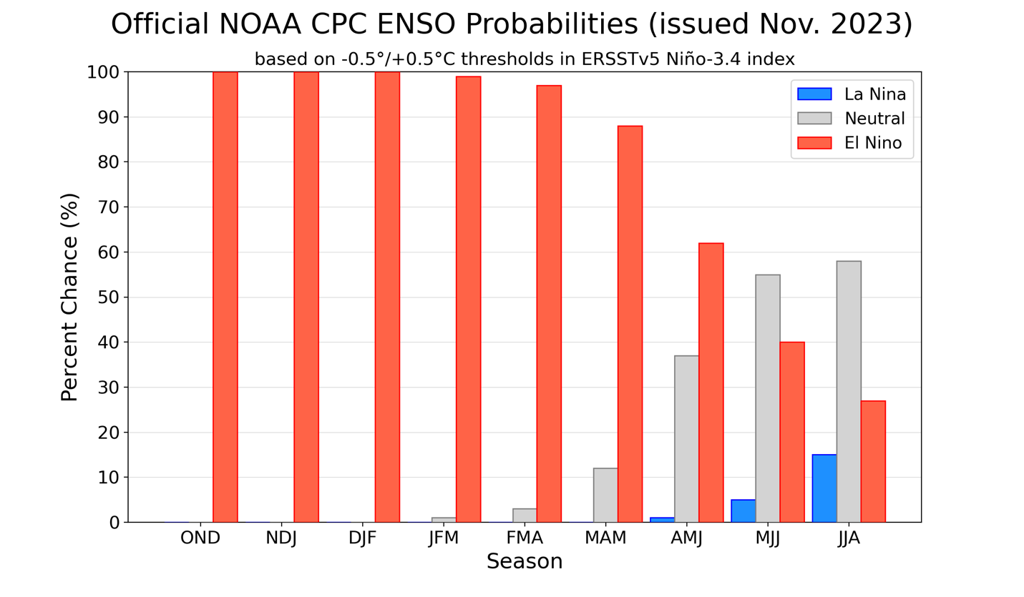
Figure 7. Official ENSO probabilities for the Niño 3.4 sea surface temperature index (5°N-5°S, 120°W-170°W). Figure updated 9 November 2023.

