EL NIÑO/SOUTHERN OSCILLATION (ENSO) DIAGNOSTIC DISCUSSION
issued by
CLIMATE PREDICTION CENTER/NCEP/NWS
11 October 2007

Synopsis: La Niña will likely continue into early 2008.
La Niña conditions strengthened during September 2007, as negative SST anomalies along the equator expanded westward and now extend from 170ºE to the South American coast (Fig. 1). The latest weekly analysis (Fig. 2) shows the largest SST departures (-2ºC to -3ºC) between 120ºW and the coast, with departures of -0.5°C to -1°C centered near the date line. The magnitude of the negative SST anomalies increased in all of the Niño regions, with the Niño-3.4 index dropping to -1.2°C and the Niño-4 index dropping to -0.5°C by the end of the month (Fig. 3). The upper-ocean heat content (average temperatures in the upper 300 m of the ocean) in the central and east-central equatorial Pacific remained below average during September (Fig. 4), with temperatures ranging from 2°C to 4°C below average at thermocline depth (Fig. 5). Consistent with these conditions, the low-level easterly winds and upper-level westerly winds remained stronger than average across the central equatorial Pacific, convection remained suppressed throughout the central and eastern equatorial Pacific, and enhanced convection again covered parts of Indonesia and the far western Pacific. Collectively, these oceanic and atmospheric conditions reflect a strengthening La Niña.
The recent SST forecasts (dynamical and statistical models) for the Niño 3.4 region indicate a weak-to-moderate La Niña continuing into early 2008 (Fig. 6). Current atmospheric and oceanic conditions and recent trends indicate that La Niña will continue and may strengthen during the next 3 months.
Expected La Niña impacts during October – December include a continuation of above-average precipitation over Indonesia and below-average precipitation over the central equatorial Pacific. For the contiguous United States, potential impacts include above average precipitation in the Pacific Northwest, and continued below average precipitation in the Southwest.
This discussion is a consolidated effort of the National Atmospheric and Oceanic Administration (NOAA), NOAA’s National Weather Service, and their funded institutions. Oceanic and atmospheric conditions are updated weekly on the Climate Prediction Center web site (El Niño/La Niña Current Conditions and Expert Discussions). Forecasts for the evolution of El Niño/La Niña are updated monthly in the Forecast Forum section of CPC's Climate Diagnostics Bulletin. The next ENSO Diagnostics Discussion is scheduled for 8 November 2007. To receive an e-mail notification when the monthly ENSO Diagnostic Discussions are released, please send an e-mail message to: ncep.list.enso-update@noaa.gov.
Climate Prediction Center
National Centers for Environmental Prediction
NOAA/National Weather Service
Camp Springs, MD 20746-4304

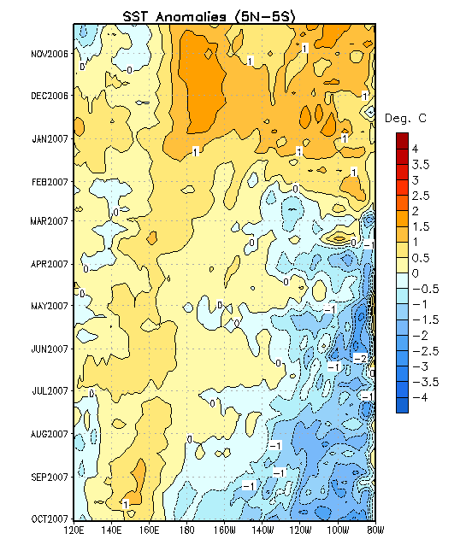
Figure 1. Time- longitude section of SST anomalies averaged for the latitude band 5ºN-5ºS. Time increases downward and longitude ranges from Indonesia on the left to South America on the right. SST anomalies are departures are from the 1971-2000 base period means (Xue et al. 2003, J. Climate, 16, 1601-1612).

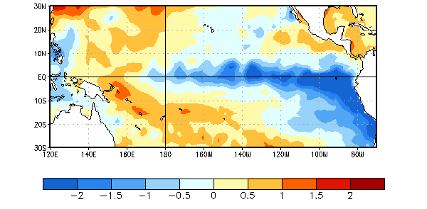
Figure 2. Sea surface temperature (SST) anomalies (°C) during the period 30 September- 6 October 2007. SST anomalies are computed with respect to the 1971-2000 base period weekly means (Xue et al. 2003, J. Climate, 16, 1601-1612).
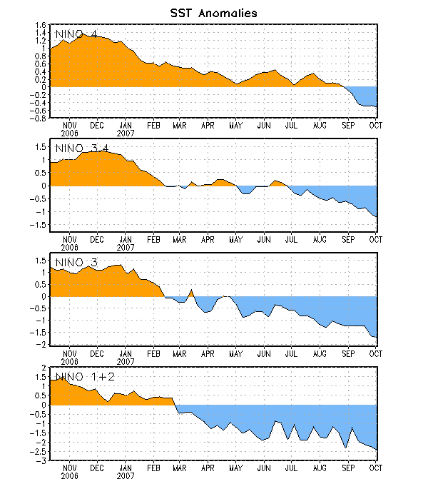
Figure 3. Time series of area-averaged sea surface temperature (SST) anomalies (°C) in the Niño regions [Niño-1+2 (0°-10°S, 90°-80°W), Niño 3 (5°N-5°S, 150°W-90°W), Niño-3.4 (5°N-5°S, 170°W-120°W), Niño-4 (150ºW-160ºE and 5ºN-5ºS)]. SST anomalies are departures are from the 1971-2000 base period means (Xue et al. 2003, J. Climate, 16, 1601-1612).

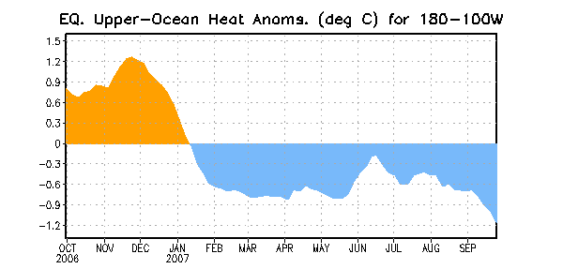

Figure 4. Area-averaged upper-ocean heat content anomalies in the equatorial Pacific (5°N-5°S, 180º-100ºW). Heat content anomalies are computed as departures from the 1982-2004 base period means.

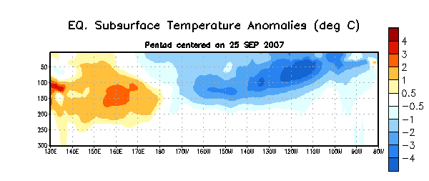
Figure 5. Depth-longitude section of equatorial Pacific upper-ocean (0-300m) temperature anomalies for 23-27 September, averaged between 5°N-5°S. Temperature anomalies are departures from the 1982-2004 base period means.

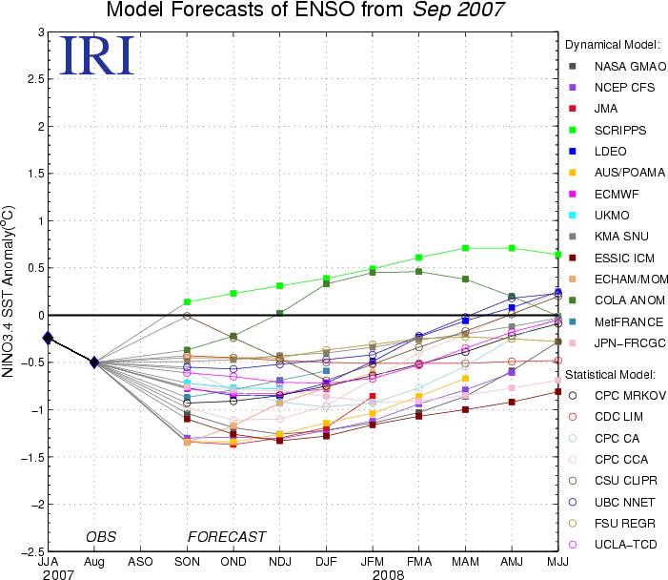

Figure 6. Forecasts of sea surface temperature (SST) anomalies for the Niño 3.4 region (5°N-5°S, 120°W-170°W). Figure courtesy of the International Research Institute (IRI) for Climate and Society. Figure updated 19 September 2007.

