EL NIÑO/SOUTHERN OSCILLATION (ENSO) DIAGNOSTIC DISCUSSION
issued by
CLIMATE PREDICTION CENTER/NCEP/NWS
8 October 2009

ENSO Alert System Status: El Niño Advisory

Synopsis: El Niño is expected to strengthen and last through the Northern Hemisphere winter 2009-2010.
A weak El Niño continued during September 2009, as sea surface temperature (SST) anomalies remained nearly unchanged across much of the equatorial Pacific Ocean (Figs. 1 & 2). Since the transition to El Niño conditions during June, the weekly values of the Niño-3.4 index have remained between +0.7°C and +0.9°C (Fig. 2). Subsurface oceanic heat content (average temperatures in the upper 300m of the ocean, Fig. 3) anomalies continued to reflect a deep layer of anomalous warmth between the ocean surface and the thermocline, particularly in the central and east-central Pacific (Fig. 4). The pattern of tropical convection also remained consistent with El Niño, with enhanced convection over the west-central Pacific and suppressed convection over Indonesia. In addition, two westerly wind bursts were observed over the western equatorial Pacific, the first occurring early in the month and the second occurring near the end of the month (Fig. 5). These oceanic and atmospheric anomalies reflect an ongoing weak El Niño.
A majority of the model forecasts for the Niño-3.4 SST index (Fig. 6) suggest that El Niño will reach at least moderate strength during the Northern Hemisphere fall (3-month Niño-3.4 SST index of +1.0°C or greater). Many model forecasts even suggest a strong El Niño (3-month Niño-3.4 SST index in excess of +1.5°C) during the fall and winter, but in recent months some models, including the NCEP CFS, have over-predicted the degree of warming observed so far in the Niño-3.4 region (Fig. 7). Based on the model forecasts, the seasonality of El Niño, and the continuation of westerly wind bursts, El Niño is expected to strengthen and most likely peak at moderate strength.
Expected El Niño impacts during October-December 2009 include enhanced precipitation over the central tropical Pacific Ocean and a continuation of drier-than-average conditions over Indonesia. For the contiguous United States, potential impacts include above-average precipitation along the Gulf Coast, from Texas to Florida, and below-average precipitation for the Pacific Northwest. Other potential impacts include a continued suppression of Atlantic hurricane activity, along with above-average temperatures and below-average snowfall for the Northern Plains.
This discussion is a consolidated effort of the National Oceanic and Atmospheric Administration (NOAA), NOAA’s National Weather Service, and their funded institutions. Oceanic and atmospheric conditions are updated weekly on the Climate Prediction Center web site (El Niño/La Niña Current Conditions and Expert Discussions). Forecasts for the evolution of El Niño/La Niña are updated monthly in the Forecast Forum section of CPC's Climate Diagnostics Bulletin. The next ENSO Diagnostics Discussion is scheduled for 5 November 2009. To receive an e-mail notification when the monthly ENSO Diagnostic Discussions are released, please send an e-mail message to: ncep.list.enso-update@noaa.gov.
Climate Prediction Center
National Centers for Environmental Prediction
NOAA/National Weather Service
Camp Springs, MD 20746-4304

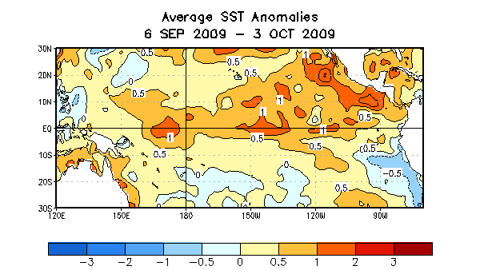

Figure 1. Average sea surface temperature (SST) anomalies (°C) for the four-week period 6 September 2009 - 3 October 2009. Anomalies are computed with respect to the 1971-2000 base period weekly means (Xue et al. 2003, J. Climate, 16, 1601-1612).

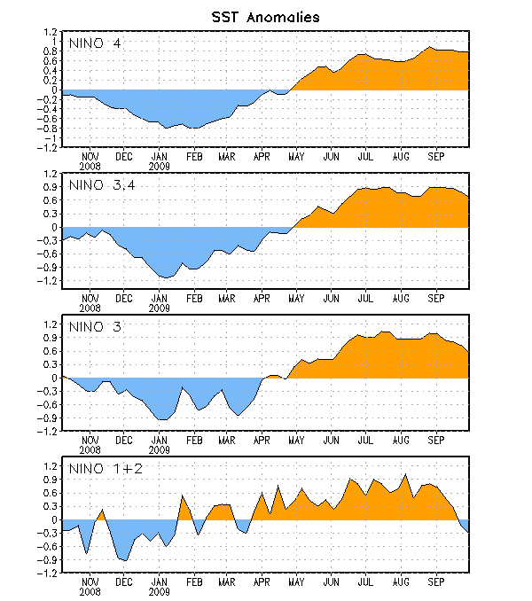
Figure 2. Time series of area-averaged sea surface temperature (SST) anomalies (°C) in the Niño regions [Niño-1+2 (0°-10°S, 90°W-80°W), Niño 3 (5°N-5°S, 150°W-90°W), Niño-3.4 (5°N-5°S, 170°W-120°W), Niño-4 (150ºW-160ºE and 5ºN-5ºS)]. SST anomalies are departures from the 1971-2000 base period weekly means (Xue et al. 2003, J. Climate, 16, 1601-1612).

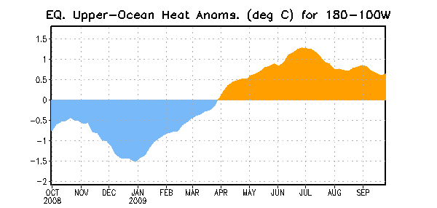
Figure 3. Area-averaged upper-ocean heat content anomalies (°C) in the equatorial Pacific (5°N-5°S, 180º-100ºW). Heat content anomalies are computed as departures from the 1982-2004 base period pentad means.

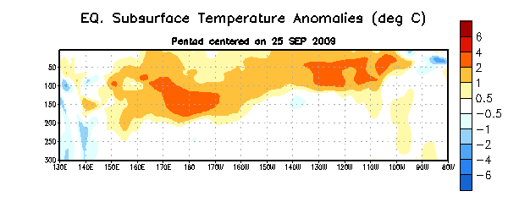
Figure 4. Depth-longitude section of equatorial Pacific upper-ocean (0-300m) temperature anomalies (°C) centered on the week of 25 September 2009. The anomalies are averaged between 5°N-5°S. Anomalies are departures from the 1982-2004 base period pentad means.

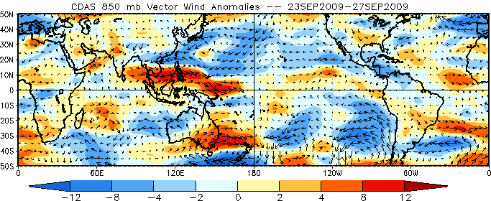
Figure 5. Average low-level (850-hPa) vector wind anomalies (meters per second) for the five day period 23 Sept 2009 - 27 Sept 2009. Red (blue) shading represents westerly (easterly) zonal wind anomalies. Anomalies are computed with respect to the 1979-1995 base period daily means (Kalnay et al, 1996).

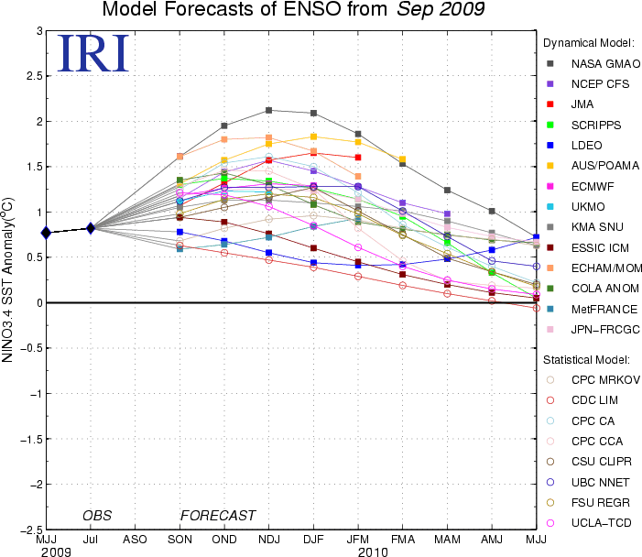

Figure 6. Forecasts of sea surface temperature (SST) anomalies for the Niño 3.4 region (5°N-5°S, 120°W-170°W). Figure courtesy of the International Research Institute (IRI) for Climate and Society. Figure updated 14 September 2009.

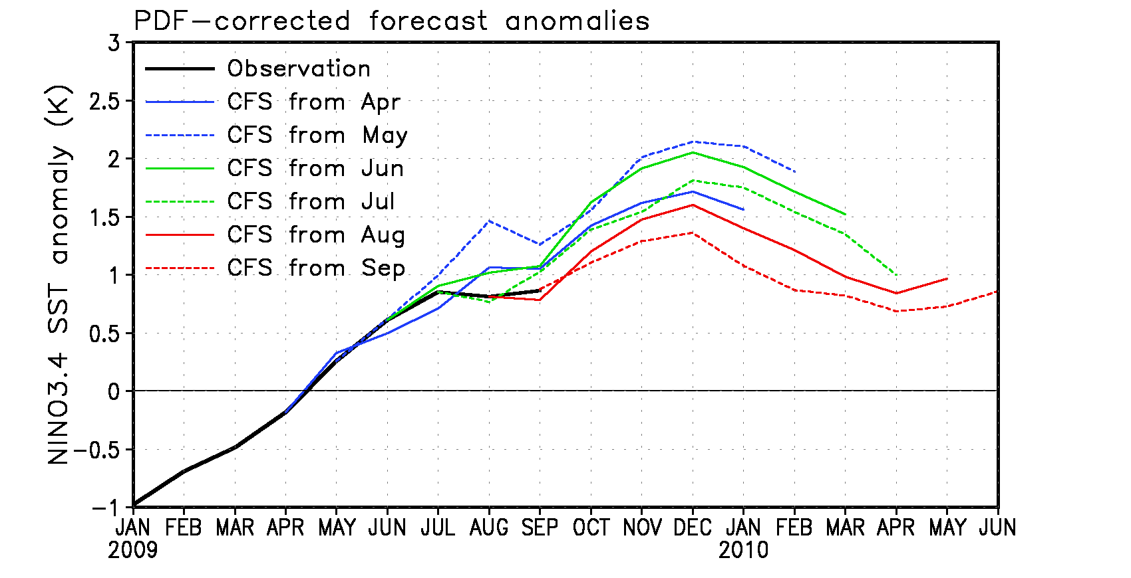
Figure 7. Forecast sea surface temperature (SST) anomalies for the Niño 3.4 region (5°N-5°S, 120°W-170°W) from the NCEP Climate Forecast System (CFS). Forecast anomalies are corrected with a PDF (probability density function) based on 1981-2006 retrospective forecasts. The PDF correction reduces the amplitude of the forecast anomalies. Figure updated 30 September 2009.

