EL NIÑO/SOUTHERN OSCILLATION (ENSO) DIAGNOSTIC DISCUSSION

issued by

CLIMATE PREDICTION CENTER/NCEP/NWS
7 October 2010

ENSO Alert System Status: La Niña Advisory

Synopsis: La Niña is expected to last at least into the Northern Hemisphere spring 2011.
La Niña continued during September 2010 as reflected by the large expanse of below-average sea surface temperatures (SSTs) across most of the equatorial Pacific Ocean (Fig. 1). All weekly Niño SST index values were between –1.3°C and –1.8°C at the end of the month (Fig. 2). In addition, the subsurface heat content (average temperatures in the upper 300m of the ocean, Fig. 3) remained below-average, reflecting a shallower-than-average thermocline in the central and eastern Pacific (Fig. 4). Convection remained enhanced over Indonesia and suppressed over the western and central equatorial Pacific (Fig. 5). This pattern was linked to a continuation of enhanced low-level easterly trade winds and anomalous upper-level westerly winds over the western and central equatorial Pacific. Collectively, these oceanic and atmospheric anomalies reflect the ongoing La Niña.
Consistent with nearly all of the forecast models (Fig. 6), La Niña is expected to last at least into the Northern Hemisphere spring 2011. Just over half of the models, as well as the dynamical and statistical averages, predict La Niña to become a strong episode (defined by a 3-month average Niño-3.4 index of –1.5°C or colder) by the November-January season before beginning to weaken. Even though the rate of anomalous cooling temporarily abated during September, this model outcome is favored due to the historical tendency for La Niña to strengthen as winter approaches.
Likely La Niña impacts during October-December 2010 include suppressed convection over the central tropical Pacific Ocean, and enhanced convection over Indonesia. The transition into the Northern Hemisphere fall means that La Niña will begin to exert an increasing influence on the weather and climate of the United States. Expected U.S. impacts include an enhanced chance of above-average precipitation in the Pacific Northwest, and below-average precipitation across the southern tier of the country. Also, La Niña can contribute to increased Atlantic hurricane activity by decreasing the vertical wind shear over the Caribbean Sea and tropical Atlantic Ocean (see the August 5th update of the NOAA Atlantic Seasonal Hurricane Outlook). Conversely, La Niña is associated with suppressed hurricane activity across the central and eastern tropical North Pacific.
This discussion is a consolidated effort of the National Oceanic and Atmospheric Administration (NOAA), NOAA’s National Weather Service, and their funded institutions. Oceanic and atmospheric conditions are updated weekly on the Climate Prediction Center web site (El Niño/La Niña Current Conditions and Expert Discussions). Forecasts for the evolution of El Niño/La Niña are updated monthly in the Forecast Forum section of CPC's Climate Diagnostics Bulletin. The next ENSO Diagnostics Discussion is scheduled for 4 November 2010. To receive an e-mail notification when the monthly ENSO Diagnostic Discussions are released, please send an e-mail message to: ncep.list.enso-update@noaa.gov.
Climate Prediction Center
National Centers for Environmental Prediction
NOAA/National Weather Service
Camp Springs, MD 20746-4304
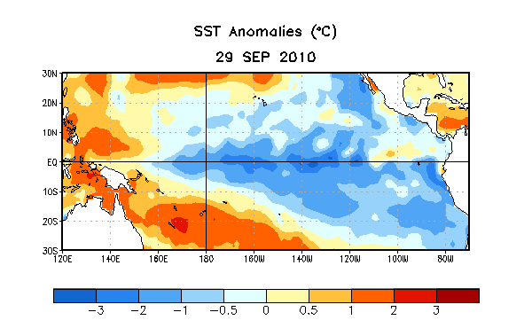
Figure 1. Average sea surface temperature (SST) anomalies (°C) for the week centered on 29 September 2010. Anomalies are computed with respect to the 1971-2000 base period weekly means (Xue et al. 2003, J. Climate, 16, 1601-1612).

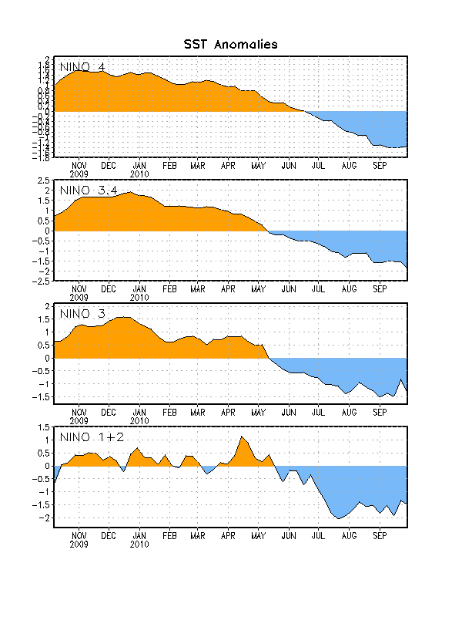
Figure 2. Time series of area-averaged sea surface temperature (SST) anomalies (°C) in the Niño regions [Niño-1+2 (0°-10°S, 90°W-80°W), Niño 3 (5°N-5°S, 150°W-90°W), Niño-3.4 (5°N-5°S, 170°W-120°W), Niño-4 (150ºW-160ºE and 5ºN-5ºS)]. SST anomalies are departures from the 1971-2000 base period weekly means (Xue et al. 2003, J. Climate, 16, 1601-1612).

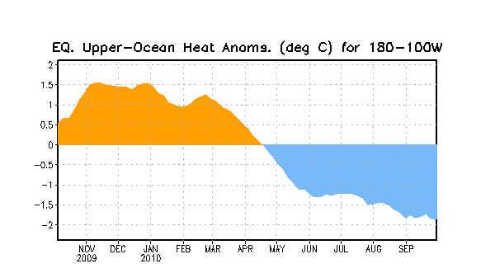
Figure 3. Area-averaged upper-ocean heat content anomalies (°C) in the equatorial Pacific (5°N-5°S, 180º-100ºW). Heat content anomalies are computed as departures from the 1982-2004 base period pentad means.

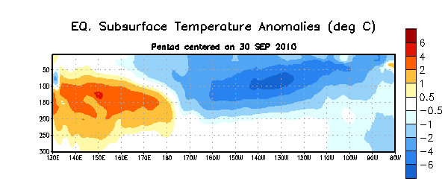
Figure 4. Depth-longitude section of equatorial Pacific upper-ocean (0-300m) temperature anomalies (°C) centered on the week of 30 September 2010. The anomalies are averaged between 5°N-5°S. Anomalies are departures from the 1982-2004 base period pentad means.

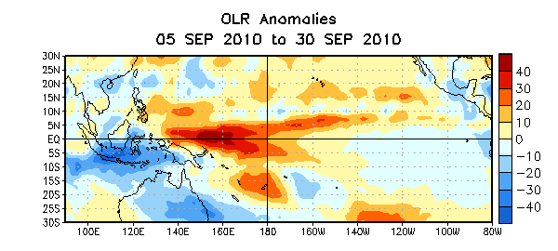
Figure 5. Average outgoing longwave radiation (OLR) anomalies (W/m²) for the four-week period 5 –30 September 2010. OLR anomalies are computed as departures from the 1979-1995 base period pentad means.

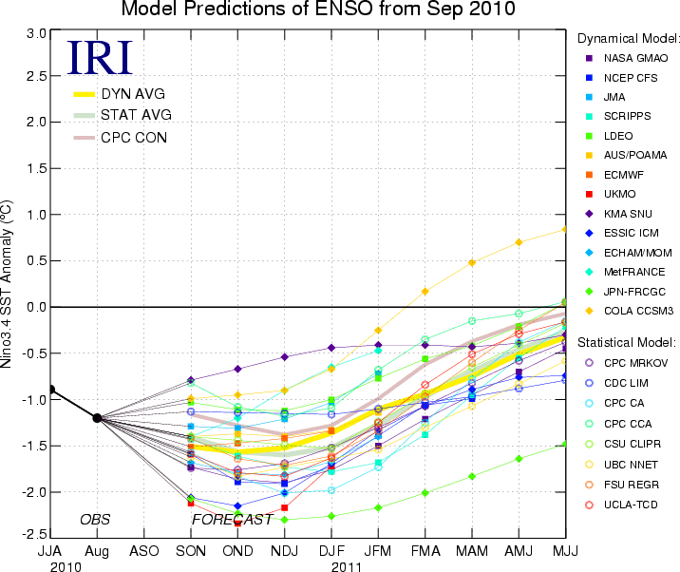
Figure 6. Forecasts of sea surface temperature (SST) anomalies for the Niño 3.4 region (5°N-5°S, 120°W-170°W). Figure courtesy of the International Research Institute (IRI) for Climate and Society. Figure updated 14 September 2010.

