EL NIÑO/SOUTHERN OSCILLATION (ENSO) DIAGNOSTIC DISCUSSION

issued by

CLIMATE PREDICTION CENTER/NCEP/NWS
and the International Research Institute for Climate and Society
4 October 2012

ENSO Alert System Status: El Niño Watch

Synopsis: Borderline ENSO-neutral/ weak El Niño conditions are expected to continue into Northern Hemisphere winter 2012-13, possibly strengthening during the next few months.
During September 2012, the trend towards El Niño slowed in several key oceanic and atmospheric indicators. However, the Pacific basin reflects borderline ENSO-neutral/ weak El Niño conditions. Equatorial sea surface temperatures (SST) remained elevated across the Pacific Ocean (Fig. 1), although anomalies decreased during the month as indicated by weekly index values in the Niño regions (Fig. 2). The oceanic heat content (average temperature in the upper 300m of the ocean) anomalies also weakened (Fig. 3), but continued to show large regions of above-average temperatures at depth across the equatorial Pacific (Fig. 4). Interestingly, low-level westerly wind anomalies were evident over the equatorial western Pacific Ocean (Fig. 5), which may portend possible strengthening of the subsurface anomalies in the coming months. Despite these winds, the atmosphere was still largely ENSO-neutral, as reflected by the Southern Oscillation index and near-average upper-level and lower-level winds across much of the Pacific. Tropical convection increased near the Date Line, which is consistent with weak El Niño conditions, but also remained elevated over eastern Indonesia, which is further westward than expected (Fig. 6). Thus, the atmosphere and ocean indicate borderline ENSO-neutral/ weak El Niño conditions.
Compared to the past few months, the chance is reduced for El Niño to develop during Northern Hemisphere fall/winter 2012-13 (see CPC/IRI consensus forecast). Due to the recent slowdown in the development of El Nino, it is not clear whether a fully coupled El Niño will emerge. The majority of models indicate that borderline ENSO-neutral/ weak El Niño conditions will continue, and about half suggest that El Niño could develop, but remain weak (Fig. 7). The official forecast therefore favors the continuation of borderline ENSO-neutral/ weak El Niño conditions into Northern Hemisphere winter 2012-13, with the possibility of strengthening during the next few months.
This discussion is a consolidated effort of the National Oceanic and Atmospheric Administration (NOAA), NOAA’s National Weather Service, and their funded institutions. Oceanic and atmospheric conditions are updated weekly on the Climate Prediction Center web site (El Niño/La Niña Current Conditions and Expert Discussions). Forecasts for the evolution of El Niño/La Niña are updated monthly in the Forecast Forum section of CPC's Climate Diagnostics Bulletin. The next ENSO Diagnostics Discussion is scheduled for 8 November 2012. To receive an e-mail notification when the monthly ENSO Diagnostic Discussions are released, please send an e-mail message to: ncep.list.enso-update@noaa.gov.
Climate Prediction Center
National Centers for Environmental Prediction
NOAA/National Weather Service
Camp Springs, MD 20746-4304

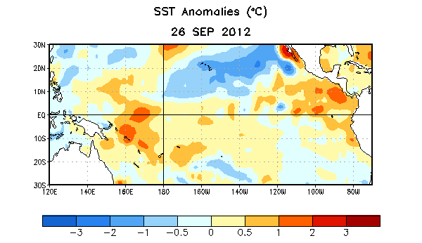
Figure 1. Average sea surface temperature (SST) anomalies (°C) for the week centered on 26 September 2012. Anomalies are computed with respect to the 1981-2010 base period weekly means.

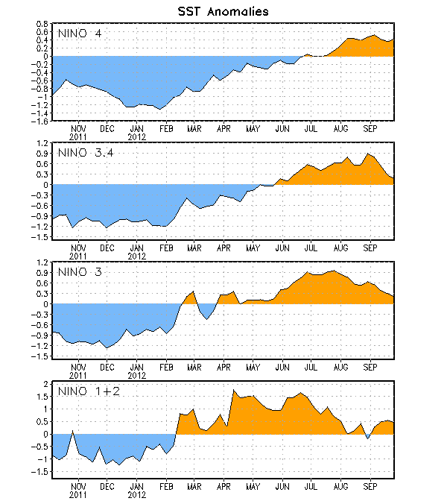
Figure 2. Time series of area-averaged sea surface temperature (SST) anomalies (°C) in the Niño regions [Niño-1+2 (0°-10°S, 90°W-80°W), Niño 3 (5°N-5°S, 150°W-90°W), Niño-3.4 (5°N-5°S, 170°W-120°W), Niño-4 (150ºW-160ºE and 5ºN-5ºS)]. SST anomalies are departures from the 1981-2010 base period weekly means.

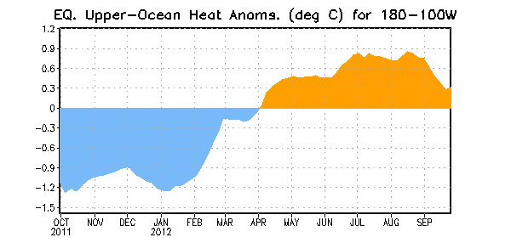
Figure 3. Area-averaged upper-ocean heat content anomaly (°C) in the equatorial Pacific (5°N-5°S, 180º-100ºW). The heat content anomaly is computed as the departure from the 1981-2010 base period pentad means.

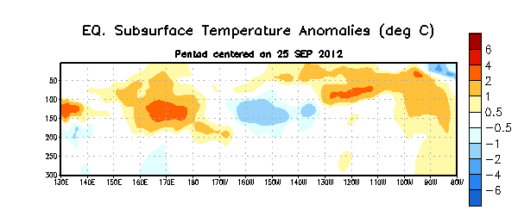
Figure 4. Depth-longitude section of equatorial Pacific upper-ocean (0-300m) temperature anomalies (°C) centered on the pentad of 25 September 2012. The anomalies are averaged between 5°N-5°S. Anomalies are departures from the 1981-2010 base period pentad means.

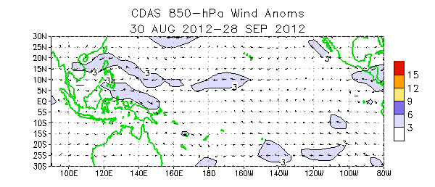

Figure 5. Average low-level (850-hPa) wind anomalies for the four-week period 30 August – 28 September 2012. Wind anomalies are computed as departures from the 1981-2010 base period means.

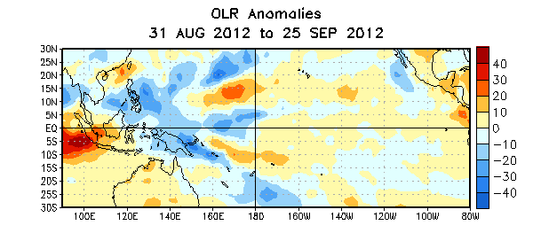

Figure 6. Average outgoing longwave radiation (OLR) anomalies (W/m²) for the four-week period 31 August – 25 September 2012. OLR anomalies are computed as departures from the 1979-1995 base period pentad means.

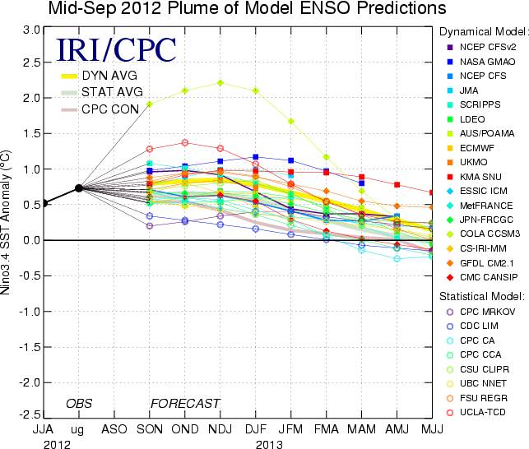
Figure 7. Forecasts of sea surface temperature (SST) anomalies for the Niño 3.4 region (5°N-5°S, 120°W-170°W). Figure courtesy of the International Research Institute (IRI) for Climate and Society. Figure updated 18 September 2012.

