EL NIÑO/SOUTHERN OSCILLATION (ENSO) DIAGNOSTIC DISCUSSION

issued by

CLIMATE PREDICTION CENTER/NCEP/NWS
and the International Research Institute for Climate and Society
9 October 2014

ENSO Alert System Status: El Niño Watch

Synopsis: El Niño is favored to begin in the next 1-2 months and last into the Northern Hemisphere spring 2015.
During September 2014, above-average sea surface temperatures (SST) continued across much of the equatorial Pacific (Fig. 1). The weekly Niño indices were relatively unchanged from the beginning of the month, with values ranging from +0.3°C (Niño-3.4) to +1.1°C (Niño-1+2) at the end of the month (Fig. 2). The change in subsurface heat content anomalies (averaged between 180º-100ºW) was also minimal (Fig. 3) due to the persistence of above-average temperatures at depth across the central and eastern Pacific (Fig. 4). Equatorial low-level winds were largely near average for the month, though brief periods of westerly wind anomalies continue to arise. Upper-level winds were also close to average for the month. The Southern Oscillation Index has remained negative, and rainfall was near average around the Date Line, with a mix of positive and negative anomalies over Indonesia and Papua New Guinea (Fig. 5). The lack of coherent atmospheric and oceanic features indicates the continuation of ENSO-neutral.
Most models predict El Niño to develop during October-December 2014 and to continue into early 2015 (Fig. 6). The consensus of forecasters indicates a 2-in-3 chance of El Niño during the November 2014 - January 2015 season. This El Niño will likely remain weak (3-month values of the Niño-3.4 index between 0.5°C and 0.9°C) throughout its duration. In summary, El Niño is favored to begin in the next 1-2 months and last into the Northern Hemisphere spring 2015 (click CPC/IRI consensus forecast for the chance of each outcome).
This discussion is a consolidated effort of the National Oceanic and Atmospheric Administration (NOAA), NOAA’s National Weather Service, and their funded institutions. Oceanic and atmospheric conditions are updated weekly on the Climate Prediction Center web site (El Niño/La Niña Current Conditions and Expert Discussions). Forecasts are also updated monthly in the Forecast Forum of CPC's Climate Diagnostics Bulletin. Additional perspectives and analysis are also available in an ENSO blog. The next ENSO Diagnostics Discussion is scheduled for 6 November 2014. To receive an e-mail notification when the monthly ENSO Diagnostic Discussions are released, please send an e-mail message to: ncep.list.enso-update@noaa.gov.

Climate Prediction Center
National Centers for Environmental Prediction
NOAA/National Weather Service
College Park, MD 20740

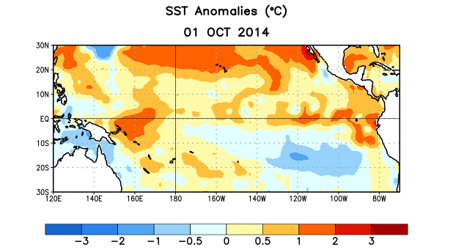
Figure 1. Average sea surface temperature (SST) anomalies (°C) for the week centered on 1 October 2014. Anomalies are computed with respect to the 1981-2010 base period weekly means.

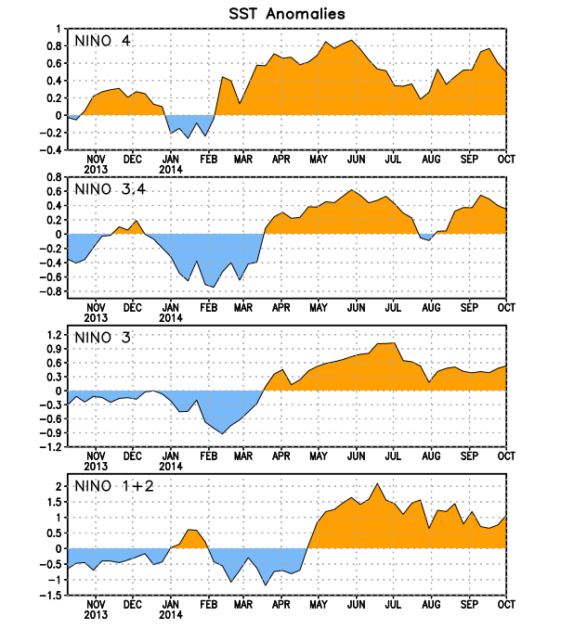
Figure 2. Time series of area-averaged sea surface temperature (SST) anomalies (°C) in the Niño regions [Niño-1+2 (0°-10°S, 90°W-80°W), Niño 3 (5°N-5°S, 150°W-90°W), Niño-3.4 (5°N-5°S, 170°W-120°W), Niño-4 (5ºN-5ºS , 150ºW-160ºE]. SST anomalies are departures from the 1981-2010 base period weekly means.
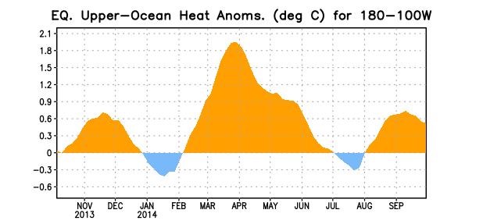
Figure 3. Area-averaged upper-ocean heat content anomaly (°C) in the equatorial Pacific (5°N-5°S, 180º-100ºW). The heat content anomaly is computed as the departure from the 1981-2010 base period pentad means.

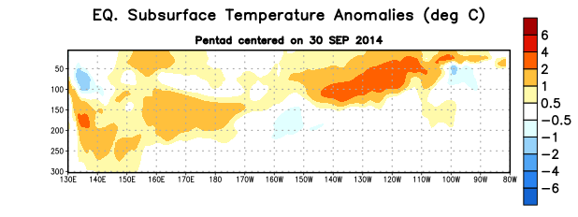
Figure 4. Depth-longitude section of equatorial Pacific upper-ocean (0-300m) temperature anomalies (°C)
centered on the pentad of 30 September 2014. The anomalies are averaged between 5°N-5°S. Anomalies are departures from the 1981-2010 base period pentad means.

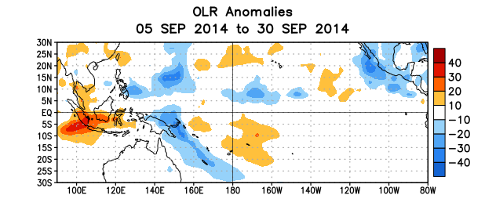
Figure 5. Average outgoing longwave radiation (OLR) anomalies (W/m²) for the period 5 – 30 September 2014. OLR anomalies are computed as departures from the 1979-1995 base period pentad means.

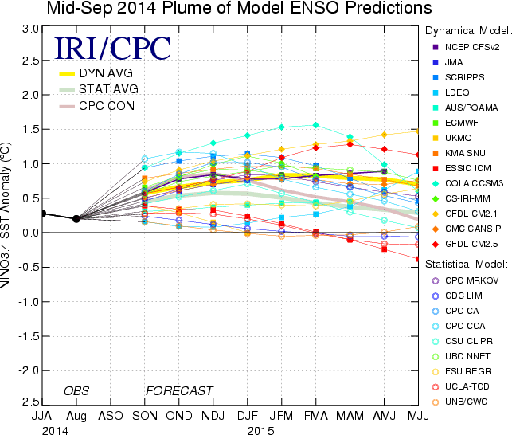

Figure 6. Forecasts of sea surface temperature (SST) anomalies for the Niño 3.4 region (5°N-5°S, 120°W-170°W). Figure updated 16 September 2014.

