EL NIÑO/SOUTHERN OSCILLATION (ENSO) DIAGNOSTIC DISCUSSION

issued by

CLIMATE PREDICTION CENTER/NCEP/NWS
and the International Research Institute for Climate and Society
13 October 2016

ENSO Alert System Status: La Niña Watch

Synopsis: La Niña is favored to develop (~70% chance) during the Northern Hemisphere fall 2016 and slightly favored to persist (~55% chance) during winter 2016-17.
ENSO-Neutral conditions were observed during September, with negative sea surface temperatures (SSTs) anomalies expanding across the eastern equatorial Pacific Ocean by early October (Fig. 1). All of the Niño regions cooled considerably during late September and early October, with the latest weekly value of Niño-3.4 index at -0.9°C (Fig. 2). Subsurface temperature anomalies also decreased toward the end of the month (Fig. 3), reflecting the strengthening of below-average temperatures at depth in the east-central equatorial Pacific (Fig. 4). Atmospheric anomalies across the equatorial Pacific edged toward La Niña during September, with a stronger tendency toward La Niña late in the month. The traditional Southern Oscillation index and the equatorial Southern Oscillation index were positive. The lower-level winds were near average across most of the basin during the month, but enhanced easterlies were becoming more persistent west of the International Date Line. Upper-level winds were anomalously westerly near and just east of the International Date Line. Convection was weakly suppressed over the central tropical Pacific and was more enhanced over Indonesia compared to last month (Fig. 5). Overall, the combined ocean and atmosphere system reflects ENSO-Neutral during September, but are more clearly trending toward La Niña conditions.
The multi-model averages favor borderline Neutral-La Niña conditions (3-month average Niño-3.4 index less than or equal to -0.5°C) persisting during the Northern Hemisphere fall and continuing into the winter (Figs. 6 and 7). Because of the recent cooling in the Niño-3.4 region and signs of renewed atmospheric coupling, the forecaster consensus now favors the formation of a weak La Niña in the near term, becoming less confident that La Niña will persist through the winter. In summary, La Niña is favored to develop (~70% chance) during the Northern Hemisphere fall 2016 and slightly favored to persist (~55% chance) during winter 2016-17 (click CPC/IRI consensus forecast for the chance of each outcome for each 3-month period).
This discussion is a consolidated effort of the National Oceanic and Atmospheric Administration (NOAA), NOAA’s National Weather Service, and their funded institutions. Oceanic and atmospheric conditions are updated weekly on the Climate Prediction Center web site (El Niño/La Niña Current Conditions and Expert Discussions). Forecasts are also updated monthly in the Forecast Forum of CPC's Climate Diagnostics Bulletin. Additional perspectives and analysis are also available in an ENSO blog. The next ENSO Diagnostics Discussion is scheduled for 10 November 2016. To receive an e-mail notification when the monthly ENSO Diagnostic Discussions are released, please send an e-mail message to: ncep.list.enso-update@noaa.gov.

Climate Prediction Center
National Centers for Environmental Prediction
NOAA/National Weather Service
College Park, MD 20740

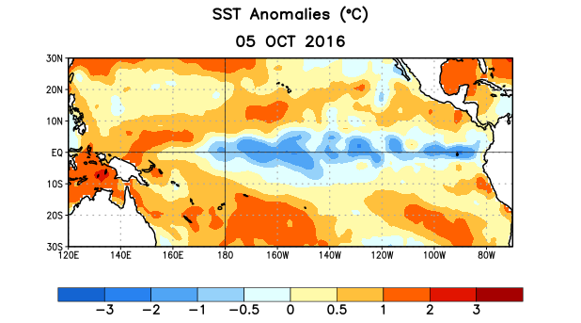
Figure 1. Average sea surface temperature (SST) anomalies (°C) for the week centered on 5 October 2016. Anomalies are computed with respect to the 1981-2010 base period weekly means.

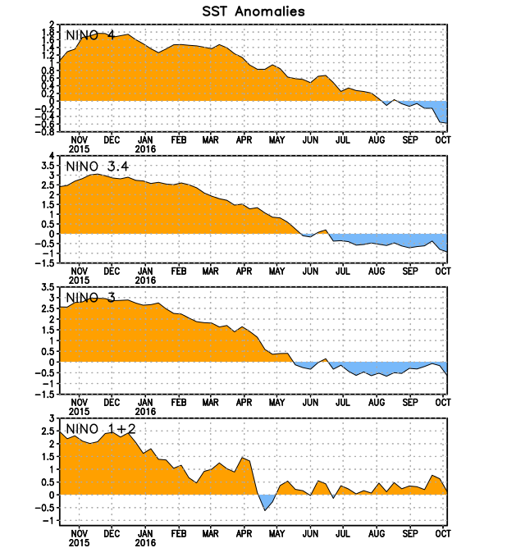
Figure 2. Time series of area-averaged sea surface temperature (SST) anomalies (°C) in the Niño regions [Niño-1+2 (0°-10°S, 90°W-80°W), Niño 3 (5°N-5°S, 150°W-90°W), Niño-3.4 (5°N-5°S, 170°W-120°W), Niño-4 (5ºN-5ºS , 150ºW-160ºE]. SST anomalies are departures from the 1981-2010 base period weekly means.
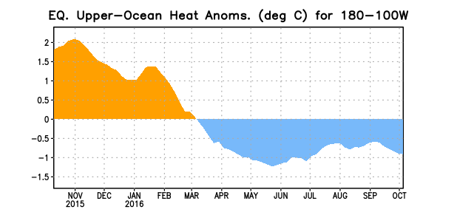
Figure 3. Area-averaged upper-ocean heat content anomaly (°C) in the equatorial Pacific (5°N-5°S, 180º-100ºW). The heat content anomaly is computed as the departure from the 1981-2010 base period pentad means.

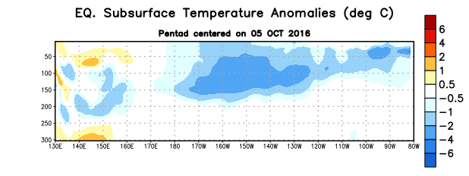
Figure 4. Depth-longitude section of equatorial Pacific upper-ocean (0-300m) temperature anomalies (°C)
centered on the pentad of 5 October 2016. The anomalies are averaged between 5°N-5°S. Anomalies are departures from the 1981-2010 base period pentad means.

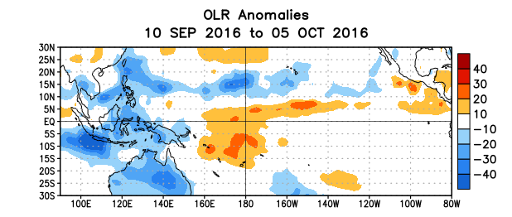
Figure 5. Average outgoing longwave radiation (OLR) anomalies (W/m²) for the period 10 September – 5 October 2016. OLR anomalies are computed as departures from the 1981-2010 base period pentad means.

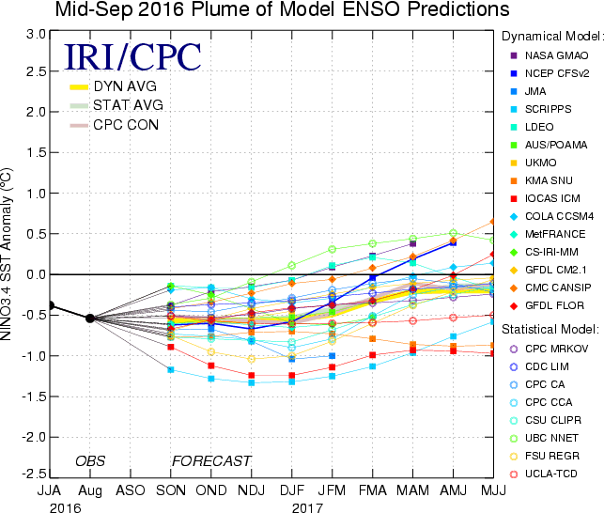
Figure 6. Forecasts of sea surface temperature (SST) anomalies for the Niño 3.4 region (5°N-5°S, 120°W-170°W). Figure updated 13 September 2016.

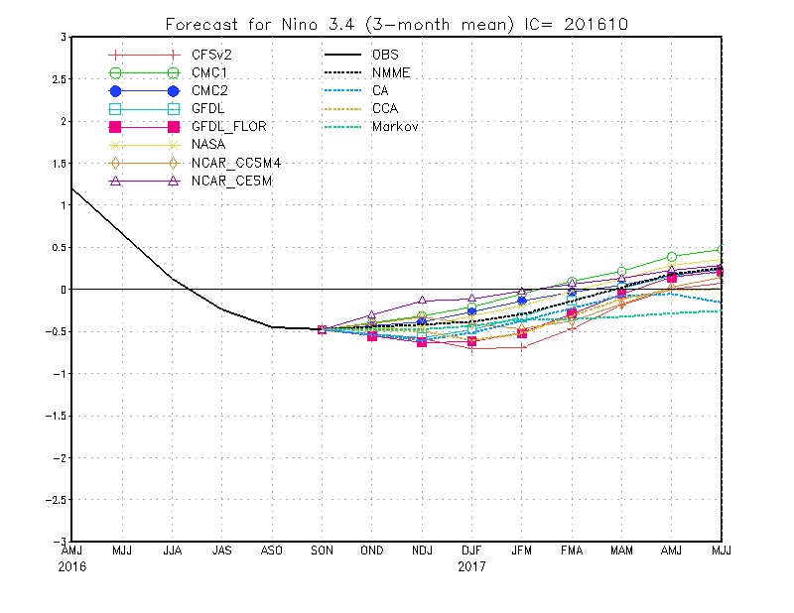
Figure 7. Forecasts of sea surface temperature (SST) anomalies for the Niño 3.4 region (5°N-5°S, 120°W-170°W) from the North American Multi-Model Ensemble and CPC statistical models. Figure updated 11 October 2016.

