EL NIÑO/SOUTHERN OSCILLATION (ENSO) DIAGNOSTIC DISCUSSION

issued by

CLIMATE PREDICTION CENTER/NCEP/NWS
and the International Research Institute for Climate and Society
12 October 2017

ENSO Alert System Status: La Niña Watch

Synopsis: La Niña conditions are favored (~55-65%) during the Northern Hemisphere fall and winter 2017-18.
During September, ENSO-neutral conditions were reflected in near-to-below average sea surface temperatures (SSTs) across most of the central and eastern Pacific Ocean (Fig. 1). The weekly Niño indices were volatile during the month, with negative values increasing to near zero during the past week in the Niño-4, Niño-3.4, and Niño-3 regions (Fig. 2). In contrast, sub-surface temperature anomalies were increasingly negative during September (Fig. 3), reflecting the shallow depth of the thermocline across the central and eastern Pacific (Fig. 4). Also, convection was suppressed near the International Date Line and enhanced near Indonesia (Fig. 5). Over the western equatorial Pacific Ocean, low-level trade winds were anomalously easterly and upper-level winds were anomalously westerly. Overall, the ocean and atmosphere system remains consistent with ENSO-neutral, although edging closer to La Niña conditions.

For the upcoming Northern Hemisphere fall and winter 2017-18, a weak La Niña is favored in the dynamical model averages of the IRI/CPC plume (Fig. 6) and North American Multi-Model Ensemble (NMME) (Fig. 7). Several models indicate a period of near-average Niño-3.4 values in the upcoming weeks, but then predict reinvigorated growth of negative SST anomalies across the equatorial Pacific Ocean. These forecasts are supported by the ongoing easterly wind anomalies across portions of the Pacific Ocean and the reservoir of below-average subsurface temperatures. In summary, La Niña conditions are favored (~55-65%) during the Northern Hemisphere fall and winter 2017-18 (click CPC/IRI consensus forecast for the chance of each outcome for each 3-month period).

This discussion is a consolidated effort of the National Oceanic and Atmospheric Administration (NOAA), NOAA’s National Weather Service, and their funded institutions. Oceanic and atmospheric conditions are updated weekly on the Climate Prediction Center web site (El Niño/La Niña Current Conditions and Expert Discussions). Forecasts are also updated monthly in the Forecast Forum of CPC's Climate Diagnostics Bulletin. Additional perspectives and analysis are also available in an ENSO blog. The next ENSO Diagnostics Discussion is scheduled for 9 November 2017. To receive an e-mail notification when the monthly ENSO Diagnostic Discussions are released, please send an e-mail message to: ncep.list.enso-update@noaa.gov.

Climate Prediction Center
National Centers for Environmental Prediction
NOAA/National Weather Service
College Park, MD 20740

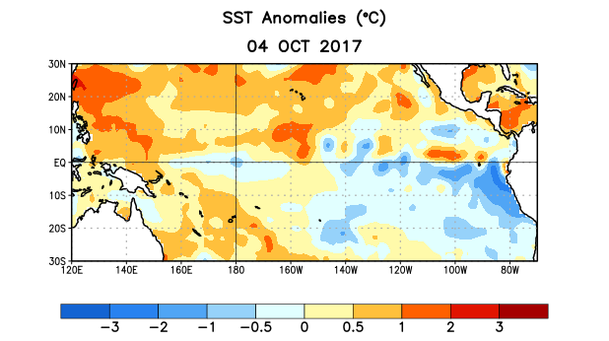
Figure 1. Average sea surface temperature (SST) anomalies (°C) for the week centered on 4 October 2017. Anomalies are computed with respect to the 1981-2010 base period weekly means.

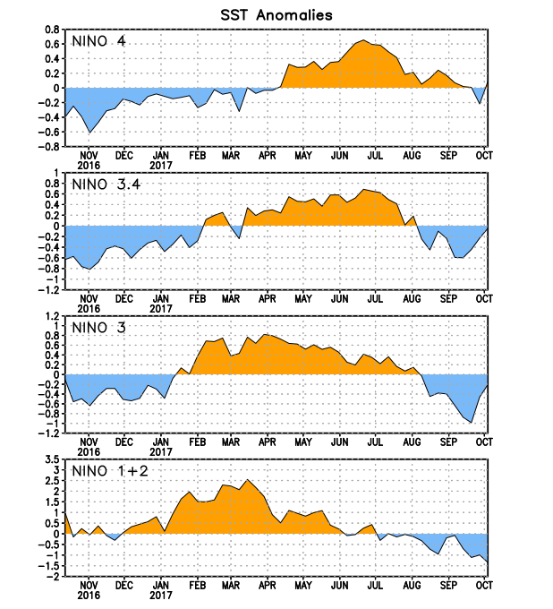
Figure 2. Time series of area-averaged sea surface temperature (SST) anomalies (°C) in the Niño regions [Niño-1+2 (0°-10°S, 90°W-80°W), Niño-3 (5°N-5°S, 150°W-90°W), Niño-3.4 (5°N-5°S, 170°W-120°W), Niño-4 (5ºN-5ºS , 150ºW-160ºE]. SST anomalies are departures from the 1981-2010 base period weekly means.
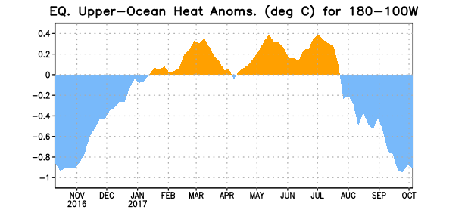
Figure 3. Area-averaged upper-ocean heat content anomaly (°C) in the equatorial Pacific (5°N-5°S, 180º-100ºW). The heat content anomaly is computed as the departure from the 1981-2010 base period pentad means.

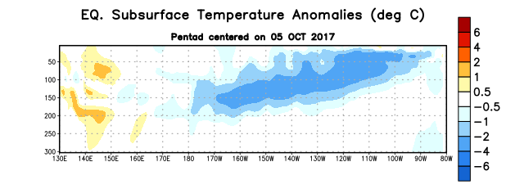
Figure 4. Depth-longitude section of equatorial Pacific upper-ocean (0-300m) temperature anomalies (°C) centered on the pentad of 5 October 2017. Anomalies are departures from the 1981-2010 base period pentad means.

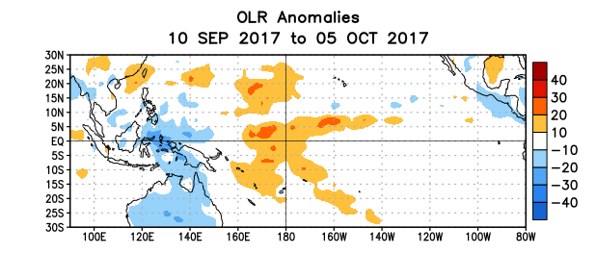
Figure 5. Average outgoing longwave radiation (OLR) anomalies (W/m²) for the period 10 September – 5 October 2017. OLR anomalies are computed as departures from the 1981-2010 base period pentad means.

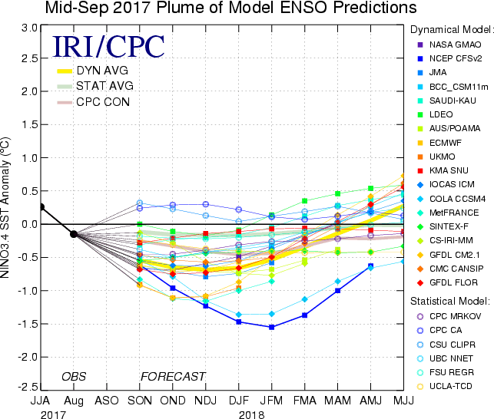

Figure 6. Forecasts of sea surface temperature (SST) anomalies for the Niño 3.4 region (5°N-5°S, 120°W-170°W). Figure updated 20 September 2017.

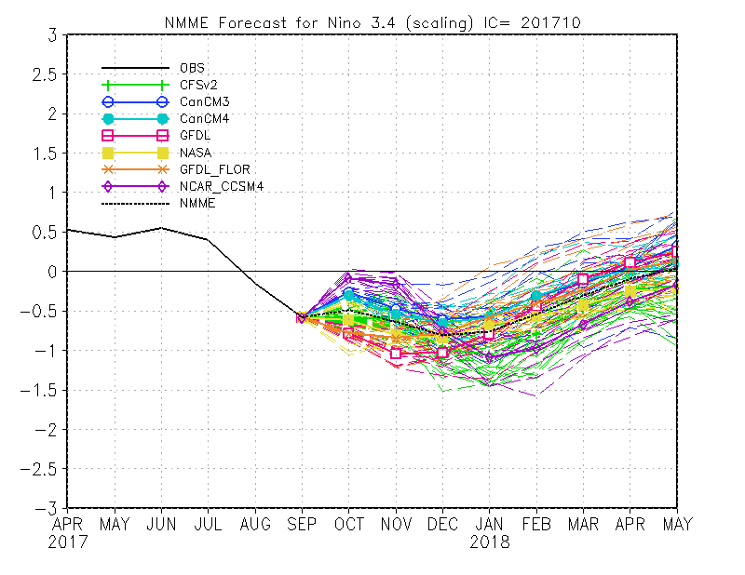
Figure 7. Forecasts of sea surface temperature (SST) anomalies for the Niño 3.4 region (5°N-5°S, 120°W-170°W) from the North American Multi-Model Ensemble. Figure updated 9 October 2017.

