EL NIÑO/SOUTHERN OSCILLATION (ENSO) DIAGNOSTIC DISCUSSION

issued by

CLIMATE PREDICTION CENTER/NCEP/NWS

and the International Research Institute for Climate and Society

10 October 2019

ENSO Alert System Status: Not Active

Synopsis: ENSO-neutral is favored during the Northern Hemisphere fall 2019 (~85% chance), continuing through spring 2020 (55-60% chance).

Near-average sea surface temperatures (SST) were evident in the east-central Pacific Ocean during most of September, though SST anomalies increased during the past couple of weeks (Fig. 1). In the last week, the SST indices in the westernmost Niño-4 and Niño-3.4 regions were +1.0°C and +0.5°C, respectively, and the indices in the easternmost Niño-3 and Niño-1+2 regions remained near-to-below average (+0.3°C and -0.6°C respectively; Fig. 2). The subsurface temperature anomalies (averaged across 180°-100°W) increased during the month (Fig. 3) partially because a downwelling oceanic Kelvin wave expanded eastward (Fig. 4). This wave was triggered by low-level westerly wind anomalies across the western and central equatorial Pacific Ocean. At upper-levels, easterly wind anomalies prevailed over much of the Pacific during September. Also, the region of suppressed convection over Indonesia intensified and expanded to the Date Line (Fig. 5). Despite the recent warming, the overall oceanic and atmospheric system remained consistent with ENSO-neutral.
The majority of models in the IRI/CPC plume (Fig. 6) continue to favor ENSO-neutral (Niño-3.4 index between -0.5°C and +0.5°C) through the Northern Hemisphere spring. Many dynamical forecast models, including the NCEP CFSv2, suggest Niño-3.4 SST index values will remain near +0.5°C during the next month or so before decreasing, but remaining above zero. Consequently, forecasters believe the recent oceanic warmth reflects sub-seasonal variability and is not indicative of an evolution toward El Niño. However, chances for El Niño remain between approximately 25-30% through the winter and spring. In summary, ENSO-neutral is favored during the Northern Hemisphere fall 2019 (~85% chance), continuing through spring 2020 (55-60% chance; click CPC/IRI consensus forecast for the chance of each outcome for each 3-month period).
This discussion is a consolidated effort of the National Oceanic and Atmospheric Administration (NOAA), NOAA’s National Weather Service, and their funded institutions. Oceanic and atmospheric conditions are updated weekly on the Climate Prediction Center web site (El Niño/La Niña Current Conditions and Expert Discussions). Forecasts are also updated monthly in the Forecast Forum of CPC's Climate Diagnostics Bulletin. Additional perspectives and analysis are also available in an ENSO blog. The next ENSO Diagnostics Discussion is scheduled for 14 November 2019. To receive an e-mail notification when the monthly ENSO Diagnostic Discussions are released, please send an e-mail message to: ncep.list.enso-update@noaa.gov.

Climate Prediction Center
National Centers for Environmental Prediction
NOAA/National Weather Service
College Park, MD 20740

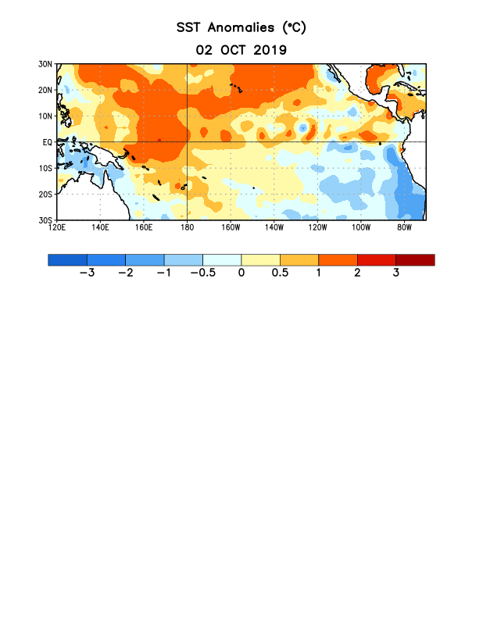
Figure 1. Average sea surface temperature (SST) anomalies (°C) for the week centered on 2 October 2019. Anomalies are computed with respect to the 1981-2010 base period weekly means.

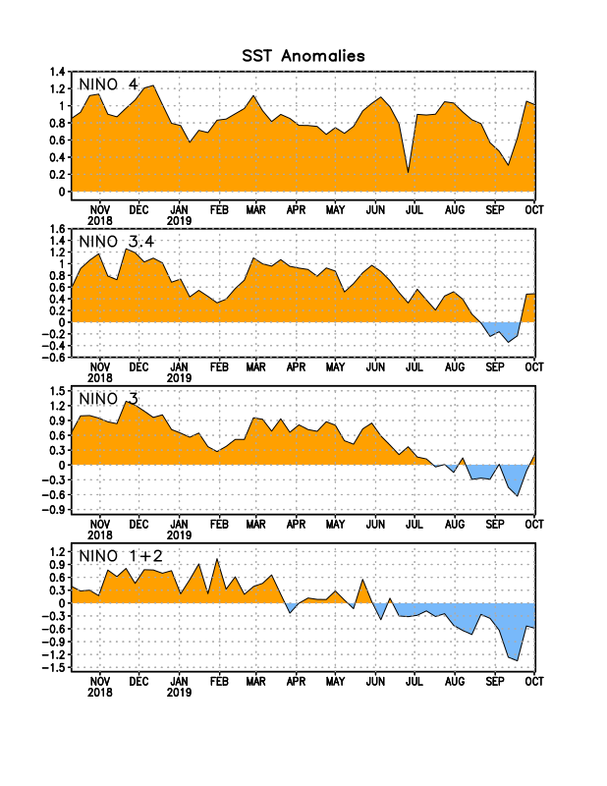
Figure 2. Time series of area-averaged sea surface temperature (SST) anomalies (°C) in the Niño regions [Niño-1+2 (0°-10°S, 90°W-80°W), Niño-3 (5°N-5°S, 150°W-90°W), Niño-3.4 (5°N-5°S, 170°W-120°W), Niño-4 (5ºN-5ºS , 150ºW-160ºE)]. SST anomalies are departures from the 1981-2010 base period weekly means.
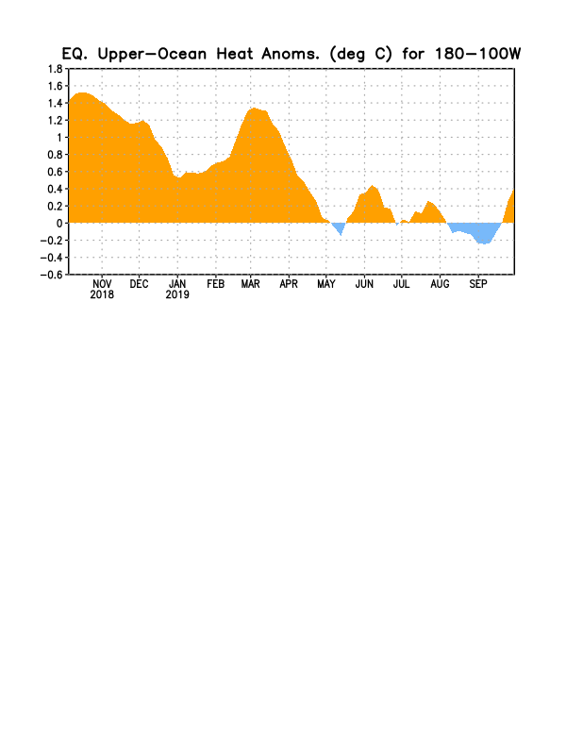
Figure 3. Area-averaged upper-ocean heat content anomaly (°C) in the equatorial Pacific (5°N-5°S, 180º-100ºW). The heat content anomaly is computed as the departure from the 1981-2010 base period pentad means.

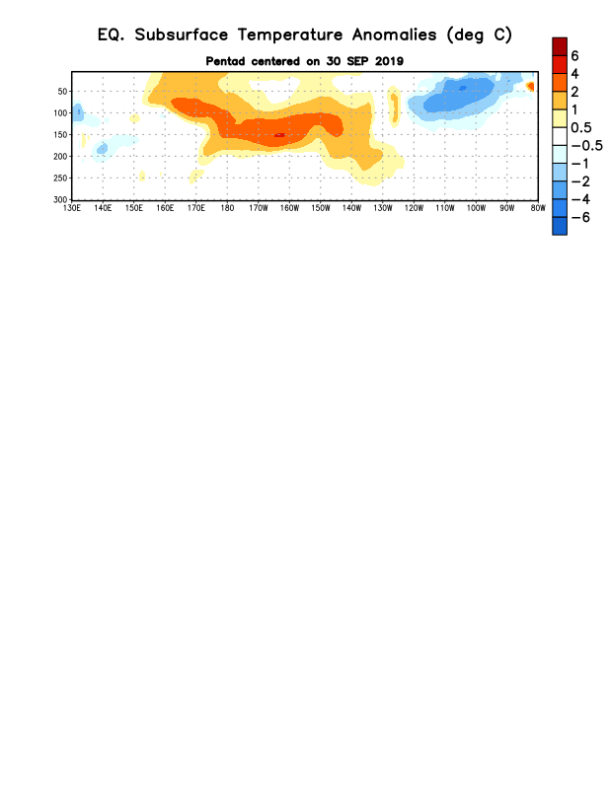
Figure 4. Depth-longitude section of equatorial Pacific upper-ocean (0-300m) temperature anomalies (°C) centered on the pentad of 30 September 2019. Anomalies are departures from the 1981-2010 base period pentad means.

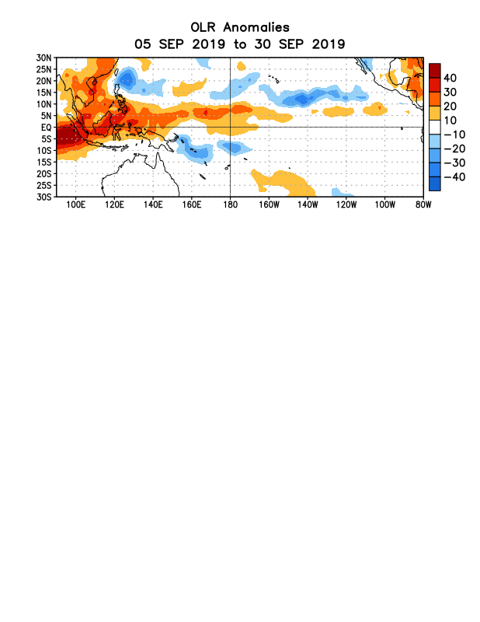
Figure 5. Average outgoing longwave radiation (OLR) anomalies (W/m²) for the period 5 – 30 September 2019. OLR anomalies are computed as departures from the 1981-2010 base period pentad means.

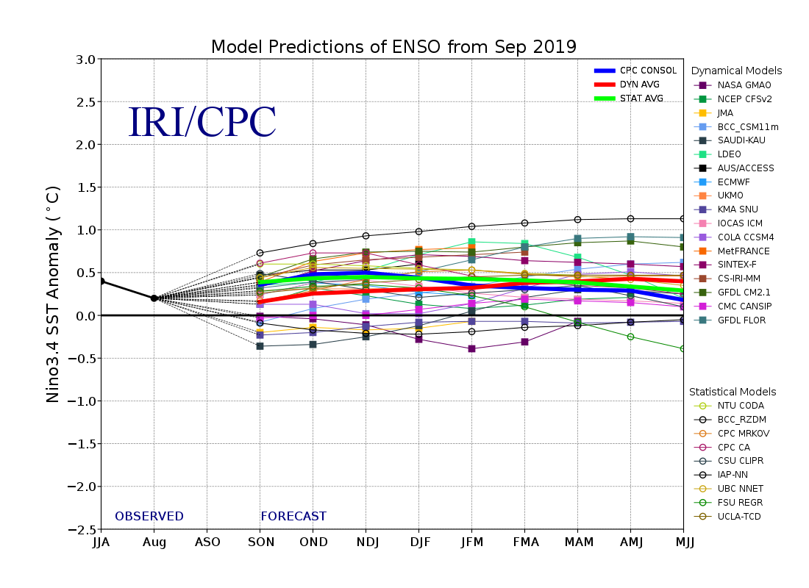
Figure 6. Forecasts of sea surface temperature (SST) anomalies for the Niño 3.4 region (5°N-5°S, 120°W-170°W). Figure updated 19 September 2019.

