EL NIÑO/SOUTHERN OSCILLATION (ENSO) DIAGNOSTIC DISCUSSION

issued by

CLIMATE PREDICTION CENTER/NCEP/NWS

and the International Research Institute for Climate and Society

8 October 2020

ENSO Alert System Status: La Niña Advisory

Synopsis: La Niña is likely to continue through the Northern Hemisphere winter 2020-21 (~85% chance) and into spring 2021 (~60% chance during February-April).

La Niña continued during September, as evidenced by below-average sea surface temperatures (SSTs) extending from the Date Line to the eastern Pacific Ocean (Fig. 1). The SST indices in the two westernmost Niño regions, Niño-4 and Niño-3.4, cooled throughout the month, and the Niño-3.4 index was -1.1ºC in the past week (Fig. 2). The equatorial subsurface temperature anomalies (averaged from 180°-100°W) remained substantially unchanged (Fig. 3), and continued to reflect below-average temperatures from the surface to 200m depth in the eastern Pacific Ocean (Fig. 4). The atmospheric circulation anomalies over the tropical Pacific Ocean remained consistent with La Niña. Low-level wind anomalies were easterly across most of the tropical Pacific, and upper-level wind anomalies were westerly over the east-central Pacific. Tropical convection continued to be suppressed from the western Pacific to the Date Line, and a slight enhancement of convection emerged over Indonesia (Fig. 5). Also, both the Southern Oscillation and Equatorial Southern Oscillation indices remained positive. Overall, the coupled ocean-atmosphere system indicates the continuation of La Niña.
A majority of the models in the IRI/CPC plume predict La Niña (Niño-3.4 index less than -0.5°C) to persist through the Northern Hemisphere winter 2020-21 and to weaken during the spring (Fig. 6). The latest forecasts from several models, including the NCEP CFSv2, suggest the likelihood of a moderate or even strong La Niña (Niño-3.4 index values < -1.0ºC) during the peak November-January season. The forecaster consensus supports that view in light of significant atmosphere-ocean coupling already in place. In summary, La Niña is likely to continue through the Northern Hemisphere winter 2020-21 (~85% chance) and into spring 2021 (~60% chance during February-April; click CPC/IRI consensus forecast for the chances in each 3-month period).
La Niña is anticipated to affect temperature and precipitation across the United States during the upcoming months (the 3-month seasonal temperature and precipitation outlooks will be updated on Thurs. October 15th).
This discussion is a consolidated effort of the National Oceanic and Atmospheric Administration (NOAA), NOAA’s National Weather Service, and their funded institutions. Oceanic and atmospheric conditions are updated weekly on the Climate Prediction Center web site (El Niño/La Niña Current Conditions and Expert Discussions). Forecasts are also updated monthly in the Forecast Forum of CPC's Climate Diagnostics Bulletin. Additional perspectives and analysis are also available in an ENSO blog. The next ENSO Diagnostics Discussion is scheduled for 12 November 2020. To receive an e-mail notification when the monthly ENSO Diagnostic Discussions are released, please send an e-mail message to: ncep.list.enso-update@noaa.gov.

Climate Prediction Center
National Centers for Environmental Prediction
NOAA/National Weather Service
College Park, MD 20740

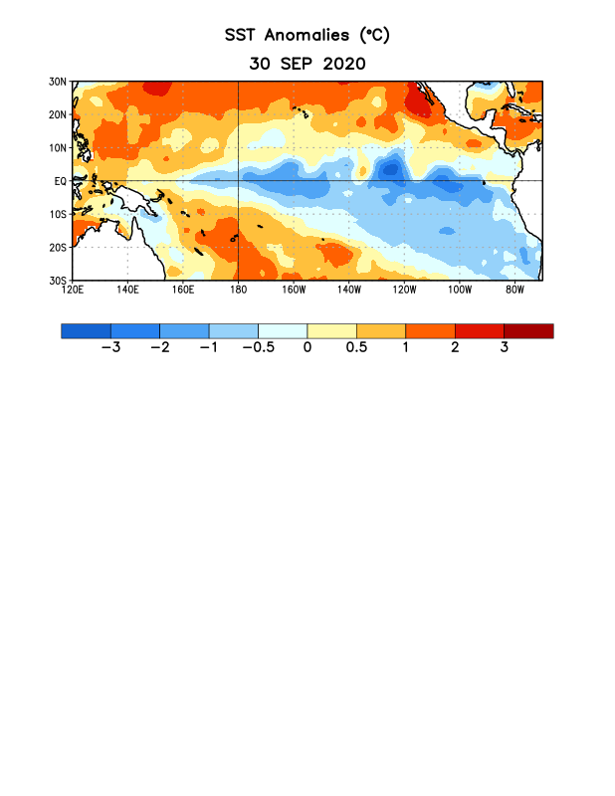
Figure 1. Average sea surface temperature (SST) anomalies (°C) for the week centered on 30 September 2020. Anomalies are computed with respect to the 1981-2010 base period weekly means.

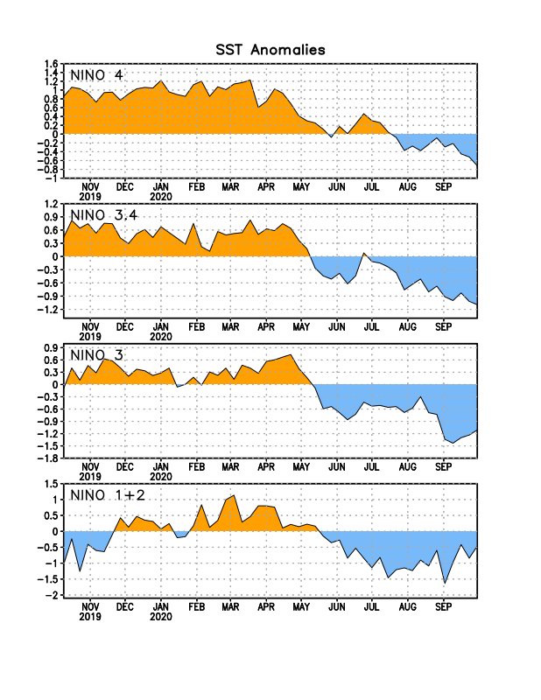
Figure 2. Time series of area-averaged sea surface temperature (SST) anomalies (°C) in the Niño regions [Niño-1+2 (0°-10°S, 90°W-80°W), Niño-3 (5°N-5°S, 150°W-90°W), Niño-3.4 (5°N-5°S, 170°W-120°W), Niño-4 (5ºN-5ºS , 150ºW-160ºE)]. SST anomalies are departures from the 1981-2010 base period weekly means.
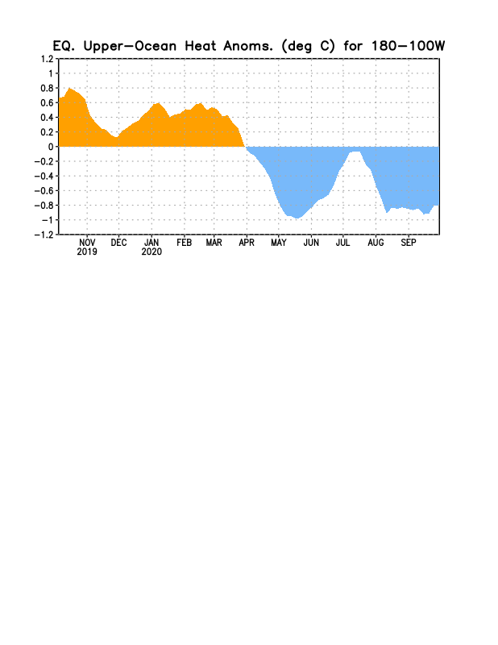
Figure 3. Area-averaged upper-ocean heat content anomaly (°C) in the equatorial Pacific (5°N-5°S, 180º-100ºW). The heat content anomaly is computed as the departure from the 1981-2010 base period pentad means.

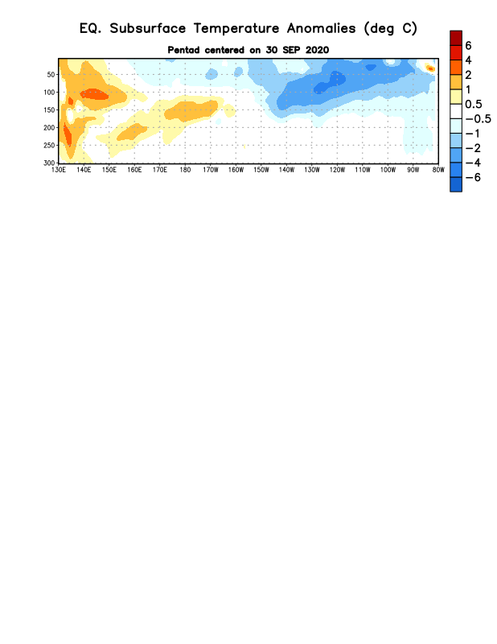
Figure 4. Depth-longitude section of equatorial Pacific upper-ocean (0-300m) temperature anomalies (°C) centered on the pentad of 30 September 2020. Anomalies are departures from the 1981-2010 base period pentad means.

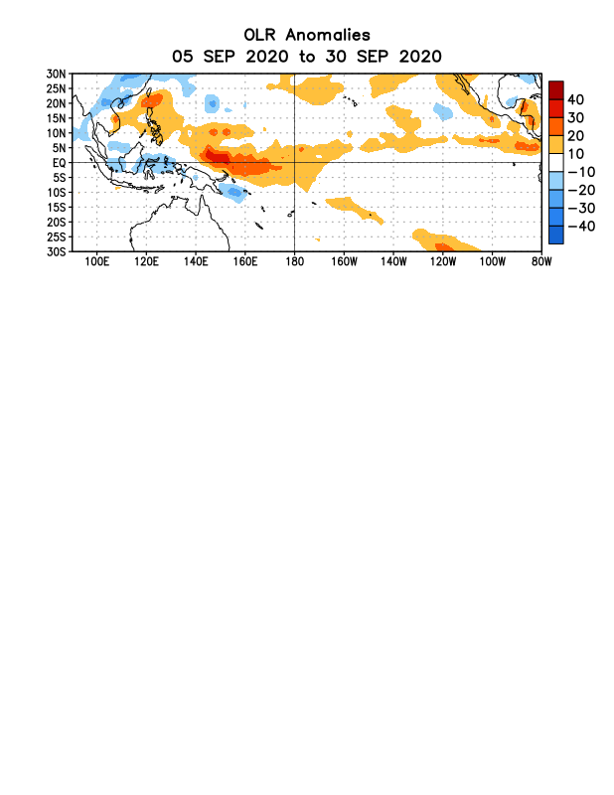
Figure 5. Average outgoing longwave radiation (OLR) anomalies (W/m²) for the period 5 – 30 September 2020. OLR anomalies are computed as departures from the 1981-2010 base period pentad means.

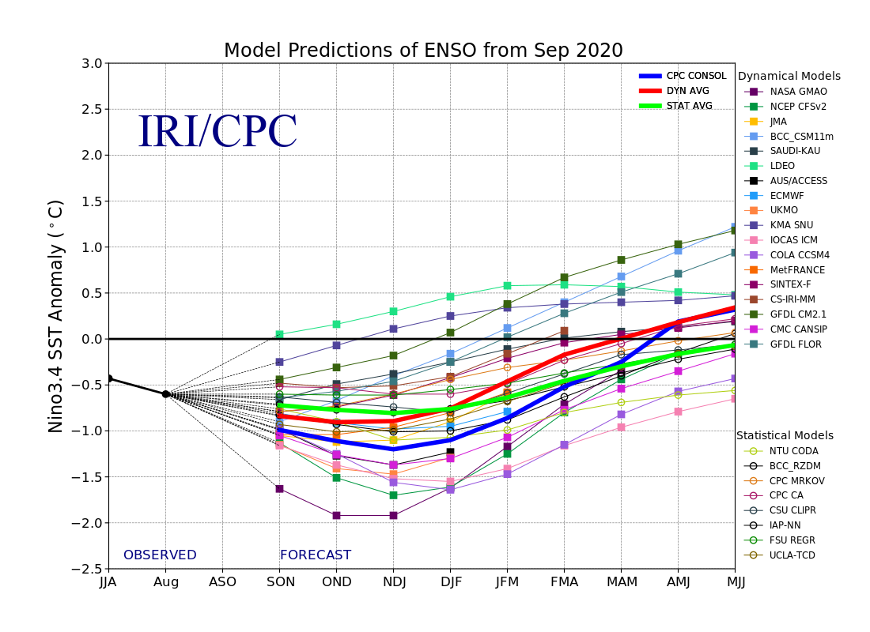
Figure 6. Forecasts of sea surface temperature (SST) anomalies for the Niño 3.4 region (5°N-5°S, 120°W-170°W). Figure updated 18 September 2020.

