EL NIÑO/SOUTHERN OSCILLATION (ENSO) DIAGNOSTIC DISCUSSION

issued by

CLIMATE PREDICTION CENTER/NCEP/NWS

and the International Research Institute for Climate and Society

14 October 2021

ENSO Alert System Status: La Niña Advisory

Synopsis: La Niña conditions have developed and are expected to continue with an 87% chance of La Niña in December 2021- February 2022.

In the past month, La Niña conditions emerged, as indicated by below-average sea surface temperatures (SSTs) across the central and east-central equatorial Pacific (Fig. 1). In the last week, the Niño-3.4 and Niño-4 index values were -0.6ºC and -0.7ºC, respectively (Fig. 2). The Niño-3 and Niño-1+2 indices were not as cool, with values at -0.3ºC and 0.1ºC. Below-average subsurface temperatures (averaged from 180-100ºW) strengthened significantly in the past month (Fig. 3), as negative anomalies were observed at depth across most of the central and eastern Pacific Ocean (Fig. 4). Low-level easterly wind anomalies and upper-level westerly wind anomalies were observed over most of the equatorial Pacific. Tropical convection was suppressed near and west of the Date Line and enhanced over Indonesia (Fig. 5), while the Southern Oscillation Index and Equatorial Southern Oscillation Index were both positive. Overall, the coupled ocean-atmosphere system was consistent with La Niña conditions.
The IRI/CPC plume average of forecasts for the Niño-3.4 SST index favors La Niña to continue through the fall and winter 2021-22 (Fig. 6). The forecaster consensus also anticipates La Niña to continue through the winter, with ENSO-neutral predicted to return during March-May 2022. Because of the recent oceanic cooling and coupling to the atmosphere, forecasters now anticipate a 57% chance of one season (November-January) reaching -1.0ºC or less in the Niño-3.4 index. Thus, at its peak, a moderate-strength La Niña is favored. In summary, La Niña conditions have developed and are expected to continue with an 87% chance of La Niña in December 2021- February 2022 (click CPC/IRI consensus forecast for the chances in each 3-month period).
La Niña is anticipated to affect temperature and precipitation across the United States during the upcoming months (the 3-month seasonal temperature and precipitation outlooks will be updated on Thurs. October 21st).
This discussion is a consolidated effort of the National Oceanic and Atmospheric Administration (NOAA), NOAA’s National Weather Service, and their funded institutions. Oceanic and atmospheric conditions are updated weekly on the Climate Prediction Center web site (El Niño/La Niña Current Conditions and Expert Discussions). Additional perspectives and analysis are also available in an ENSO blog. A probabilistic strength forecast is available here. The next ENSO Diagnostics Discussion is scheduled for 11 November 2021. To receive an e-mail notification when the monthly ENSO Diagnostic Discussions are released, please send an e-mail message to: ncep.list.enso-update@noaa.gov.

Climate Prediction Center
National Centers for Environmental Prediction
NOAA/National Weather Service
College Park, MD 20740

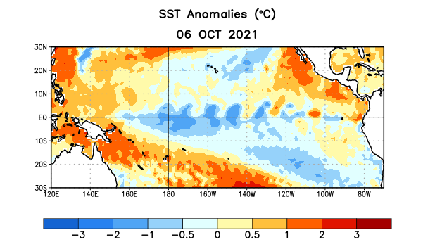
Figure 1. Average sea surface temperature (SST) anomalies (°C) for the week centered on 6 October 2021. Anomalies are computed with respect to the 1991-2020 base period weekly means.

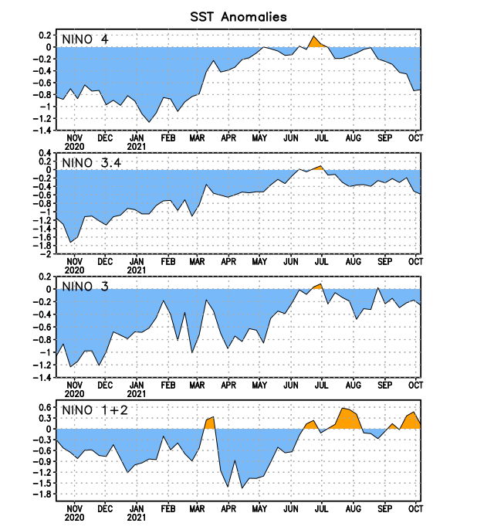
Figure 2. Time series of area-averaged sea surface temperature (SST) anomalies (°C) in the Niño regions [Niño-1+2 (0°-10°S, 90°W-80°W), Niño-3 (5°N-5°S, 150°W-90°W), Niño-3.4 (5°N-5°S, 170°W-120°W), Niño-4 (5ºN-5ºS, 150ºW-160ºE)]. SST anomalies are departures from the 1991-2020 base period weekly means.
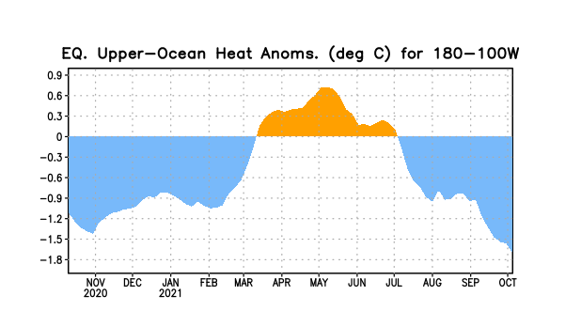
Figure 3. Area-averaged upper-ocean heat content anomaly (°C) in the equatorial Pacific (5°N-5°S, 180º-100ºW). The heat content anomaly is computed as the departure from the 1991-2020 base period pentad means.

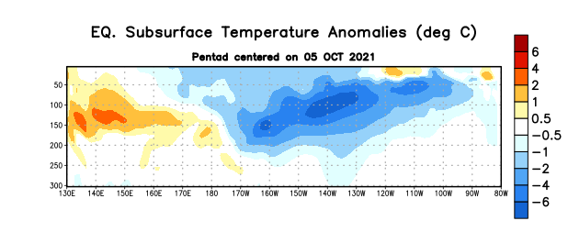

Figure 4. Depth-longitude section of equatorial Pacific upper-ocean (0-300m) temperature anomalies (°C) centered on the pentad of 5 October 2021. Anomalies are departures from the 1991-2020 base period pentad means.

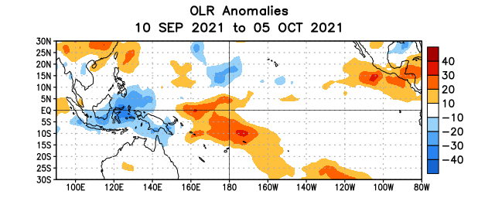
Figure 5. Average outgoing longwave radiation (OLR) anomalies (W/m²) for the period 10 September – 5 October 2021. OLR anomalies are computed as departures from the 1991-2020 base period pentad means.

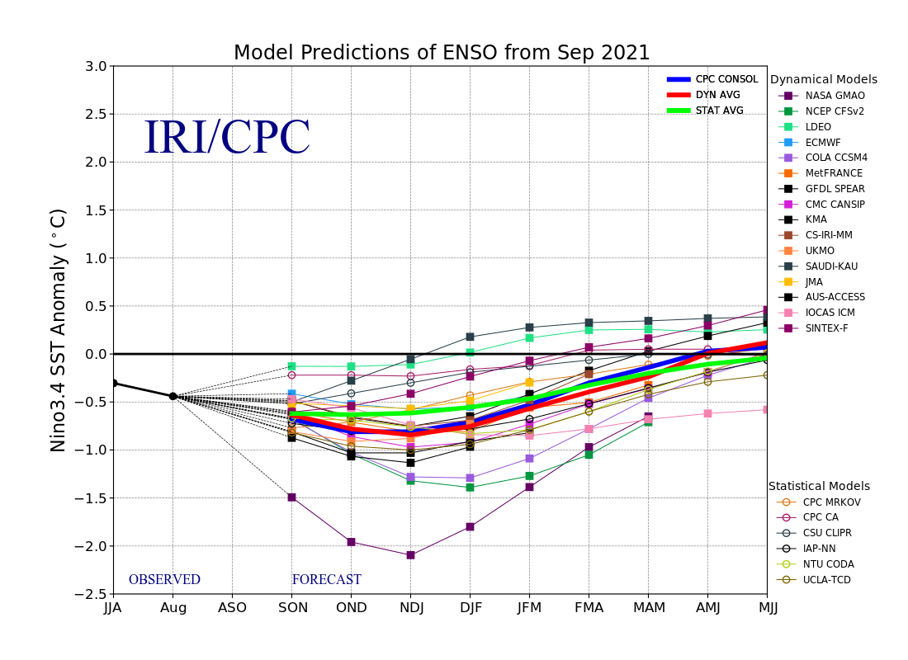
Figure 6. Forecasts of sea surface temperature (SST) anomalies for the Niño 3.4 region (5°N-5°S, 120°W-170°W). Figure updated 20 September 2021.

