EL NIÑO/SOUTHERN OSCILLATION (ENSO) DIAGNOSTIC DISCUSSION

issued by

CLIMATE PREDICTION CENTER/NCEP/NWS

13 October 2022

ENSO Alert System Status: La Niña Advisory

Synopsis: There is a 75% chance of La Niña during the Northern Hemisphere winter (December-February) 2022-23, with a 54% chance for ENSO-neutral in February-April 2023.

Below-average sea surface temperatures (SSTs) continued across the central and eastern equatorial Pacific Ocean during September (Fig. 1). Most of the Niño indices decreased during the past month, with the latest weekly index values spanning -0.8ºC to -1.6ºC (Fig. 2). For the last couple of months, negative subsurface temperature anomalies remained mostly unchanged (Fig. 3), reflecting the persistence of below-average temperatures across the eastern Pacific Ocean (Fig. 4). Low-level easterly wind anomalies and upper-level westerly wind anomalies prevailed across most of the equatorial Pacific. Convection was suppressed over the western and central tropical Pacific and was enhanced over Indonesia (Fig. 5). Overall, the coupled ocean-atmosphere system continued to reflect La Niña.
The most recent IRI plume forecast of the Niño-3.4 SST index indicates La Niña will persist into the Northern Hemisphere winter 2022-23, and then transition to ENSO-neutral in January-March 2023 (Fig. 6). The forecaster consensus for this month favors a slightly later transition to ENSO-neutral, during February-April 2023, which is consistent with the latest North American Multi-Model Ensemble (NMME). However, predicting the timing of transitions is challenging, and there continues to be uncertainty over how long La Niña may last. In summary, there is a 75% chance of La Niña during the Northern Hemisphere winter (December-February) 2022-23, with a 54% chance for ENSO-neutral in February-April 2023 (Fig. 7).
This discussion is a consolidated effort of the National Oceanic and Atmospheric Administration (NOAA), NOAA’s National Weather Service, and their funded institutions. Oceanic and atmospheric conditions are updated weekly on the Climate Prediction Center web site (El Niño/La Niña Current Conditions and Expert Discussions). Additional perspectives and analysis are also available in an ENSO blog. A probabilistic strength forecast is available here. The next ENSO Diagnostics Discussion is scheduled for 10 November 2022. To receive an e-mail notification when the monthly ENSO Diagnostic Discussions are released, please send an e-mail message to: ncep.list.enso-update@noaa.gov.

Climate Prediction Center
National Centers for Environmental Prediction
NOAA/National Weather Service
College Park, MD 20740

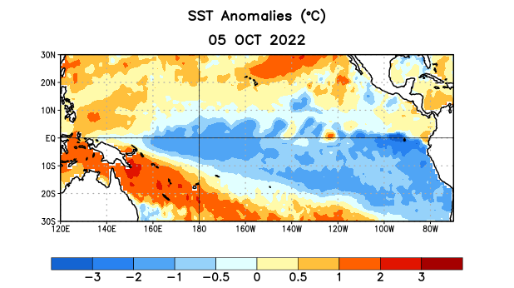
Figure 1. Average sea surface temperature (SST) anomalies (°C) for the week centered on 5 October 2022. Anomalies are computed with respect to the 1991-2020 base period weekly means.

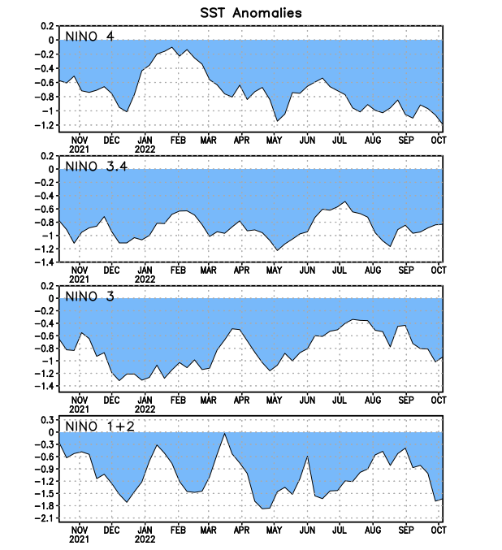
Figure 2. Time series of area-averaged sea surface temperature (SST) anomalies (°C) in the Niño regions [Niño-1+2 (0°-10°S, 90°W-80°W), Niño-3 (5°N-5°S, 150°W-90°W), Niño-3.4 (5°N-5°S, 170°W-120°W), Niño-4 (5ºN-5ºS, 150ºW-160ºE)]. SST anomalies are departures from the 1991-2020 base period weekly means.

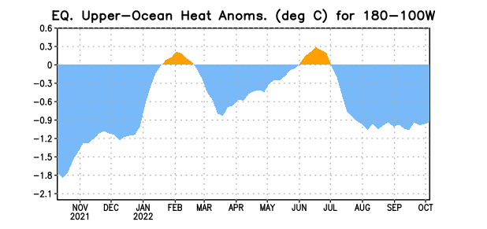

Figure 3. Area-averaged upper-ocean heat content anomaly (°C) in the equatorial Pacific (5°N-5°S, 180º-100ºW). The heat content anomaly is computed as the departure from the 1991-2020 base period pentad means.

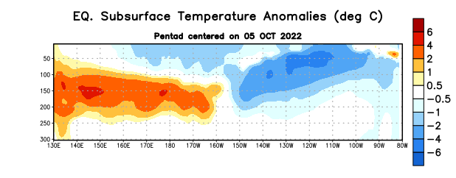
Figure 4. Depth-longitude section of equatorial Pacific upper-ocean (0-300m) temperature anomalies (°C) centered on the pentad of 5 October 2022. Anomalies are departures from the 1991-2020 base period pentad means.

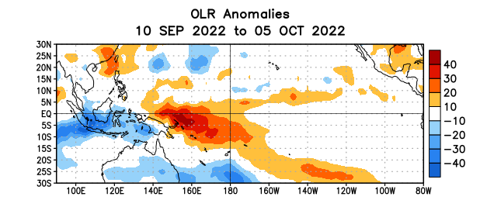

Figure 5. Average outgoing longwave radiation (OLR) anomalies (W/m²) for the period 10 September – 5 October 2022. OLR anomalies are computed as departures from the 1991-2020 base period pentad means.

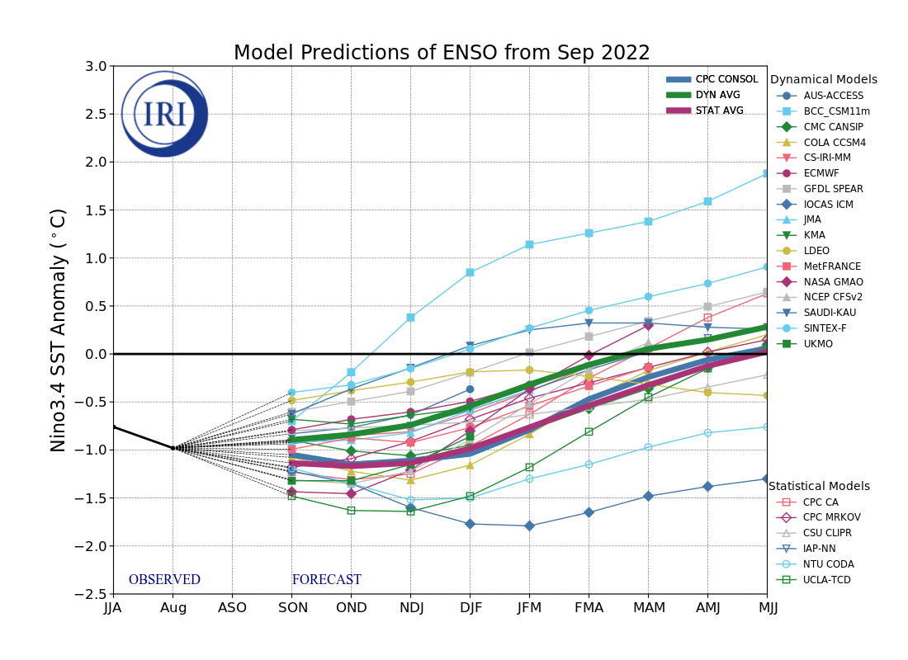
Figure 6. Forecasts of sea surface temperature (SST) anomalies for the Niño 3.4 region (5°N-5°S, 120°W-170°W). Figure updated 19 September 2022 by the International Research Institute (IRI) for Climate and Society.
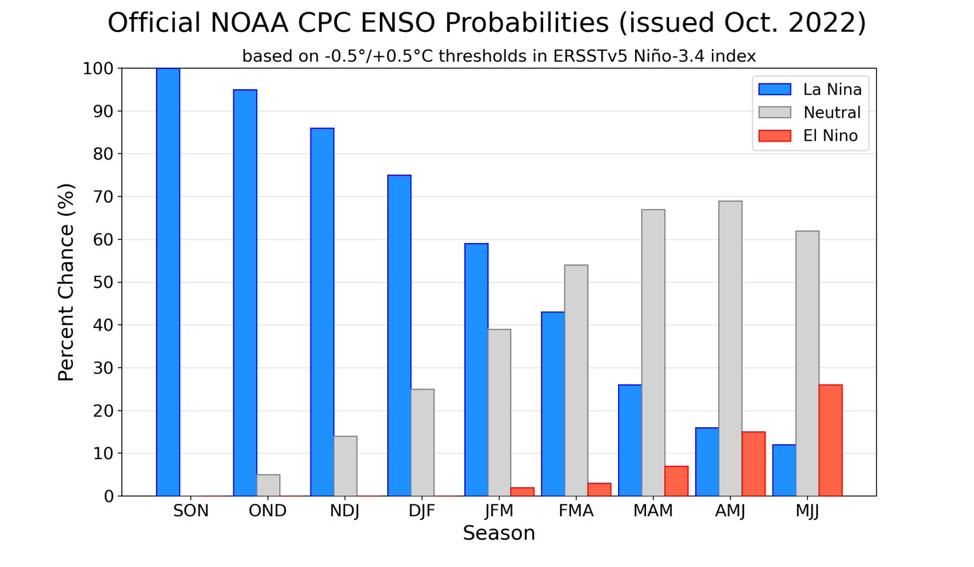
Figure 7. Official ENSO probabilities for the Niño 3.4 sea surface temperature index (5°N-5°S,
120°W-170°W). Figure updated 13 October 2022.

