EL NIÑO/SOUTHERN OSCILLATION (ENSO) DIAGNOSTIC DISCUSSION
issued by
CLIMATE PREDICTION CENTER/NCEP/NWS
6 September 2007

Synopsis: La Niña conditions will further develop during the next 3 months.
During August 2007, negative sea surface temperature (SST) anomalies in the eastern equatorial Pacific expanded westward, and now extend from the coast of South America to the date line (180ºW) (Fig. 1). Consistent with this additional cooling, three of the Niño indices remained cooler than −0.5 ºC throughout August, with only Niño 4 remaining average (latest weekly values: Niño 1+2 (−2.3ºC), Niño 3 (−1.2ºC), Niño 3.4 (−0.6ºC), Niño 4 (+0.0ºC)) (Fig. 2). The upper-ocean heat content (average temperatures in the upper 300 m of the ocean) in the central and east-central equatorial Pacific continued to be below average (Fig. 3), with temperatures at thermocline depth ranging from 1°C to 3°C below average (Fig. 4). While not as pronounced as in previous months, the low-level easterly winds remained stronger than average in the west-central equatorial Pacific, convection was suppressed throughout the central and eastern equatorial Pacific, and an area of slightly enhanced convection again covered parts of Indonesia and the far western Pacific. Collectively, the oceanic and atmospheric conditions reflect La Niña conditions.
The recent SST forecasts for the Niño 3.4 region range from ENSO-neutral to La Niña (Fig. 5). Nearly all of the dynamical ENSO models forecast the continuing development of La Niña during the next couple of months, and several of the statistical models also indicate the continuation of La Niña conditions through the end of the year. Therefore, current atmospheric conditions (stronger than average easterlies over the west-central Pacific) and observed oceanic trends indicate that La Niña conditions will further develop and possibly strengthen during the next 3 months.
Based on current conditions in the tropical Pacific, the most recent model outlooks, and on results from historical studies on the effects of cold episodes, wetter than normal conditions are expected over Indonesia and drier than normal conditions are anticipated over the central equatorial Pacific during September - November. During this period, potential impacts over the contiguous United States include wetter than normal conditions over the Pacific Northwest and drier than normal conditions over the southwestern states.
This discussion is a consolidated effort of the National Atmospheric and Oceanic Administration (NOAA), NOAA’s National Weather Service, and their funded institutions. Oceanic and atmospheric conditions are updated weekly on the Climate Prediction Center web site (El Niño/La Niña Current Conditions and Expert Discussions). Forecasts for the evolution of El Niño/La Niña are updated monthly in the Forecast Forum section of CPC's Climate Diagnostics Bulletin. The next ENSO Diagnostics Discussion is scheduled for 11 October 2007. To receive an e-mail notification when the monthly ENSO Diagnostic Discussions are released, please send an e-mail message to: ncep.list.enso-update@noaa.gov.
Climate Prediction Center
National Centers for Environmental Prediction
NOAA/National Weather Service
Camp Springs, MD 20746-4304

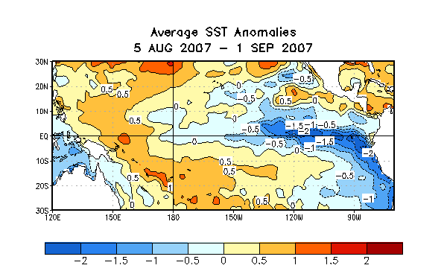
Figure 1. Sea surface temperature (SST) anomalies (°C) during the four-week period 5 August-1 September 2007. SST anomalies are computed with respect to the 1971-2000 base period weekly means (Xue et al. 2003, J. Climate, 16, 1601-1612).

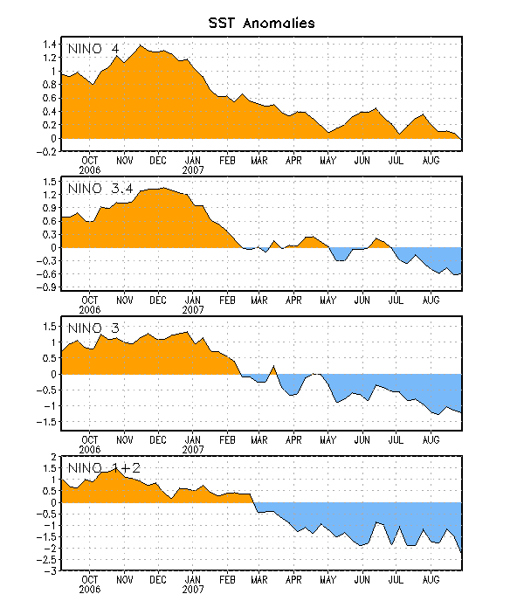
Figure 2. Time series of area-averaged sea surface temperature (SST) anomalies (°C) in the Niño regions [Niño-1+2 (0°-10°S, 90°-80°W), Niño 3 (5°N-5°S, 150°W-90°W), Niño-3.4 (5°N-5°S, 170°W-120°W), Niño-4 (150ºW-160ºE and 5ºN-5ºS)]. SST anomalies are departures are from the 1971-2000 base period means (Xue et al. 2003, J. Climate, 16, 1601-1612).

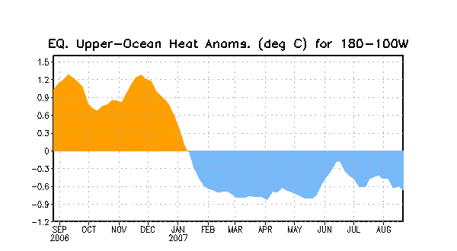

Figure 3. Area-averaged upper-ocean heat content anomalies in the equatorial Pacific (5°N-5°S, 180º-100ºW). Heat content anomalies are computed as departures from the 1982-2004 base period means.

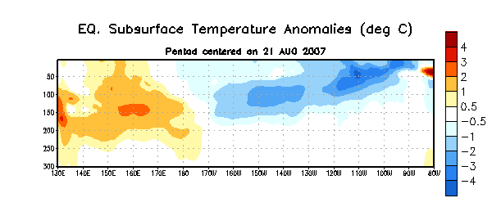
Figure 4. Depth-longitude section of upper-ocean (0-300m) temperature anomalies for the equatorial Pacific averaged between 5°N-5°S. Temperature anomalies are departures from the 1982-2004 base period means.

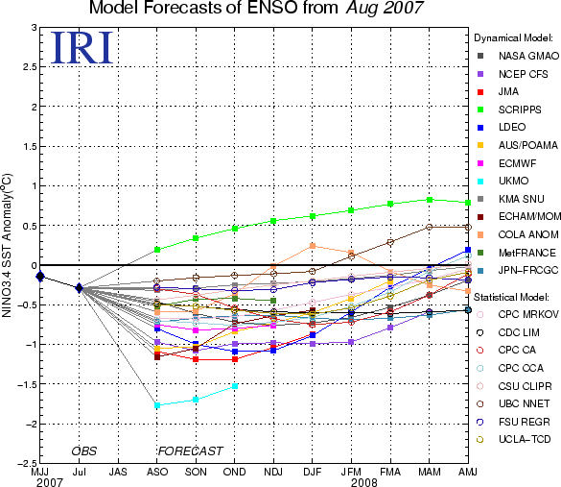

Figure 5. Forecasts of sea surface temperature (SST) anomalies for the Niño 3.4 region (5°N-5°S, 120°W-170°W). Figure courtesy of the International Research Institute (IRI) for Climate and Society.

