EL NIÑO/SOUTHERN OSCILLATION (ENSO) DIAGNOSTIC DISCUSSION

issued by

CLIMATE PREDICTION CENTER/NCEP/NWS
9 September 2010

ENSO Alert System Status: La Niña Advisory

Synopsis: La Niña is expected to last at least through the Northern Hemisphere winter 2010-11.
La Niña strengthened during August 2010, as negative sea surface temperature (SST) anomalies reached at least -1°C across most of the equatorial Pacific Ocean by the end of the month (Fig. 1). All of the Niño indices cooled to between –1.3°C and –1.8°C by the end of August (Fig. 2). Consistent with this evolution, the subsurface heat content (average temperatures in the upper 300m of the ocean, Fig. 3) decreased further, reflecting the additional cooling of sub-surface waters east of the Date Line (Fig. 4). Also convection was enhanced over Indonesia, while remaining suppressed over the western and central equatorial Pacific (Fig. 5). The pattern was associated with the continuation of enhanced low-level easterly trade winds and anomalous upper-level westerly winds over the western and central equatorial Pacific. Collectively, these oceanic and atmospheric anomalies reflect the strengthening of La Niña.
Nearly all models predict La Niña to continue at least through early 2011 (Fig. 6). However, the models continue to disagree on the eventual strength of La Niña. Based on current observations and model guidance, we expect the SST anomalies in the Niño-3.4 region to either persist near the present strength, or to strengthen into the winter as is consistent with the historical evolution of La Niña. Thus, it is likely that the peak strength of this event will be at least moderate (3-month average between –1°C to –1.4°C in Niño-3.4) to strong (3-month average of –1.5°C or less in Niño-3.4).
Expected La Niña impacts during September-November 2010 include suppressed convection over the central tropical Pacific Ocean, and enhanced convection over Indonesia. The transition into the Northern Hemisphere Fall means that La Niña will begin to exert an increasing influence on the weather and climate of the United States. These impacts include an enhanced chance of above-average precipitation in the Pacific Northwest, and below-average precipitation in the Southwest and in portions of the middle and lower Mississippi Valley and Tennessee Valley. Also, La Niña can contribute to increased Atlantic hurricane activity by decreasing the vertical wind shear over the Caribbean Sea and tropical Atlantic Ocean (see the August 5th update of the NOAA Atlantic Seasonal Hurricane Outlook), and to suppressed hurricane activity across the central and eastern tropical North Pacific.
This discussion is a consolidated effort of the National Oceanic and Atmospheric Administration (NOAA), NOAA’s National Weather Service, and their funded institutions. Oceanic and atmospheric conditions are updated weekly on the Climate Prediction Center web site (El Niño/La Niña Current Conditions and Expert Discussions). Forecasts for the evolution of El Niño/La Niña are updated monthly in the Forecast Forum section of CPC's Climate Diagnostics Bulletin. The next ENSO Diagnostics Discussion is scheduled for 7 October 2010. To receive an e-mail notification when the monthly ENSO Diagnostic Discussions are released, please send an e-mail message to: ncep.list.enso-update@noaa.gov.
Climate Prediction Center
National Centers for Environmental Prediction
NOAA/National Weather Service
Camp Springs, MD 20746-4304
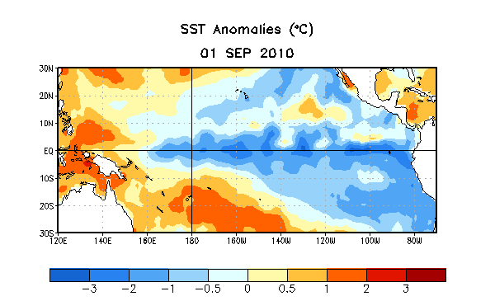
Figure 1. Average sea surface temperature (SST) anomalies (°C) for the week centered on 1 September 2010. Anomalies are computed with respect to the 1971-2000 base period weekly means (Xue et al. 2003, J. Climate, 16, 1601-1612).

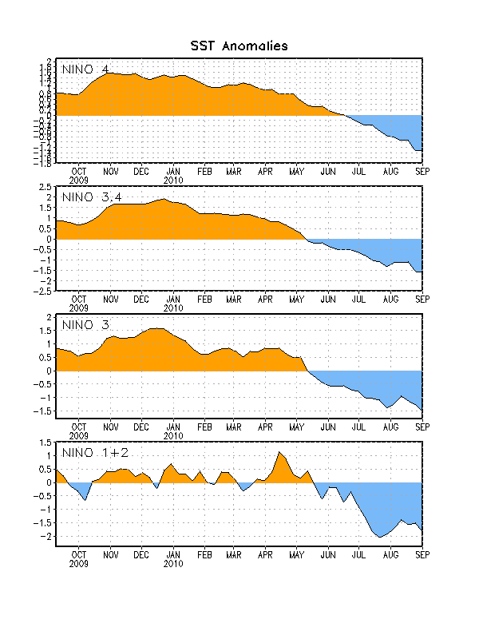
Figure 2. Time series of area-averaged sea surface temperature (SST) anomalies (°C) in the Niño regions [Niño-1+2 (0°-10°S, 90°W-80°W), Niño 3 (5°N-5°S, 150°W-90°W), Niño-3.4 (5°N-5°S, 170°W-120°W), Niño-4 (150ºW-160ºE and 5ºN-5ºS)]. SST anomalies are departures from the 1971-2000 base period weekly means (Xue et al. 2003, J. Climate, 16, 1601-1612).

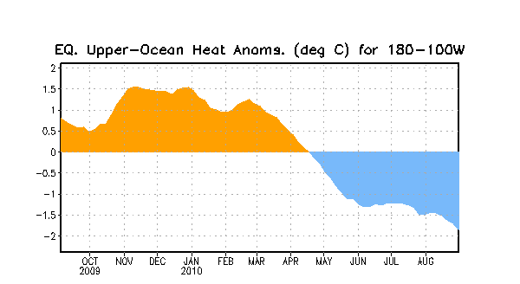
Figure 3. Area-averaged upper-ocean heat content anomalies (°C) in the equatorial Pacific (5°N-5°S, 180º-100ºW). Heat content anomalies are computed as departures from the 1982-2004 base period pentad means.

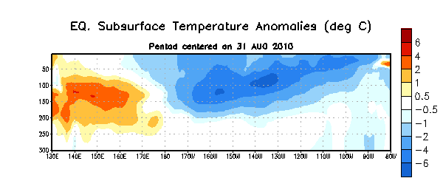
Figure 4. Depth-longitude section of equatorial Pacific upper-ocean (0-300m) temperature anomalies (°C) centered on the week of 31 August 2010. The anomalies are averaged between 5°N-5°S. Anomalies are departures from the 1982-2004 base period pentad means.

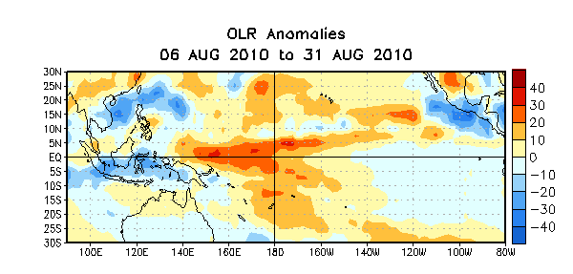
Figure 5. Average outgoing longwave radiation (OLR) anomalies (W/m²) for the four-week period 6 – 31 August 2010. OLR anomalies are computed as departures from the 1979-1995 base period pentad means.

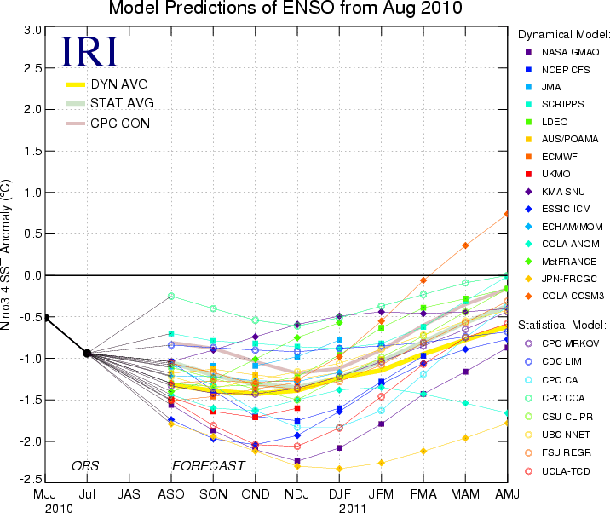
Figure 6. Forecasts of sea surface temperature (SST) anomalies for the Niño 3.4 region (5°N-5°S, 120°W-170°W). Figure courtesy of the International Research Institute (IRI) for Climate and Society. Figure updated 17 August 2010.

