EL NIÑO/SOUTHERN OSCILLATION (ENSO) DIAGNOSTIC DISCUSSION

issued by

CLIMATE PREDICTION CENTER/NCEP/NWS
and the International Research Institute for Climate and Society
6 September 2012

ENSO Alert System Status: El Niño Watch

Synopsis: El Niño conditions are likely to develop during September 2012.
ENSO-neutral conditions continued during August 2012 despite above-average sea surface temperatures (SST) across the eastern Pacific Ocean (Fig. 1). Reflecting this warmth, most of the weekly Niño index values remained near +0.5°C (Fig. 2). The oceanic heat content (average temperature in the upper 300m of the ocean) anomalies also remained elevated during the month (Fig. 3), consistent with a large region of above-average temperatures at depth across the equatorial Pacific (Fig. 4). Possible signs of El Niño development in the atmosphere included upper-level easterly wind anomalies and a slightly negative Southern Oscillation Index. Despite these indicators, key aspects of the tropical atmosphere did not support the development of El Niño conditions during the month. In particular, low-level trade winds were near average along the equator, and the pattern of tropical convection from Indonesia to the central equatorial Pacific was inconsistent with El Niño with the typical regions of both enhanced and suppressed convection shifted too far west (Fig. 5). Because of the lack of clear atmospheric anomaly patterns, ENSO-neutral conditions persisted during August. However, there are ongoing signs of a possibly imminent transition towards El Niño in the atmosphere as well as the ocean.
Most of the dynamical models, along with roughly one-half of the statistical models, now predict the onset of El Niño beginning in August-October 2012, persisting through the remainder of the year (Fig. 6). The consensus of dynamical models indicates a borderline moderate strength event (Niño 3.4 index near +1.0°C), while the statistical model consensus indicates a borderline weak El Niño (+0.4° to +0.5°C). Supported by the model forecasts and the continued warmth across the Pacific Ocean, the official forecast calls for the development of most likely a weak El Niño during September 2012, persisting through December-February 2012-13 (see CPC/IRI consensus forecast).
This discussion is a consolidated effort of the National Oceanic and Atmospheric Administration (NOAA), NOAA’s National Weather Service, and their funded institutions. Oceanic and atmospheric conditions are updated weekly on the Climate Prediction Center web site (El Niño/La Niña Current Conditions and Expert Discussions). Forecasts for the evolution of El Niño/La Niña are updated monthly in the Forecast Forum section of CPC's Climate Diagnostics Bulletin. The next ENSO Diagnostics Discussion is scheduled for 4 October 2012. To receive an e-mail notification when the monthly ENSO Diagnostic Discussions are released, please send an e-mail message to: ncep.list.enso-update@noaa.gov.
Climate Prediction Center
National Centers for Environmental Prediction
NOAA/National Weather Service
Camp Springs, MD 20746-4304

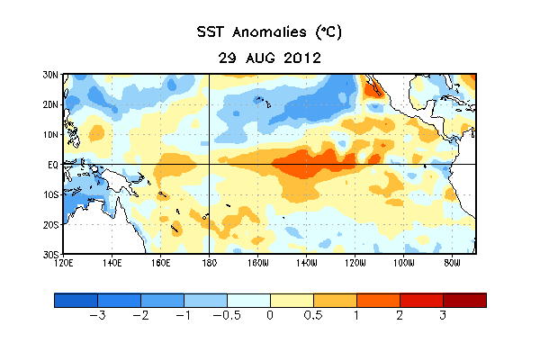
Figure 1. Average sea surface temperature (SST) anomalies (°C) for the week centered on 29 August 2012. Anomalies are computed with respect to the 1981-2010 base period weekly means.

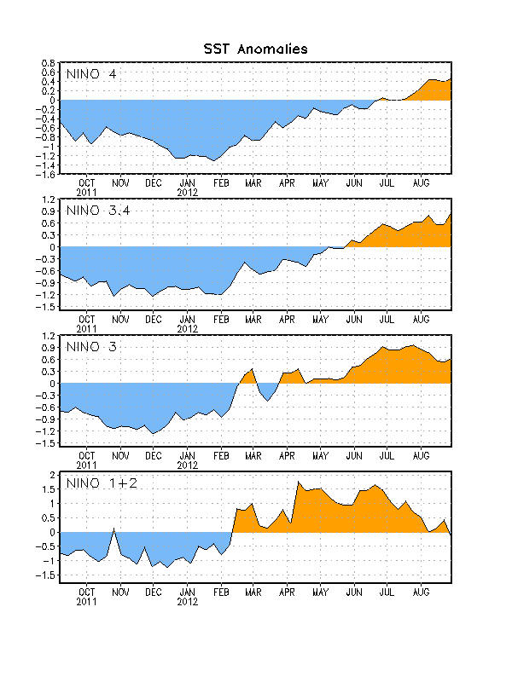
Figure 2. Time series of area-averaged sea surface temperature (SST) anomalies (°C) in the Niño regions [Niño-1+2 (0°-10°S, 90°W-80°W), Niño 3 (5°N-5°S, 150°W-90°W), Niño-3.4 (5°N-5°S, 170°W-120°W), Niño-4 (150ºW-160ºE and 5ºN-5ºS)]. SST anomalies are departures from the 1981-2010 base period weekly means.

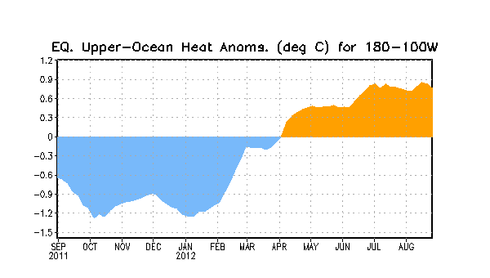
Figure 3. Area-averaged upper-ocean heat content anomaly (°C) in the equatorial Pacific (5°N-5°S, 180º-100ºW). The heat content anomaly is computed as the departure from the 1982-2010 base period pentad means.

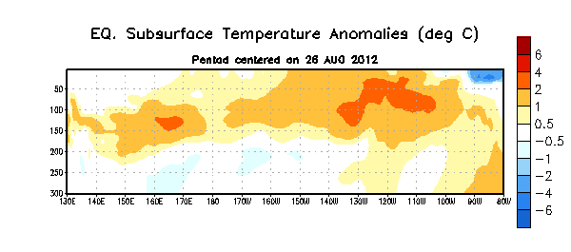
Figure 4. Depth-longitude section of equatorial Pacific upper-ocean (0-300m) temperature anomalies (°C) centered on the pentad of 26 August 2012. The anomalies are averaged between 5°N-5°S. Anomalies are departures from the 1982-2010 base period pentad means.

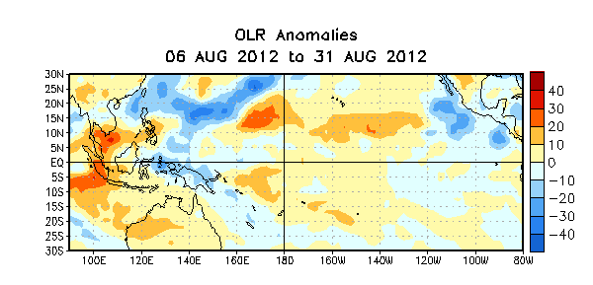

Figure 5. Average outgoing longwave radiation (OLR) anomalies (W/m²) for the four-week period 6 – 31 August 2012. OLR anomalies are computed as departures from the 1979-1995 base period pentad means.

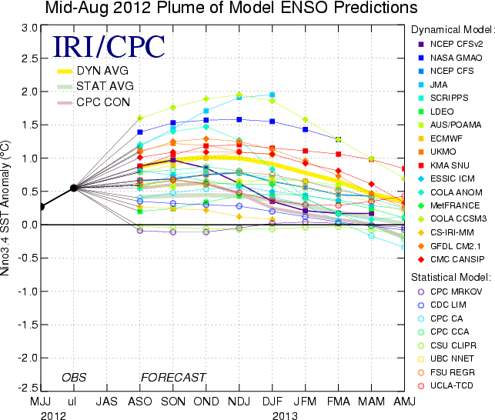
Figure 6. Forecasts of sea surface temperature (SST) anomalies for the Niño 3.4 region (5°N-5°S, 120°W-170°W). Figure courtesy of the International Research Institute (IRI) for Climate and Society. Figure updated 16 August 2012.

