EL NIÑO/SOUTHERN OSCILLATION (ENSO) DIAGNOSTIC DISCUSSION

issued by

CLIMATE PREDICTION CENTER/NCEP/NWS
and the International Research Institute for Climate and Society
5 September 2013

ENSO Alert System Status: Not Active

Synopsis: ENSO-neutral is favored through the Northern Hemisphere winter 2013-14.
ENSO-neutral conditions persisted during August 2013, as reflected by near-average sea surface temperatures (SSTs) across much of the equatorial Pacific, with below-average SSTs in the eastern Pacific (Fig. 1). Consistent with this pattern, weekly Niño-4 and Niño-3.4 indices were between -0.5 and 0.2°C, while Niño-3 and Niño-1+2 indices were at or cooler than -0.5°C (Fig. 2). The oceanic heat content (average temperature in the upper 300m of the ocean) remained near to slightly above average during August (Fig. 3), due to the persistence of above-average sub-surface temperatures across much of the eastern half of the Pacific (Fig. 4). The low-level and upper-level winds were near average across the equatorial Pacific. Convection continued to be enhanced over Indonesia and suppressed in the central and eastern Pacific (Fig. 5). Collectively, these atmospheric and oceanic conditions reflect ENSO-neutral.
Most model forecasts continue to predict ENSO-neutral (Niño-3.4 index between -0.5°C and 0.5°C) into the Northern Hemisphere spring 2014 (Fig. 6). For the next several seasons, the average of the statistical model forecasts is near -0.5°C, while the average of the dynamical model forecasts is near or just above 0.0°C. Similar to last month, the forecast consensus favors ENSO-neutral (60% chance or greater) through December – February 2013-14 (see CPC/IRI consensus forecast).
This discussion is a consolidated effort of the National Oceanic and Atmospheric Administration (NOAA), NOAA’s National Weather Service, and their funded institutions. Oceanic and atmospheric conditions are updated weekly on the Climate Prediction Center web site (El Niño/La Niña Current Conditions and Expert Discussions). Forecasts for the evolution of El Niño/La Niña are updated monthly in the Forecast Forum section of CPC's Climate Diagnostics Bulletin. The next ENSO Diagnostics Discussion is scheduled for 10 October 2013. To receive an e-mail notification when the monthly ENSO Diagnostic Discussions are released, please send an e-mail message to: ncep.list.enso-update@noaa.gov.
Climate Prediction Center
National Centers for Environmental Prediction
NOAA/National Weather Service
College Park, MD 20740

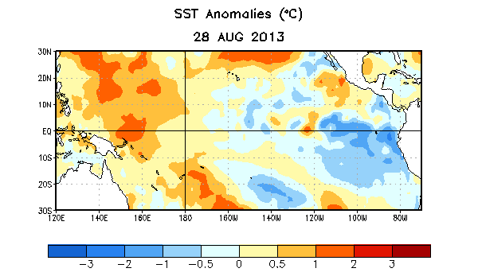
Figure 1. Average sea surface temperature (SST) anomalies (°C) for the week centered on 28August 2013. Anomalies are computed with respect to the 1981-2010 base period weekly means.

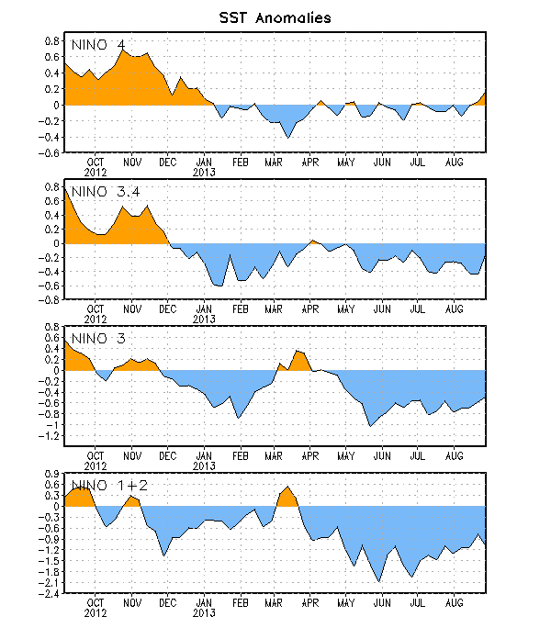
Figure 2. Time series of area-averaged sea surface temperature (SST) anomalies (°C) in the Niño regions [Niño-1+2 (0°-10°S, 90°W-80°W), Niño 3 (5°N-5°S, 150°W-90°W), Niño-3.4 (5°N-5°S, 170°W-120°W), Niño-4 (150ºW-160ºE and 5ºN-5ºS)]. SST anomalies are departures from the 1981-2010 base period weekly means.

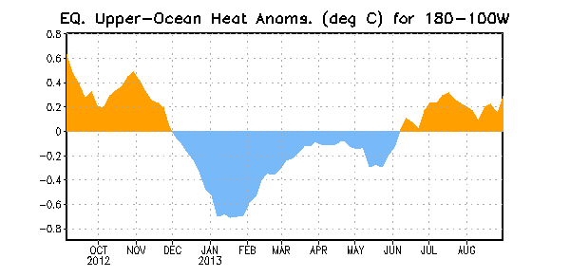
Figure 3. Area-averaged upper-ocean heat content anomaly (°C) in the equatorial Pacific (5°N-5°S, 180º-100ºW). The heat content anomaly is computed as the departure from the 1981-2010 base period pentad means.

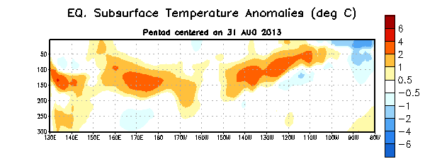
Figure 4. Depth-longitude section of equatorial Pacific upper-ocean (0-300m) temperature anomalies (°C) centered on the pentad of 31 August 2013. The anomalies are averaged between 5°N-5°S. Anomalies are departures from the 1981-2010 base period pentad means.

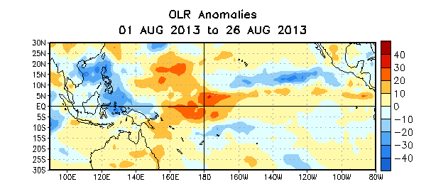
Figure 5. Average outgoing longwave radiation (OLR) anomalies (W/m²) for the four-week period 1 – 26 August 2013. OLR anomalies are computed as departures from the 1979-1995 base period pentad means.

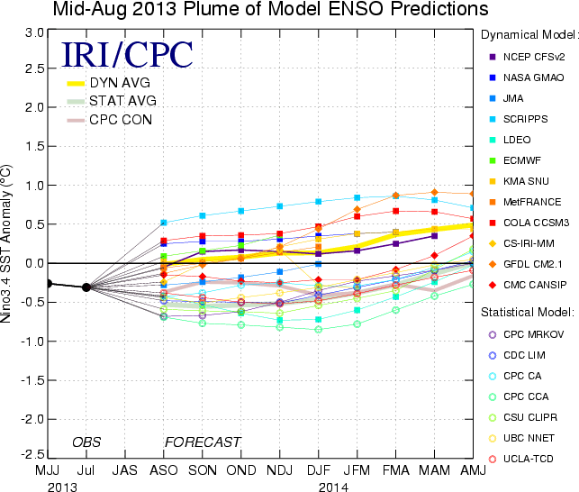
Figure 6. Forecasts of sea surface temperature (SST) anomalies for the Niño 3.4 region (5°N-5°S, 120°W-170°W). Figure courtesy of the International Research Institute (IRI) for Climate and Society. Figure updated 13 August 2013.

