EL NIÑO/SOUTHERN OSCILLATION (ENSO) DIAGNOSTIC DISCUSSION

issued by

CLIMATE PREDICTION CENTER/NCEP/NWS
and the International Research Institute for Climate and Society
4 September 2014

ENSO Alert System Status: El Niño Watch

Synopsis: The chance of El Niño is at 60-65% during the Northern Hemisphere fall and winter.
During August 2014, above-average sea surface temperatures (SST) continued across much of the equatorial Pacific (Fig. 1). Most of the Niño indices warmed during the month with values of +0.5°C in Niño-4, +0.4°C in Niño-3.4, +0.4°C in Niño-3, and +0.8°C in Niño-1+2 (Fig. 2). Subsurface heat content anomalies (averaged between 180º-100ºW) also increased during the month (Fig. 3) as above-average subsurface temperatures developed across the central and east-central equatorial Pacific (Fig. 4). This warming is associated with the downwelling phase of an equatorial oceanic Kelvin wave triggered in July by low-level westerly wind anomalies. Westerly wind anomalies continued in the central and eastern part of the basin early in August, but weakened by the end of the month. Enhanced easterly upper-level wind anomalies have prevailed during much of the month, and the Southern Oscillation Index has been negative. However, convective cloudiness remained generally near average over most of the region, except for below average cloudiness observed across the central and western Pacific (Fig. 5). The lack of a coherent atmospheric El Niño pattern and near-average SSTs in the central Pacific indicate a continuation of ENSO-neutral.
Most of the models continue to predict El Niño to develop during September-November and to continue into early 2015 (Fig. 6). A majority of models and the multi-model averages favor a weak El Niño. At this time, the consensus of forecasters expects El Niño to emerge during September-October and to peak at weak strength during the late fall and early winter (3-month values of the Niño-3.4 index between 0.5°C and 0.9°C). The chance of El Niño is at 60-65% during the Northern Hemisphere fall and winter (click CPC/IRI consensus forecast for the chance of each outcome).
This discussion is a consolidated effort of the National Oceanic and Atmospheric Administration (NOAA), NOAA’s National Weather Service, and their funded institutions. Oceanic and atmospheric conditions are updated weekly on the Climate Prediction Center web site (El Niño/La Niña Current Conditions and Expert Discussions). Forecasts are also updated monthly in the Forecast Forum of CPC's Climate Diagnostics Bulletin. Additional perspectives and analysis are also available in an ENSO blog. The next ENSO Diagnostics Discussion is scheduled for 9 October 2014. To receive an e-mail notification when the monthly ENSO Diagnostic Discussions are released, please send an e-mail message to: ncep.list.enso-update@noaa.gov.

Climate Prediction Center
National Centers for Environmental Prediction
NOAA/National Weather Service
College Park, MD 20740

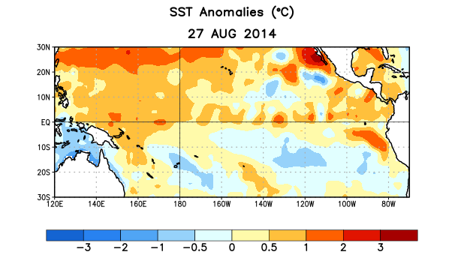
Figure 1. Average sea surface temperature (SST) anomalies (°C) for the week centered on 27 August 2014. Anomalies are computed with respect to the 1981-2010 base period weekly means.

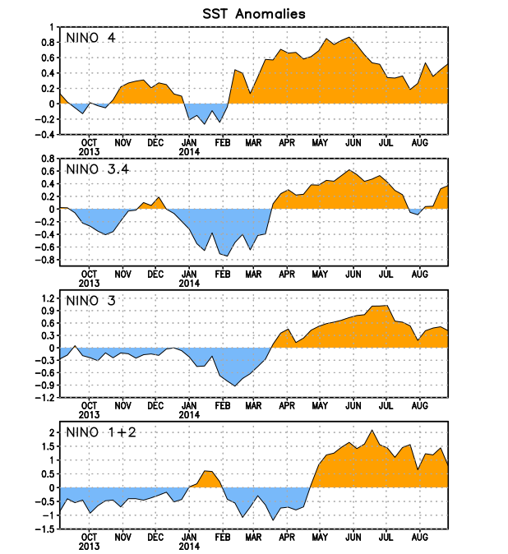
Figure 2. Time series of area-averaged sea surface temperature (SST) anomalies (°C) in the Niño regions [Niño-1+2 (0°-10°S, 90°W-80°W), Niño 3 (5°N-5°S, 150°W-90°W), Niño-3.4 (5°N-5°S, 170°W-120°W), Niño-4 (5ºN-5ºS , 150ºW-160ºE]. SST anomalies are departures from the 1981-2010 base period weekly means.
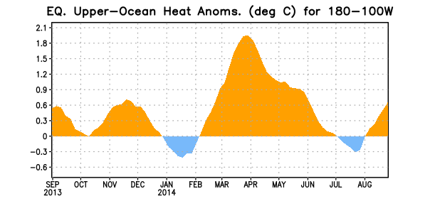

Figure 3. Area-averaged upper-ocean heat content anomaly (°C) in the equatorial Pacific (5°N-5°S, 180º-100ºW). The heat content anomaly is computed as the departure from the 1981-2010 base period pentad means.

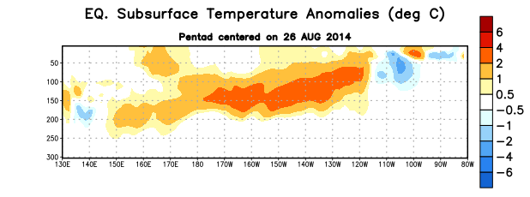
Figure 4. Depth-longitude section of equatorial Pacific upper-ocean (0-300m) temperature anomalies (°C)
centered on the pentad of 26 August 2014. The anomalies are averaged between 5°N-5°S. Anomalies are departures from the 1981-2010 base period pentad means.

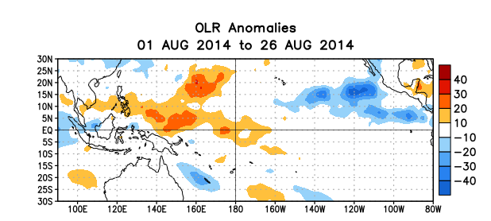
Figure 5. Average outgoing longwave radiation (OLR) anomalies (W/m²) for the period 1 – 26 August 2014. OLR anomalies are computed as departures from the 1979-1995 base period pentad means.

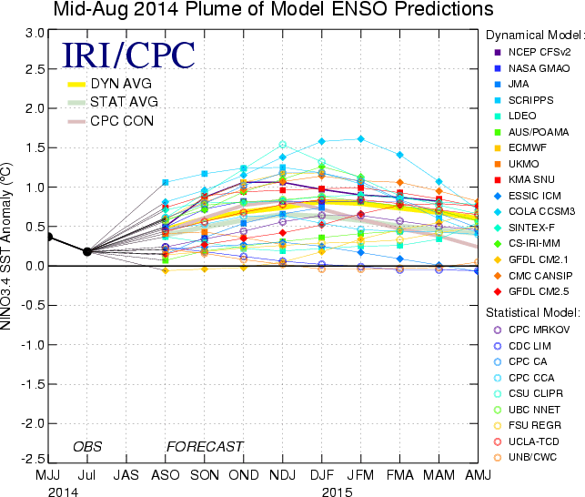

Figure 6. Forecasts of sea surface temperature (SST) anomalies for the Niño 3.4 region (5°N-5°S, 120°W-170°W). Figure updated 19 August 2014.

