EL NIÑO/SOUTHERN OSCILLATION (ENSO) DIAGNOSTIC DISCUSSION

issued by

CLIMATE PREDICTION CENTER/NCEP/NWS
and the International Research Institute for Climate and Society
8 September 2016

ENSO Alert System Status: Not Active

Synopsis: ENSO-Neutral conditions are slightly favored (between 55-60%) during the upcoming Northern Hemisphere fall and winter 2016-17.
ENSO-Neutral conditions were observed over the past month, although sea surface temperatures (SSTs) were below-average over the east-central equatorial Pacific Ocean (Fig. 1). While the Niño-3.4 and Niño-3 regions remained around -0.5°C for most of the month, Niño-4 and Niño 1+2 were -0.1°C and +0.3°C, respectively, by the end of the month (Fig. 2). Subsurface temperatures across the eastern and central Pacific remained below average (Fig. 3), and negative temperature anomalies remained weak across the western Pacific (Fig. 4). Atmospheric anomalies over the tropical Pacific Ocean largely indicated ENSO-Neutral conditions. The traditional Southern Oscillation index and the equatorial Southern Oscillation index were weakly positive during August. The lower-level winds were near average, while the upper-level winds were anomalously westerly in a small region to the east of the International Date Line. Convection was suppressed over the western and central tropical Pacific, although less suppressed compared to last month (Fig. 5). Overall, the combined ocean and atmosphere system continues to reflect ENSO-Neutral.
The multi-model averages favor borderline Neutral-La Niña conditions (3-month average Niño-3.4 index less than or equal to -0.5°C) during the Northern Hemisphere fall, continuing into winter (Fig. 6). However, the more recently updated model runs from the North American Multi-Model Ensemble (NMME) more strongly favor ENSO-Neutral (Fig. 7). The forecaster consensus prefers this outcome, which is supported by the lack of significant anomalies in several indicators over the past month (winds, convection, subsurface temperatures). Overall, ENSO-Neutral conditions are slightly favored (between 55-60%) during the upcoming Northern Hemisphere fall and winter 2016-17 (click CPC/IRI consensus forecast for the chance of each outcome for each 3-month period).
This discussion is a consolidated effort of the National Oceanic and Atmospheric Administration (NOAA), NOAA’s National Weather Service, and their funded institutions. Oceanic and atmospheric conditions are updated weekly on the Climate Prediction Center web site (El Niño/La Niña Current Conditions and Expert Discussions). Forecasts are also updated monthly in the Forecast Forum of CPC's Climate Diagnostics Bulletin. Additional perspectives and analysis are also available in an ENSO blog. The next ENSO Diagnostics Discussion is scheduled for 13 October 2016. To receive an e-mail notification when the monthly ENSO Diagnostic Discussions are released, please send an e-mail message to: ncep.list.enso-update@noaa.gov.

Climate Prediction Center
National Centers for Environmental Prediction
NOAA/National Weather Service
College Park, MD 20740

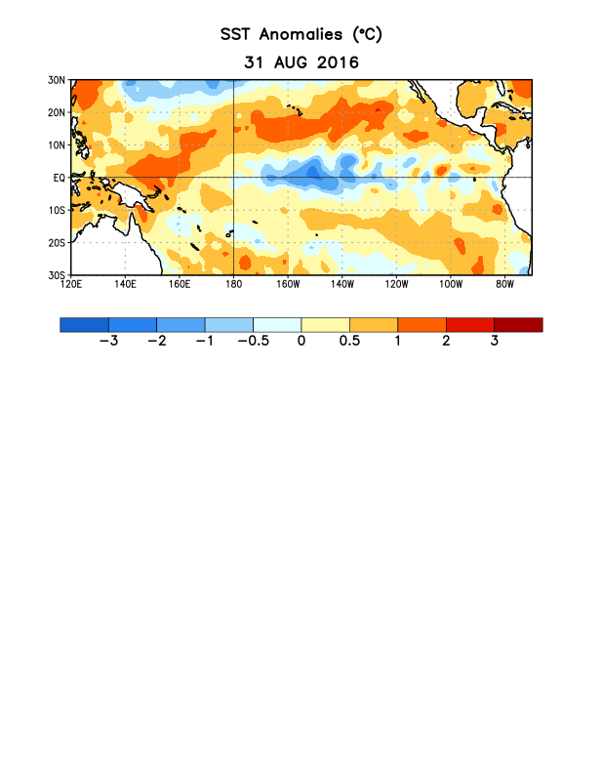
Figure 1. Average sea surface temperature (SST) anomalies (°C) for the week centered on 31 August 2016. Anomalies are computed with respect to the 1981-2010 base period weekly means.

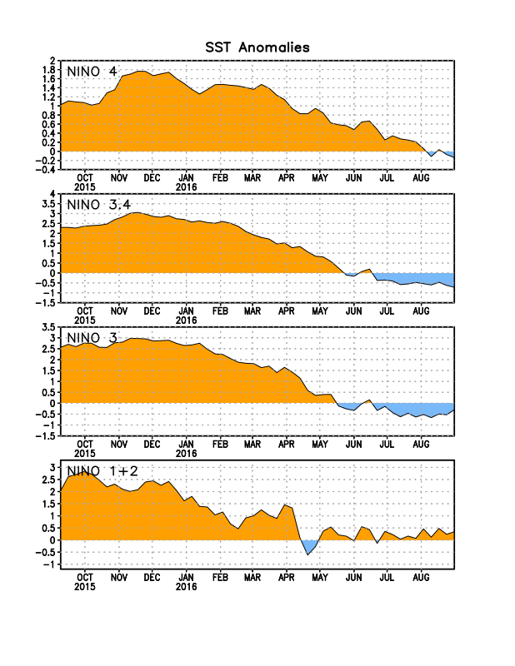
Figure 2. Time series of area-averaged sea surface temperature (SST) anomalies (°C) in the Niño regions [Niño-1+2 (0°-10°S, 90°W-80°W), Niño 3 (5°N-5°S, 150°W-90°W), Niño-3.4 (5°N-5°S, 170°W-120°W), Niño-4 (5ºN-5ºS , 150ºW-160ºE]. SST anomalies are departures from the 1981-2010 base period weekly means.
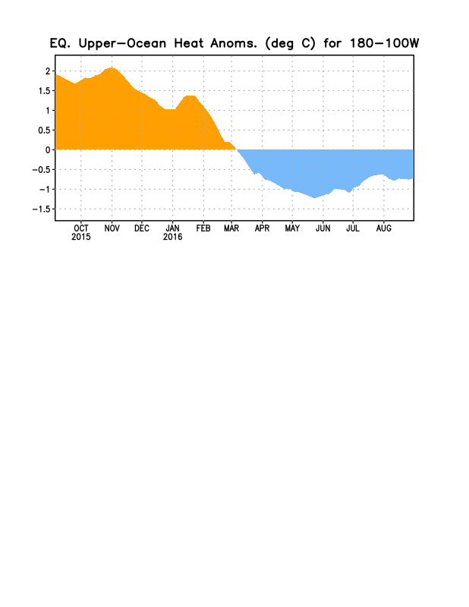
Figure 3. Area-averaged upper-ocean heat content anomaly (°C) in the equatorial Pacific (5°N-5°S, 180º-100ºW). The heat content anomaly is computed as the departure from the 1981-2010 base period pentad means.

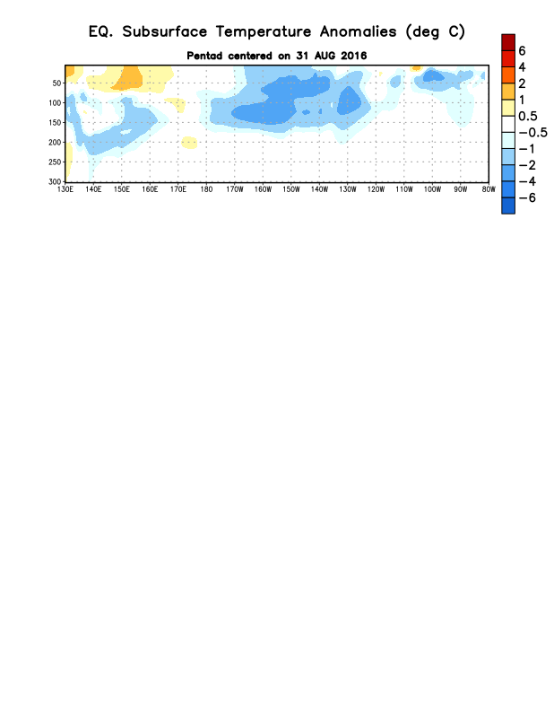
Figure 4. Depth-longitude section of equatorial Pacific upper-ocean (0-300m) temperature anomalies (°C)
centered on the pentad of 31 August 2016. The anomalies are averaged between 5°N-5°S. Anomalies are departures from the 1981-2010 base period pentad means.

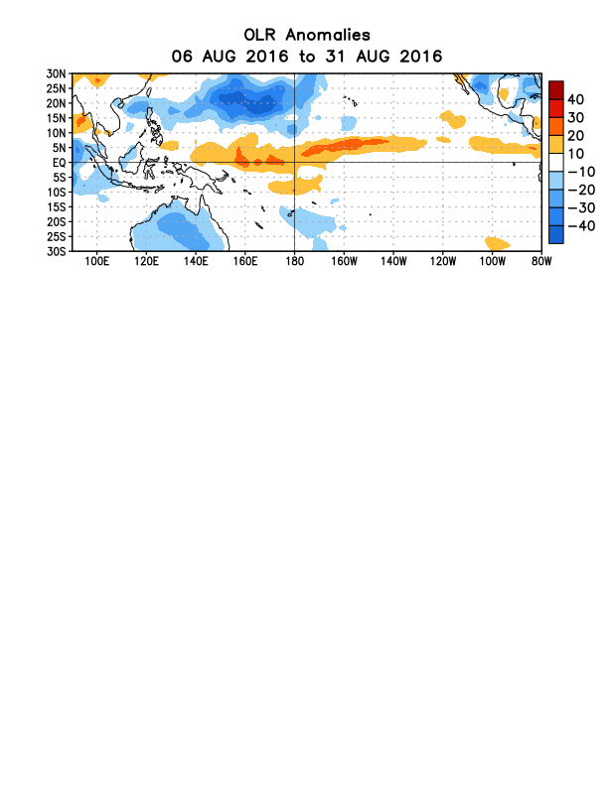
Figure 5. Average outgoing longwave radiation (OLR) anomalies (W/m²) for the period 6 – 31 August 2016. OLR anomalies are computed as departures from the 1981-2010 base period pentad means.

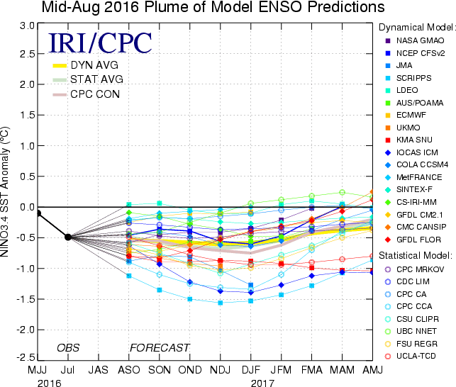
Figure 6. Forecasts of sea surface temperature (SST) anomalies for the Niño 3.4 region (5°N-5°S, 120°W-170°W). Figure updated 16 August 2016.

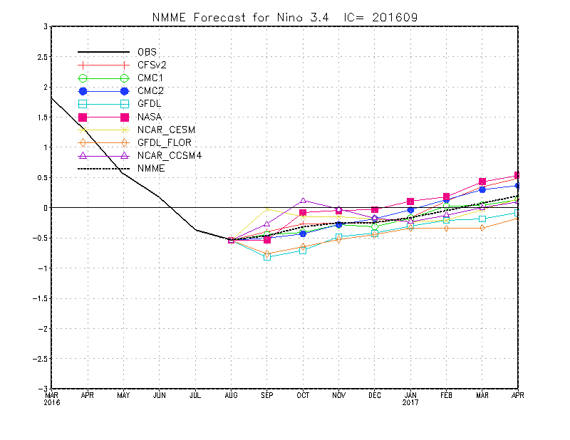
Figure 7. Forecasts of sea surface temperature (SST) anomalies for the Niño 3.4 region (5°N-5°S, 120°W-170°W) from the North American Multi-Model Ensemble. Figure updated 6 September 2016.

