EL NIÑO/SOUTHERN OSCILLATION (ENSO) DIAGNOSTIC DISCUSSION

issued by

CLIMATE PREDICTION CENTER/NCEP/NWS
and the International Research Institute for Climate and Society
14 September 2017

ENSO Alert System Status: La Niña Watch

Synopsis: There is an increasing chance (~55-60%) of La Niña during the Northern Hemisphere fall and winter 2017-18.
Over the last month, equatorial sea surface temperatures (SSTs) were near-to-below average across the central and eastern Pacific Ocean (Fig. 1). ENSO-neutral conditions were apparent in the weekly fluctuation of Niño-3.4 SST index values between -0.1°C and -0.6°C (Fig. 2). While temperature anomalies were variable at the surface, they became increasingly negative in the sub-surface ocean (Fig. 3), due to the shoaling of the thermocline across the east-central and eastern Pacific (Fig. 4). Though remaining mostly north of the equator, convection was suppressed over the western and central Pacific Ocean and slightly enhanced near Indonesia (Fig. 5). The low-level trade winds were stronger than average over a small region of the far western tropical Pacific Ocean, and upper-level winds were anomalously easterly over a small area of the east-central Pacific. Overall, the ocean and atmosphere system remains consistent with ENSO-neutral.

A majority of the models in the IRI/CPC suite of Niño-3.4 predictions favor ENSO-neutral through the Northern Hemisphere 2017-18 winter (Fig. 6). However, the most recent predictions from the NCEP Climate Forecast System (CFSv2) and the North American Multi-Model Ensemble (NMME) indicate the formation of La Niña as soon as the Northern Hemisphere fall 2017 (Fig. 7). Forecasters favor these predictions in part because of the recent cooling of surface and sub-surface temperature anomalies, and also because of the higher degree of forecast skill at this time of year. In summary, there is an increasing chance (~55-60%) of La Niña during the Northern Hemisphere fall and winter 2017-18 (click CPC/IRI consensus forecast for the chance of each outcome for each 3-month period).

This discussion is a consolidated effort of the National Oceanic and Atmospheric Administration (NOAA), NOAA’s National Weather Service, and their funded institutions. Oceanic and atmospheric conditions are updated weekly on the Climate Prediction Center web site (El Niño/La Niña Current Conditions and Expert Discussions). Forecasts are also updated monthly in the Forecast Forum of CPC's Climate Diagnostics Bulletin. Additional perspectives and analysis are also available in an ENSO blog. The next ENSO Diagnostics Discussion is scheduled for 12 October 2017. To receive an e-mail notification when the monthly ENSO Diagnostic Discussions are released, please send an e-mail message to: ncep.list.enso-update@noaa.gov.

Climate Prediction Center
National Centers for Environmental Prediction
NOAA/National Weather Service
College Park, MD 20740

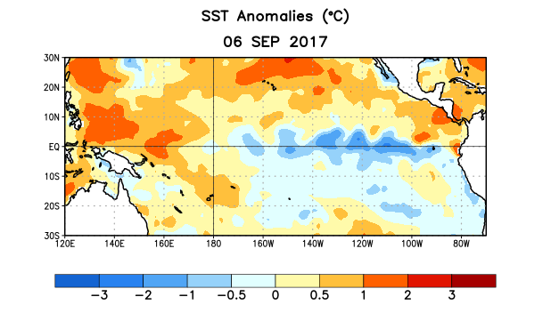
Figure 1. Average sea surface temperature (SST) anomalies (°C) for the week centered on 6 September 2017. Anomalies are computed with respect to the 1981-2010 base period weekly means.

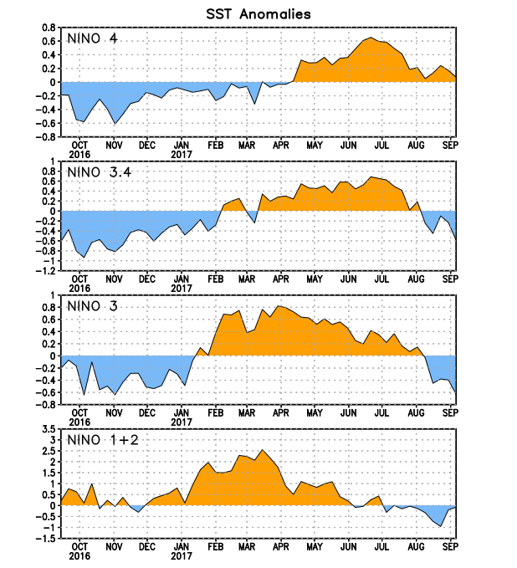
Figure 2. Time series of area-averaged sea surface temperature (SST) anomalies (°C) in the Niño regions [Niño-1+2 (0°-10°S, 90°W-80°W), Niño-3 (5°N-5°S, 150°W-90°W), Niño-3.4 (5°N-5°S, 170°W-120°W), Niño-4 (5ºN-5ºS , 150ºW-160ºE]. SST anomalies are departures from the 1981-2010 base period weekly means.
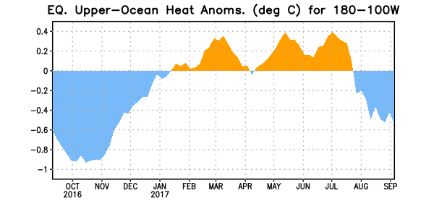
Figure 3. Area-averaged upper-ocean heat content anomaly (°C) in the equatorial Pacific (5°N-5°S, 180º-100ºW). The heat content anomaly is computed as the departure from the 1981-2010 base period pentad means.

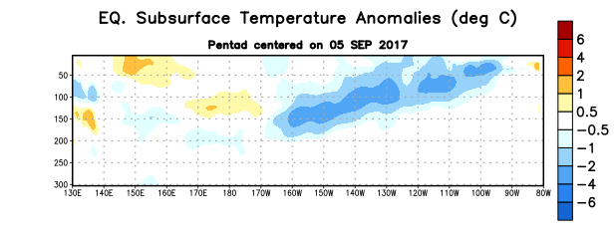
Figure 4. Depth-longitude section of equatorial Pacific upper-ocean (0-300m) temperature anomalies (°C) centered on the pentad of 5 September 2017. Anomalies are departures from the 1981-2010 base period pentad means.

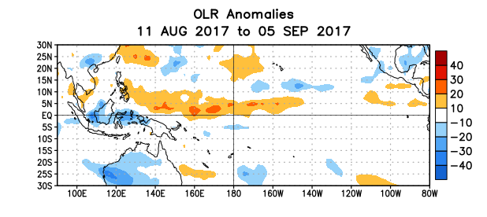
Figure 5. Average outgoing longwave radiation (OLR) anomalies (W/m²) for the period 11 August – 5 September 2017. OLR anomalies are computed as departures from the 1981-2010 base period pentad means.

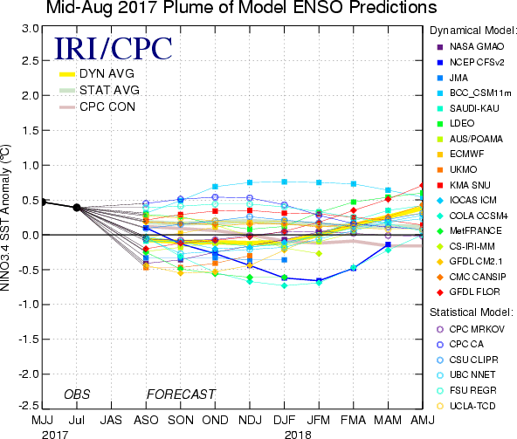

Figure 6. Forecasts of sea surface temperature (SST) anomalies for the Niño 3.4 region (5°N-5°S, 120°W-170°W). Figure updated 18 August 2017.

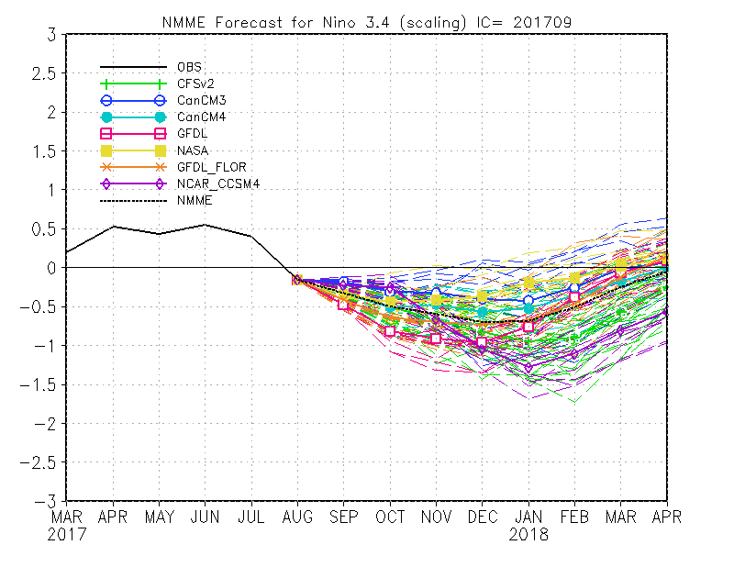
Figure 7. Forecasts of sea surface temperature (SST) anomalies for the Niño 3.4 region (5°N-5°S, 120°W-170°W) from the North American Multi-Model Ensemble. Figure updated 7 September 2017.

